Request for Approval under the “Generic Clearance for Improving Customer Experience: OMB Circular A-11, Section 280 Implementation”

(OMB Control Number:2900-0876)

TITLE OF INFORMATION COLLECTION: VBA Disability Compensation Non-Rating Claims Survey

PURPOSE OF COLLECTION:
Through the Veterans Benefits Administration (VBA), the Department of Veterans Affairs processes claims that do not involve an examination. Non-rating claims often involve complex administrative determinations such as compensation offsets (military retired pay, separation pay, disability severance pay, etc.) eligibility determinations, eligibility determinations, and actions such as automobile and adaptive equipment claims. In FY24, VBA completed 2.2 million non-rating claims. There currently is not a survey to capture critical data/feedback on the Veteran’s experience. This experience data and direct insights are needed to identify opportunities to improve non-rating claims process. Non-rating claims are also processed by nine Benefits Eligibility Support Team (BEST) divisions, which do not have any coverage in existing VSignals surveys. The feedback received from these surveys will support making short- and long-term process and program improvements.

TYPE OF ACTIVITY: (Check one)

[ ] Customer Research (Interview, Focus Groups, Surveys)
[ X] Customer Feedback Survey
[ ] Usability Testing of Products or Services

ACTIVITY DETAILS

- If this is a survey, will the results of this survey be reported to Touchpoints as part of quarterly reporting obligations specified in OMB Circular A-11 Section 280?
[ ] Yes
[X ] No
[ ] Not a survey

- How will you collect the information? (Check all that apply)
[ ] Web-based or other forms of Social Media
[ ] Telephone
[ ] In-person
[ ] Mail
[X ] Other, Email Based survey

- Who will you collect the information from?
VEO has been commissioned by VBA to measure the satisfaction and experience of customers with their disability compensation non-rating claims process with VBA Compensation Service. VEO proposes to conduct a brief survey on customers who have experienced the non-rating claims process. The survey itself will consist of a handful of questions revolving around human-centered design, focusing on such elements as trust, emotion, effective, and ease with the service they received.

- How will you ask a respondent to provide this information?
The respondents will be contacted by email within 30 days of their interaction. The email will contain a link to the survey. After responding to the survey questions the respondent can click submit to provide their feedback.

- What will the activity look like?
Respondents will be contacted by email within 30 days of their exam. They will have 14 days to complete the survey. A link will be enclosed so the survey may be completed using an online interface, with customized customer information. The survey itself will consist of a handful of questions revolving around a human-centered design, focusing on such elements as trust, emotion, effective, and ease of the interaction.

- Please provide your question list.

[1] Please indicate the resource you relied on the most throughout the [claim type] process:
  - VA National Call Center
  - VA employee (in-person)
  - Veterans Service Organization Representative
  - Attorney or accredited agent
  - Family member or friend
  - VA-Managed Social Media Accounts (Facebook, Instagram, Youtube, etc.)
  - Non-VA Social Media Accounts or Groups (Facebook, Reddit, X (Formerly Twitter), etc.)
  - None of these

[2] It was easy to find the information I needed from VA resources such as (VA website, VA employee, VA apps, other) when filing my claim.
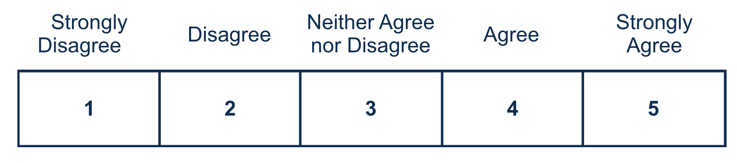
[3] Getting status updates on my [claim type] throughout the claims process was easy.
[4] I am satisfied with the time it took to receive a decision on my [claim type] claim.
[5] The decision notification letter was easy to understand.
[6] The evidence submitted for my [claim type] was fully reviewed.

[7] The VA clearly explained my options for appealing or requesting a review of the decision on my [claim type] claim.
[8] I trust the Department of Veterans Affairs to deliver on its mission to serve America’s Veterans.

- When will the activity happen?
Respondents will be contacted by email within 30 days of their exam. They will have 14 days to complete the survey. This will be an ongoing continuous survey.

- Is an incentive (e.g., money or reimbursement of expenses, token of appreciation) provided to participants?
[ ] Yes [ X ] No
If Yes, describe:

BURDEN HOURS

Category of Respondent | No. of Respondents | Participation Time | Burden  Hours
VBA Disability Compensation Non-Rating Claims Survey | 25,000 | 5 | 2,083
Totals | 25,000 | 5 | 2,083

CERTIFICATION:

I certify the following to be true:
- The collections are voluntary;
- The collections are low-burden for respondents (based on considerations of total burden hours or burden-hours per respondent) and are low-cost for both the respondents and the Federal Government;
- The collections are non-controversial;
- Any collection is targeted to the solicitation of opinions from respondents who have experience with the program or may have experience with the program in the near future;
- Personally identifiable information (PII) is collected only to the extent necessary and is not retained;
- Information gathered is intended to be used for general service improvement and program management purposes
- Upon agreement between OMB and the agency aggregated data may be released as part of A-11, Section 280 requirements only on performance.gov. Summaries of customer research and user testing activities may be included in public-facing customer journey maps.
- Additional release of data will be coordinated with OMB.

Name and email address of person who developed this survey/focus group/interview:

Name: Juan Jackson

Email address: juan.jackson@va.gov

All instruments used to collect information must include:
OMB Control No. 2900-0876
Expiration Date: 02/28/2026

HELP SHEET

(OMB Control Number: XXXX-XXXX)

TITLE OF INFORMATION COLLECTION: Provide the name of the collection that is the subject of the request. (e.g. Comment card for soliciting feedback on xxxx)

PURPOSE: Provide a brief description of the purpose of this collection and how it will be used. If this is part of a larger study or effort, please include this in your explanation.

TYPE OF COLLECTION: Check one box. If you are requesting approval of other instruments under the generic, you must complete a form for each instrument.

CERTIFICATION: Please read the certification carefully. If you incorrectly certify, the collection will be returned as improperly submitted or it will be disapproved.

Personally Identifiable Information: Agencies should only collect PII to the extent necessary, and they should only retain PII for the period of time that is necessary to achieve a specific objective.

BURDEN HOURS:
Category of Respondents: Identify who you expect the respondents to be in terms of the following categories: (1) Individuals or Households;(2) Private Sector; (3) State, local, or tribal governments; or (4) Federal Government. Only one type of respondent can be selected per row.
No. of Respondents: Provide an estimate of the Number of respondents.
Participation Time: Provide an estimate of the amount of time required for a respondent to participate (e.g. fill out a survey or participate in a focus group)
Burden: Provide the Annual burden hours: Multiply the Number of responses and the participation time and divide by 60.

