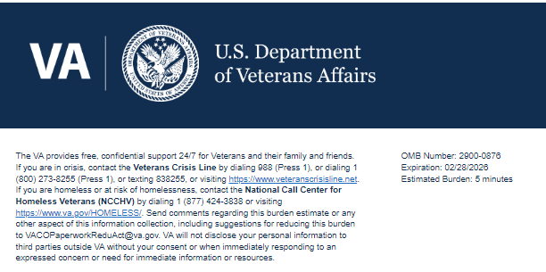

Help us serve you better.

We want to hear about your recent visit at <Vet Center name>. By indicating if any of the statements below reflect your experience, you directly help us improve Vet Center services.

Please do not include any personally identifiable information, Social Security Number, Veteran ID, or medical information in any of your responses.

This voluntary survey should take you approximately 5 minutes to complete.

- How did you learn about Vet Center services? (Select all that apply)

- An advisor from a governmental, social, or non-profit organization
- Vet Center Outreach staff
- Online search
- Healthcare provider
- Trusted friend, acquaintance, another Service member or Veteran
- Through the VA
- Other:

2. Why did you choose the Vet Center for counseling and other services? (Select all that apply)

- An advisor from a governmental, social, or non-profit organization
- Vet Center Outreach staff
- Online search
- Healthcare provider
- Trusted friend, acquaintance, another Service member or Veteran
- Through the VA
- Other:

3. During military service, I felt comfortable accessing or using mental healthcare.

- Strongly Disagree
- Disagree
- Neither Agree nor Disagree
- Agree
- Strongly Agree

4. The Vet Center offers remote and/or in-person services that are accessible to me.

- Strongly Disagree
- Disagree
- Neither Agree nor Disagree
- Agree
- Strongly Agree

5. I was aware of the Vet Center Program before my initial engagement with Vet Center Staff.

- Strongly Disagree
- Disagree
- Neither Agree nor Disagree
- Agree
- Strongly Agree

6. Following my initial engagement with Vet Center staff, the process to become a Vet Center client was clear.

- Strongly Disagree
- Disagree
- Neither Agree nor Disagree
- Agree
- Strongly Agree

7. The Vet Center staff explained the relationship between Vet Centers and the VA to me in a way I could understand.

- Strongly Disagree
- Disagree
- Neither Agree nor Disagree
- Agree
- Strongly Agree

8. I trust Vet Centers to provide services for improving my quality of life.
- Strongly Disagree
- Disagree
- Neither Agree nor Disagree
- Agree
- Strongly Agree

9. Would you like to provide additional feedback with a concern, compliment, or recommendation about your visit at <Vet Center Name>?

- Concern
- Compliment
- Recommendation
- Will not provide additional feedback

10. Use the text box below to provide details about your experience. Please do not include any personally identifiable information, Social Security Number, Veteran ID, or medical information.

[Text Box]

11. Can Vet Centers contact you about your feedback?

- Yes, Vet Centers can contact me about my experience.
- No, I do not want Vet Centers to contact me about my experience.

12. Would you like to volunteer your demographic information to help Vet Centers better serve you? *optional
- Yes
- No
13. <logic displays only if respondent selects Yes to previous question> What is your race and/or ethnicity? (Select all that Apply)

- American Indian or Alaska Native
- Asian
- Black or African American
- Hispanic or Latino
- Middle Eastern or North African
- Native Hawaiian or Pacific Islander
- White

Thank you for choosing VA.

Privacy Notice: By filling out this survey, you are authorizing VA database access to retrieve Veteran contact information to follow up with you accordingly for purposes of service recovery, potential crisis, or to learn more about feedback you have shared regarding your experience with VA. Your contact information and response may be referred to the Veterans Crisis Line if an automated review indicates your response may be concerning. The Veterans Crisis Line may contact you for follow up as a result of that referral. VA may utilize individual Veteran survey data from this survey or other sources to ensure the final scores truly and accurately represent the experiences of Veterans. This collection of information is authorized by 38 U.S.C. Section 301 (https://www.federalregister.gov/d/2021-01526).

Respondent Burden: An agency may not conduct or sponsor, and a person is not required to respond to, a collection of information unless it displays a currently valid OMB control number. The OMB control number for this project is 2900-0876, and it expires 02/28/2026. Public reporting burden for this collection of information is estimated to average 5 minutes per respondent, per year, including the time for reviewing instructions, searching existing data sources, gathering and maintaining the data needed, and completing and reviewing the collection of information. Send comments regarding this burden estimate and any other aspect of this collection of information, including suggestions for reducing the burden, to VA Reports Clearance Officer at vapra@va.gov. Please refer to OMB Control No. 2900-0876 in any correspondence. Do not send your completed VA Form to this email address.

