Healthy Teaching Kitchen (HTK) Survey
Version 001
Working Draft, Pre-Decisional, Deliberative document – Internal VA Use Only


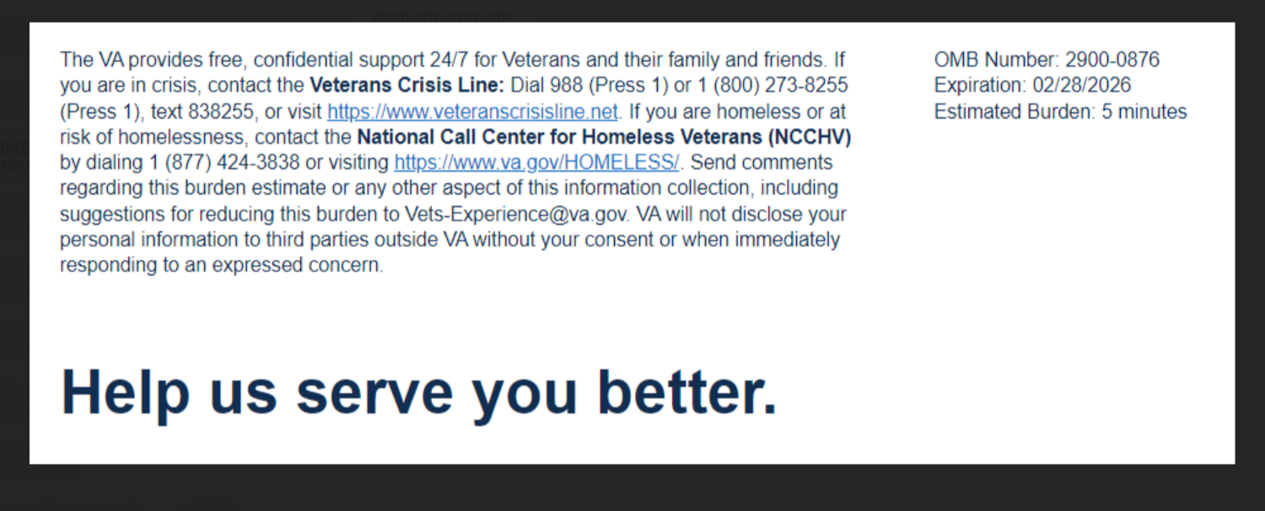

Your opinion matters.

Please take this brief, eleven question survey to let us know about your experience with the VA Healthy Teaching Kitchen class(es). By completing this survey, we can better serve you and other Veterans. Thank you for choosing VA and helping us improve the Veteran Experience at VA.
This voluntary survey should take you approximately 5 minutes to complete.

1) What state is your VA facility located in?(Logic: Required)

2) Which Facility did you visit?(Logic: Required)

3) The Healthy Teaching Kitchen instructor explained healthy eating and cooking to me in a way that I was able to understand.
Strongly Disagree Disagree Neither Agree nor Disagree Agree Strongly Agree

4) After attending Healthy Teaching Kitchen, I will practice the skills the instructor talked about in class.
Strongly Disagree Disagree Neither Agree nor Disagree Agree Strongly Agree

5) The instructor asked if I understood or gave me an opportunity to demonstrate what I learned during Healthy Teaching Kitchen (such as safe knife skills, following a recipe, or preparing a recipe)
Strongly Disagree Disagree Neither Agree nor Disagree Agree Strongly Agree N/A

6) As a result of the Healthy Teaching Kitchen class(es), I feel confident that I can make changes that support my health and wellness.
Strongly Disagree Disagree Neither Agree nor Disagree Agree Strongly Agree

7) As a result of the Healthy Teaching Kitchen class(es), I have learned to adjust recipes to meet my health goals.
Strongly Disagree Disagree Neither Agree nor Disagree Agree Strongly Agree

8) As a result of the Healthy Teaching Kitchen class(es), I have learned to adjust recipes to use what I have available.
Strongly Disagree Disagree Neither Agree nor Disagree Agree Strongly Agree

9) The Healthy Teaching Kitchen instructor treated me in a respectful manner.
Strongly Disagree Disagree Neither Agree nor Disagree Agree Strongly Agree

10) I would recommend Healthy Teaching Kitchen classes to other Veterans.
Strongly Disagree Disagree Neither Agree nor Disagree Agree Strongly Agree

11) I trust the Healthy Teaching Kitchen as part of my overall VA healthcare. (Logic: Required)
Strongly Disagree Disagree Neither Agree nor Disagree Agree Strongly Agree

12) What did you find the most and/or least helpful about the HTK program?Please do not include any personally identifiable information: Name, Social Security Number, Veteran ID, or medical information. (New Question)
[Free text]



Privacy Notice: By filling out this survey, you are authorizing VA database access to retrieve Veteran contact information to follow up with you accordingly for purposes of service recovery, potential crisis, or to learn more about feedback you have shared regarding your experience with VA. Your contact information and response may be referred to the Veterans Crisis Line if an automated review indicates your response may be concerning. The Veterans Crisis Line may contact you for follow up as a result of that referral. VA may utilize individual Veteran survey data from this survey or other sources to ensure the final scores truly and accurately represent the experiences of Veterans. This collection of information is authorized by 38 U.S.C. Section 301. The Systems of Records Notice can be found here: https://www.federalregister.gov/d/2021-01526.
Respondent Burden: An agency may not conduct or sponsor, and a person is not required to respond to, a collection of information unless it displays a currently valid OMB control number. The OMB control number for this project is 2900-0876 and it expires 02/28/2026. Public reporting burden for this collection of information is estimated to average 5 minutes per respondent, per year, including the time for reviewing instructions, searching existing data sources, gathering and maintaining the data needed, and completing and reviewing the collection of information. Send comments regarding this burden estimate and any other aspect of this collection of information, including suggestions for reducing the burden, to VA Reports Clearance Officer at vapra@va.gov. Please refer to OMB Control No. 2900-0876 in any correspondence. Do not send your completed VA Form to this email address.

