Request for Approval under the “Generic Clearance for Improving Customer Experience: OMB Circular A-11, Section 280 Implementation”

(OMB Control Number: 2900-0876)

TITLE OF INFORMATION COLLECTION: Healthy Teaching Kitchen Change Request

PURPOSE OF COLLECTION:
What are you hoping to learn / improve? How do you plan to use what you learn? Are there artifacts (user personas, journey maps, digital roadmaps, summary of customer insights to inform service improvements, performance dashboards) the data from this collection will feed?
- This is a change request to add 1 free text question to the already approved Healthy Teaching Kitchen Survey. The outcome of this change required would be to provide qualitative feedback, identify areas for improvement, and allow users to share additional insights. This will help enhance the program by addressing user needs and increasing overall satisfaction and engagement.
- The VA Healthy Teaching Kitchen program provides Veterans with nutrition knowledge, cooking skills, and guided practice to build confidence in cooking at home with healthy, minimally processed foods. VA facilities across the country offer Healthy Teaching Kitchen (HTK) programs which teach over 5,000 Veterans and their support persons per year about food, nutrition and how to prepare and store balanced, healthy dishes. Classes are open to VA-enrolled Veterans and a “plus one” if desired– this can be a partner, family member, caretaker or anyone involved in helping you purchase an prepare food. HTK classes are taught in-person at VA facilities, or online via the VA Video Connect (VVC) platform and range from demonstration-style, to hands-on and cook-along participation. Classes include nutrition education and discussion on different nutrients, meal balancing, grocery shopping, meal planning, cooking skills, and more. The classes also provide simple, quick and tasty recipes to support your health journey. Many HTKs also include disease-specific options, such as carbohydrate-controlled cooking for diabetes, support for heart health, and anti-inflammatory cooking.
- There is no standardized measurement of the quality of the programing (patient and/or customer experience), assessment of the Veteran’s understanding, or changes to Veteran health and wellness because of attendance. A Vsignals survey for VA Healthy Teaching Kitchen will provide enterprise-wide assessment of the programing, Veteran understanding, and health impacts.

TYPE OF ACTIVITY: (Check one)

[ ] Customer Research (Interview, Focus Groups, Surveys)
[ X ] Customer Feedback Survey
[ ] Usability Testing of Products or Services

ACTIVITY DETAILS

- If this is a survey, will the results of this survey be reported to Touchpoints as part of quarterly reporting obligations specified in OMB Circular A-11 Section 280?
[ ] Yes
[X] No
[ ] Not a survey

- How will you collect the information? (Check all that apply)
[X] Web-based or other forms of Social Media
[ ] Telephone
[ ] In-person
[ ] Mail
[ ] Other, Explain

- Who will you collect the information from?
Explain who will be interviewed and why the group is appropriate for the Federal program / service to connect with. Please provide a description of how you plan to identify your potential group of respondents and if only a sample will be solicited for feedback, how you will select them(e.g., anyone who provided an email address to a call center rep, a representative sample of Veterans who received outpatient services in May 2019, do you have a list of customers to reach out to (e.g., a CRM database that has the contact information, intercept interviews at a particular field office?)
- Veterans experience data for this survey is collected by using an online transactional survey disseminated via an invitation link sent out after competition of a Healthy Teaching Kitchen course.

- How will you ask a respondent to provide this information?
(e.g., after an application is submitted online, the final screen will present the opportunity to provide feedback by presenting a link to a feedback form / an actual feedback form)
- The survey will be offered to Veterans that have completed a Healthy Teaching Kitchen course. It will be completed by an online transactional survey disseminated via an invitation link.

- What will the activity look like?
Describe the information collection activity – e.g. what happens when a person agrees to participate? Will facilitators or interviewers be used? What’s the format of the interview/focus group? If a survey, describe the overall survey layout/length/other details? If User Testing, what actions will you observe / how will you have respondents interact with a product you need feedback on?
- The questionnaire is brief and contains general Likert-scale (a scale of 1-5 from Strongly Disagree to Strongly Agree) questions to assess customer satisfaction as well as questions assessing the knowledge, speed, and manner of the interaction. After the survey has been distributed, recipients have two weeks to complete the survey and will receive a reminder email after one week.

- Please provide your question list.
- Please see attached document for correct formatting. Some formatting may have been lost due to issues with copy/pasting into this writeup. Additionally, “Required” and “Logic” statements are for explaining survey logic and will not appear on the actual survey.

Healthy Teaching Kitchen (HTK) Survey
Version 001
Working Draft, Pre-Decisional, Deliberative document – Internal VA Use Only


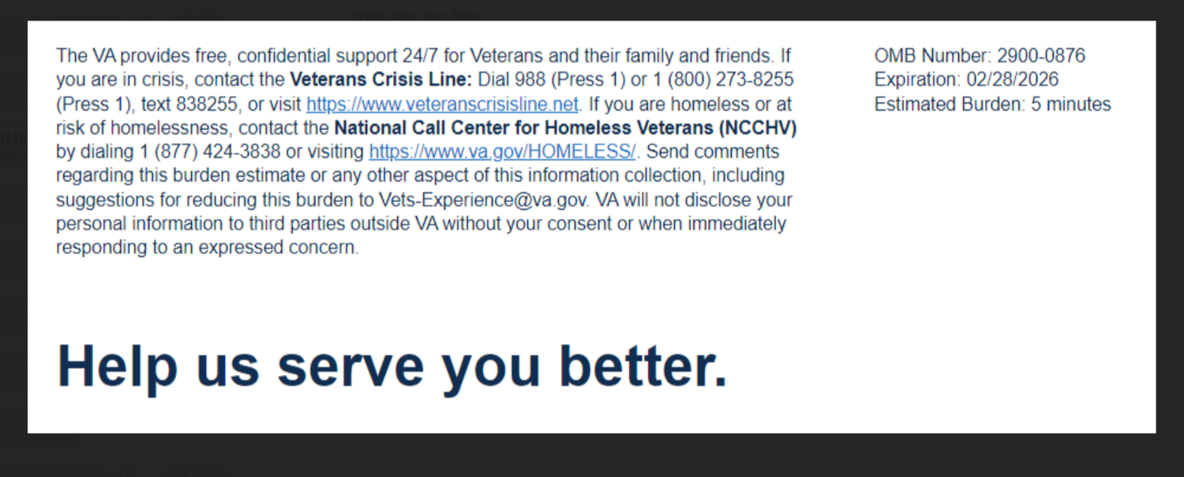

Your opinion matters.

Please take this brief, eleven question survey to let us know about your experience with the VA Healthy Teaching Kitchen class(es). By completing this survey, we can better serve you and other Veterans. Thank you for choosing VA and helping us improve the Veteran Experience at VA.
This voluntary survey should take you approximately 5 minutes to complete.

1) What state is your VA facility located in?(Logic: Required)

2) Which Facility did you visit?(Logic: Required)

3) The Healthy Teaching Kitchen instructor explained healthy eating and cooking to me in a way that I was able to understand.
Strongly Disagree Disagree Neither Agree nor Disagree Agree Strongly Agree

4) After attending Healthy Teaching Kitchen, I will practice the skills the instructor talked about in class.
Strongly Disagree Disagree Neither Agree nor Disagree Agree Strongly Agree

5) The instructor asked if I understood or gave me an opportunity to demonstrate what I learned during Healthy Teaching Kitchen (such as safe knife skills, following a recipe, or preparing a recipe)
Strongly Disagree Disagree Neither Agree nor Disagree Agree Strongly Agree N/A

6) As a result of the Healthy Teaching Kitchen class(es), I feel confident that I can make changes that support my health and wellness.
Strongly Disagree Disagree Neither Agree nor Disagree Agree Strongly Agree

7) As a result of the Healthy Teaching Kitchen class(es), I have learned to adjust recipes to meet my health goals.
Strongly Disagree Disagree Neither Agree nor Disagree Agree Strongly Agree

8) As a result of the Healthy Teaching Kitchen class(es), I have learned to adjust recipes to use what I have available.
Strongly Disagree Disagree Neither Agree nor Disagree Agree Strongly Agree

9) The Healthy Teaching Kitchen instructor treated me in a respectful manner.
Strongly Disagree Disagree Neither Agree nor Disagree Agree Strongly Agree

10) I would recommend Healthy Teaching Kitchen classes to other Veterans.
Strongly Disagree Disagree Neither Agree nor Disagree Agree Strongly Agree

11) I trust the Healthy Teaching Kitchen as part of my overall VA healthcare. (Logic: Required)
Strongly Disagree Disagree Neither Agree nor Disagree Agree Strongly Agree

12) What did you find the most and/or least helpful about the HTK program?Please do not include any personally identifiable information: Name, Social Security Number, Veteran ID, or medical information. (New Question)
[Free text]



Privacy Notice: By filling out this survey, you are authorizing VA database access to retrieve Veteran contact information to follow up with you accordingly for purposes of service recovery, potential crisis, or to learn more about feedback you have shared regarding your experience with VA. Your contact information and response may be referred to the Veterans Crisis Line if an automated review indicates your response may be concerning. The Veterans Crisis Line may contact you for follow up as a result of that referral. VA may utilize individual Veteran survey data from this survey or other sources to ensure the final scores truly and accurately represent the experiences of Veterans. This collection of information is authorized by 38 U.S.C. Section 301. The Systems of Records Notice can be found here: https://www.federalregister.gov/d/2021-01526.
Respondent Burden: An agency may not conduct or sponsor, and a person is not required to respond to, a collection of information unless it displays a currently valid OMB control number. The OMB control number for this project is 2900-0876 and it expires 02/28/2026. Public reporting burden for this collection of information is estimated to average 5 minutes per respondent, per year, including the time for reviewing instructions, searching existing data sources, gathering and maintaining the data needed, and completing and reviewing the collection of information. Send comments regarding this burden estimate and any other aspect of this collection of information, including suggestions for reducing the burden, to VA Reports Clearance Officer at vapra@va.gov. Please refer to OMB Control No. 2900-0876 in any correspondence. Do not send your completed VA Form to this email address.

Please make sure that all instruments, instructions, and scripts are submitted with the request.
- Done.

- When will the activity happen?
Describe the time frame or number of events that will occur (e.g., We will conduct focus groups on May 13,14,15, We plan to conduct customer intercept interviews over the course of the Summer at the field offices identified in response to #2 based on scheduling logistics concluding by Sept. 10th, or “This survey will remain on our website in alignment with the timing of the overall clearance.”)
- An invitation link to complete the survey will be sent out after a Veteran completes a Healthy Teaching course. Data will be collected once this online survey is completed.

- Is an incentive (e.g., money or reimbursement of expenses, token of appreciation) provided to participants?
[ ] Yes [X] No
If Yes, describe:

BURDEN HOURS

Category of Respondent | No. of Respondents | Participation Time | Burden  Hours
 | 5,000 | 5 minutes | 417
Totals | 5,000 | 5 minutes | 417

CERTIFICATION:

I certify the following to be true:
- The collections are voluntary;
- The collections are low-burden for respondents (based on considerations of total burden hours or burden-hours per respondent) and are low-cost for both the respondents and the Federal Government;
- The collections are non-controversial;
- Any collection is targeted to the solicitation of opinions from respondents who have experience with the program or may have experience with the program in the near future;
- Personally identifiable information (PII) is collected only to the extent necessary and is not retained;
- Information gathered is intended to be used for general service improvement and program management purposes
- The agency will follow the procedures specified in OMB Circular A-11 Section 280 for the required quarterly reporting to OMB of trust data and experience driver data from surveys.
- Outside of the quarterly reporting mentioned in the bullet immediately above, if the agency intends to release journey maps, user personas, reports, or other data-related summaries stemming from this collection, the agency must include appropriate caveats around those summaries, noting that conclusions should not be generalized beyond the sample, considering the sample size and response rates. The agency must submit the data summary itself (e.g., the report) and the caveat language mentioned above to OMB before it releases them outside the agency. OMB will engage in a passback process with the agency.

Name and email address of person who developed this survey/focus group/interview:

Name: Sergio Gazaryan

Email address: sergei.gazaryan@va.gov

All instruments used to collect information must include:
OMB Control No. 2900-0876
Expiration Date: 02/28/2026

HELP SHEET

(OMB Control Number: 2900-0876)

TITLE OF INFORMATION COLLECTION: Provide the name of the collection that is the subject of the request. (e.g. Comment card for soliciting feedback on xxxx)

PURPOSE: Provide a brief description of the purpose of this collection and how it will be used. If this is part of a larger study or effort, please include this in your explanation.

TYPE OF COLLECTION: Check one box. If you are requesting approval of other instruments under the generic, you must complete a form for each instrument.

CERTIFICATION: Please read the certification carefully. If you incorrectly certify, the collection will be returned as improperly submitted or it will be disapproved.

Personally Identifiable Information: Agencies should only collect PII to the extent necessary, and they should only retain PII for the period of time that is necessary to achieve a specific objective.

BURDEN HOURS:
Category of Respondents: Identify who you expect the respondents to be in terms of the following categories: (1) Individuals or Households;(2) Private Sector; (3) State, local, or tribal governments; or (4) Federal Government. Only one type of respondent can be selected per row.
No. of Respondents: Provide an estimate of the Number of respondents.
Participation Time: Provide an estimate of the amount of time required for a respondent to participate (e.g. fill out a survey or participate in a focus group)
Burden: Provide the Annual burden hours: Multiply the Number of responses and the participation time and divide by 60.

