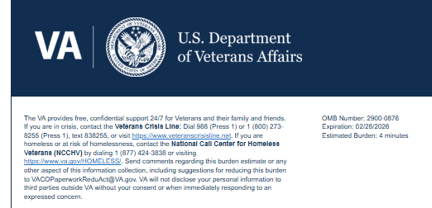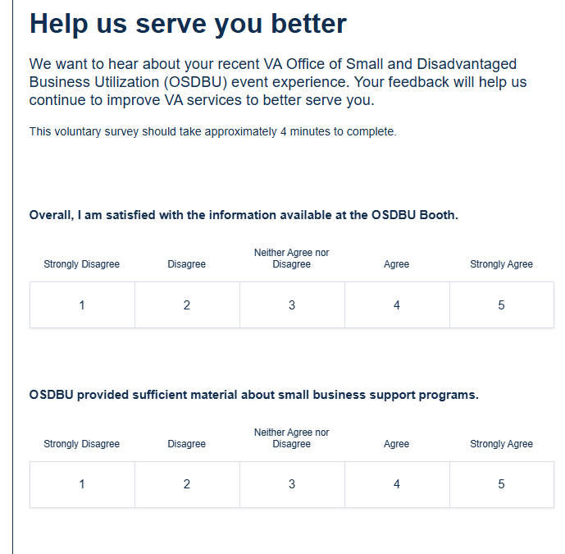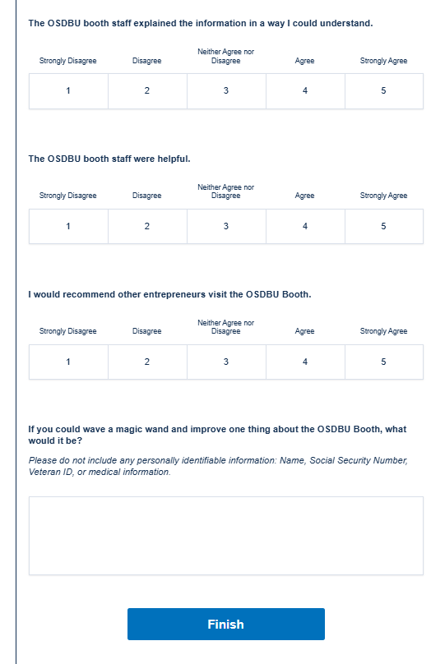

VA Burden Statement: An agency may not conduct or sponsor, and a person is not required to respond to, a collection of information unless it displays a currently valid OMB control number. The OMB control number for this project is 2900-0876, and it expires 02/28/2026. Public reporting burden for this collection of information is estimated to average 4 minutes per respondent, per year, including the time for reviewing instructions, searching existing data sources, gathering, and maintaining the data needed, and completing and reviewing the collection of information. Send comments regarding this burden estimate and any other aspect of this collection of information, including suggestions for reducing the burden, to VA Reports Clearance Officer at PRAVA@va.gov. Please refer to OMB Control No. 2900-0876 in any correspondence. Do not send your completed survey to this email address.

