DFC-001A
OMB 3015-0004

JUSTIFICATION FOR NON-SUBSTANTIVE CHANGES
March 28, 2025
- Justification for Requested Changes

Adding a yes/no question as part of Question 5: Describe the Transaction relating to the critical minerals Executive Order titled Immediate Measures to Increase American Mineral Production signed on March 20, 2025.

The change is circled in red below.
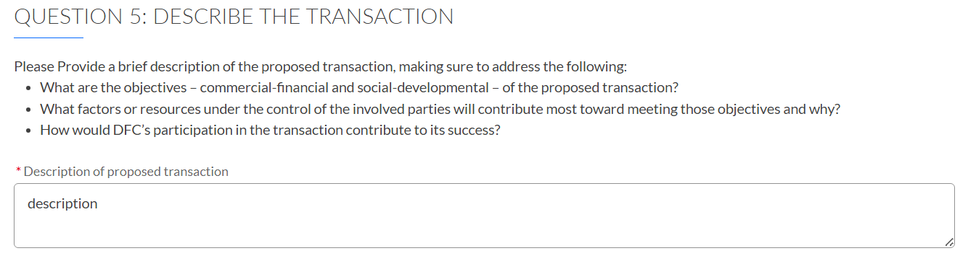

Is this application related to the sourcing of Critical Minerals and/or the development of its processing capacity related to the Executive Order titled Immediate Measures to Increase American Mineral Production signed on March 20, 2025?

- There is no change to the estimated burden associated with these changes.

- There is no change to the estimated annualized cost to the Federal government associated with these changes.

