Non-substantive Change Request
OMB Control Number 3316-0063
EMPLOYMENT APPLICATION
Date Submitted: March 18, 2025

Summary of request: Tennessee Valley Authority is requesting a change request to revise questions to align with E.O. 14168 Defending Women From Gender Ideology Extremism and Restoring Biological Truth to the Federal Government.
Description of Changes Requested: This request updates sex questions used in TVA’s Employment Application to be in accordance with EO 14168.
☑ Revision of an existing question(s)
☑ Deletion of an existing question(s)
Description of Changes to Burden:
Form | Approved Burden | Requested Burden
Employment Application | Total Time: 0.2  0.2 per response 15,923 respondents | Total Time: 0.2  0.2 per response 10,000 respondents
Total | Total time: 3185 | Total time: 2000

Description of Changes:
Approved:
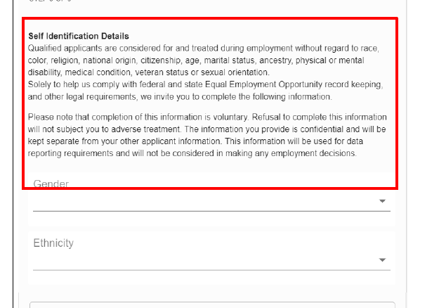

Requested Change:
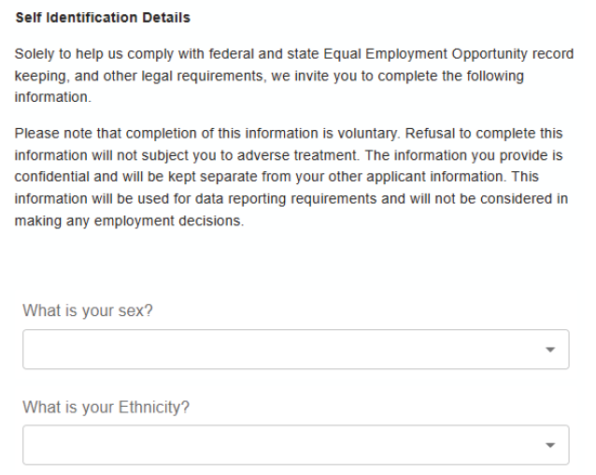
Approved:
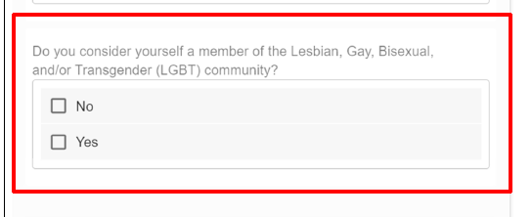

Requested change:
DELETE

