April 21, 2025

2025 ARMS Phase 2 Questionnaire Additions and Deletions – Cotton PPCR

**Section A: Field Selection**

Question 3: From

To:

Added question 5 -

From: How many acres of cotton did this operation plant in the selected field for the 2025 crop {acres} ?

Question 5 (approved version) now Question 6

From:

To:

**Section B: Field Characteristics**

Question 1a From: “Are the acres in the selected field Certified Organic {y/n}

To: Are the acres in the selected field certified organic or transitioning into certified organic cotton production {y-Certified Organic; y-Transitioning; No}?

Question 1b From: “Was the selected field transitioning into organic cotton production in 2025?”

To: What was the cost, per acre, for third party organic certification?.

Question 7a From: “Excluding pounds of seed cotton, what was your yield goal for cotton lint at planting for the selected field?”

To: What was your yield goal for cotton lint at planting for the selected field? (EXCLUDE pounds of seed cotton.)

Seed Cost Question

From Item 9:

To Question 13

Seeding Rate Question

To:

Question 13: Hybrid seed – Removed

Question 15: Planting GMO/GE seeds - Removed

Question 16

From:

To new Question 15:

Question 17 (non-GMO/non-GE traits) – Removed.

Question 18 (plant commercial seed product) – Removed.

Question 19 (genetically engineered, insect resistant seed variety) – Removed.

Question 20 (refuge for insect pests) – Removed.

Question 21 (refuge to comply with Bt management guidelines) – Removed.

Question 22 (size of the refuge) – Removed.

NEW Question 19l

Question 26 (Highly Erodible Land)

From:

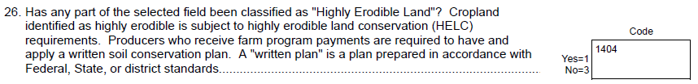

To:



Question 27: Written Conservation Plan – Removed.

Question 31 (Table of soil & water concerns) – Removed.

NEW Questions 24a & 24b:

Question 33b (now Question 25b)

From “Conservation Stewardship Program (CSP)” to “Conservation Security or Conservation Stewardship Program (CSP)”

NEW Question 26

**Section C: Nutrient or Fertilizer Applications**

Question 4b

From:

To:

Question 5

From:

To:

Question 7c (soil organic matter content increase, decrease, same) – Removed.

Question 12a (reason test were done at no cost) – Removed.

New Question 14:

New Question 14b:

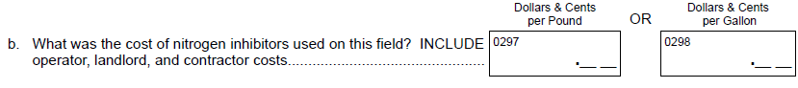

Question 15a - From: “To how many acres in the selected field was manure or compost applied?”

To: “To how many acres in the selected field was manure or compost (including composted manure) applied?”

Question 15d – From: “Was the manure or compost”

To: “Was the manure or compost (including composted manure)”

Question 15e – From: “Was the manure or compost”

To: “Was the manure or compost (including composted manure)”

Question 15f – From “Was the major source of manure or compost”

To: “Was the major source of manure or compost (including composted manure) from”

Question 15g – From: “Was the manure or compost”

To: “Was the manure or compost (including composted manure)”

Question 15g(i) – From:

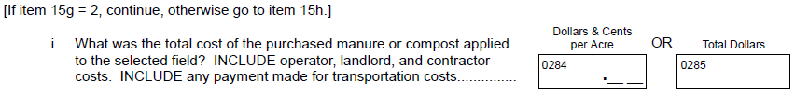

To:

Question 15h (distance in miles between location & field) – Removed.

NEW Question 16i & 16i(i):

Question 16 From: “Were the manure application rates to the selected field influenced by Federal, State, or local restrictions?”

To: “Were the manure or compost (including composted manure) application rates to the selected field influenced by Federal, State, or local restrictions?”

**Section D: Biocontrol or Pesticide Applications**

Question 1 – New column 10: “Was this applied using variable rate technology (VRT)? {y/n}”

NEW Question 4c: “How much was spent for fungicide products applied to the selected field? INCLUDE operator, landlord, and contractor costs”

Question 5 “boll weevil eradication program (BWEP)?” – Removed.

**Section E: Pest Management Practices**

Question 9 – From: “Was an established scouting process such as systematic sampling, recording counts, etc. used or were insect traps used in the selected field? EXCLUDE traps checked as part of either BWEP or PBWP”

To: “Was an established scouting process such as systematic sampling, recording counts, etc. used or were insect traps used in the selected field? EXCLUDE traps checked as part of a boll weevil eradication program”

Question 9a “Measure damage from budworm & bollworm” – Removed.

Question 9b “Average insect count per acre” – Removed.

Question 9b(i) “Boll damage sore” – Removed.

Question 11 Table “Was field scouted for” – Removed.

Question 12a “Reason scouting done for no cost” – Removed.

Question 16a – From: “What were the total materials and application costs for all biological pest controls for the selected field? INCLUDE operator, landlord, and contractor costs. INCLUDE cost for beneficial organisms, insects, nematodes, and fungi. EXCLUDE biological pesticides previously reported”

To:

Question 20 – From “What was the difference in yields in the Bt crop with the yields in the non-Bt refuge crop?”

To:

Question 21 – From: “Did you use a soil-insecticide or insecticidal seed treatment in the refuge in 2025?”

To:

Question 22 – From:

To:

Question 23 – From:

To:

Question 24 – From:

To:

Question 25 – From:

To:

NEW Questions 26 and 27:

NEW Instruction – Old Question 27 & New Question 29 for columns 4-6: “After noticing the decline in the effectiveness of this herbicide in controlling weeds on the selected field, did you”

Old Questions 28 & 29 – Removed.

New Questions 20, 31, and 32 –

**Section F: Field Operations**

New Question 2

NEW Question 9: “Was the cotton harvested and hauled from the selected field dried (or will be dried) before it was sold or stored?” {y/n}

Question 9d – From: “Pest scouting, excluding any activity for the BWEP or PBWP”

To: “Pest scouting”

NEW Question 12: “Were any of the technical or consultant services listed in item 10a-g provided to you at no cost or were partially reimbursed by the Natural Resources Conservation Service?” {y/n}

OLD Questions 11 & 12 – Removed.

NEW Instruction – Old Question 12 & New Question 13 for columns 4-6: “If the tool was used - ”

NEW Question 16:

NEW Questions 19d, e, f

**Section G: Irrigation**

No Changes

**Conclusion:**

No Changes

2025 ARMS Phase 2 Questionnaire Additions and Deletions – Potatoes PPR

No Changes