April 28, 2025

2025 Fruit Chemical Use
California Version – Dates has been removed from the Commodity Table.

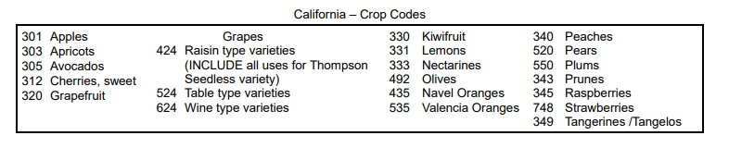
Deletion – Pages 7 and 8.

