Attachment F-1 – Questionnaire Packet NCHS Letters with FAQs and Web Card Insert

[NCHS Letterhead]

Date

Name of Director
Name of Community/Center
Community/Center Address
Community/Center city, state, zip code

Dear <NAME OF DIRECTOR>,

You are invited to participate in the 2024 National Post-acute and Long-term Care Study (NPALS). The CDC’s National Center for Health Statistics conducts NPALS.

To participate in this important study, please complete the questionnaire by web over a safe and secure network by going to this URL address and typing in your unique User ID and one-time password:

URL:
User ID:
Password:

Benefits to completing by web include getting only the questions that apply to your community/center based on your responses—so it takes less time—and having the option to print a copy of your completed questionnaire for your records. However, if you prefer to use hardcopy, please complete the enclosed questionnaire and return it in the pre-addressed, postage-paid envelope provided.

Please submit your questionnaire by web or hardcopy by _______ to avoid receiving another questionnaire for this community.

Completing the questionnaire will take 30 minutes on average. Before starting, please consult or have your records available to be prepared to answer questions on the number of residents/participants (see question X), numbers of select types of staff (see question X), and the residents’/participants’ demographic distribution, activities of daily living, health conditions, and health care use (see questions X-X).

NPALS data inform long-term care providers, planners, researchers, and policymakers about the important work your community/center does to meet the needs of your residents/participants and families. We have enclosed an NCHS Data Brief as an example of how your data may be used. Your participation in this survey is voluntary, but will assist greatly in helping to further our nation’s understanding of the long-term care needs of seniors and younger adults with disabilities. The information you provide will be used only for statistical purposes and held in the strictest confidence. Please see the confidentiality brochure in this packet for more information.

If you need technical support or have further questions about this survey please see the Frequently Asked Questions on the back of this letter, visit https://www.cdc.gov/nchs/npals/index.htm, or call (XXX) XXX-XXXX.

Thank you, in advance, for your help in this important study.

Sincerely,

Brian Moyer, PhD
Director, National Center for Health Statistics

2024 National Post-Acute and Long-Term Care Study (NPALS)
Residential Care Community Frequently Asked Questions (FAQs)

Why should I participate in this survey?
CDC’s National Center for Health Statistics (NCHS) recognizes that residential care communities are an important component of the long-term care spectrum in the United States. NCHS’ National Post-acute and Long-term Care Study (NPALS) (formerly known as the National Study of Long-Term Care Providers or NSLTCP) tracks changes, every two years, in the supply and use of seven major sectors of long-term care services—assisted living and similar residential care, adult day, home health, nursing home, hospice, inpatient rehabilitation, and long-term care hospital. When you participate in NPALS, you help ensure that the survey data for residential care communities and current residents are up-to-date and accurately portray your industry to health care planners and policymakers.

Should I participate if I participated a couple of years ago?
Yes. Your participation in this 2024 survey is important. NPALS is conducted every two years to obtain accurate, up-to-date information about residential care communities, other long-term care providers, and the people they serve to detect changes in the long-term care industry over time.

What other residential care communities are being contacted to participate in this survey?
The survey includes about 11,600 residential care communities. To protect the privacy of individual residential care communities, their staff, and the residents they serve, we do not release the names of these residential care communities to anyone.

Why can’t some other community take our place?
You represent other communities like yours. If you do not participate in NPALS, there is no guarantee that residential care communities like yours will be represented adequately and the representation of your community’s unique qualities may be lost.

Where did you get my name?
Individual state licensing agencies provided the names of all licensed, certified, or otherwise regulated residential care communities in their respective states.

Will the results be made public?
Yes. NCHS intends to publish reports using 2024 NPALS survey data starting in late 2025. Reports will be published at https://www.cdc.gov/nchs/npals/index.htm. If you would like to be notified when new NPALS products are available, please subscribe to the NCHS long-term care listserv by going to https://www.cdc.gov/nchs/npals/longterm_listserv.htm and completing the steps. While results from this survey will be made publicly available, all data will be kept strictly confidential and aggregated, so that the names of the communities, staff, residents, and respondents will not be identifiable.

Who will see my information?
We take your privacy very seriously. All information that relates to or describes identifiable characteristics of individuals, a practice, or an establishment will be used only for statistical purposes. NCHS staff, contractors, and agents will not disclose or release responses in identifiable form without the consent of the individual or establishment in accordance with section 308(d) of the Public Health Service Act (42 U.S.C. 242m(d)) and the Confidential Information Protection and Statistical Efficiency Act or CIPSEA (44 U.S.C. 3561-3583). In accordance with CIPSEA, every NCHS employee, contractor, and agent has taken an oath and is subject to a jail term of up to five years, a fine of up to $250,000, or both if he or she willfully discloses ANY identifiable information about you. In addition to the above cited laws, NCHS complies with the Federal Cybersecurity Enhancement Act of 2015 (6 U.S.C. §§ 151 and 151 note) which protects Federal information systems from cybersecurity risks by screening their networks.

Who supports this study?
This survey is supported by The Center for Excellence in Assisted Living (CEAL), American Seniors Housing Association (ASHA), Argentum, LeadingAge, and the American Health Care Association/National Center for Assisted Living/ (AHCA/NCAL).

For more FAQS see [RCC participant webpage]

2024 National Post-Acute and Long-Term Care Study (NPALS)
Adult Day Services Center Frequently Asked Questions (FAQs)

Why should I participate in this survey?
CDC’s National Center for Health Statistics (NCHS) recognizes that adult day services centers are an important component of the long-term care spectrum in the United States. NCHS’ National Post-acute and Long-term Care Study (NPALS) (formerly known as the National Study of Long-Term Care Providers or NSLTCP) tracks changes, every two years, in the supply and use of seven major sectors of long-term care services—adult day, assisted living and similar residential care, home health, nursing home, hospice, inpatient rehabilitation, and long-term care hospital. When you participate in NPALS, you help ensure that the survey data for adult day services centers and enrolled participants are up-to-date and accurately portray your industry to health care planners and policymakers.

Should I participate if I participated a couple of years ago?
Yes. Your participation in this 2024 survey is important. NPALS is conducted every two years to obtain accurate, up-to-date information about adult day services centers, other long-term care providers, and the people they serve to detect changes in the long-term care industry over time.

What other adult day services centers are being contacted to participate in this survey?
The survey includes about 5,500 adult day services centers operating in the United States. To protect the privacy of individual centers, their staff, and the participants they serve, we do not release the names of these centers to anyone.

Why can’t some other center take our place?
You represent other centers like yours. If you do not participate in NSLTCP, there is no guarantee that adult day services centers like yours will be represented adequately and the representation of your center’s unique qualities will be lost.

Where did you get my name?
A nonprofit association of adult day services centers, under contract to NCHS, compiled a list of all adult day services centers in the U.S.

Will the results be made public?
Yes. NCHS intends to publish reports using 2024 NPALS survey data starting in late 2025. Reports will be published at https://www.cdc.gov/nchs/npals/index.htm. If you would like to be notified when new NPALS products are available, please subscribe to the NCHS long-term care listserv by going to https://www.cdc.gov/nchs/npals/longterm_listserv.htm and completing the steps. While results from this survey will be made publicly available, all data will be kept strictly confidential and aggregated, so that the names of the centers, staff, participants, and respondents will not be identifiable.

Who will see my information?
We take your privacy very seriously. All information that relates to or describes identifiable characteristics of individuals, a practice, or an establishment will be used only for statistical purposes. NCHS staff, contractors, and agents will not disclose or release responses in identifiable form without the consent of the individual or establishment in accordance with section 308(d) of the Public Health Service Act (42 U.S.C. 242m(d)) and the Confidential Information Protection and Statistical Efficiency Act or CIPSEA (44 U.S.C. 3561-3583). In accordance with CIPSEA, every NCHS employee, contractor, and agent has taken an oath and is subject to a jail term of up to five years, a fine of up to $250,000, or both if he or she willfully discloses ANY identifiable information about you. In addition to the above cited laws, NCHS complies with the Federal Cybersecurity Enhancement Act of 2015 (6 U.S.C. §§ 151 and 151 note) which protects Federal information systems from cybersecurity risks by screening their networks.

Who supports this study?
This survey is supported by the National Adult Day Services Association (NADSA), LeadingAge, and Advancing States.

For more FAQS see [ADSC participant webpage]

Web Survey Insert
(will revise to reflect 2024 wave)

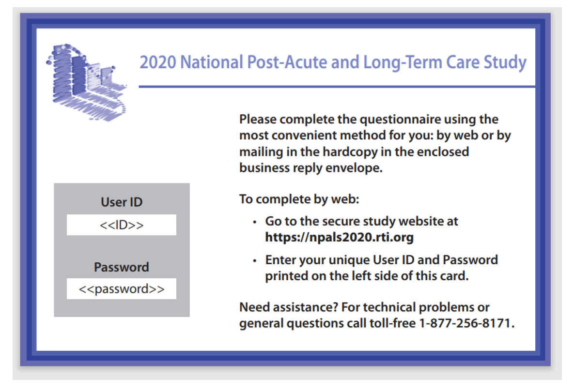

[NCHS Letterhead]

Date
Name of Director
Name of Community/Center
Community/Center Address
Community/Center city, state, zip code

Dear <NAME OF DIRECTOR >,

Recently, we invited you to participate in the 2024 National Post-acute and Long-term Care Study (NPALS). The packet we sent asked you to complete and return the NPALS questionnaire. To date, we have not received your completed questionnaire.

We understand that you are very busy. Your responses are very important to help further the nation’s understanding of the long-term care needs of seniors and younger adults with disabilities in the United States. The information you provide will be used only for statistical purposes and held in the strictest confidence. See http://www.cdc.gov/nchs/nsltcp/nsltcp_products.htm for products using NPALS data.

To participate in this important study, please complete the questionnaire by web over a safe and secure network by going to this URL address and typing in your unique User ID and one-time password:
URL:
User ID:
Password:

Benefits to completing by web include getting only the questions that apply to your community/center based on your responses—so it takes less time—and having the option to print a copy of your completed questionnaire for your records. However, if you prefer to use hardcopy, please complete the enclosed questionnaire and return it in the pre-addressed, postage-paid envelope provided.

Please submit your questionnaire by web or hardcopy by ________ to avoid receiving another questionnaire for this community/center. If you are the director for more than one community/center selected for this study, you will receive and be asked to complete a separate questionnaire for each selected community/center. If you have already returned your completed questionnaire for the community/center located at the address on the questionnaire label, this letter and your package may have crossed in the mail; you do not have to complete the questionnaire a second time.

Completing the questionnaire will take 30 minutes on average. Before starting, please consult or have your records available to be prepared to answer questions on the number of residents/participants (see question X), numbers of select types of staff (see question XX), and the residents’/participants’ demographic distribution, activities of daily living, health conditions, and health care use (see questions XX-XX).

The information you provide will be used only for statistical purposes and held in the strictest confidence. Please see the enclosed confidentiality brochure for more information. See https://www.cdc.gov/nchs/npals/studyresults.htm for examples of products using NPALS data.

If you need technical support or have further questions about this survey, see the FAQs on the back of this letter, visit https://www.cdc.gov/nchs/npals/index.htm, or call (XXX) XXX-XXXX.

Thank you, in advance, for your help with this important research study.

Sincerely,

Brian Moyer, PhD
Director, National Center for Health Statistics

[NCHS Letterhead]

Date
Name of Director
Name of Community/Center
Community/Center Address
Community/Center city, state, zip code

Dear <NAME OF DIRECTOR >,

We contacted you recently about participating in the 2024 National Post-acute and Long-term Care Study (NPALS). We need your help with this important research to further our nation’s understanding of the long-term care needs of seniors and younger adults with disabilities.

To participate, please complete the questionnaire by web over a safe and secure network by going to this URL address and typing in your unique User ID and one-time password:

URL:
User ID:
Password:

Benefits to completing by web include getting only the questions that apply to your community/center based on your responses—so it takes less time—and having the option to print a copy of your completed questionnaire for your records. However, if you prefer to use hardcopy, please complete the enclosed questionnaire and return it in the pre-addressed, postage-paid envelope provided.

Please submit the questionnaire by web or hardcopy by _________ to avoid receiving another questionnaire for this community/center.. If you are the director for more than one community/center selected for this study, you will receive and be asked to complete a separate questionnaire for each selected community/center. If you have already completed and returned your questionnaire, this letter and your package may have crossed in the mail; you do not have to complete the questionnaire a second time.

Completing the questionnaire will take 30 minutes on average. We made the questionnaire easier to complete compared to previous years. Before starting, please consult or have your records available to be prepared to answer questions on the number of residents/participants (see question x), numbers of select types of staff (see question x), and the residents’/participants’ demographic distribution, activities of daily living, health conditions, and health care use(see questions x-x).

The information you provide will be used only for statistical purposes and held in the strictest confidence. Please see the confidentiality brochure at [hyperlink for RCC/ADSC participant page] for more information.

See https://www.cdc.gov/nchs/npals/studyresults.htm for examples of products using NPALS data.

If you need technical support or have further questions about this survey, see the FAQs on the back of this letter, visit https://www.cdc.gov/nchs/npals/index.htm, or call (XXX) XXX-XXXX.

Thank you, in advance, for your help with this important research study.

Sincerely,

Brian Moyer, PhD
Director, National Center for Health Statistics

[NCHS Letterhead]

Date
Name of Director
Name of Community/Center
Community/Center Address
Community/Center city, state, zip code

Dear <NAME OF DIRECTOR >,

We contacted you recently about participating in the 2024 National Post-acute and Long-term Care Study (NPALS). We need your help with this important research to further our nation’s understanding of the long-term care needs of seniors and younger adults with disabilities.

To participate, please complete the questionnaire by web over a safe and secure network by going to this URL address and typing in your unique User ID and one-time password:

URL:
User ID:
Password:

Benefits to completing by web include getting only the questions that apply to your community/center based on your responses—so it takes less time—and having the option to print a copy of your completed questionnaire for your records. However, if you prefer to use hardcopy, please complete the enclosed questionnaire and return it in the pre-addressed, postage-paid envelope provided.

Please submit the questionnaire by web or hardcopy by _________. If you are the director for more than one community/center selected for this study, you will receive and be asked to complete a separate questionnaire for each selected community/center. If you have already completed and returned your questionnaire, this letter and your package may have crossed in the mail; you do not have to complete the questionnaire a second time.

Completing the questionnaire will take 30 minutes on average. We made the questionnaire easier to complete compared to previous years. Before starting, please consult or have your records available to be prepared to answer questions on the number of residents/participants (see question x), numbers of select types of staff (see question x), and the residents’/participants’ demographic distribution, activities of daily living, health conditions, and health care use(see questions x-x).

The information you provide will be used only for statistical purposes and held in the strictest confidence. Please see the confidentiality brochure at [hyperlink for RCC/ADSC participant page] for more information.

See https://www.cdc.gov/nchs/npals/studyresults.htm for examples of products using NPALS data.

If you need technical support or have further questions about this survey, see the FAQs on the back of this letter, visit https://www.cdc.gov/nchs/npals/index.htm, or call (XXX) XXX-XXXX.

Thank you, in advance, for your help with this important research study.

Sincerely,

Brian Moyer, PhD
Director, National Center for Health Statistics

