Attachment F-2
Resident and Participant NCHS Data Briefs

(We are providing screenshots of the first page of the 2020 data briefs)

RCC DB accessed at: https://www.cdc.gov/nchs/data/databriefs/db454.pdf

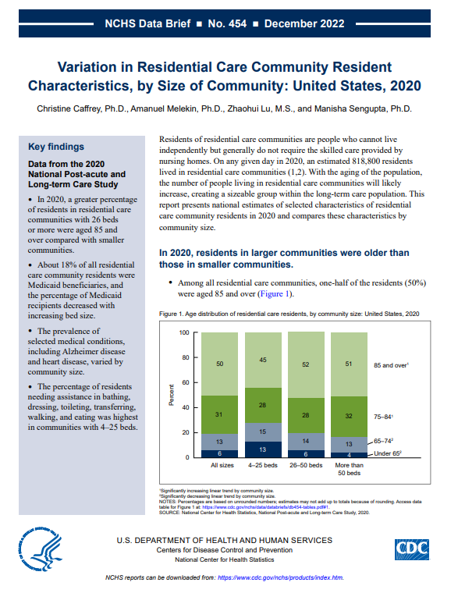

ADSC DB accessed at: https://www.cdc.gov/nchs/data/databriefs/db453.pdf

