**Attachment 2a: Advertisement/flyer**

**Participants Wanted for Research Study**

The National Center for Health Statistics is looking for persons aged 18 or over who are parents or caregivers of a child 0-17 years old to answer questions about childhood experiences. These questions will ask about positive childhood experiences as well as some difficult experiences, such as abuse.

The research interview will be [through [[Zoom]] and will be] no longer than 60 minutes. Participants will receive [$50,].

**FOR MORE INFORMATION or to sign-up**

Call [Recruitment Team] at: 800-322-8671

**Or E-mail us at:** recruitmentteam@cdc.gov

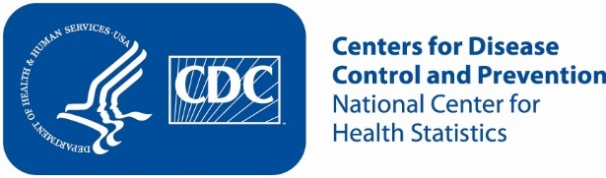

**Attachment 2b: Advertisement/flyer parents**

**Participants Wanted for Research Study**

The National Center for Health Statistics is looking for persons aged 18 or over who are parents or caregivers of a child 0-17 years old to answer a variety and health related questions. These questions will ask about positive childhood experiences as well as some difficult experiences, such as abuse.

The research interview will be [through [[Zoom]] and will be] no longer than 60 minutes. Participants will receive [$50,].

**FOR MORE INFORMATION or to sign-up**

Call [Recruitment Team] at: 800-322-8671

**Or E-mail us at:** recruitmentteam@cdc.gov



**Attachment 2c: Advertisement/flyer teens**

**Participants Wanted for Research Study**

The National Center for Health Statistics is looking for persons aged 14-17 years old to answer a variety of health-related questions. These questions will ask about positive childhood experiences as well as some difficult experiences, such as abuse.

The research interview will be [through [Zoom]] and will be] no longer than 60 minutes. Participants will receive [$50,].

**FOR MORE INFORMATION or to sign-up**

Call [Recruitment Team] at: 800-322-8671

**Or E-mail us at:** recruitmentteam@cdc.gov

