**Attachment 3a: Advertisement/flyer**

**Participants Wanted for Research Study**

The National Center for Health Statistics is looking to talk with adults with an intellectual [and/or developmental] disability or need support in doing everyday things like learning new things, solving problems, and making decisions.

The research interview [will be through Zoom and] will be no longer than 75 minutes. Participants will receive $50.

**For more information or to let us know that you would like to take part.**

**Call our recruitment team at:** 800-322-8671

or

**E-mail:** recruitmentteam@cdc.gov

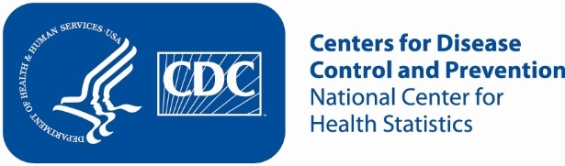

**Attachment 3b: Advertisement/flyer**

**Participants Wanted for Research Study**

The National Center for Health Statistics is looking to talk with adults who take care of an adult with an intellectual [and/or developmental] disability.

The research interview [will be through Zoom and] will be no longer than 75 minutes. Participants will receive $50.

**For more information or to let us know that you would like to take part.**

**Call our recruitment team at:**  800-322-8671

or

**E-mail:** recruitmentteam@cdc.gov



**Attachment 3c: Advertisement/flyer**

**Participants Wanted for Research Study**

The National Center for Health Statistics is looking for adults with Autism, Asperger's disorder, pervasive developmental disorder, or autism spectrum disorder to talk about health related issues.

The research interview [will be through Zoom and] will be no longer than 75 minutes. Participants will receive $50.

**For more information or to let us know that you would like to take part.**

**Call our recruitment team at:**  800-322-8671

or

**E-mail:** recruitmentteam@cdc.gov



**Attachment 3d: Advertisement/flyer**

**Participants Wanted for Research Study**

The National Center for Health Statistics is looking for adults with Cerebral Palsy, to talk about health related issues.

The research interview [will be through Zoom and] will be no longer than 75 minutes. Participants will receive $50.

**For more information or to let us know that you would like to take part.**

**Call our recruitment team at:**  800-322-8671

or

**E-mail:** recruitmentteam@cdc.gov



**Attachment 3e: Advertisement/flyer**

**Participants Wanted for Research Study**

The National Center for Health Statistics is looking for adults with an intellectual [and/or developmental] disability, and those who support them day-to-day.

The research interviews [will be through Zoom and] will be no longer than 75 minutes. Participants will receive $50 each.

**For more information or to let us know that you would like to take part.**

**Call our recruitment team at:**  800-322-8671

or

**E-mail:** recruitmentteam@cdc.gov

