**Attachment 3a: Advertisement/flyer**

**Participants Wanted for Research Study**

The National Center for Health Statistics is looking for people aged [18/45/65] or over [[who have experienced / are experiencing] difficulties with [[thinking or] memory] / [remembering] or concentrating]]] to answer questions related to [their experiences and] their health.

The research interview will be [through Zoom and will be] no longer than 60 minutes. Participants will receive $50 [cash/e-gift card].

**FOR MORE INFORMATION or to sign-up**

Call Recruitment Team at: 800-322-8671

or

**E-mail:** recruitmentteam@cdc.gov

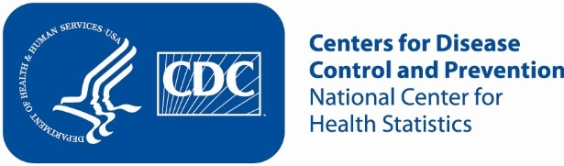

**Attachment 3b: Advertisement/flyer**

**Participants Wanted for Research Study**

The National Center for Health Statistics is looking for people aged [18/45/65] or over who have been told by a health care professional that they have [mild] cognitive impairment to answer questions related to their experiences and their health.

The research interview will be [through Zoom and will be] no longer than 60 minutes. Participants will receive $50 [cash/e-gift card].

**FOR MORE INFORMATION or to sign-up**

Call Recruitment Team at: 800-322-8671

or

**E-mail:** recruitmentteam@cdc.gov

