Attachment 3a: Advertisement/flyer

Participants Wanted for Research Study

The National Center for Health Statistics is looking to talk with adults with an intellectual [and/or developmental] disability or need support in doing everyday things like learning new things, solving problems, and making decisions.

The research interview [will be through Zoom and] will be no longer than 75 minutes. Participants will receive $50.

For more information or to let us know that you would like to take part.

Call our recruitment team at: 800-322-8671
or
E-mail: recruitmentteam@cdc.gov

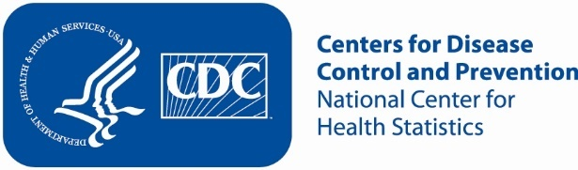

Attachment 3b: Advertisement/flyer

Participants Wanted for Research Study

The National Center for Health Statistics is looking to talk with adults who take care of an adult with an intellectual [and/or developmental] disability.
The research interview [will be through Zoom and] will be no longer than 75 minutes. Participants will receive $50.

For more information or to let us know that you would like to take part.

Call our recruitment team at: 800-322-8671
or
E-mail: recruitmentteam@cdc.gov

Attachment 3c: Advertisement/flyer

Participants Wanted for Research Study

The National Center for Health Statistics is looking for adults with Autism, Asperger's disorder, pervasive developmental disorder, or autism spectrum disorder to talk about health related issues.

The research interview [will be through Zoom and] will be no longer than 75 minutes. Participants will receive $50.

For more information or to let us know that you would like to take part.

Call our recruitment team at: 800-322-8671
or
E-mail: recruitmentteam@cdc.gov

Attachment 3d: Advertisement/flyer

Participants Wanted for Research Study

The National Center for Health Statistics is looking for adults with Cerebral Palsy, to talk about health related issues.

The research interview [will be through Zoom and] will be no longer than 75 minutes. Participants will receive $50.

For more information or to let us know that you would like to take part.

Call our recruitment team at: 800-322-8671
or
E-mail: recruitmentteam@cdc.gov

Attachment 3e: Advertisement/flyer

Participants Wanted for Research Study

The National Center for Health Statistics is looking for adults with an intellectual [and/or developmental] disability, and those who support them day-to-day.

The research interviews [will be through Zoom and] will be no longer than 75 minutes. Participants will receive $50 each.

For more information or to let us know that you would like to take part.

Call our recruitment team at: 800-322-8671
or
E-mail: recruitmentteam@cdc.gov

