|  |
| --- |
| **NCI/Office of Communications and Public Liaison** |
| **APPENDIX 1A** |
| **CUSTOMER SERVICE AND demographic QUESTIONS** |

|  |
| --- |
|  |

Customer Service Questions

The Public Burden statement for the phone demographics is on the workspace pictured below; here are the actual demographics questions:

<https://nci--tst.custhelp.com/ci/documents/detail/5/1/12/d20f5cee1379622717570b0dd5ba13012e07435c>

The VA Demographics share the public burden statement, which is on the workspace above; here is the actual VA survey:

<https://nci--tst.custhelp.com/ci/documents/detail/5/6/12/3d59acc925ccbfd3f780e854ed1be3795a3be5a7>

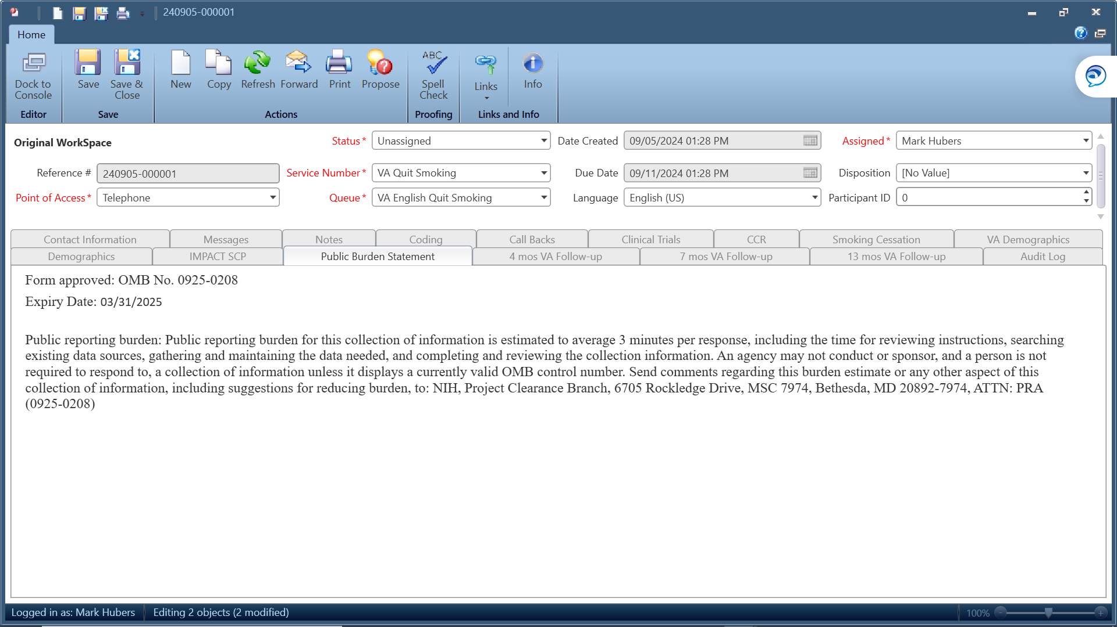

**Questions:**

* **Have you used the service before?**
* **How did you find our Service?**
* **Zip Code?**

Demographic Survey Questions

What is your age?

* Age (Text box)
* Callers aged 96 or older
* Don’t know
* Refusal
* Did not ask
* Exempt

What is your Sex?

* Male
* Female
* Did not ask

What is your race and/or ethnicity? Select all that apply.

* American Indian or Alaskan Native
* Asian
* Black or African American
* Hispanic or Latino
* Middle Eastern or North African
* Native Hawaiian or Pacific Islander
* White

American Indian or Native Alaskan: Please include nationality or tribe. For example, the Navajo Nation, the Blackfeet Tribe of the Blackfeet Indian Reservation of Montana, the Native Village of Barrow Inupiat Traditional Government, the Nome Eskimo Community, Aztec, Maya, etc.

Asian: Please select all that apply.

* Valid Skip
* Chinese
* Vietnamese
* Asian Indian
* Korean
* Filipino
* Japanese
* Other Asian

If "Other Asian," please include an example, like Pakastani, Hmong, Afghan, etc.

Black or African American: Please select all that apply.

* Valid Skip
* African American
* Nigerian
* Jamaican
* Ethiopian
* Haitian
* Somali
* Other Black/African American

If "Other Black African American," please include an example, such as Trinidadian and Tobagonian, Ghanaian, Congolese, etc.

Hispanic or Latino: Please select all that apply.

* Valid Skip
* Mexican
* Cuban
* Puerto Ricon
* Dominican
* Salvadoran
* Guatemalan
* Other Hispanic or Latino

If "Other Hispanic Latino," please include an example, such as Columbian, Honduran, Spaniard, etc.

Middle Eastern or Northern African: Please select all that apply.

* Valid Skip
* Lebanese
* Syrian
* Iranian
* Iraqi
* Egyptian
* Israeli
* Other Middle Eastern or Northern African

If "Other Middle Eastern Northern African," please include examples like Moroccan, Yemeni, Kurdish, etc.

Native Hawaiian or Pacific Islander: Please select all that apply.

* Valid Skip
* Native Hawaiian
* Tongan
* Samoan
* Fijian
* Chamorro
* Marshallese
* Other Native Hawaiian or Pacific Islander

If "Other Native Hawaiian or Pacific Islander", please include an example, like Chuukese, Palauan, Tahitian, etc.

White: Please select all that apply.

* Valid Skip
* English
* Italian
* German
* Polish
* Irish
* Scottish
* Other White

If "Other White", please include an example, like French, Swedish, Norwegian, etc.

What Is the Highest Level of Education You Have Completed?

* Grade school
* Some high school
* High school graduate
* Some college
* College graduate
* Post-graduate
* Not sampled
* Don’t know
* Refusal
* Did not ask
* Exempt

Is There a Place You Usually Go to When You are Sick or Need Advice About Your Health?

* Yes
* No
* Don't Know
* Refused
* Did not ask
* Exempt

What Kind of Place Do You Go to Most Often?

* A doctor’s office
* A clinic, health center, or hospital clinic
* The emergency room, or
* Some other place
* No one place
* Valid skip
* Don’t know
* Refused
* Did not ask
* Exempt

In the Last 12 Months, Did You Have Any Healthcare Coverage, Including Health Insurance, Prepaid Plans Such As HMOs, or Government Plans Such as Medicare?

* Yes
* No
* Don’t know
* Refused
* Did not ask
* Exempt

Would You Say You Had This Coverage During All 12 Months or Less Than 12 Months?

* All 12 months
* Less than 12 months
* Valid Skip
* Don’t know
* Refused
* Did not ask
* Exempt

Which Type of Coverage Did You Have?

* Was it public, such as Medicare, Medicaid, or other government plans?
* Was it private, such as an HMO, Blue Cross, Kaiser, or Aetna?
* Or was it both public and private?
* Valid skip
* Don’t know
* Refused
* Did not ask
* Exempt

The final questions concern your family income. I understand this is sensitive information, and I would like to stress again that all of your information is confidential. What Was Your Total Household Income from All Sources Before Taxes Last Year? Just Stop Me When I Get to the Right Category

* Less than $10,000
* $10,000 to $19,000
* $20,000 to $29,000
* $30,000 to $39,000
* $40,000 to $59,000
* $60,000 to $79,000
* $80,000 or more
* Don’t know
* Refused
* Did not ask
* Exempt

Including Yourself, How Many People Living in Your Household are Supported by This Total Household Income?

* Total People (Text box)
* Don’t know
* Refused
* Did not ask
* Exempt