|  |
| --- |
| **NCI/Office of Communications and Public Liaison** |
| **APPENDIX 1AB** |
| **AUTOMATED CUSTOMER SERVICE AND demographic QUESTIONS** |

|  |
| --- |
|  |

Customer Service Questions

The Public Burden statement for the phone demographics is on the workspace:

<https://nci--tst.custhelp.com/ci/documents/detail/5/1/12/d20f5cee1379622717570b0dd5ba13012e07435c>

The VA Demographics share the public burden statement, which is on the workspace above; here is the actual VA survey:

<https://nci--tst.custhelp.com/ci/documents/detail/5/6/12/3d59acc925ccbfd3f780e854ed1be3795a3be5a7>

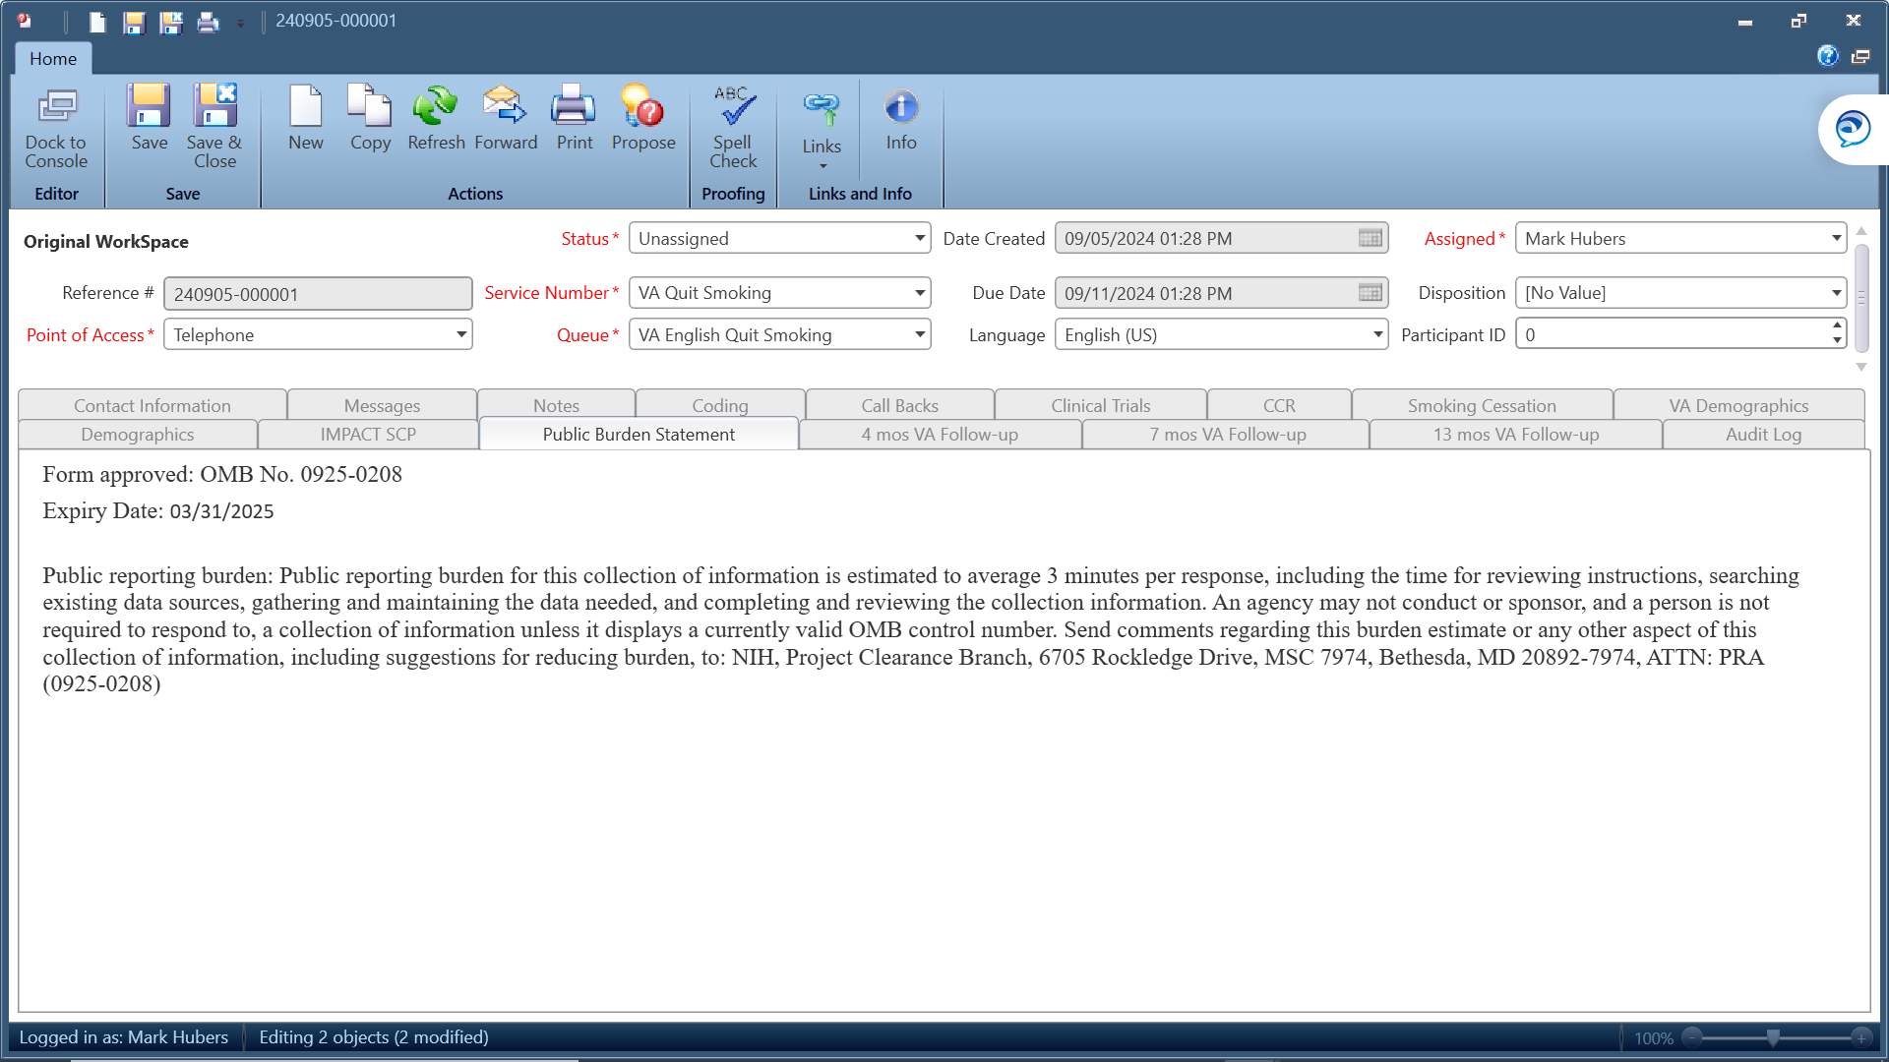

**Questions:**

* **Have you used the service before?**
* **How did you find our Service?**
* **Zip Code?**

Demographic Survey Questions

Please select a response from the following responses:

What is your age?

* 1- 18-34
* 2- 35-49
* 3- 50-64
* 4- 65-74
* 5- 75+

What is your Sex?

* 1- Male
* 2- Female

What is your race and/or ethnicity? Select all that apply.

* American Indian or Alaskan Native
* Asian
* Black or African American
* Hispanic or Latino
* Middle Eastern or North African
* Native Hawaiian or Pacific Islander
* White

American Indian or Native Alaskan: Please include nationality or tribe. For example, the Navajo Nation, the Blackfeet Tribe of the Blackfeet Indian Reservation of Montana, the Native Village of Barrow Inupiat Traditional Government, the Nome Eskimo Community, Aztec, Maya, etc.

Asian: Please select all that apply.

* Valid Skip
* Chinese
* Vietnamese
* Asian Indian
* Korean
* Filipino
* Japanese
* Other Asian

If "Other Asian," please include an example, like Pakastani, Hmong, Afghan, etc.

Black or African American: Please select all that apply.

* Valid Skip
* African American
* Nigerian
* Jamaican
* Ethiopian
* Haitian
* Somali
* Other Black/African American

If "Other Black African American," please include an example, such as Trinidadian and Tobagonian, Ghanaian, Congolese, etc.

Hispanic or Latino: Please select all that apply.

* Valid Skip
* Mexican
* Cuban
* Puerto Ricon
* Dominican
* Salvadoran
* Guatemalan
* Other Hispanic or Latino

If "Other Hispanic Latino," please include an example, such as Columbian, Honduran, Spaniard, etc.

Middle Eastern or Northern African: Please select all that apply.

* Valid Skip
* Lebanese
* Syrian
* Iranian
* Iraqi
* Egyptian
* Israeli
* Other Middle Eastern or Northern African

If "Other Middle Eastern Northern African," please include examples like Moroccan, Yemeni, Kurdish, etc.

Native Hawaiian or Pacific Islander: Please select all that apply.

* Valid Skip
* Native Hawaiian
* Tongan
* Samoan
* Fijian
* Chamorro
* Marshallese
* Other Native Hawaiian or Pacific Islander

If "Other Native Hawaiian or Pacific Islander," please include an example, such as Chuukese, Palauan, Tahitian, etc.

White: Please select all that apply.

* Valid Skip
* English
* Italian
* German
* Polish
* Irish
* Scottish
* Other White

If "Other White," please include examples like French, Swedish, Norwegian, etc.

What Is the Highest Level of Education You Have Completed?

* 1- Some high school or less
* 2- High school graduate
* 3- College graduate
* 4- Post-graduate
* 5- I do not wish to respond

Is There a Place You Usually Go to When You Are Sick or Need Advice About Your Health?

* 1- Yes
* 2 -No
* 3- Don't Know
* 4- I do not wish to respond

What Kind of Place Do You Go to Most Often?

* 1- A doctor’s office
* 2- A clinic or health center
* 3- The emergency room or urgent care
* 4- Some other place, or
* 5- Don’t know

What Was Your Total Household Income from All Sources Before Taxes Last Year?

* 1- Less than $25,000
* 2- $25,000 - $49,000
* 3- $50,000 - $74,000
* 4- more than $75,000
* 5- I do not wish to respond

Including Yourself, How Many People Living in Your Household are Supported by This Total Household Income?

* 1- 1
* 2- 2
* 3- 3
* 4- 4 or more
* 5- I do not wish to respond