NCI/Office of Communications and Public Liaison
APPENDIX 1C
SMOKING CESSATION INTAKE FORM (SCIF) with SCREEN SHOTS

Public Burden Statement

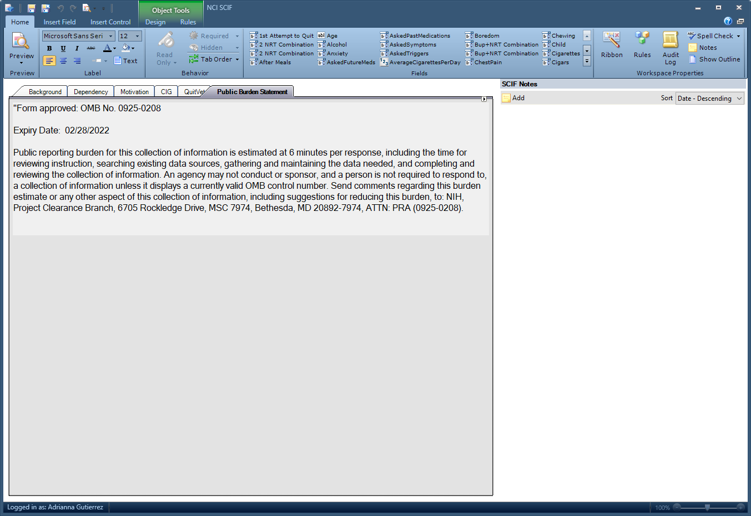

Background

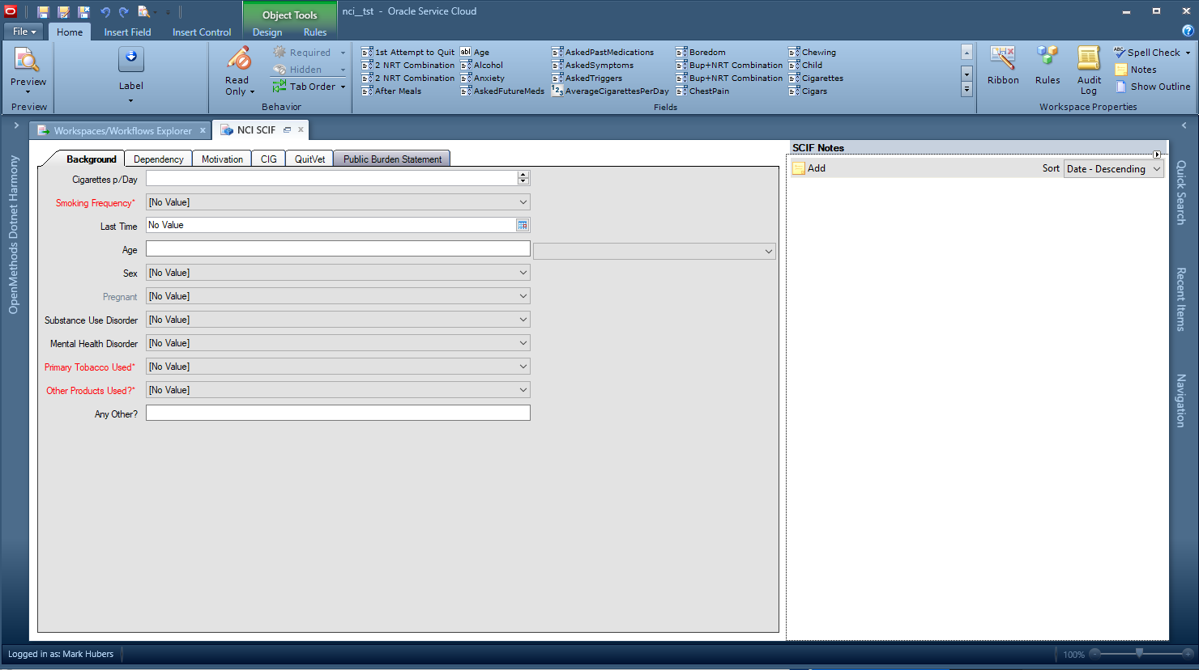
Dependency – Summary

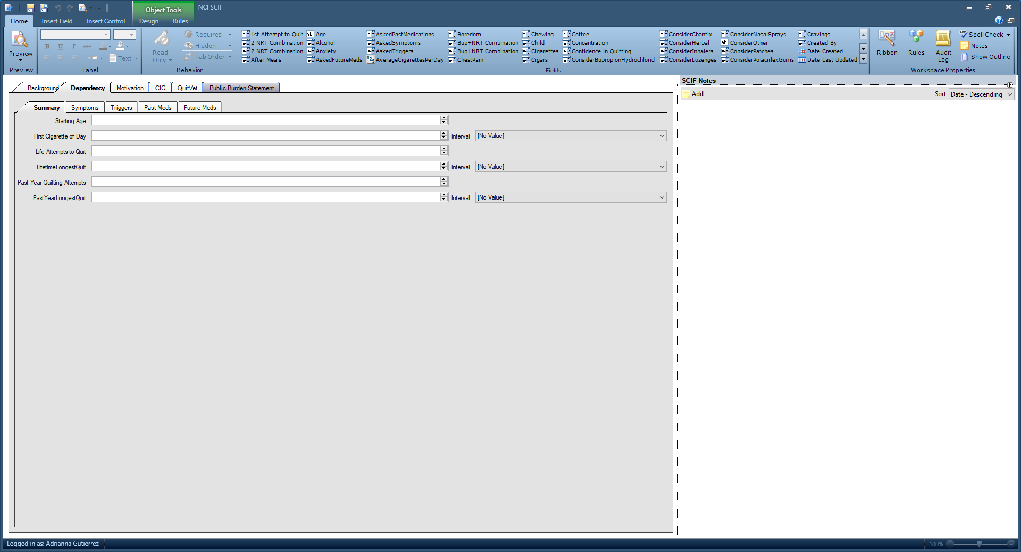

Motivation

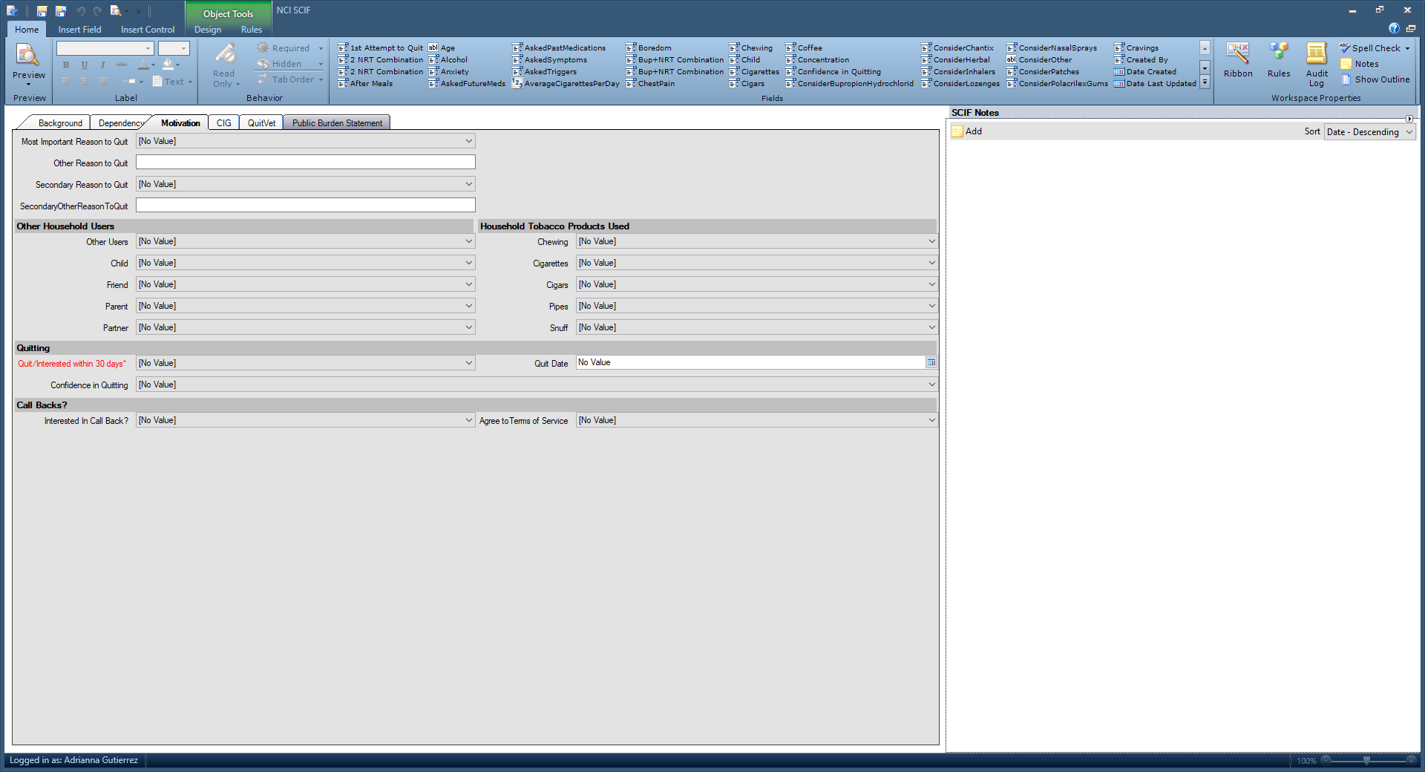

CIG

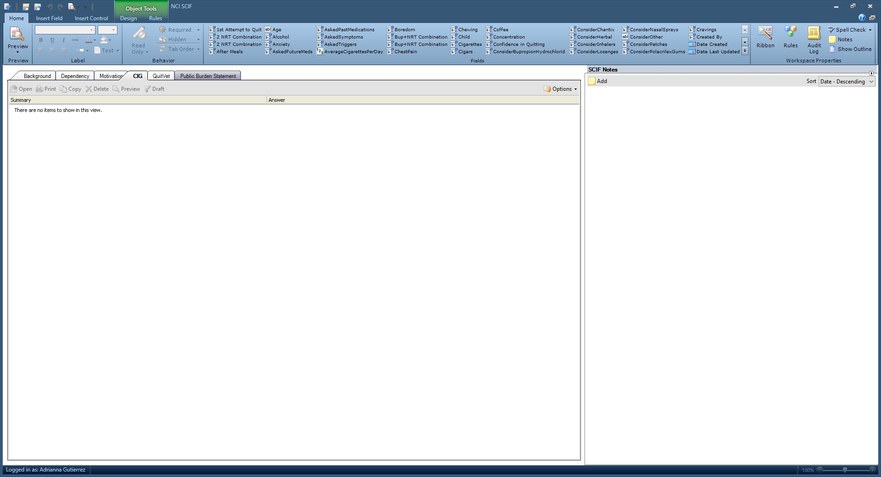

QuitVet

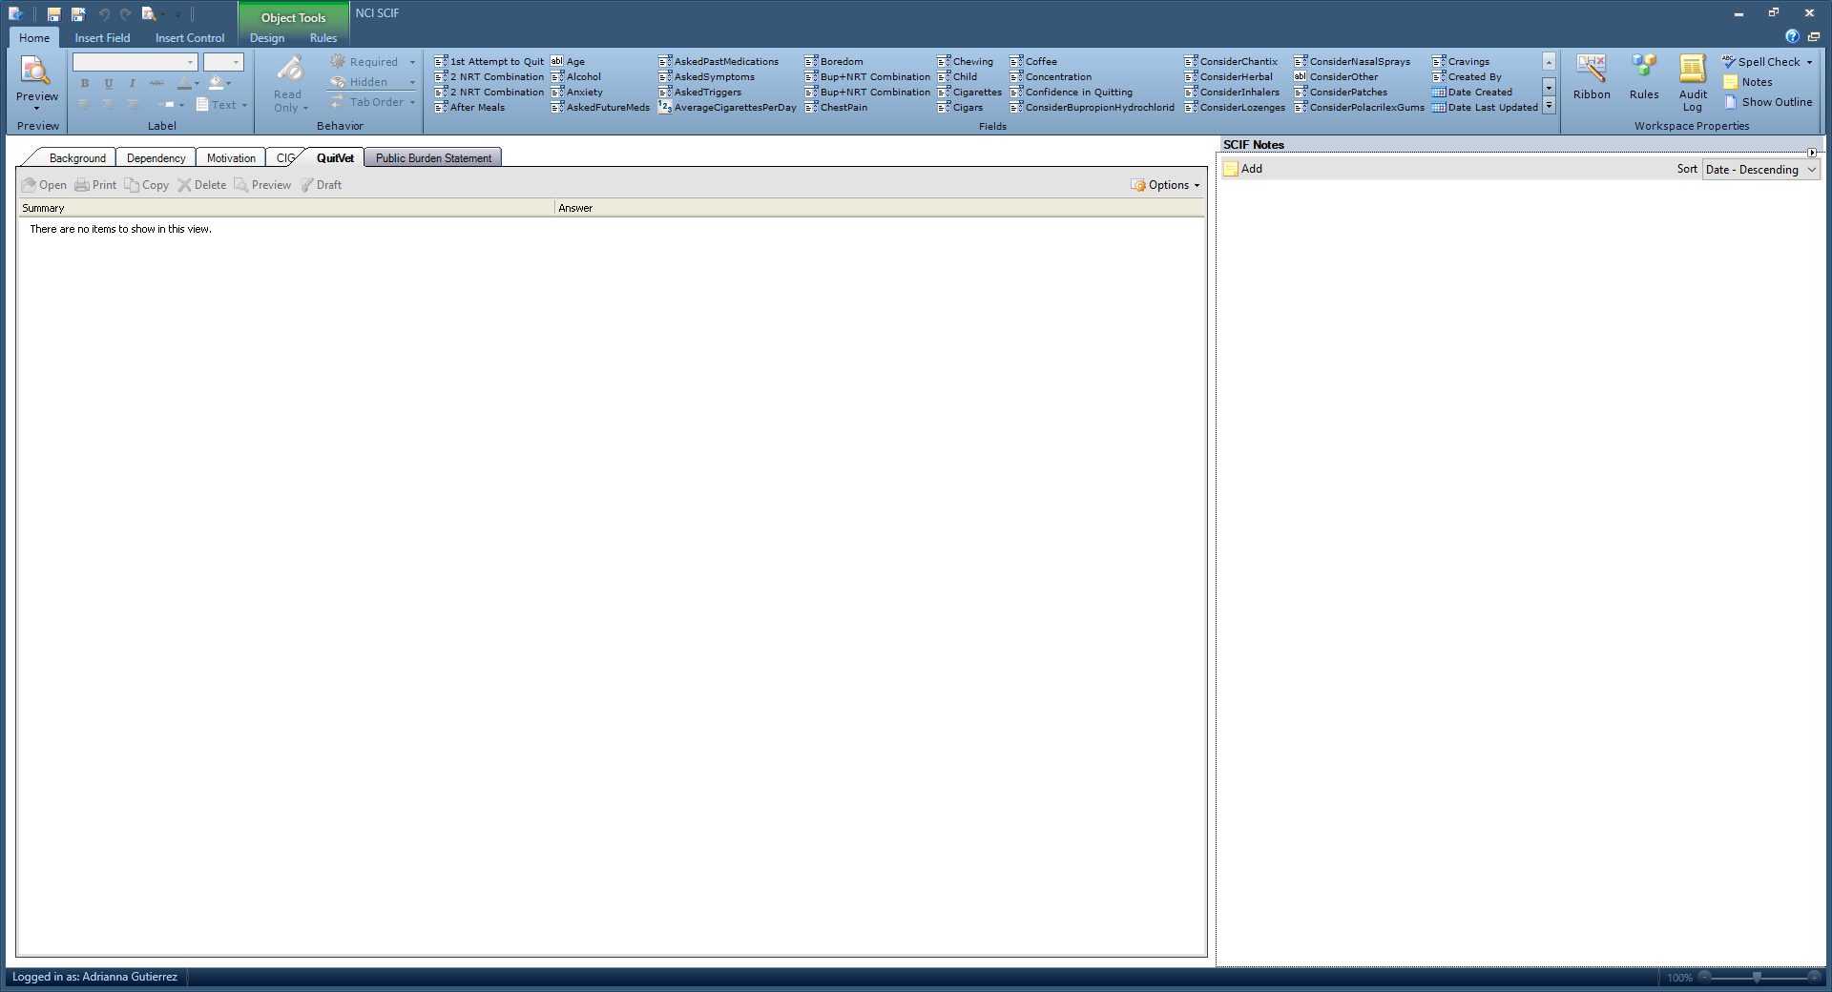
Service
- Subject of Interaction
- Subject 1
  - G-COVID-19
  - G-General Cancer Questions
  - G-Symptoms
  - G-Cancer Statistics/Epidemiological Stats
  - G-Prognosis
  - G-Research Donations
  - G-General Donations
  - G-Suicidal Client
  - G-Other Inquiries
  - CP-Risk Factors
  - CP-Genetics
  - CP-Prevention
  - Tests
  - TX-General Treatment
  - TX Surgery
  - TX-Radiation Therapy
  - TX-Chemotherapy
  - TX-Immunotherapy
  - TX-Targeted Therapy
  - TX-Hormone Therapy
  - TX-Stem Cell Transplant
  - TX-Complementary and Alternative Medicine
  - CAM-Medical Marijuana
  - CAM-Biological Based Products
  - CAM-Manual Therapies
  - CAM-Whole Systems
  - CAM-Mind Body/Spiritual/Energy Med.
  - CAM-High Does Vitamin C
  - Side Effects
  - CT-General Information Only
  - CT-General Information & Search
  - CT-CCR Clinical Trials
  - CT-Results and Outcomes
  - Coping
  - MC-Finding Health Care Services
  - MC-Managing Costs and Medical Information
  - MC-Palliative/Hospice Care
  - Publication Requests
  - SM-Cigarettes
  - SM-Cigars, Cigarillos or Little Cigars
  - SM-Pipes
  - SM-Chewing Tobacco
  - SM-Other Tobacco
  - SM-Marijuana (recreational use)
  - SM-Cessation Counseling/Information
  - SM-E-cigs
  - SM-NRT (nicotine replacement therapy)
  - NCI-About NCI
  - NCI-Key Initiatives
  - NCI-Budget
  - NCI-Problems with a CT Search
  - NCI-Permissions Requests
  - NCI-Other
  - NCI-Risk Tools
  - NCI-QuitSTART and other apps
  - SEER Cancer Statistics
  - SEER Datasets and Software
  - SEER Manuals
  - SEER Registries/Training etc.
  - SEER-other
  - FB-Advertising (products/services)
  - FB-Fundraising
  - FB-Other Languages
  - FB-CAM Cures
- Subject 2 Same as 1
- Subject 3 Same as 1
- Subject 4 Same as 1
- Subject 5 Same as 1

- Cancer Site 1
- Aids-related cancers
- ALL
- AML
- Anal
- Biliary tract
- Bladder
- Brain
- Breast
- Carcinoma of unknown primary
- Cervical
- CLL
- CML
- Colorectal
- Endometrial/Uterine
- Esophageal
- Eye
- Gastrointestinal carcinoid tumor/GIST
- Head and neck
- Hodgkin lymphoma
- Myeloma/Plasma cell neoplasm
- Non-Hodgkin lymphoma
- Ovarian
- Pancreas
- Prostate
- Renal (kidney) and renal pelvis
- Skin cancer (nonmelanoma)
- Small intestine
- Soft tissue
- Stomach/Gastric
- Thyroid
- Break off
- Other – Central nervous system
- Other – Digestive
- Other – Endocrine system
- Other – Hematologic system
- Other – Leukemia
- Other – Lymphoma
- Other – Musculoskeletal and connective tissue
- Other – Reproductive, female
- Other – Reproductive, mal
- Other – Respiratory
- Other – Urinary organs
- Other cancers
- Childhood cancers
- Not applicable/No specific site mentioned

- Special Codes
- Special Code
- No Value
- COVID-19
- NCCAPS (NCI COVID study)
- CTCA Calls
- VA Smoking Chat
- TMIST
- All of Us Research Program Dr. Rosenberg Affordable Care Act (ACA)
- In the News (anything people saw on TV e.g. Angelina Jolie, etc.)
- Vice President’s Cancer Initiative
- First in Human
- CT Feedback (PIQ only)
- Cancer Research Initiative Mailbox
- Genomics Podcast
- VA Lung Screening
- Pediatric Petitions/Funding
- FDA Referral (quit smoking)
- Exceptional Responders
- MATCH
- Ped MATCH
- Emperor of All Maladies
- VM Callback
- FB Live Event
- Hurricane
- DART
- Every Try Counts
- Cell Phone Risk
- E2112
- PIQ Custom Phone Response
- PIQ Referred by DOC
- PIO Referred by Center for Global
- Health
- PIQ Incarcerated Client
- Special Code 2 (same as 1)

- Referrals Given
- Referral 1
- No Value
- CIS information service
- Smoking Quitline
- Public Inquiries
- POS
- NCI Doc/Program
- NCI Designated Cancer Center
- NCI CCR/Clinical Center
- NCCCP
- CDC-BCCEDP
- CDC-BCCEDP – Missouri
- Genetics Services
- Other Healthcare Facility
- National or Community Org/Other Gov. Program
- International Referral
- Other
- None
- Break Off
- Referral 2 (same as 1)
- Referral 3 (same as 1)
- Referral 4 (same as 1)
- Follow-up Actions
- Action 1
- No Value
- None
- Sent information by mail
- Emailed information
- Social Media post
- Warm transfer org/agency
- Scheduled call back
- Other
- Action 2 (same as 1)
- Clinical Trials
- N/A
- Client Initiated
- IS Initiated

- Background Screen
- Cigarettes per Day
- Age
- Sex
- Male
- Female
- Substance Use Disorder
- Yes
- No
- Mental Health Disorder
- Yes
- No

Dependency Screen:
- Age when starting smoking cigarettes
- First cigarette of the day after awakening
- In life, number of quit attempts for 1 day or longer
- Duration (beyond a day) of successful quitting
- In past year, number of quit attempts
      - First call to the quit line in the past 12 months?
- Longest time quit

- Types of tobacco have you used in the past 30 days
      - Cigarettes
        - Menthol cigarettes?
          - Yes, I usually smoke menthol cigarettes
          - No, I usually smoke other types of cigarettes (non-menthol)
          - Don’t know
          - Refused
          - Not asked
      - E-Cigarettes
      - Cigars, cigarillos, or little cigars
      - A pipe
      - Chewing tobacco, snuff, dip, or snus
      - Nicotine pouches
      - Dissolvable tobacco
      - Any other type of tobacco

- Last time smoked a cigarette, even a puff :
      - dd/mm/yyyy
      - Don’t know
      - Refused
      - Not asked

- Avg. Number of cigarettes smoked each day ___

- Currently smoke cigarettes every day, some days, or not at all? (Note: “currently” refers to right now, today.)
      - Everyday
      - Some days
        - Number of days smoked in the last 30 days: ___
          - Don’t know
          - Refused
          - Not asked
      - Not at all
      - Don’t know
      - Refused
      - Not asked
- Age?
- Sex?
- If female, are you pregnant right now?

- Symptoms experienced after quitting
      - Feeling irritable, angry, agitated
      - Mood swings, depressed, down, or blue
      - Nervous, anxious, jumpy
      - Cravings
      - Trouble sleeping, nightmares, dreams
      - Has not tried to quit before (1st quit attempt)
      - Weight gain
      - Increased appetite or hunger
      - Tired, fatigued
      - Feeling ill, sick, nausea, general malaise
      - Headache
      - Chest pain, shortness of breath
      - Stress
      - Unable to concentrate
      - Dizzy, lightheaded
      - Shakes
      - Other (please explain)

- Triggers
- Did not ask triggers
- After meals
- Alcohol
- Other substance abuse
- Anxiety
- Coffee
- Driving
- Fatigue
- Driving
- Phone calls
- Sadness
- Stress
- Watching TV
- Work breaks
- Nightmares
- Intrusive thoughts
- Other (please explain)

- Past medication to quit
- Did not ask
- Used in past
- Bupropion hydrochloride (e.g.Zyban, Wellbutrin)
- Chantrix
- Herbal
- Inhalers
- Lozenges
- Nasal sprays
      - Patches
      - Policrilex gums
- 2 NRT combinations
- Bup+NRT combination
- Other

- Future Meds
- Did not ask
- Not interested
- Bupropion hydrochloride
- Chantrix
- Herbal
- Inhalers
- Lozenges
- Nasal sprays
      - Patches
      - Policrilex gums
- 2 NRT combinations
- Bup+NRT combination
- Other

- Comorbidity
- Substance Abuse
- Other

Motivation Screen Questions:

- Most important reason for wanting to quit
      - Restrictions placed on smokers in restaurants, at work, and other public places
      - Family or friends
      - To feel more in control of your life
      - To improve your health
      - To save money
      - To improve your health
      - Because your doctor told you to
      - Because of your children (grandkids)
      - For a healthy pregnancy
      - Just tired of smoking
      - Professionalism, Role model
      - Religious reasons
      - Extracurricular activities (e.g. basketball, jogging, dancing, volleyball, etc.)
      - Age
      - Concern about cancer prompted by death of family member or public figure
      - Dirty/bad habit
      - Other (please explain)
      - Did not ask

- Secondary Reason?
      - See examples from last question
      - No other reason
      - Did not ask

- Others in the household currently using tobacco products (one or more)
- Other Users?
      - Child?
      - Friend?
      - Parent?
      - Partner?

- Household Tobacco Products Used
- Chewing
- Cigarettes
- Cigars
- Pipes
- Snuff

- Quitting
- Quitting next 30 days?
- Quit date
- Confidence in Quitting
- No value
- Somewhat confident
- Confident
- Neutral
- Not confident at all

- Call Backs?
- Interested in call back?
- Agree to terms of service?

