Security Authentication PIN (SAP) Code Generation Steps – Screenshots

Public-Facing SAP Code Generation via Vanity URL (ssa.gov/pin):
- User leverages the Vanity URL and signs in to their mySocialSecurity account using their Login.Gov or ID.me credential
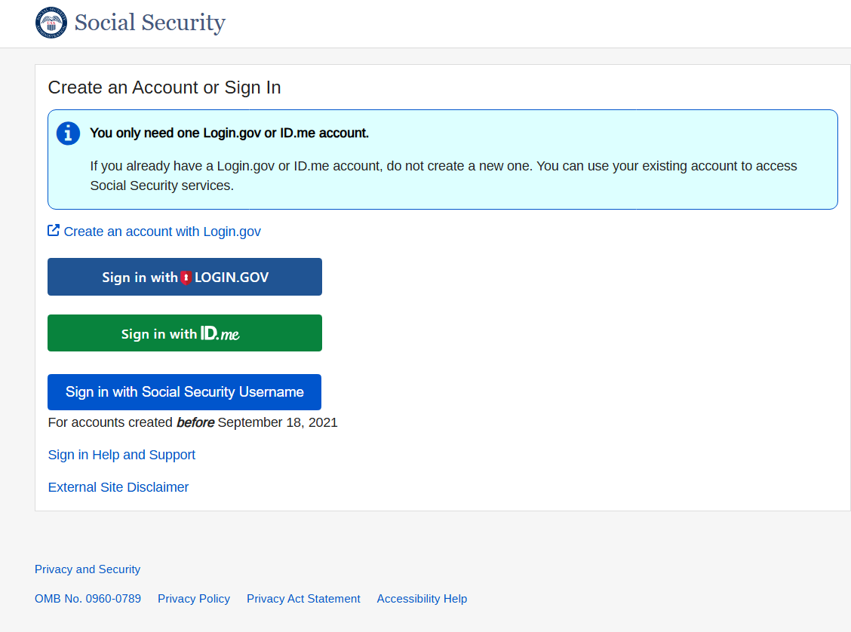

- After completing login, user is navigated directly to screen where they can generate the SAP code
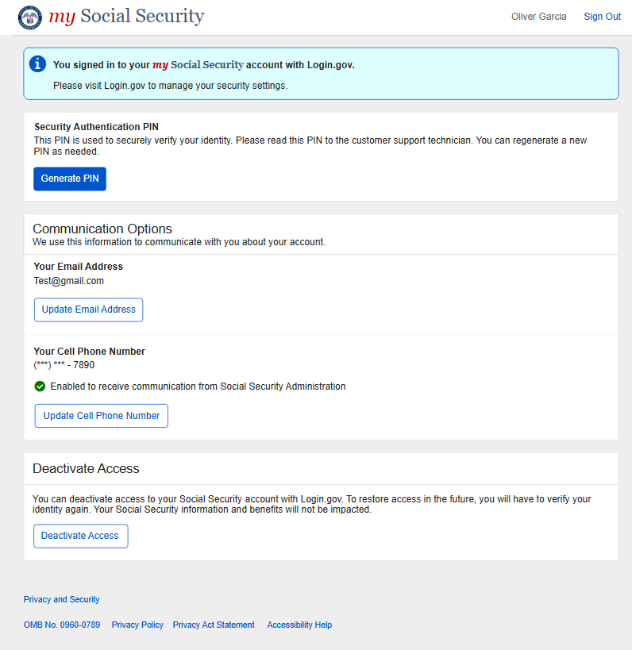

- User generates PIN and shares PIN with SSA Technician
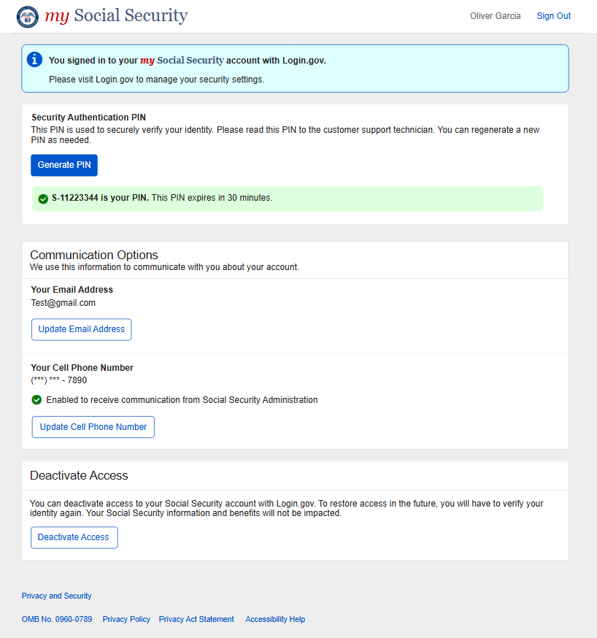

Public-Facing SAP Code Generation via Traditional URL (ssa.gov)

- User signs in to their mySocialSecurity account via traditional URL using their Login.Gov or ID.me credential

- User selects ‘My Profile’ in the MySSA Home page

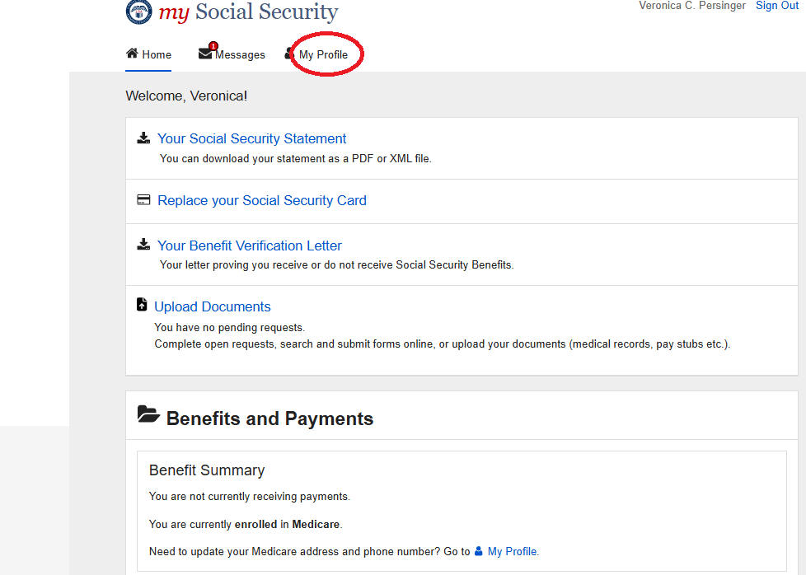

- User selects ‘Security’ from the mySSA ‘My Profile’ page to navigate to SAP screen.
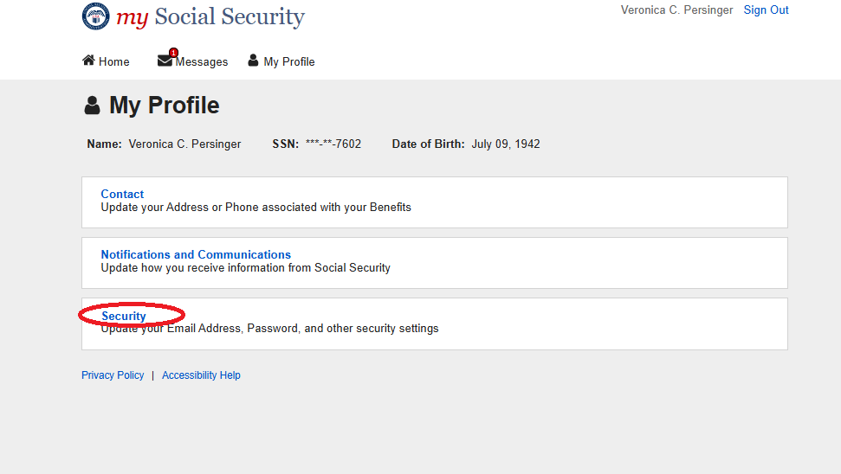

- User arrives at screen where they can generate the SAP code

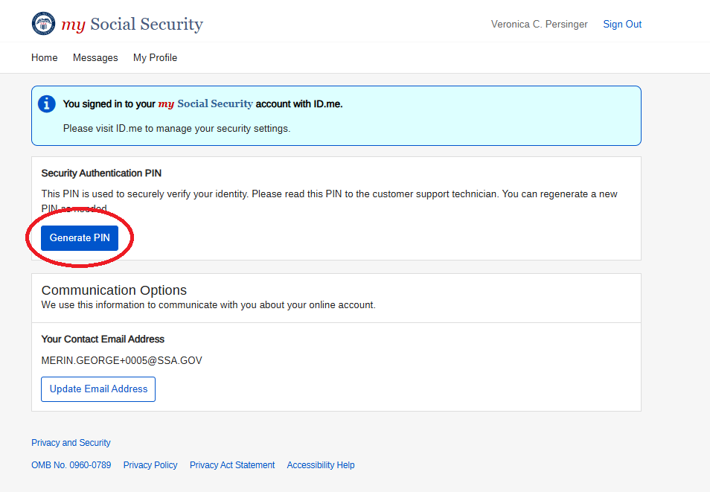

- User generates PIN and shares PIN with SSA Technician
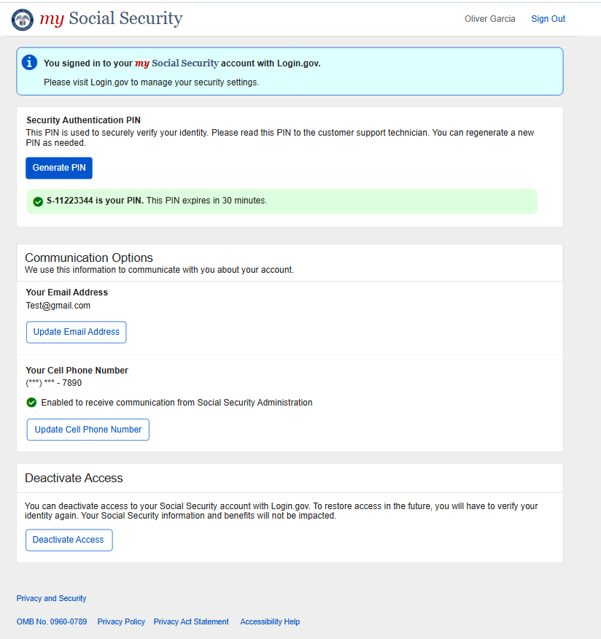

Technician Experience Dashboard – SAP Validation Screen
- Technician enters SAP code provided by customer and validates code.
