**Individual Service Plan (S-13)**

UAC Portal Version with Integrated UC Path Features

**DATA ENTRY WINDOW:** UC Path New Admission Assessment – Individual Service Plan

|  |  |  |  |  |
| --- | --- | --- | --- | --- |
| Information | | | | |
| **Assessment Status** | **<Dropdown Menu>** (-Select One- *Pending; Complete*) |  | | |
| System Information | | | | |
| **Submitted Date** | <Pop-up Calendar> *MM/DD/YYYY* | |  | |
|  | **>|Cancel** | **>|Save & New** | | **>|Save** |

**DATA ENTRY WINDOW:** UC PathMandatory Services

|  |  |  |  |
| --- | --- | --- | --- |
| **New Service: Mandatory** | | | |
| **Service\*** | <Dropdown Menu> (-Select One- *Orientation, Assessment, Medical, Education; Recreation & Leisure Time; Individual Counseling; Group Counseling; Access to Religious Services; Case Management; Legal Orientation; Vocation)* |  | |
| **Task\*** | ***<Dropdown Menu>*** *(*Conditional Logic* See* *Ref. Table 3: ISP Task**)* |
| **Person Responsible\*** | *(Open Text)* | **Notes:** | *(Open Text)* |
| Dates | | | |
| **Service Start Date\*** | <Pop-up Calendar> *MM/DD/YYYY* | **Service End Date** | <Pop-up Calendar> *MM/DD/YYYY* |
| **Frequency\*** | *(Open Text)* |  | |
|  | **>|Cancel** | **>|Save & New** | **>|Save** |

THE PAPERWORK REDUCTION ACT OF 1995 (Pub. L. 104-13) STATEMENT OF PUBLIC BURDEN: The purpose of this information collection is used by care providers to document all services provided to the child. Public reporting burden for this collection of information is estimated to average 0.33 hours per response, including the time for reviewing instructions, gathering, and maintaining the data needed, and reviewing the collection of information. This is a mandatory collection of information (Homeland Security Act, 6 U.S.C. 279, and Trafficking Victims Protection Reauthorization Act, 8 U.S.C. 1232). An agency may not conduct or sponsor, and a person is not required to respond to, a collection of information subject to the requirements of the Paperwork Reduction Act of 1995, unless it displays a currently valid OMB control number. If you have any comments on this collection of information, please contact [UACPolicy@acf.hhs.gov.](mailto:UACPolicy@acf.hhs.gov.)

**DATA ENTRY WINDOW:** UC PathOther Services

|  |  |  |  |
| --- | --- | --- | --- |
| **New Service: Optional** | | | |
| **Service\*** | <Dropdown Menu> (-Select One- *Orientation, Assessment, Medical, Education; Recreation & Leisure Time; Individual Counseling; Group Counseling; Access to Religious Services; Case Management; Legal Orientation; Vocation; None)* |  |  |
| **Task\*** | ***<Dropdown Menu>*** *(*Conditional Logic* See* *Ref. Table 3: ISP Task**)* | **Notes:** | *(Open Text)* |
| **Person Responsible\*** | *(Open Text)* |  | |
| Dates | | | |
| **Service Start Date\*** | <Pop-up Calendar> *MM/DD/YYYY* | **Service End Date** | <Pop-up Calendar> *MM/DD/YYYY* |
| **Frequency\*** | *(Open Text)* |  | |
|  | **>|Cancel** | **>|Save & New** | **>|Save** |

**DATA ENTRY WINDOW:** Documents Upload Tab

|  |  |  |  |
| --- | --- | --- | --- |
| **Add File Details** | | | |
| **Record Type:** | **<Dropdown Menu>** (-Select One- *See Records Type List)* | | |
| **Title** | *(Open Text)* |  | |
| **Document Type** | **<Dropdown Menu>** (-Select One- *See* *Ref Table 1: Document Type List**)* |
| **Date Document Issued (if Applicable)** | <Pop-up Calendar> *MM/DD/YYYY* |
| **Date Received:** | <Pop-up Calendar> *MM/DD/YYYY* |
| **Expiration Date (if applicable):** | <Pop-up Calendar> *MM/DD/YYYY* | **Description:** | *(Open Text)* |
|  | | | **>|Save** |

**DATA ENTRY WINDOW:** ISP Certification Tab

|  |  |  |  |
| --- | --- | --- | --- |
| **Certification (Case Manager)** | | | |
| **List Team Individuals who Contributed to ISP:\*** | *(Open Text)* | | |
| **1** I confirm that I have completed all of the required sections and the information is accurate to the best of my knowledge | | | |
| **Printed Name:\*** | **<Search Field>** (Help Text: *Search undefined…)* | **Title** | *(Auto-Populate)* |
| **Translator Name: \*** | *(Open Text)* | **Language: \*** | <Dropdown Menu> (-Select Language- See *Ref. Table 2: Languages*) |
|  | | | **>|Save** |
| System Information | | | |
| **Created by:** | *SYSTEM GENERATED* | **Last Modified by:** | *SYSTEM GENERATED* |
| **Submitted Date/Time:** | *SYSTEM GENERATED* |

**DISPLAY**: UAC Portal ISP with Integrated UC Path Features – REDLINE CHANGES

|  |  |  |  |  |
| --- | --- | --- | --- | --- |
| **UAC Basic Information** | | | | |
| Photo of Child | **First Name:** | *(Auto Populate)* | **AKA:** | *(Auto Populate)* |
| **Last Name:** | *(Auto Populate)* | **Status:** | *(Auto Populate)* |
| **Date of Birth:** | *(Auto Populate)* | **Admitted Date:** | *(Auto Populate)* |
| **A#:** | *(Auto Populate)* | **Length of Stay:** | *System Generated* |
| **Country of Birth:** | *(Auto Populate)* | **Current Program:** | *(Auto Populate)* |
| **Sex:** | *(Auto Populate)* | **Portal ID:** | *(Auto Populate)* |
|  | Physical Location of the Child: | | *(Auto populate –* [*Source UAC Portal Discharge Tab)*](bookmark://LocatioOfChildAppendix) | |

|  |  |  |  |
| --- | --- | --- | --- |
| **Individual Service Plan** | | | |
| **Case Manager** | *(Auto Populate)* | **Clinician** | *(Auto-Populate)* |
| **Assessment Status:** | *(Auto-Populate)* |  | |
| **Does the child have a 504 Service Plan?** | *(Auto-Populate)* |
| System Information | | | |
| **Submitted Date** | *(Auto-Populate)* *MM/DD/YYYY* |  | |

|  |  |  |  |  |  |
| --- | --- | --- | --- | --- | --- |
| **Service** | **Task** | **Frequency** | **Start Date** | **End Date** | **Person Responsible** |
| **Orientation** | Program Orientation | One Time | *(Auto-Populate) MM/DD/YYYY* | *(Auto-Populate) MM/DD/YYYY* | *(Auto-Populate)* |
| **Assessment** | UAC Assessment | One Time | *(Auto-Populate) MM/DD/YYYY* | *(Auto-Populate) MM/DD/YYYY* | *(Auto-Populate)* |
| **Medical** | Medical Exam w/in 48 Hours of Admission | One Time | *(Auto-Populate) MM/DD/YYYY* | *(Auto-Populate) MM/DD/YYYY* | *(Auto-Populate)* |
| **Education** | Assessment | One Time | *(Auto-Populate) MM/DD/YYYY* | *(Auto-Populate) MM/DD/YYYY* | *(Auto-Populate)* |
| Plan | One Time | *(Auto-Populate) MM/DD/YYYY* | *(Auto-Populate) MM/DD/YYYY* | *(Auto-Populate)* |
| Classes | Daily | *(Auto-Populate) MM/DD/YYYY* | *(Auto-Populate) MM/DD/YYYY* | *(Auto-Populate)* |
| **Recreation and Leisure** | Large Muscle Activity and Leisure Time | 1 hour of each/ weekday; 5 hours total/ weekends | *(Auto-Populate) MM/DD/YYYY* | *(Auto-Populate) MM/DD/YYYY* | *(Auto-Populate)* |
| **Individual Counseling** | Session | Once Weekly | *(Auto-Populate) MM/DD/YYYY* | *(Auto-Populate) MM/DD/YYYY* | *(Auto-Populate)* |
| **Group Counseling** | Session | Twice Weekly (or once weekly with community meeting) | *(Auto-Populate) MM/DD/YYYY* | *(Auto-Populate) MM/DD/YYYY* | *(Auto-Populate)* |
| **Access to Religious Services** | Attendance | Upon Request | *(Auto-Populate) MM/DD/YYYY* | *(Auto-Populate) MM/DD/YYYY* | *(Auto-Populate)* |
| **Case Management** | Discharge Planning; Family Reunification | Ongoing Once Weekly Meetings with UAC for updates | *(Auto-Populate) MM/DD/YYYY* | *(Auto-Populate) MM/DD/YYYY* | *(Auto-Populate)* |
| **Legal Orientation** | KYR Presentation;  Confidential Legal Consultation | One time each | *(Auto-Populate) MM/DD/YYYY* | *(Auto-Populate) MM/DD/YYYY* | *(Auto-Populate)* |
| **Vocation** | Training Activities | Once Weekly | *(Auto-Populate) MM/DD/YYYY* | *(Auto-Populate) MM/DD/YYYY* | *(Auto-Populate)* |

|  |  |  |  |  |  |
| --- | --- | --- | --- | --- | --- |
| Other Services | | | | | |
| **Service** | **Tasks** | **Frequency** | **Start Date** | **End Date** | **Person Responsible** |
| *Auto-Populate* | *Auto-Populate* | *Auto-Populate* | *Auto-Populate* | *Auto-Populate* | *Auto-Populate* |
| *Auto-Populate* | *Auto-Populate* | *Auto-Populate* | *Auto-Populate* | *Auto-Populate* | *Auto-Populate* |
| *Auto-Populate* | *Auto-Populate* | *Auto-Populate* | *Auto-Populate* | *Auto-Populate* | *Auto-Populate* |

|  |  |  |  |  |
| --- | --- | --- | --- | --- |
| **Certification (Case Manager)** | | | | |
| **List Team Individuals Who Contributed to ISP:\*** | *Auto-Populate* | | | |
| **1** I confirm that I have completed all of the required sections and the information is accurate to the best of my knowledge | | | | |
| **Printed Name:\*** | *(Auto-Populate)* | **Title** | | *(Auto-Populate)* |
| **Translator Name:\*** | *(Auto-Populate)* | **Language:\*** | | *(Auto-Populate)* |
| System Information | | | | |
| **Created by:** | *SYSTEM GENERATED* | **Last Modified by:** | | *SYSTEM GENERATED* |
|  |  | **Submitted Date/ Time:** | | *SYSTEM GENERATED* |
| Certificate | | | | |
| **Signature:** | *(Auto-Populate)* | **Date:** | *(Auto-Populate)* | |
| **Print Name:** | *(Auto-Populate)* | **Title:** | *(Auto-Populate)* | |

## APPENDIX: A – UC Path User Interface

The images below depict the user interface design for Individual Service Plan data entry and display as contemplated for UC Path, currently approved under the Services Provided to Unaccompanied Alien Children information Collection (OMB# 0970-0553)

**DATA ENTRY:**

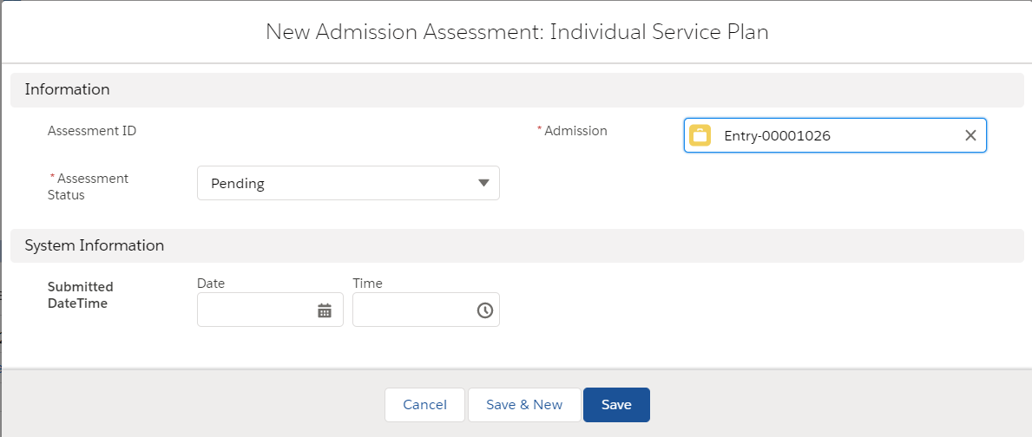

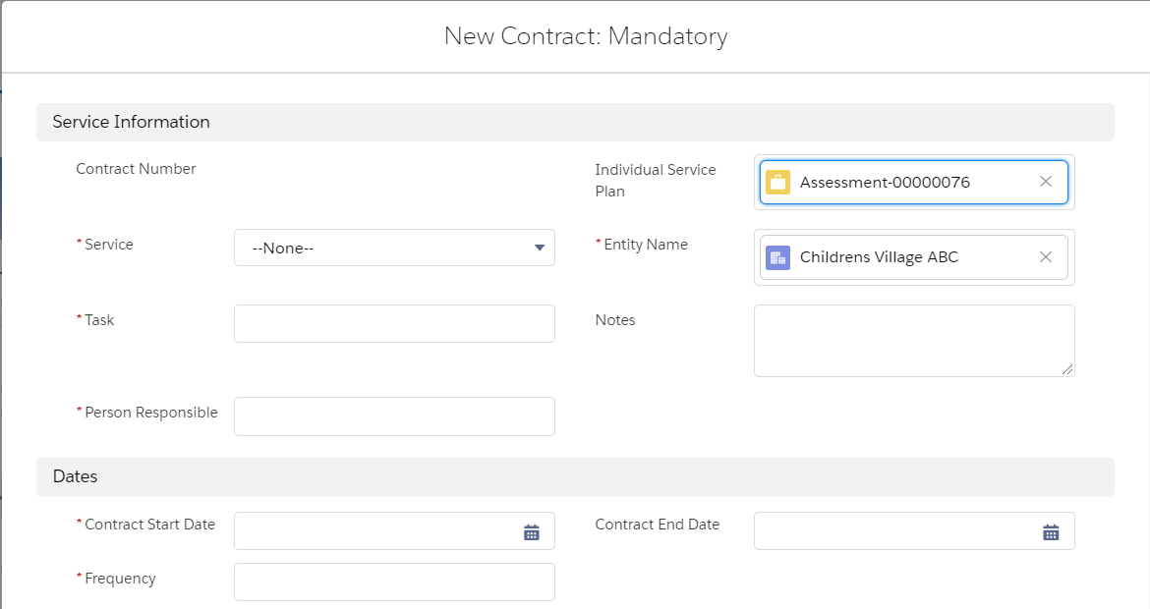

**DISPLAY:**

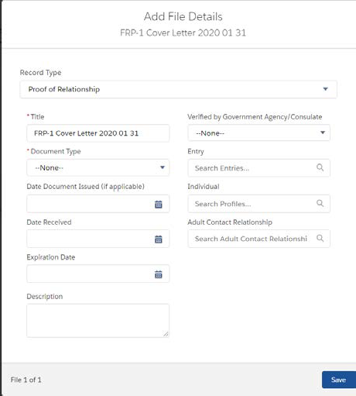

Sex

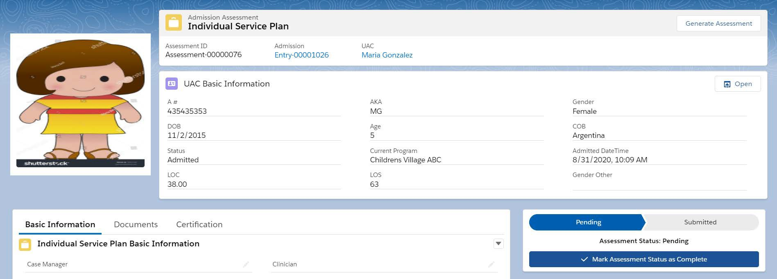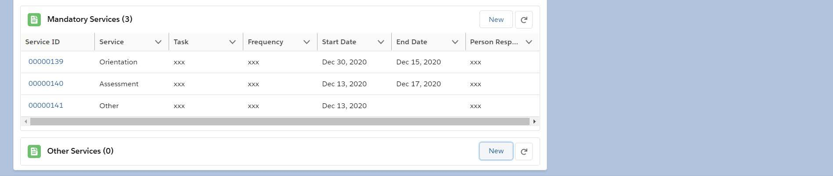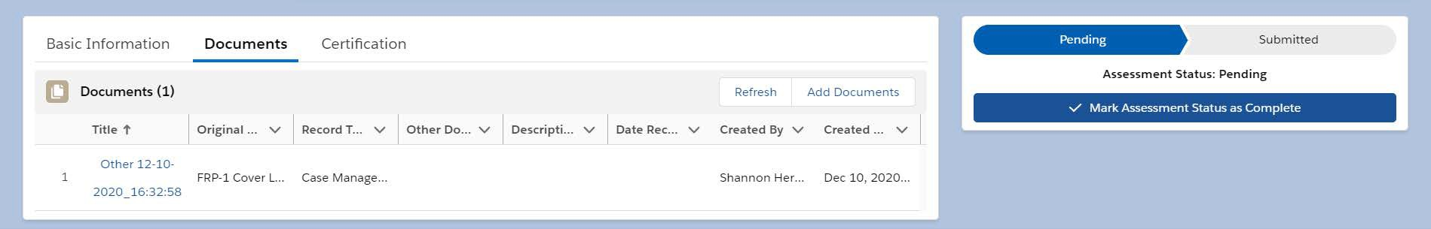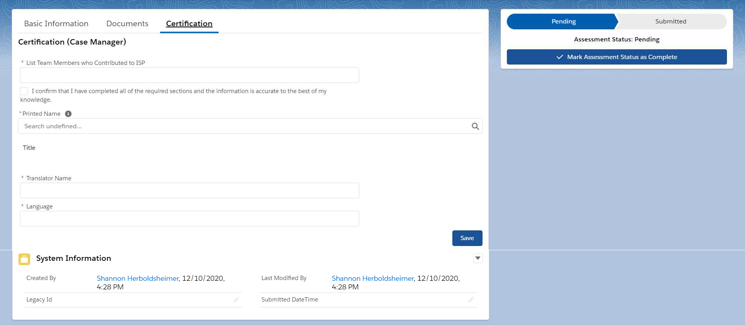

## APPENDIX B: Reference Tables

|  |
| --- |
| **Reference Table 1: Document Type** |
| **<Dropdown Menu>** (-Select Document Type- *UAC Identity Document; Sponsor’s Authorization for Release of Information; Sponsor’s Family Reunification Application; Sponsor’s Supporting Documents; Household Member Documents; Adult Caregiver Documents; Proof of Sponsor-UAC Relationship; Proof of Address; Cancelled Sponsor Application Documents; Case Management Notes; Clinical Notes; Home Study Report; PRS Report; UAC DHS/ Legal Documents; L-3 Form; Notification of Concern; 504 Service Plan (S-25); Other)* |

|  |
| --- |
| **Reference Table 2: Languages** |
| <Dropdown Menu> ( - Select Language – *Spanish; Acateco; K’iche’; Q’eqchi; Mam; Non-verbal; Sign Language; Unknown Dialect; Achi; Albanian; Arabic; Armenian; Asante; Awakatek; Azerbaijani; Bambara; Bengali; Cantonese Chinese; Chatino; Chechen; Chorti; Chuj; Creole – Haitian (French); Creole – Spanish; Czech; Dari; Dutch; Eman; English; Ewe; Fanti; Farsi (Persian); French; Fujianese; Fulani; Fuzhou; Ga; Garifuna; Georgian; German; Gujarati; Haryanvi; Hausa; Hebrew; Hindi; Hungarian; Italian; Ixil; Jacatelco (Popti); Japanese; Kaqchikel; Kikongo; Korean; Kotokoli; Kurdish; Kyrgyz; Lachi; Latvian; Lenka; Lingala; Malinke; Mandarin Chinese; Mandingo; Marwari; Maya; Mazatec; Miskito; Mixteco; Mopan; Nahuatl; Nepali; Otomi; Pashai; Pashto; Patois; Polish; Poqomam; Poqomchi; Portugese; Pular; Punjabi; Qanjobal; Quechua; Rohingya; Romani (Gypsy); Romanian; Russian; Serbian; Sipakapense; Slovak; Somali; Soinke; Susu; Swahili; Sylheti; Tajik; Tamil; Tarahumara; Tectiteco; Telugu; Thai; Thibetan; Tigrinya; Tlapanec; Tojolabal; Triqui; Turkish; Twi; Tzeltal; Tzotzil; Tz’utujil; Ukranian; Urdu; Uspanteko; Uzbek; Vietnamese; Wolof; Yoruba; Zaghawa; Zapotec; Zarma; Zoque*) |

|  |  |
| --- | --- |
| **Reference Table 3: ISP Task Options Conditional Logic** | |
| If this “Service” is selected in the New Services (Mandatory or Optional) data entry window… | …Then these options auto-populate the “Task” field in the New Contract data entry window |
| **Orientation** | *Program Orientation* |
| **Assessment** | *UAC Assessment* |
| **Medical** | *Medical Exam w/in 48 Hours of Admission; Other - Specify* |
| **Education** | *Assessment; Plan; Classes; Other - Specify* |
| **Recreation and Leisure** | *Large Muscle Activity and Leisure Time; Other - Specify* |
| **Individual Counseling** | *Session; Other - Specify* |
| **Group Counseling** | *Session; Other - Specify* |
| **Access to Religious Services** | *Attendance; Other - Specify* |
| **Case Management** | *Discharge Planning; Family Reunification; Other - Specify* |
| **Legal Orientation** | *KYR Presentation;*  *Confidential Legal Consultation; Other - Specify* |
| **Vocation** | *Training Activities; Other - Specify* |