Data Entry Window REDLINE
Profile Information
Active Sponsor Application 1 | Previous Sponsor Application 1
THE PAPERWORK REDUCTION ACT OF 1995 (Pub. L. 104-13) STATEMENT OF PUBLIC BURDEN: The purpose of this information collection is to allow ORR to create profiles for sponsors, their adult household members, and identified adult caregivers in the system. Public reporting burden for this collection of information is estimated to average 0.75 hours per response, including the time for reviewing instructions, gathering, and maintaining the data needed, and reviewing the collection of information. This is a mandatory collection of information (Homeland Security Act, 6 U.S.C. 279, and Trafficking Victims Protection Reauthorization Act, 8 U.S.C. 1232). An agency may not conduct or sponsor, and a person is not required to respond to, a collection of information subject to the requirements of the Paperwork Reduction Act of 1995, unless it displays a currently valid OMB control number. If you have any comments on this collection of information, please contact UACPolicy@acf.hhs.gov.

Basic Information
A# | (Open Text)
Name | Salutation: | <Dropdown Menu> (-Select One- None, Miss; Mr.; Ms.; Mrs.; Sir; Dr.; Hon.; Prof; Rev.) | AKA | (Open Text)
Name | First Name: | (Open Text)
Name | Middle Name: | (Open Text)
Name | Last Name : | (Open Text)
DOB | <Pop-Up Calendar> MM/DD/YYYY
COB | <Dropdown Menu> (-Select One- See Reference Table 1 – Countries) |  | Marriage Status: | <Dropdown Menu> (-Select One – Single; Married; Separated; Divorced; Widowed)
Sex | <Dropdown Menu> (-Select Gender- Male; Female) |  | Alternate Phone Number | (Open Text)
Phone | (Open Text) |  | Comments | (Open Text)
Email | (Open Text) |  | Other Languages Spoken | <Dropdown Menu> (-Select One- See Reference Table 2 – Languages)
Primary Language Spoken | <Dropdown Menu> (-Select One- See Reference Table 2 – Languages) |  | Additional Cultural Information | (Open Text)
Religious Affiliation | (Open Text)
Legacy Address | (Open Text)

Additional Background Check Information
FFS Requires FBI Background Check 1 | FFS Requires CA/N Check 1
FFS Requires State/ Local Check 1

Contact Flag Information
Criminal Flag 1 | Criminal Flag Date | <Pop-Up Calendar> MM/DD/YYY
Criminal Flag 1 | Criminal Flag Notes | (Open Text)
Fraud Flag 1 | Fraud Flag Date | <Pop-Up Calendar> MM/DD/YYY
Fraud Flag 1 | Fraud Flag Notes | (Open Text)
Denied Flag 1 | Denied Flag Date | <Pop-Up Calendar> MM/DD/YYY
Denied Flag 1 | Denied Flag Notes | (Open Text)
Previous Sponsorship Flag 1 | Denied Flag Date | <Pop-Up Calendar> MM/DD/YYY
Previous Sponsorship Flag 1 | Previous Sponsor Flag Notes | (Open Text)
Legacy Sponsor Flag 1 | Legacy Sponsor Flag Notes | (Open Text)

System Information
Legacy ID | (Open Text) | Entity Name | <Search Bar> (Open Text)
 | >| Cancel | >| Save & New | >| Save

APPENDIX A – UC Path Screen Shots
Adult Contract Profile: Data Entry Window
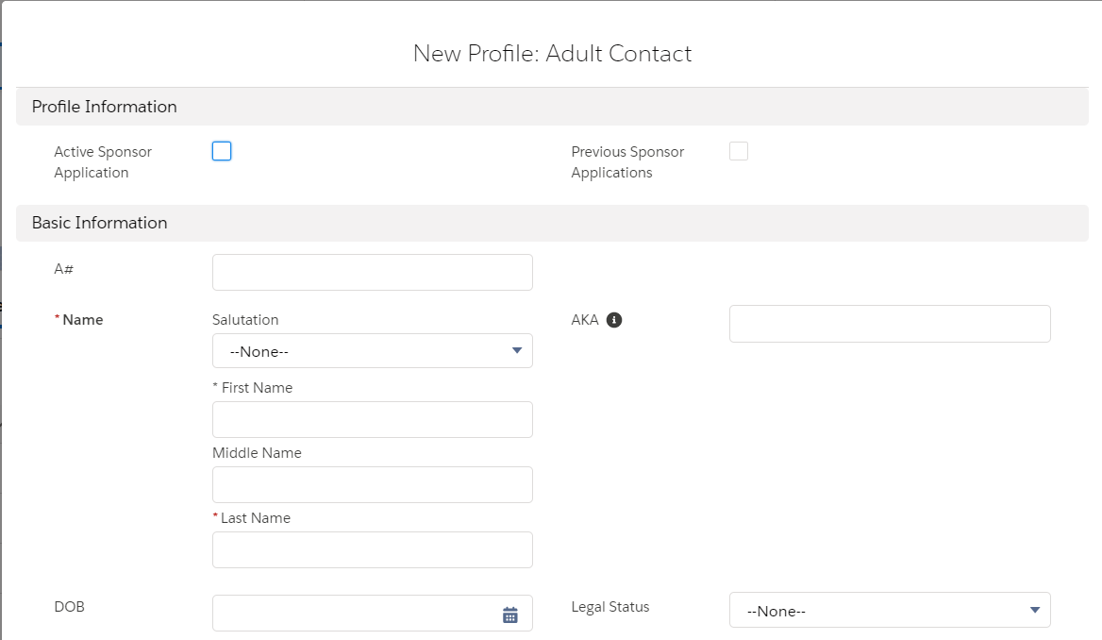

Documents Data Entry Window

Children Data Entry Window

Address History Data Entry Window

Associated Unaccompanied Child Data Entry Window
Child
Child
Child

Self-Disclosed Criminal History Data Entry Window

Adult Contact Profile: Display
Sex
Sex
Sex
Child

APPENDIX B – Dropdown Menu Reference Tables
Reference Table 1: Countries
<Dropdown Menu> (-Select Country- Afghanistan; Aland Islands; Albania; Algeria; American Samoa; Andorra; Angola; Anguilla; Antarctica; Antigua and Barbuda; Arabian Peninsula; Argentina; Armenia; Aruba; Australia; Austria; Azerbaijan; Bahamas; Bahrain; Bangladesh; Barbados; Belarus; Belgium; Belize; Benin; Bermuda; Bhutan; Bolivia; Bonaire, Sint Eustatius and Saba; Bosnia and Herzegovina; Botswana; Bouvet Island; Brazil; British Virgin Islands; Brunei; Bulgaria; Burkina Faso; Burundi; Cambodia; Cameroon; Canada; Cape Verde; Cayman Islands; Central African Republic; Chad; Chile; China; Chinese Taipei; Christmas Island; Cocos Islands; Colombia; Comoro Islands; Congo; Cook Islands; Costa Rica; Cote D'Ivoire; Croatia; Cuba; Curaçao; Cyprus; Czech Republic; Czechoslovakia; Dem Rep Of The Congo; Denmark; Djibouti; Dominica; Dominican Republic; East Timor; Ecuador; Egypt; El Salvador; Equatorial Guinea; Eritrea; Estonia; Ethiopia; Falkland Islands; Faroe Islands; Fiji; Finland; France; French Guiana; French Polynesia; French Southern And Antarctic; Gabon; Gambia; Georgia; Germany; Ghana; Gibraltar; Greece; Greenland; Grenada; Guadeloupe; Guam; Guatemala; Guernsey; Guinea; Guinea-Bissau; Guyana; Haiti; Heard Island and McDonald Islands; Holy See; Honduras; Hong Kong; Hungary; Iceland; India; Indonesia; Iran; Iraq; Ireland; Isle of Man; Israel; Italy; Ivory Coast; Jamaica; Japan; Jersey; Jordan; Kazakhstan; Kenya; Kiribati; Korea; Kosovo; Kuwait; Kyrgyzstan; Laos; Latvia; Lebanon; Lesotho; Liberia; Libya; Liechtenstein; Lithuania; Luxembourg; Macao; Macedonia; Madagascar; Malawi; Malaysia; Maldives; Mali; Malta; Mariana Islands; Northern Maritime; Marshall Islands; Martinique; Mauritania; Mauritius; Mayotte; Mexico; Micronesia; Moldova; Monaco; Mongolia; Montenegro; Montserrat; Morocco; Mozambique; Myanmar; Namibia; Nauru; Nepal; Netherlands; Netherlands Antilles; New Caledonia; New Zealand; Nicaragua; Niger; Nigeria; Niue; Norfolk Island; North Korea; Norway; Oman; Pakistan; Palau; Palestinian Territory, Occupied; Panama; Papua New Guinea; Paraguay; Peru; Philippines; Pitcairn Islands; Poland; Portugal; Puerto Rico; Qatar; Reunion; Romania; Russia; Rwanda; ST. Pierre And Miquelon; Saint Barthelemy; Saint Kitts and Nevis; Saint Lucia; Saint Martin (French part); Saint Vincent And the Grenadines; Samoa; San Marino; Sao Tome and Principe; Saudi Arabia; Senegal; Serbia; Seychelles; Sierra Leone; Singapore; Sint Maarten (Dutch part); Slovakia; Slovenia; Solomon Islands; Somalia; South Africa; South Georgia and the South Sandwich Islands; South Korea; South Sudan; Spain; Sri Lanka; St. Helena; Sudan; Suriname; Svalbard and Jan Mayen; Swaziland; Sweden; Switzerland; Syria; Taiwan; Tajikistan; Tanzania; Thailand; Togo; Tokelau; Tonga; Trinidad and Tobago; Tunisia; Turkey; Turkmenistan; Turks And Caicos Islands; Tuvalu; USSR; Uganda; Ukraine; United Arab Emirates; United Kingdom; United States of America; Unknown; Uruguay; Uzbekistan; Vanuatu; Venezuela; Vietnam; Virgin Islands, U.S.; Wallis And Futuna Islands; West Bank; Western Sahara; Western Samoa; Yemen; Yugoslavia; Zambia; Zimbabwe)

Reference Table 2: Languages
<Dropdown Menu> ( - Select Language – Spanish; Acateco; K’iche’; Q’eqchi; Mam; Non-verbal; Sign Language; Unknown Dialect; Achi; Albanian; Arabic; Armenian; Asante; Awakatek; Azerbaijani; Bambara; Bengali; Cantonese Chinese; Chatino; Chechen; Chorti; Chuj; Creole – Haitian (French); Creole – Spanish; Czech; Dari; Dutch; Eman; English; Ewe; Fanti; Farsi (Persian); French; Fujianese; Fulani; Fuzhou; Ga; Garifuna; Georgian; German; Gujarati; Haryanvi; Hausa; Hebrew; Hindi; Hungarian; Italian; Ixil; Jacatelco (Popti); Japanese; Kaqchikel; Kikongo; Korean; Kotokoli; Kurdish; Kyrgyz; Lachi; Latvian; Lenka; Lingala; Malinke; Mandarin Chinese; Mandingo; Marwari; Maya; Mazatec; Miskito; Mixteco; Mopan; Nahuatl; Nepali; Otomi; Pashai; Pashto; Patois; Polish; Poqomam; Poqomchi; Portugese; Pular; Punjabi; Qanjobal; Quechua; Rohingya; Romani (Gypsy); Romanian; Russian; Serbian; Sipakapense; Slovak; Somali; Soinke; Susu; Swahili; Sylheti; Tajik; Tamil; Tarahumara; Tectiteco; Telugu; Thai; Thibetan; Tigrinya; Tlapanec; Tojolabal; Triqui; Turkish; Twi; Tzeltal; Tzotzil; Tz’utujil; Ukranian; Urdu; Uspanteko; Uzbek; Vietnamese; Wolof; Yoruba; Zaghawa; Zapotec; Zarma; Zoque)

