Post-Release Services (PRS) Referral (Form S-19)
Appendix – Administrative Actions
NOTE: The information displayed in this document is fake and does not belong to actual people.

Accept Case
Data auto-populated from completed PRS Referral forms in UC Portal. Users may select a single case or multiple cases to accept.

Assign case manager
Users may assign a case manager for a single case or for multiple cases. The Case manager field is a searchable lookup field.
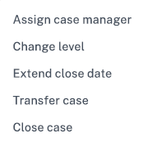
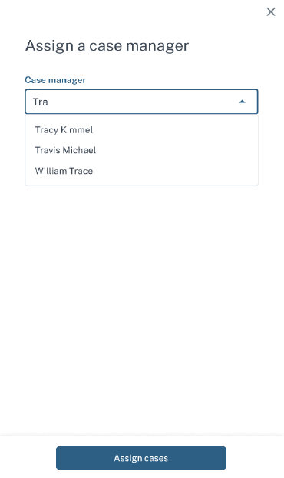
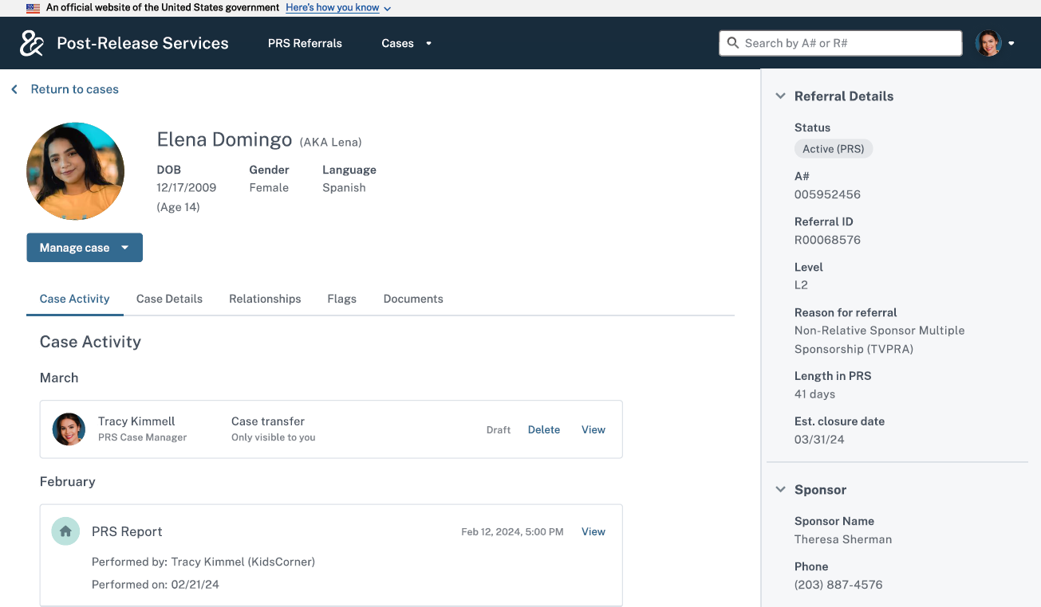
Sex

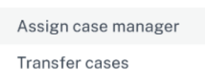
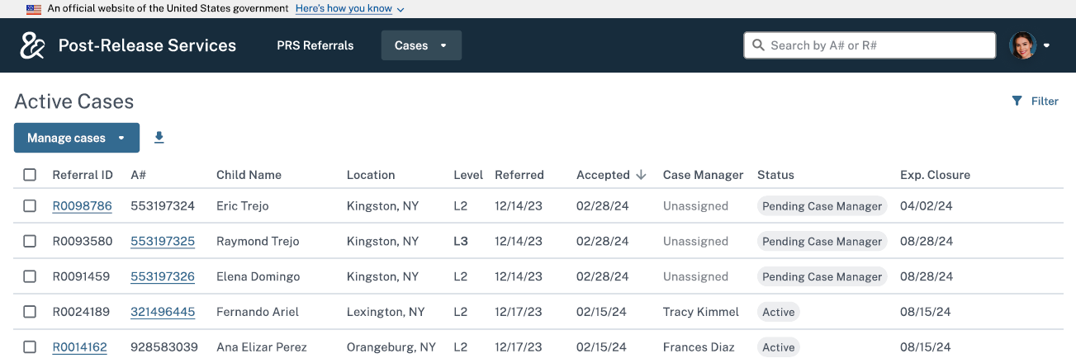
request extension
The system will generate an automated alert to inform ORR project officers that a request is ready for approval.
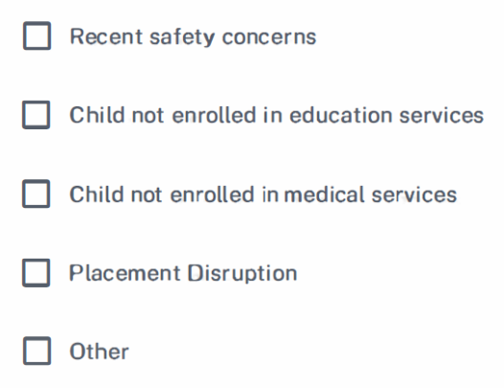
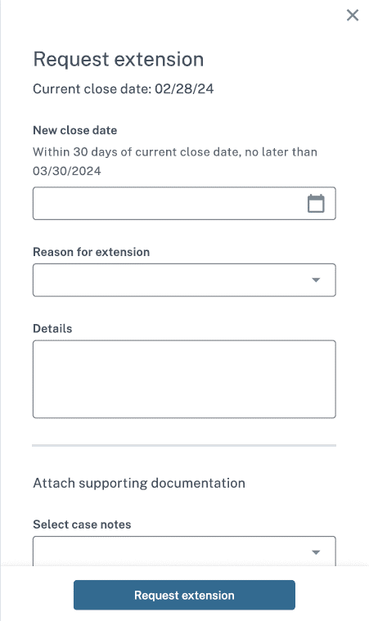
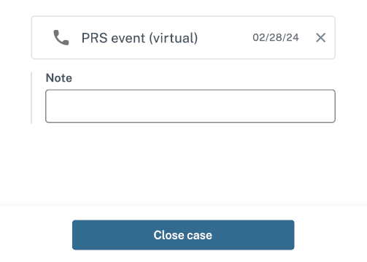
Sex
If “Other” is selected, an open text field appears for users to enter additional detail.

Optional “Note” text box appears for each document attached.

transfer case

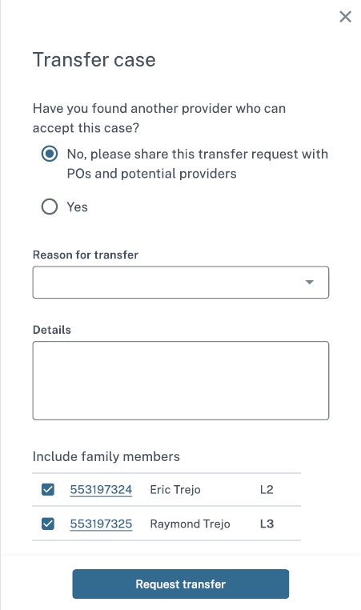
Sex
Users can automatically apply the same transfer request to multiple family members.

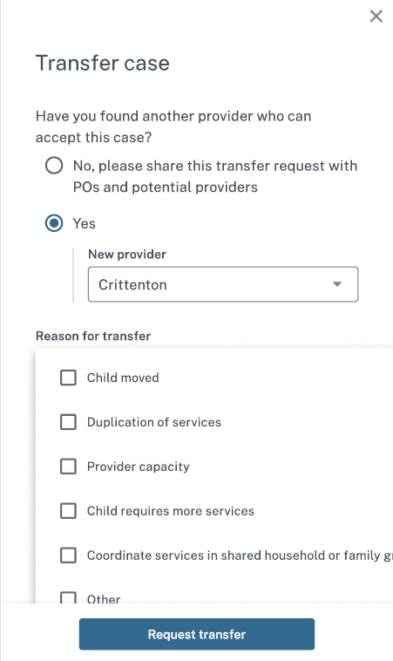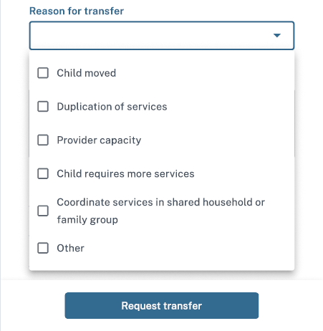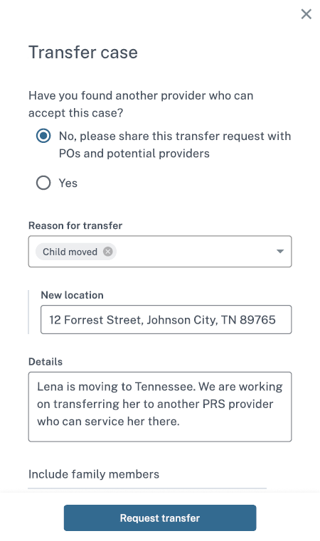
If “Yes” is selected, a searchable lookup field appears for users to select the provider.
If “Child moved” is selected as the reason for transfer, field appears for users to enter the new location.
Change PRS Level

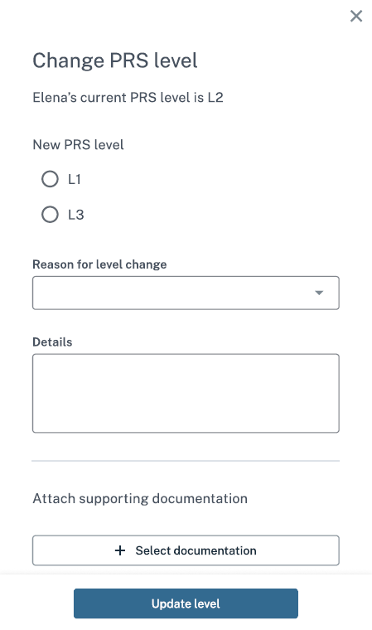

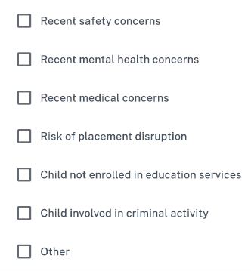
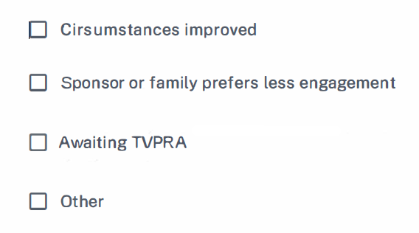
Sex
Options if level is increased:
If “Other” is selected, an open text field appears for users to enter additional detail.
Options if level is decreased:

Optional “Note” text box appears for each document attached.

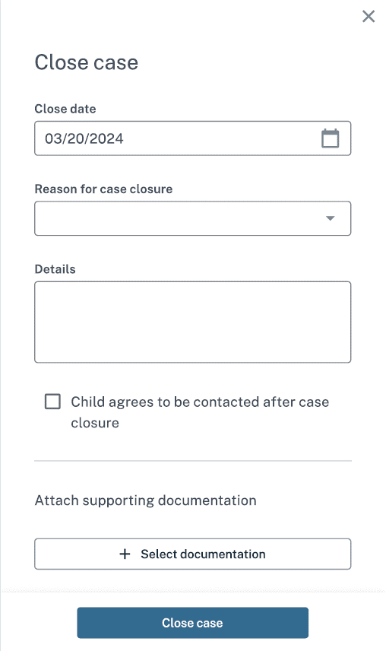
Close Case

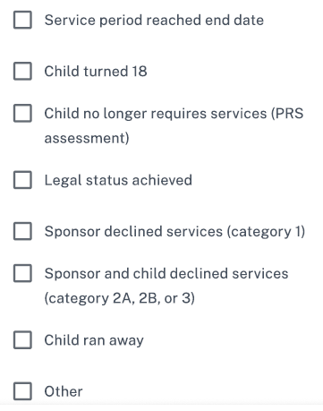
Sex
Optional “Note” text box appears for each document attached.
If “Other” is selected, an open text field appears for users to enter additional detail.

