**NOTE**: The information displayed in this document is fake and does not belong to an actual person.

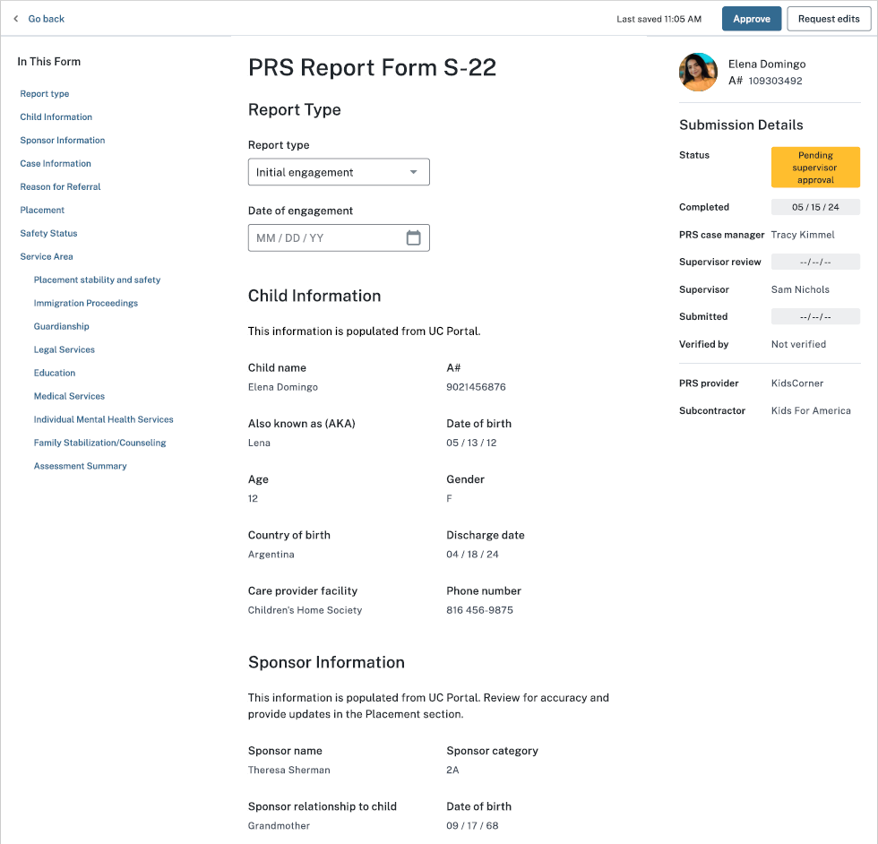

UAC

UAC

Sex

**Options:**

Initial engagement

Ongoing engagement

Closing engagement

THE PAPERWORK REDUCTION ACT OF 1995 (Pub. L. 104-13) STATEMENT OF PUBLIC BURDEN: The purpose of this information collection is to allow post-release service caseworkers to document referrals made and services provided at critical junctures of service provision, such as 14 day, 6 month, 12 month, and closure. Public reporting burden for this collection of information is estimated to average 1.08 hours per response, including the time for reviewing instructions, gathering, and maintaining the data needed, and reviewing the collection of information. This is a mandatory collection of information (Homeland Security Act, 6 U.S.C. 279, and Trafficking Victims Protection Reauthorization Act, 8 U.S.C. 1232). An agency may not conduct or sponsor, and a person is not required to respond to, a collection of information subject to the requirements of the Paperwork Reduction Act of 1995, unless it displays a currently valid OMB control number. If you have any comments on this collection of information, please contact [UACPolicy@acf.hhs.gov.](mailto:UACPolicy@acf.hhs.gov.)

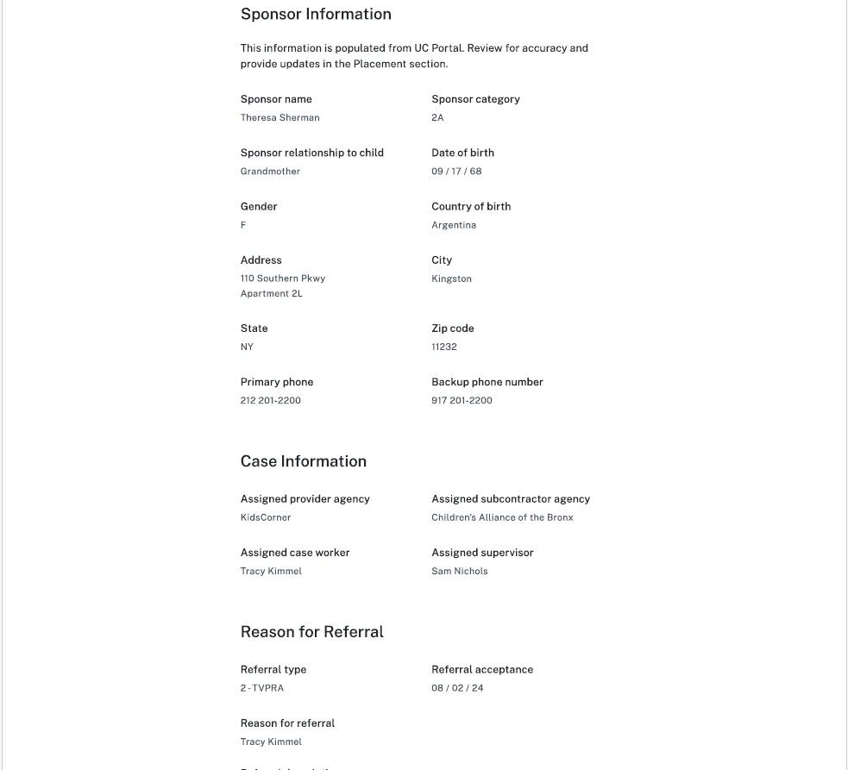

Sex



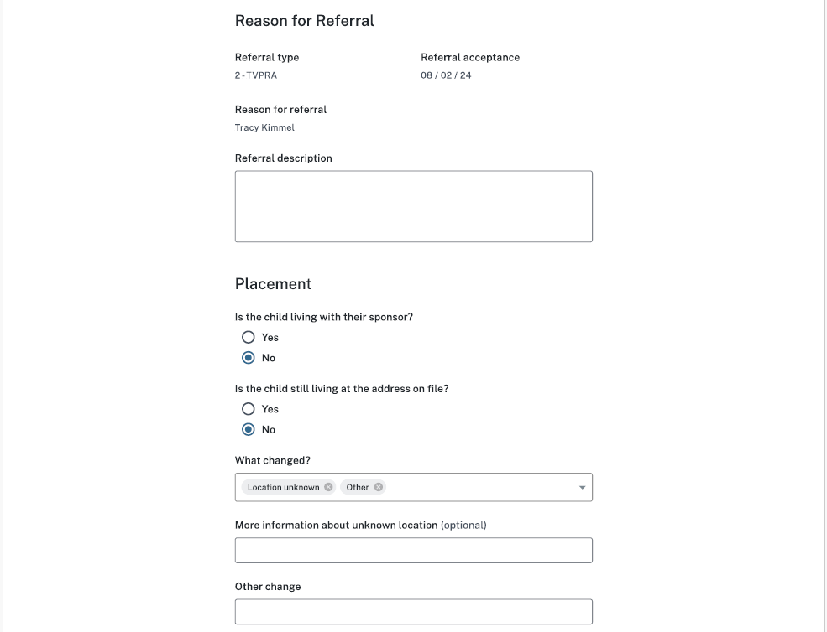

**Options:**

With alternate caregiver (ACG) or non-sponsor

Living independently

Known runaway

Returned to home country

Location unknown

Other

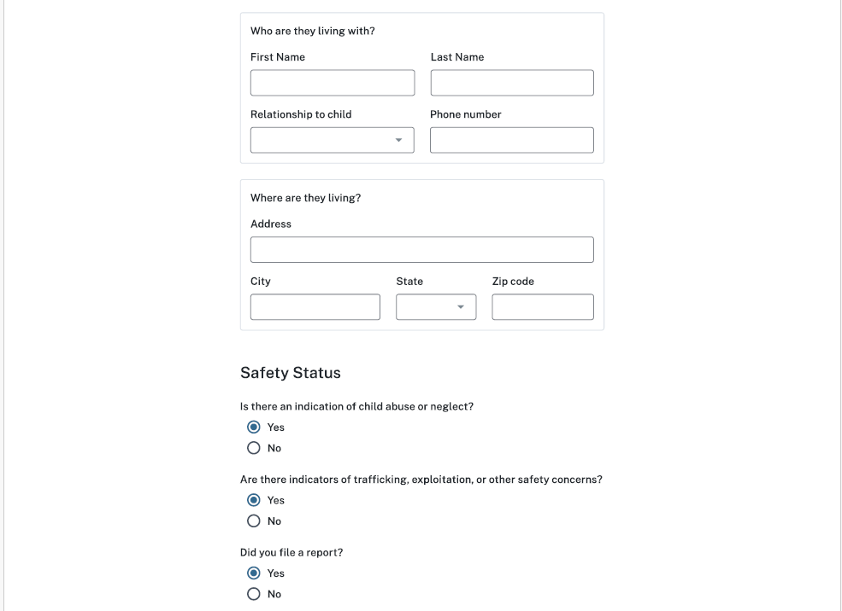



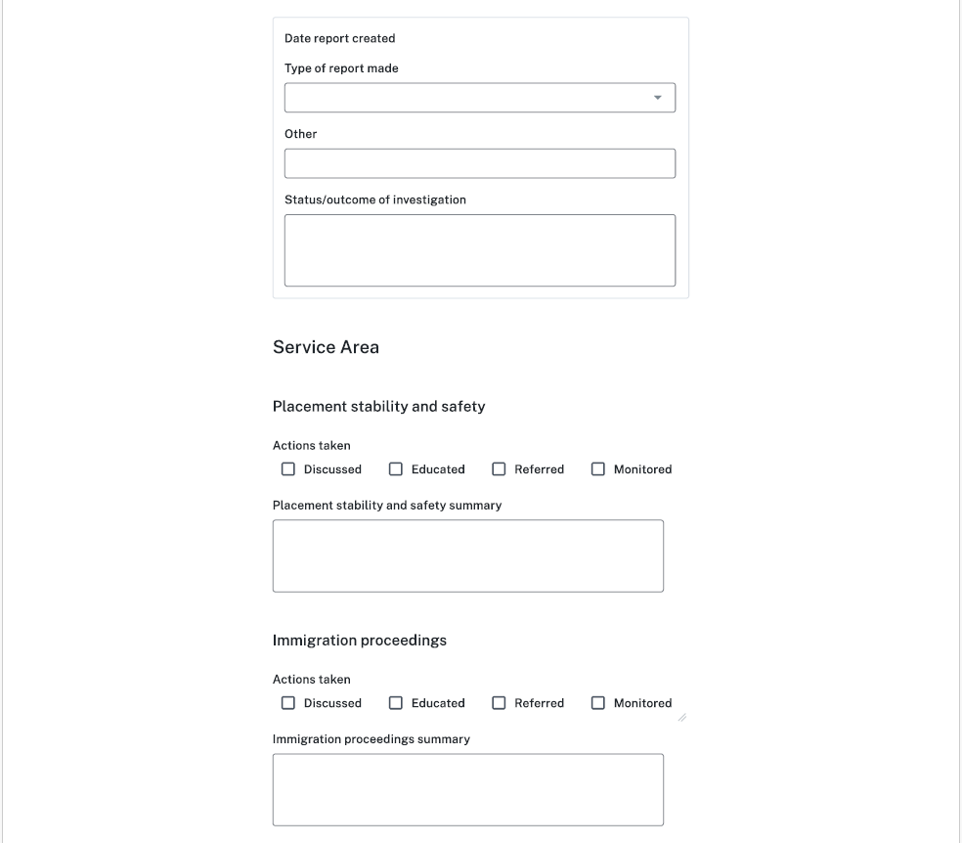

**Options:**

Law enforcement

Child Protective Services

Office of Trafficking in Persons

Other

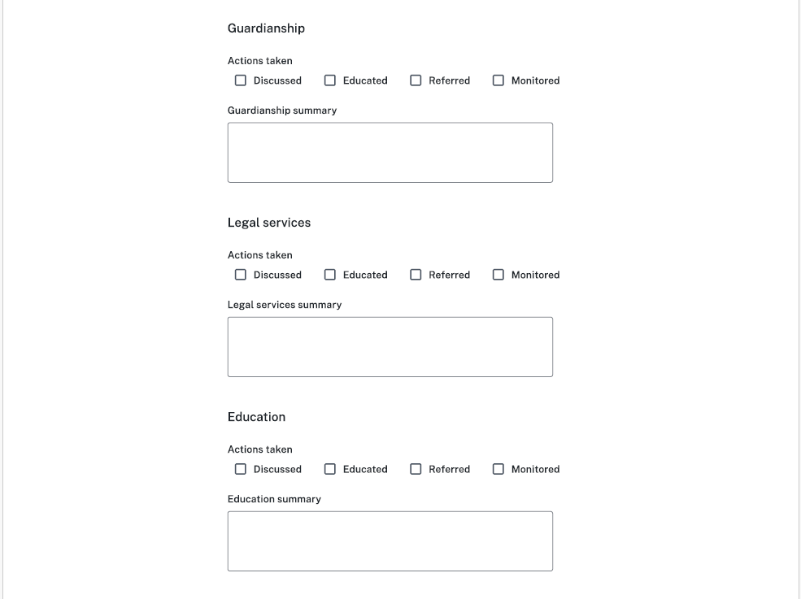



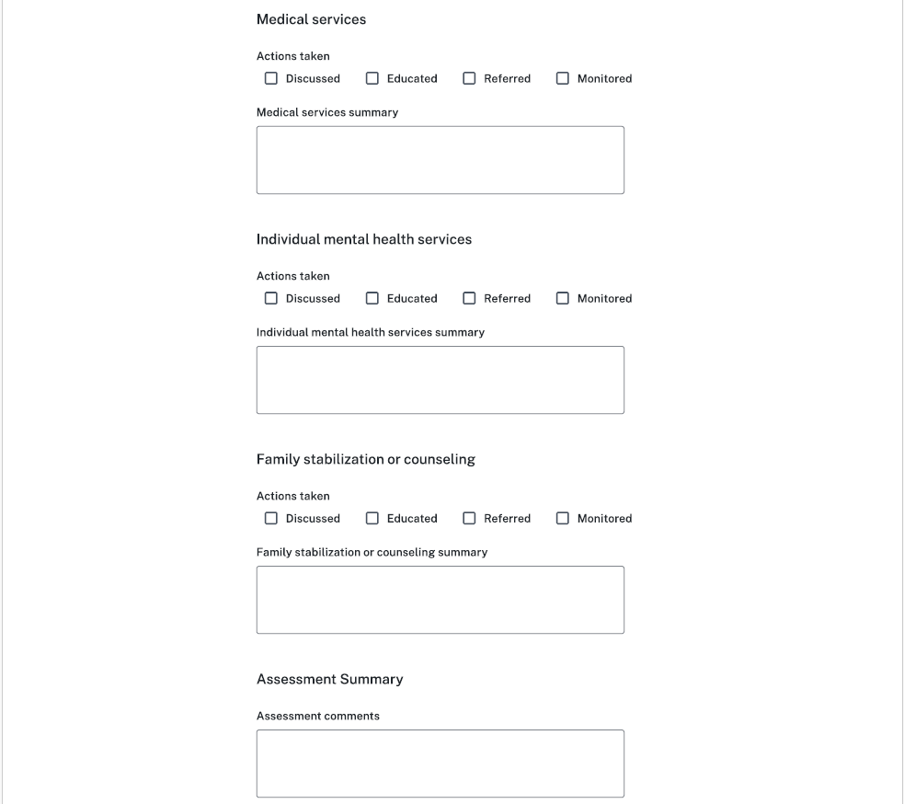



Trafficking Victims Assistance Program

Other services

Trafficking Victims Assistance Program summary

Substance abuse summary

Substance abuse



Other services summary