NOTE: The information displayed in this document is fake and does not belong to actual people.

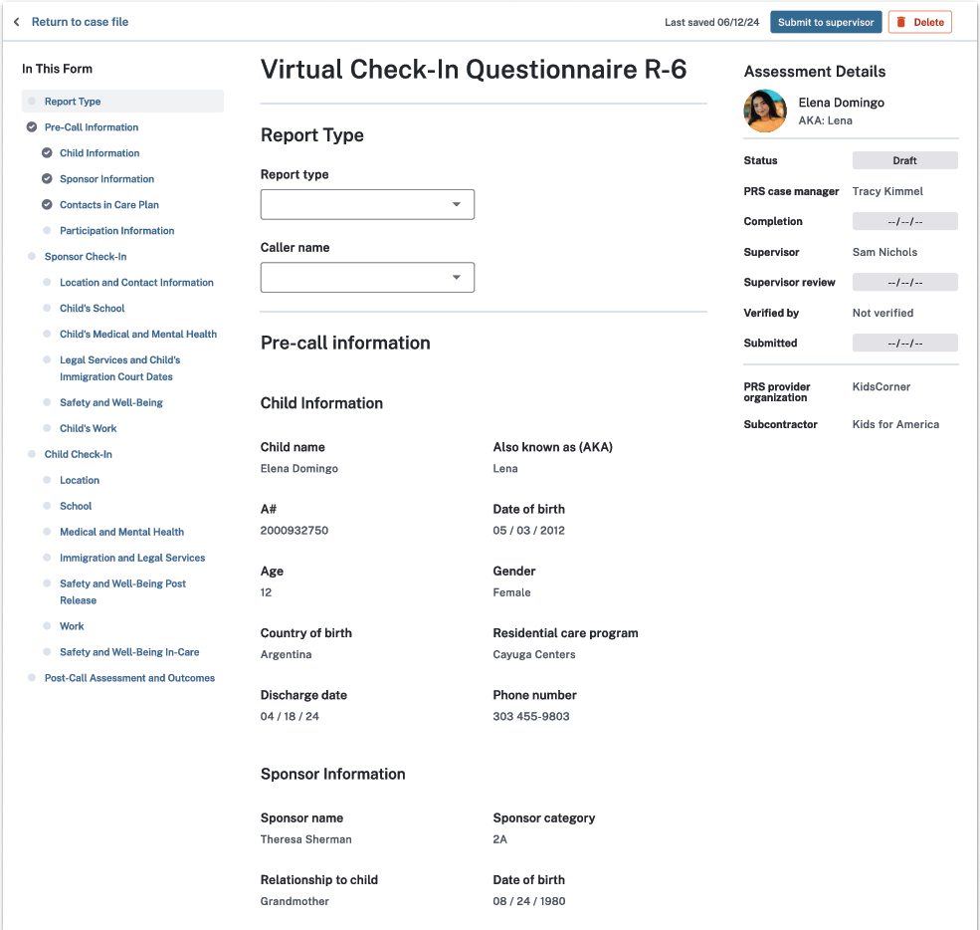

Sex

**Options:**

7-Day Virtual Check-In

14-Day Virtual Check-In

30-Day Virtual Check-In

**THE PAPERWORK REDUCTION ACT OF 1995 (Pub. L. 104-13) STATEMENT OF PUBLIC BURDEN: The purpose of this information collection is to allow care provider facilities to document the outcome of calls made to unaccompanied alien children and their sponsors after release to ensure the child is safe and refer the sponsor to additional resources as needed. Public reporting burden for this collection of information is estimated to average 0.25 hours per sponsor and child response, and 0.58 hours per response for care providers, including the time for reviewing instructions, gathering, and maintaining the data needed, and reviewing the collection of information. This is a mandatory collection of information (Homeland Security Act, 6 U.S.C. 279, and Trafficking Victims Protection Reauthorization Act, 8 U.S.C. 1232). An agency may not conduct or sponsor, and a person is not required to respond to, a collection of information subject to the requirements of the Paperwork Reduction Act of 1995, unless it displays a currently valid OMB control number. If you have any comments on this collection of information, please contact** [**UACPolicy@acf.hhs.gov.**](mailto:UACPolicy@acf.hhs.gov.)

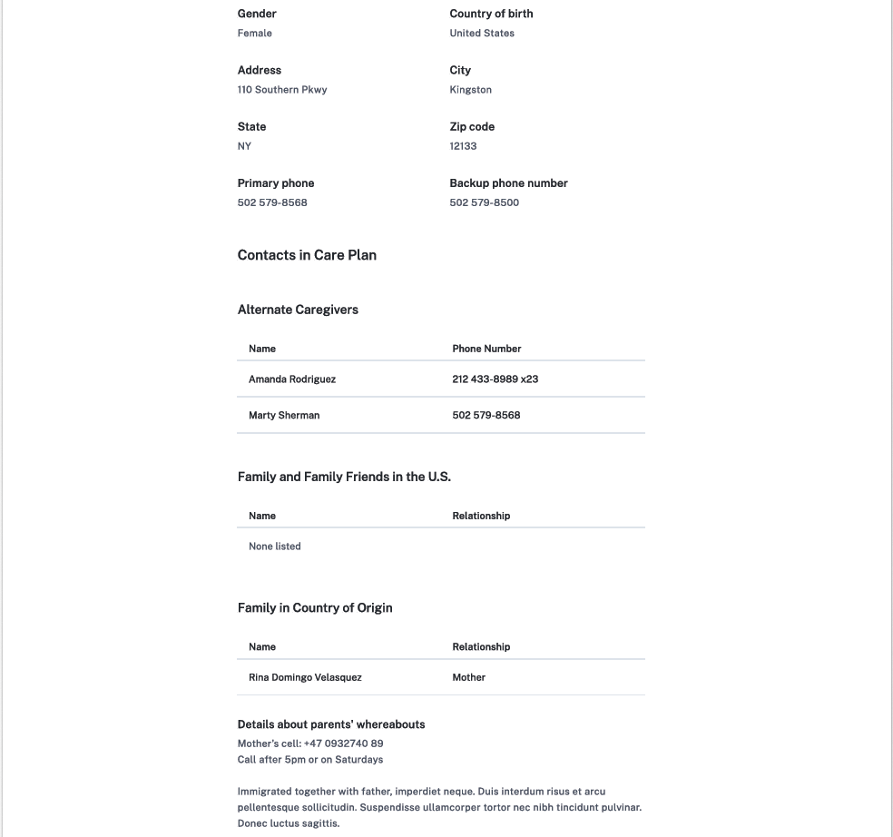



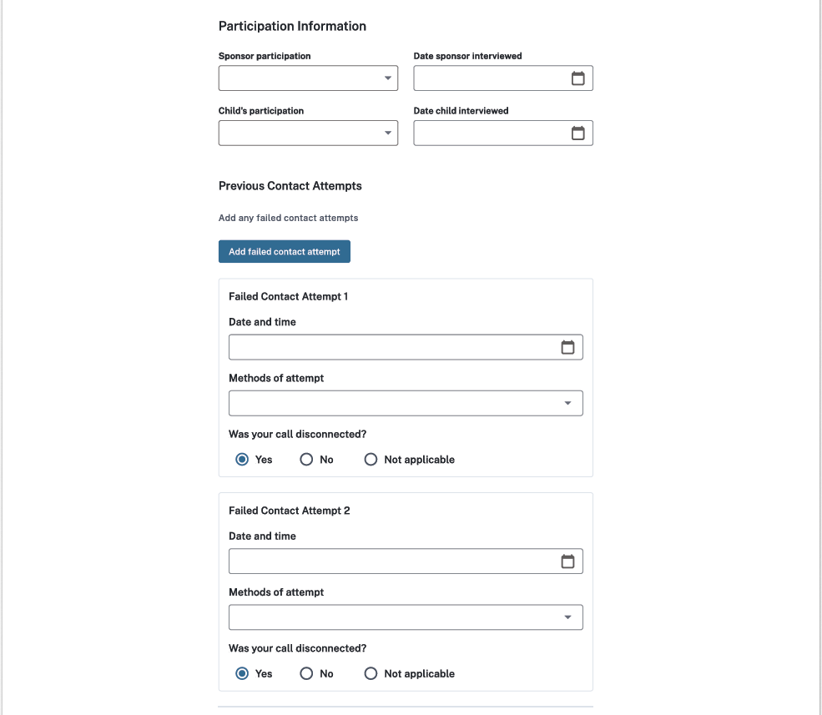

**Options:**

Called child and sponsor’s primary phone

Called child and sponsor's backup phone

Called number(s) in care plan

Called number(s) in home country

Sent WhatsApp or text message

Sent email

Sent letter

In-person visit

Other

**Options:**

Reached and participated alone

Reached and participated with someone else around

Reached and declined to participate

Not reached

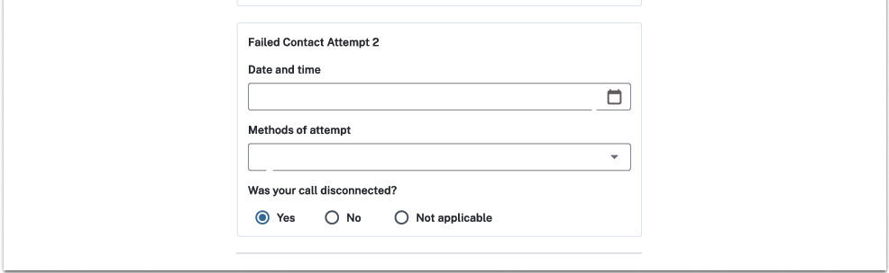

**Options:**

Called child and sponsor’s primary phone

Called child and sponsor's backup phone

Called number(s) in care plan

Called number(s) in home country

Sent WhatsApp or text message

Sent email

Sent letter

In-person visit

Other

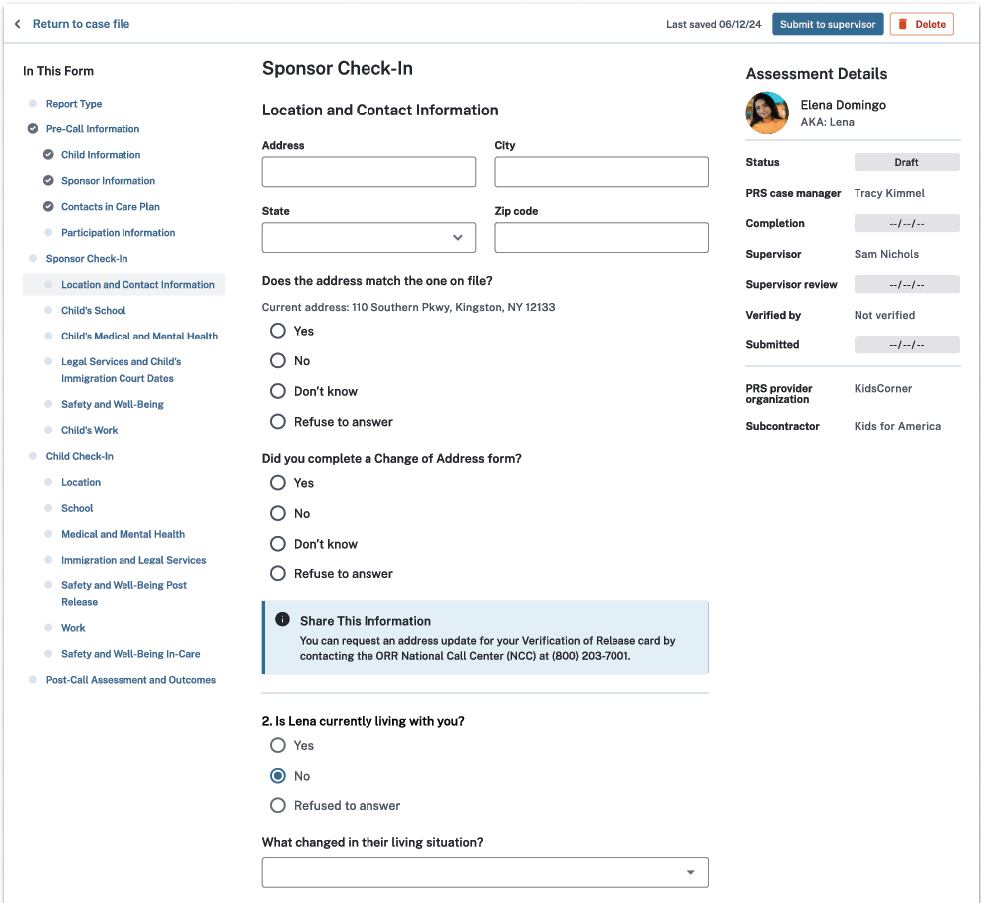

**Options:**

Living with alternate caregiver (ACG) or non-sponsor

Living independently

Known runaway

Arrested

Hospitalized

Death

Returned to home country

Location unknown

Other

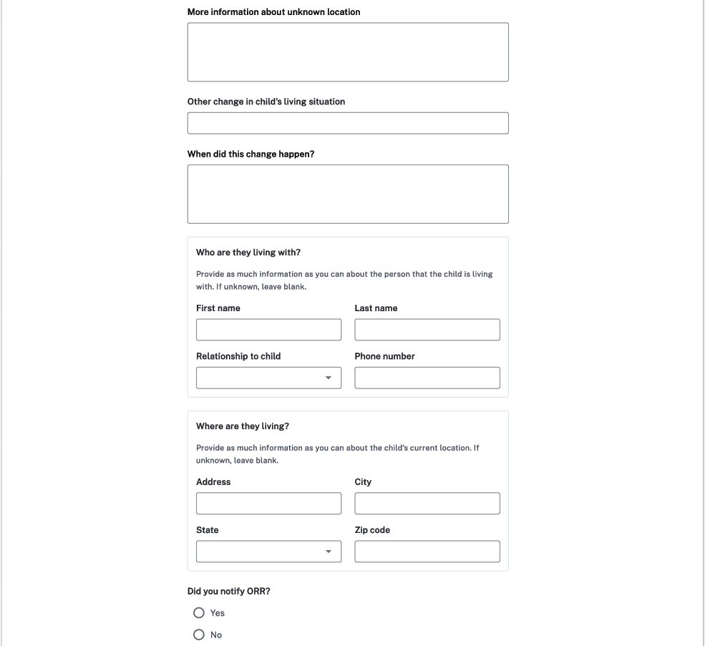

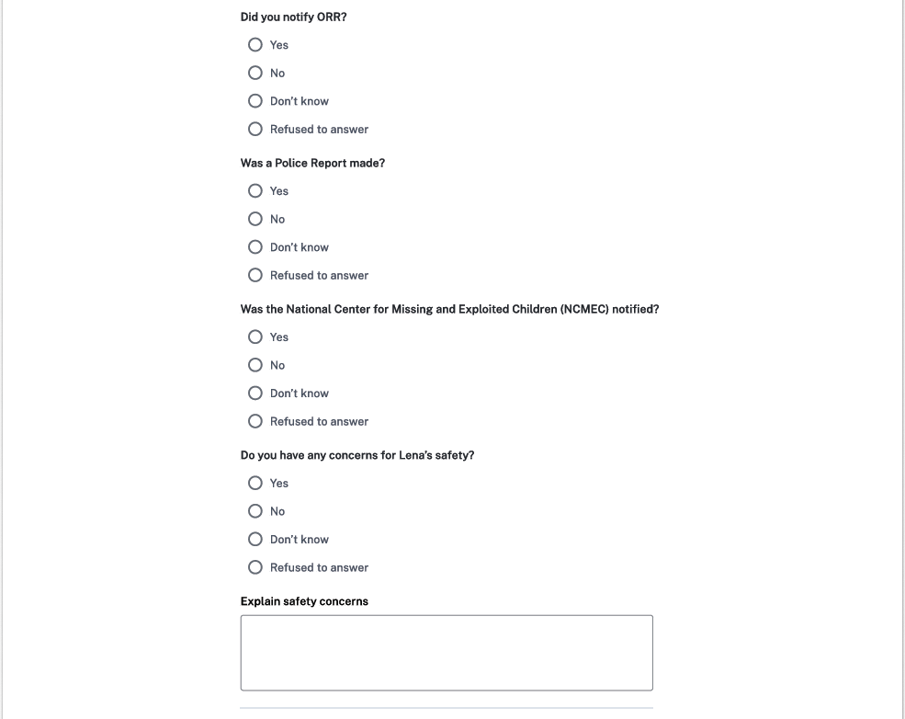



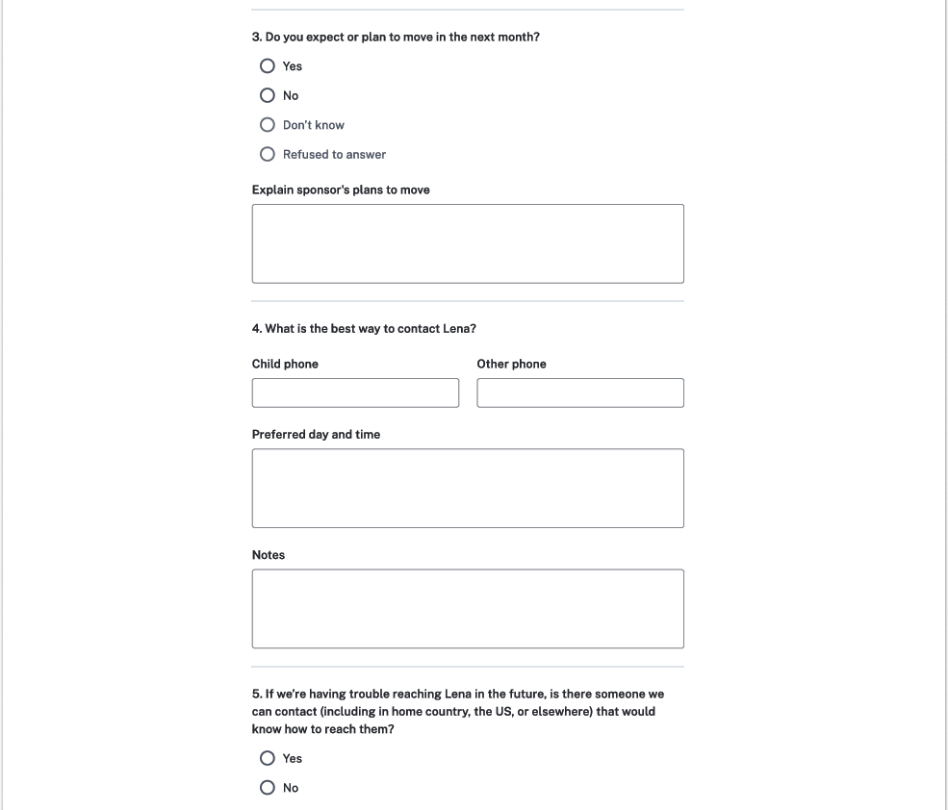

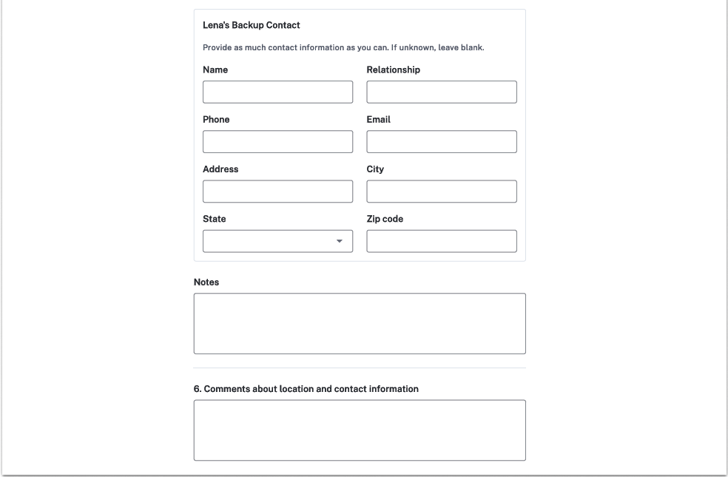

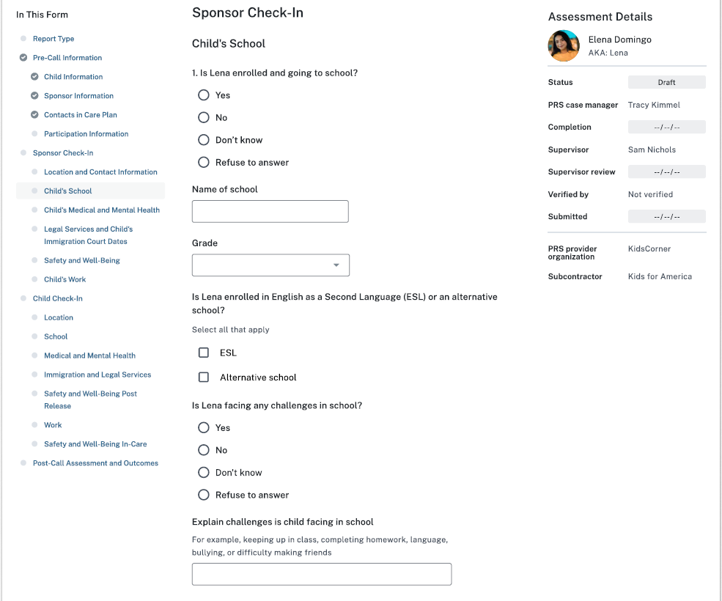

**Options:**

K, 1, 2, 3, 4, 5, 6, 7, 8, 9, 10, 11, 12, Not applicable



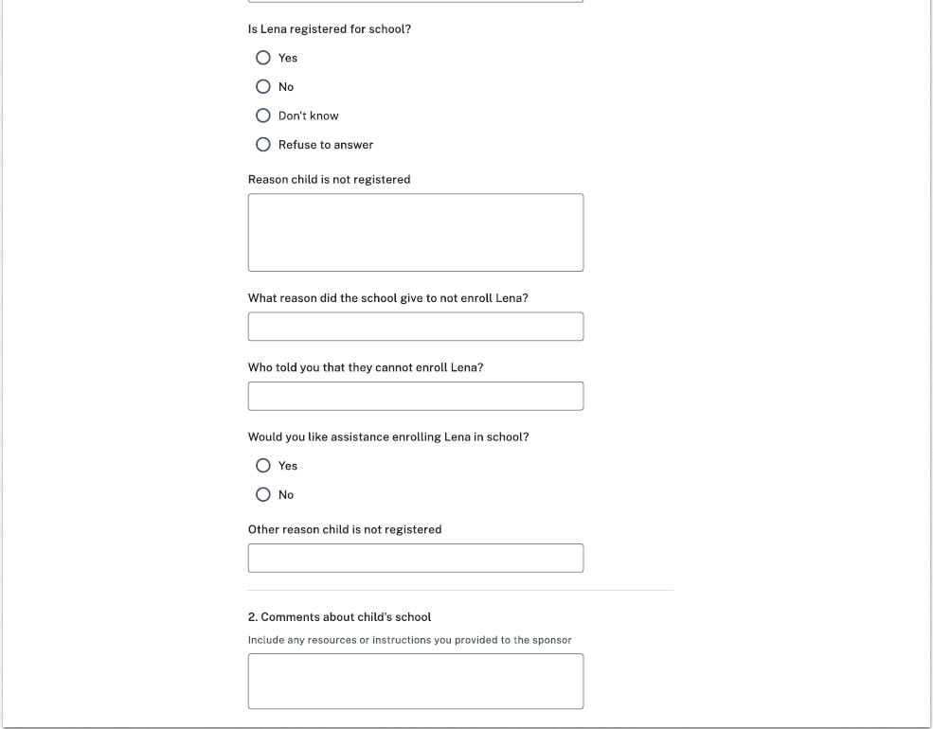

**Options:**

Immunizations

Documentation issues with identity or residency

Not planning on registering

Not of compulsory school age

Not interested or willing to attend

Transportation Issues

School not in session or summer break

School is resistant to enroll the child

Other

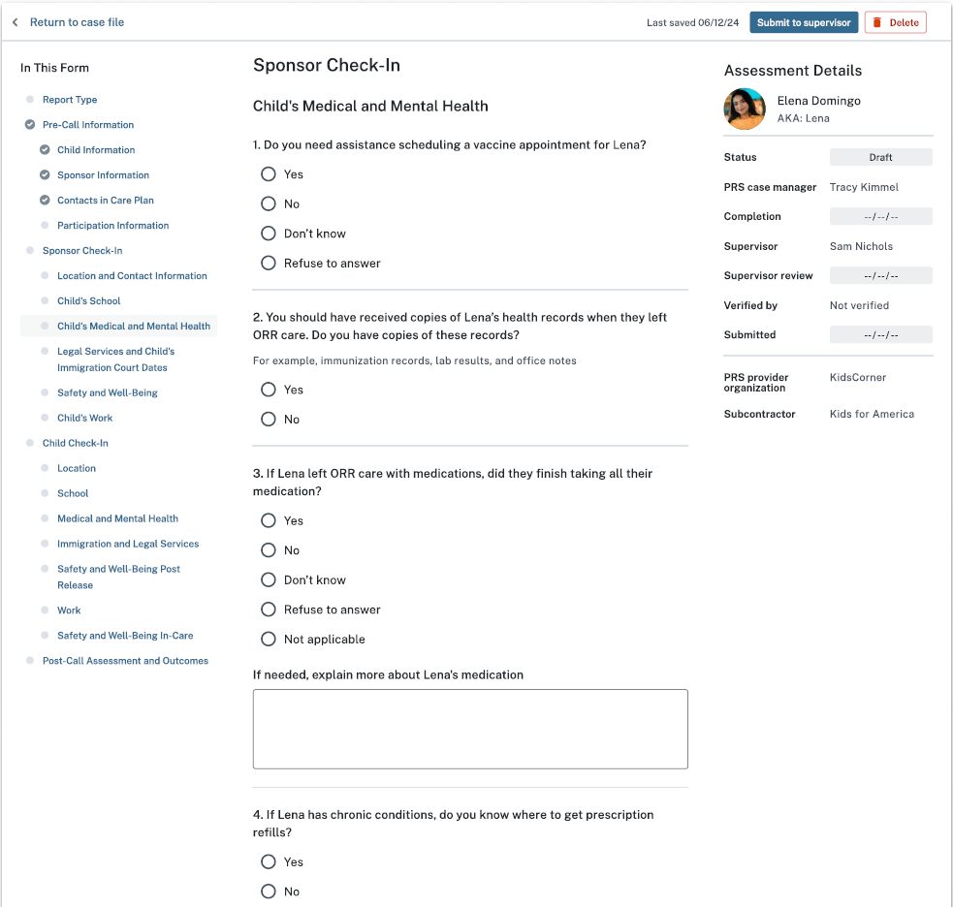

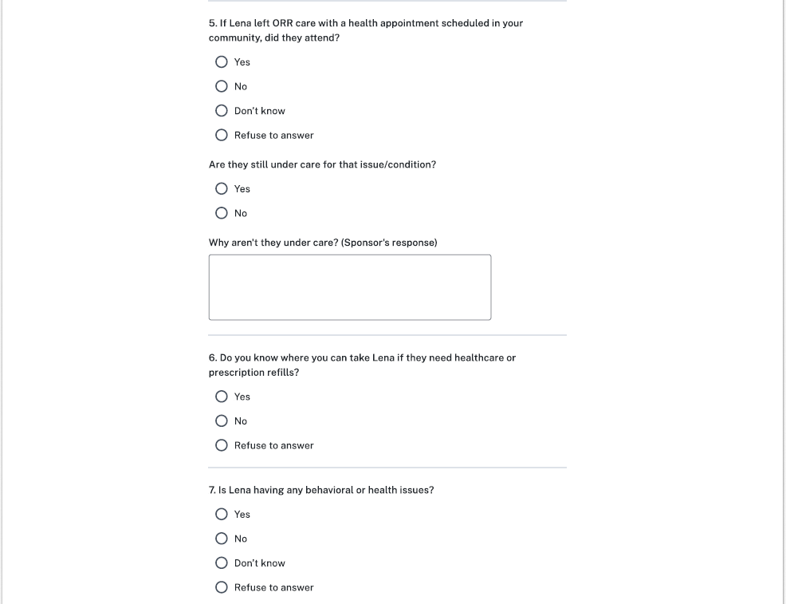



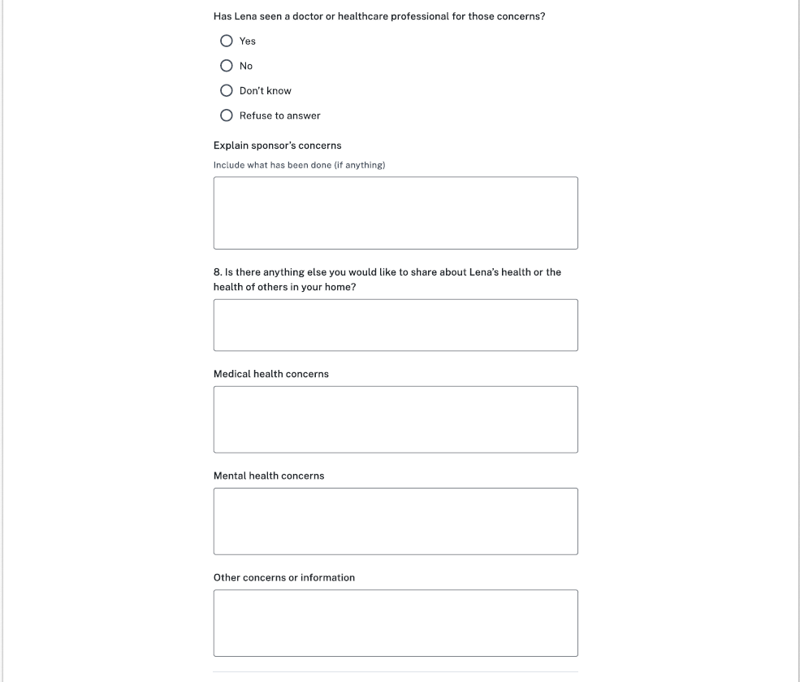

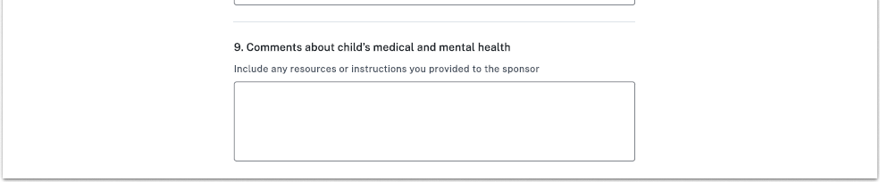

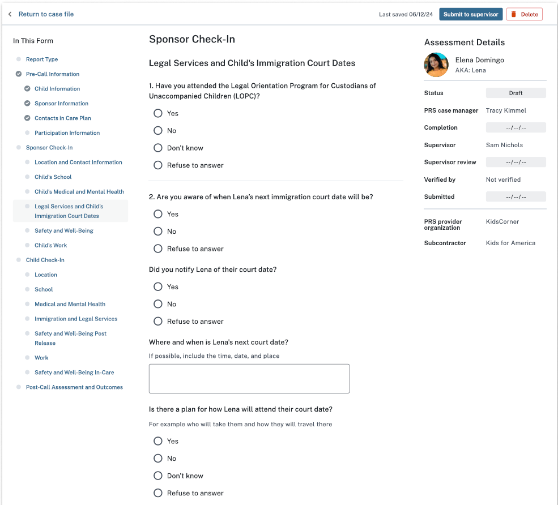

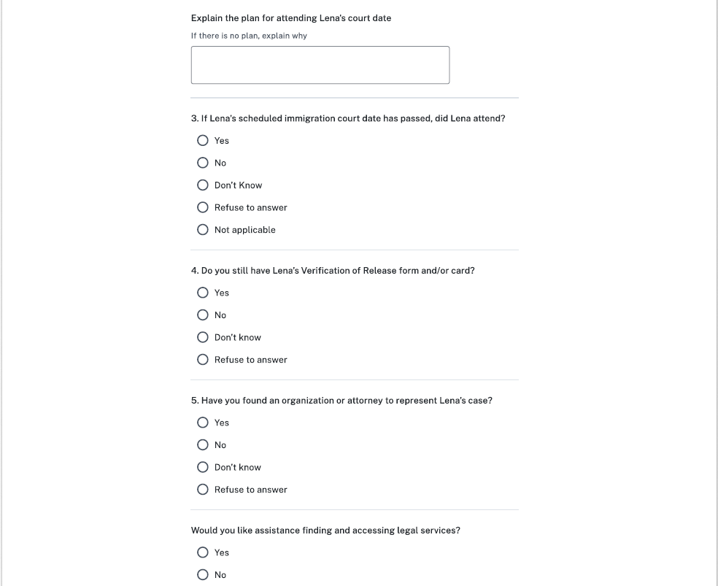



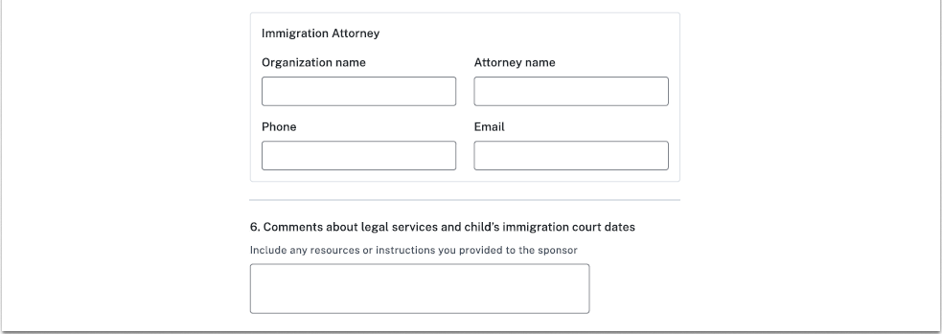

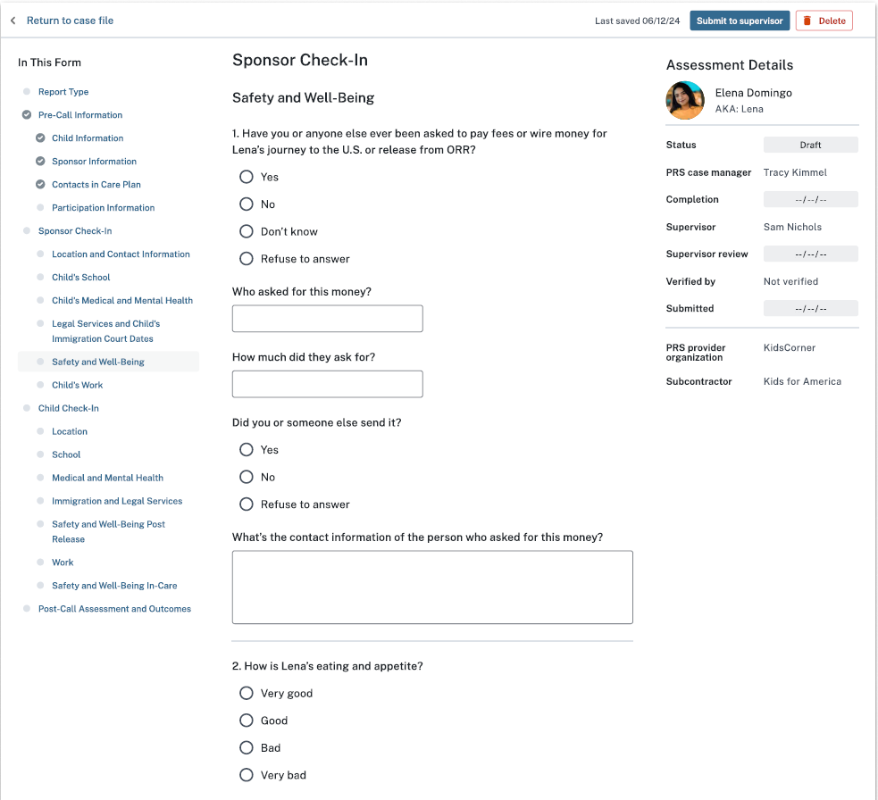

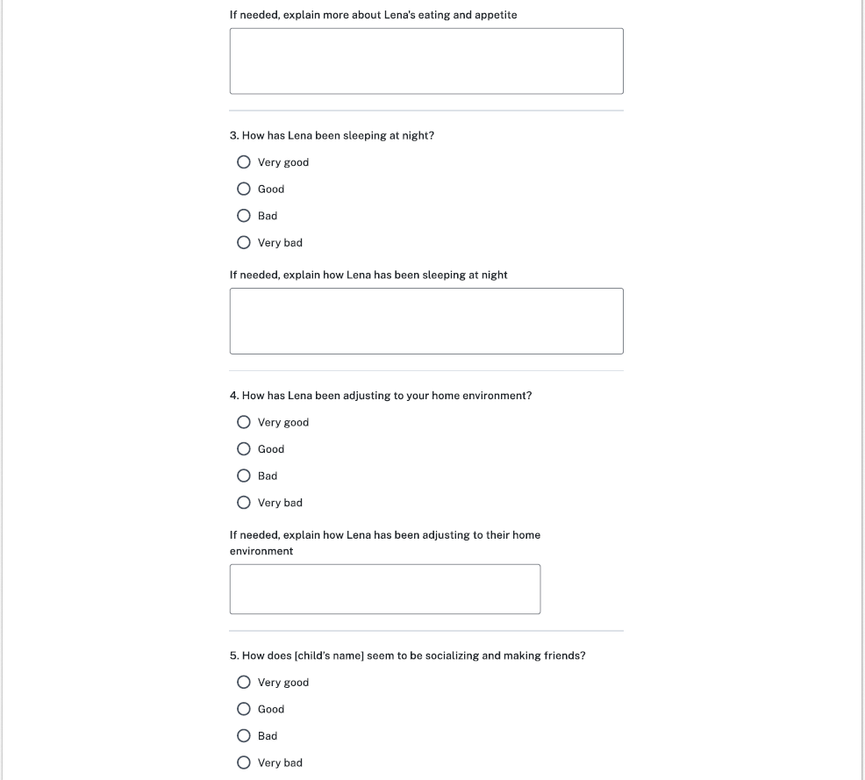



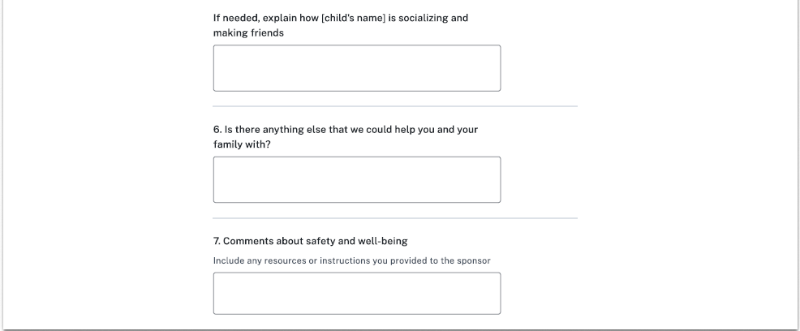

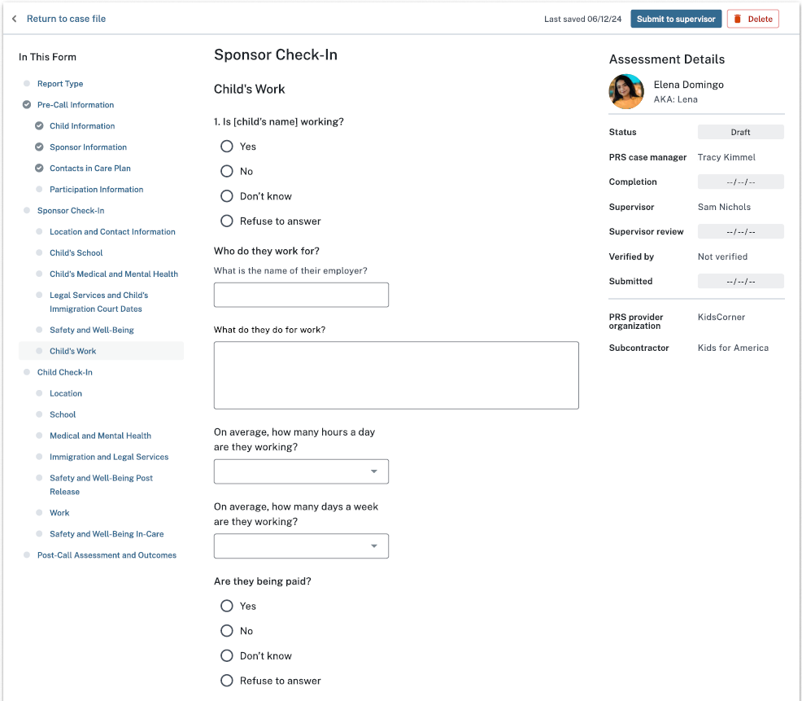



**Options:** [1-7]

**Options:** [1-24]

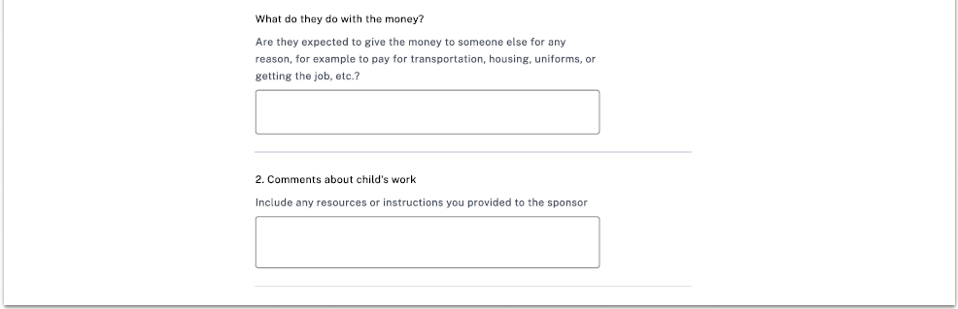

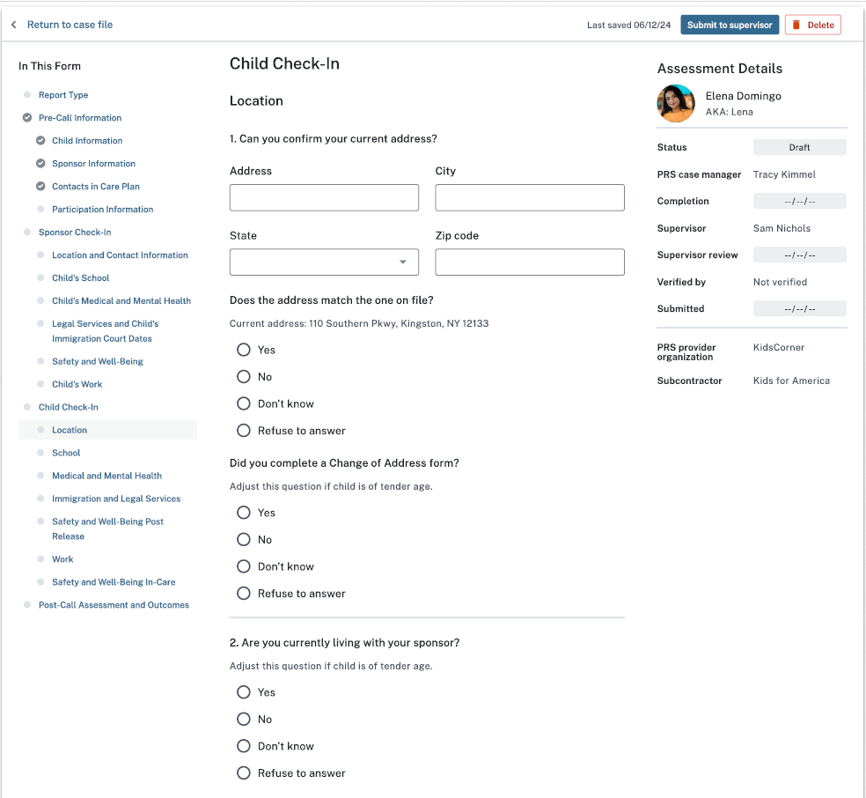



**Options:**

Living with alternate caregiver (ACG) or non-sponsor

Living independently

Location unknown

Other

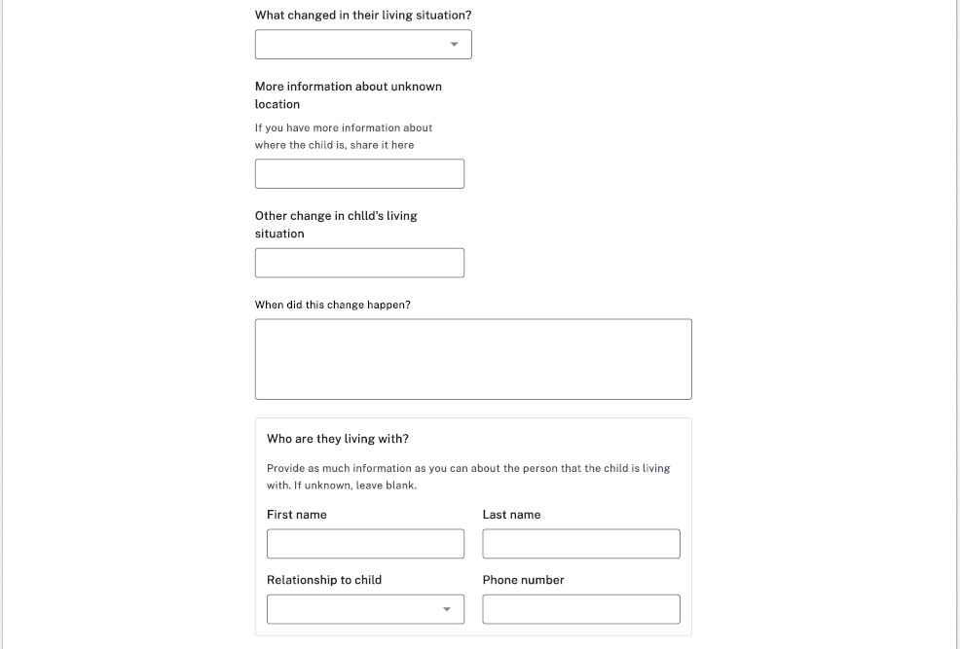

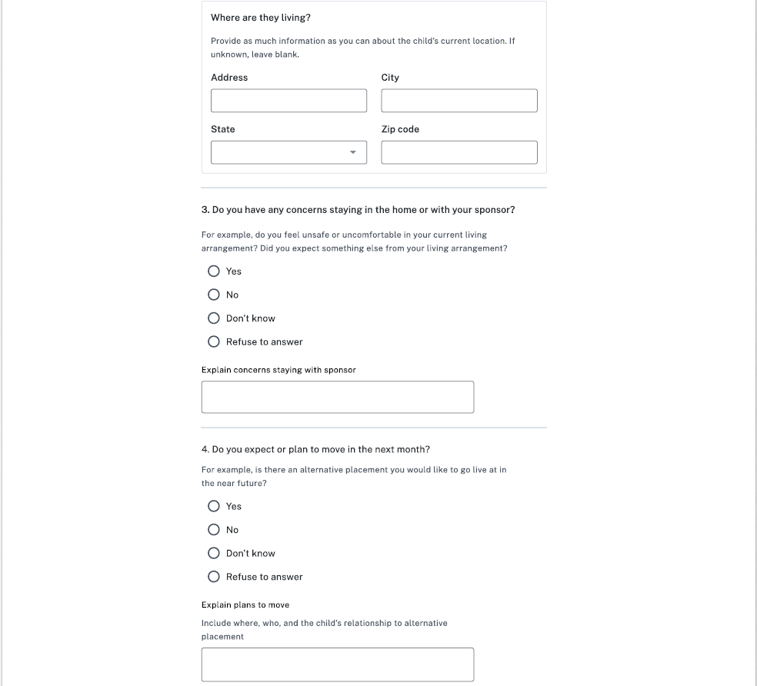

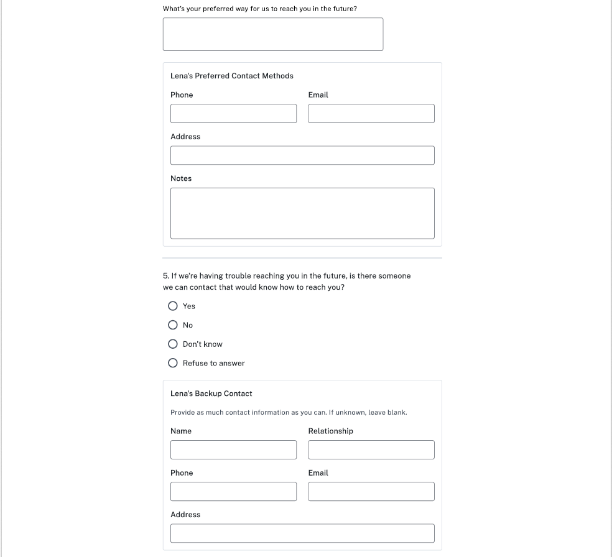



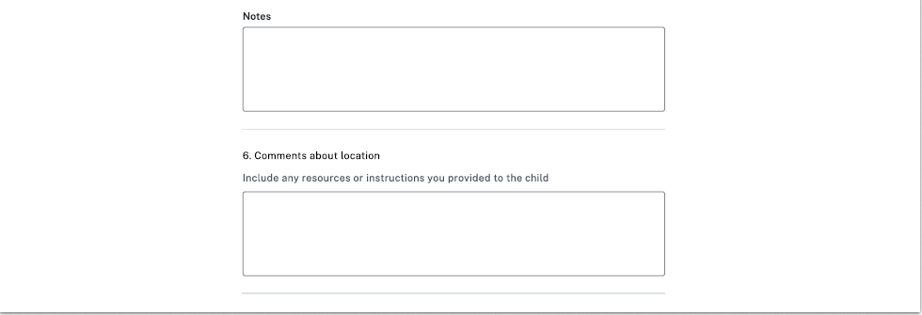

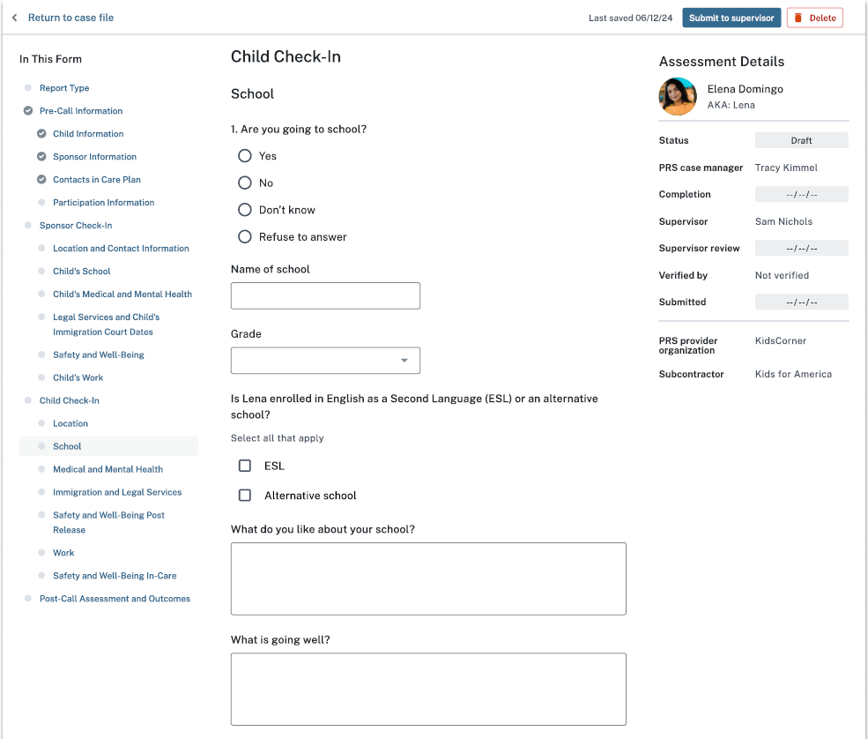

**Options:**

K, 1, 2, 3, 4, 5, 6, 7, 8, 9, 10, 11, 12, Not applicable



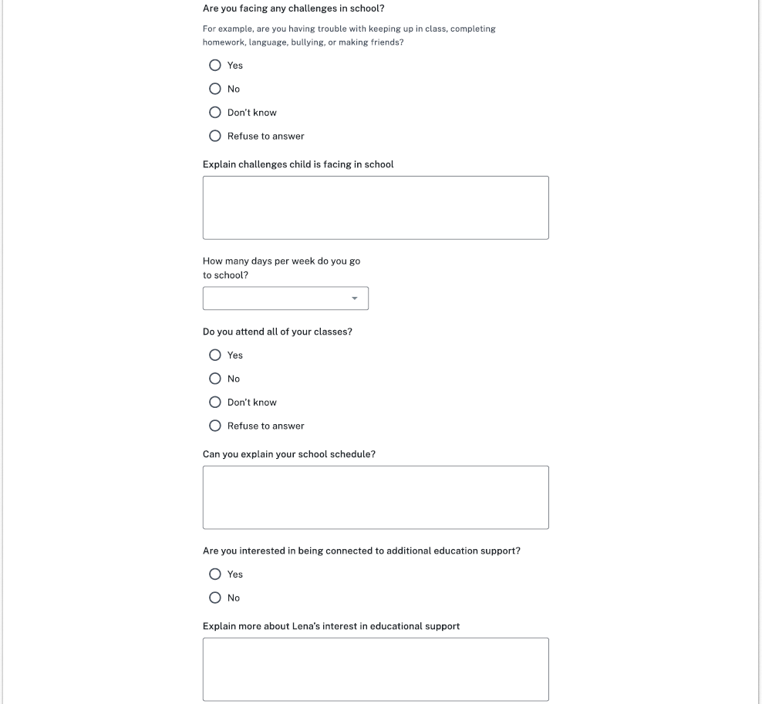

**Options:** [1-7]

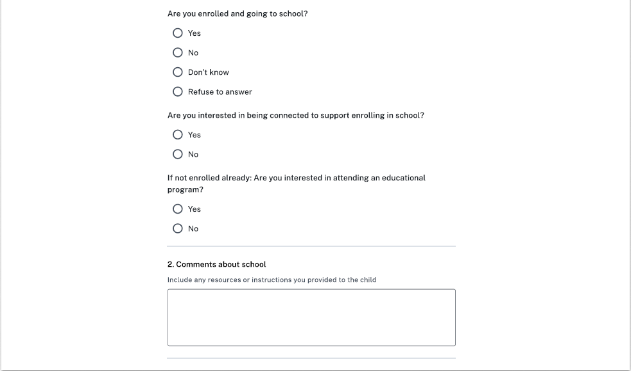

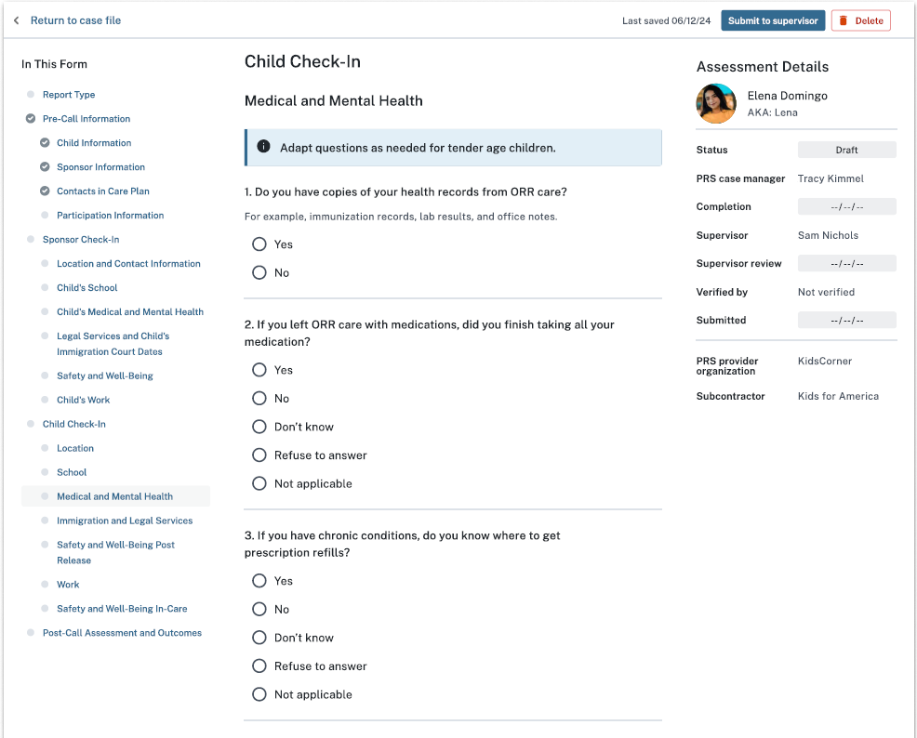



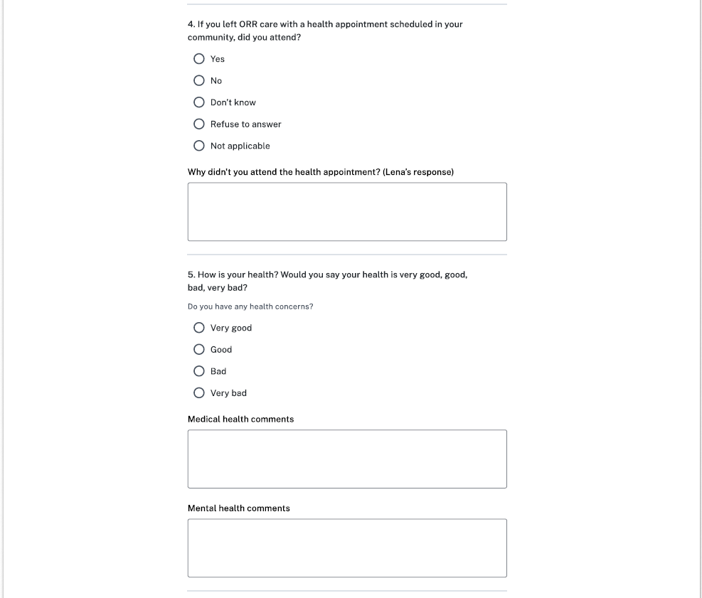

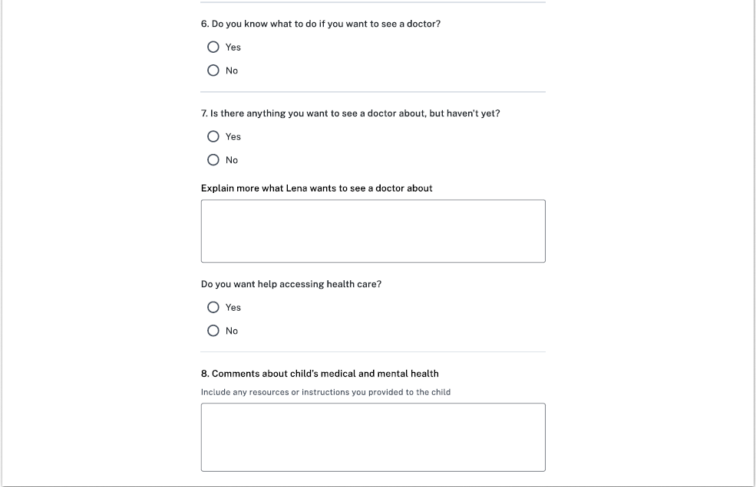



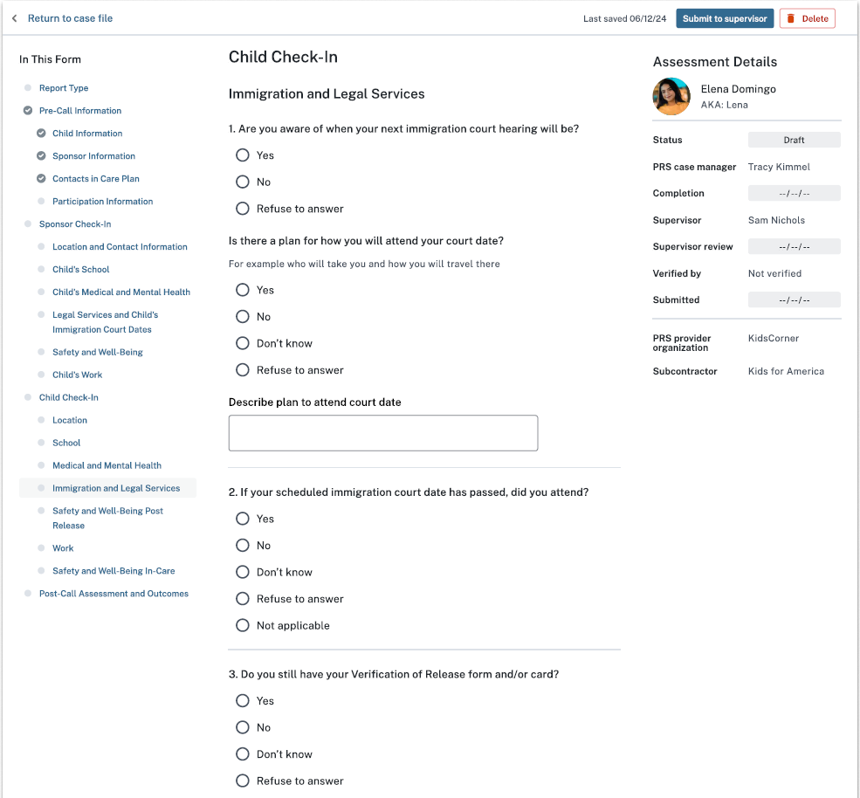



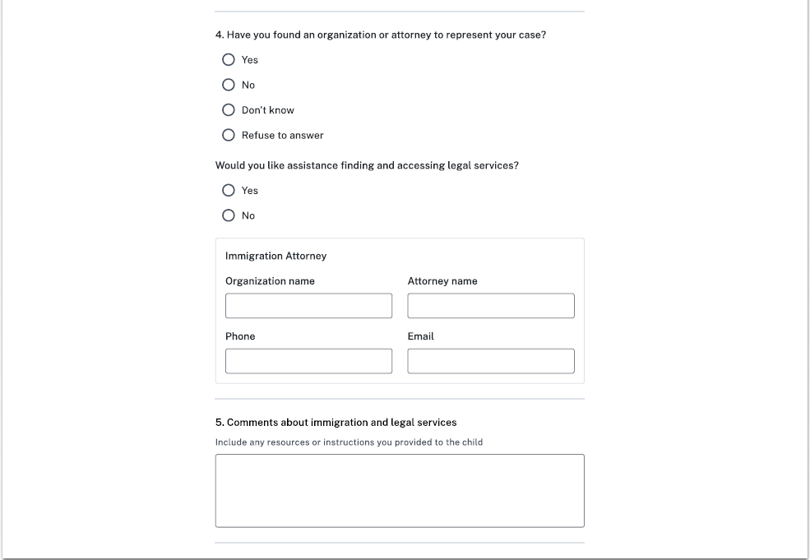

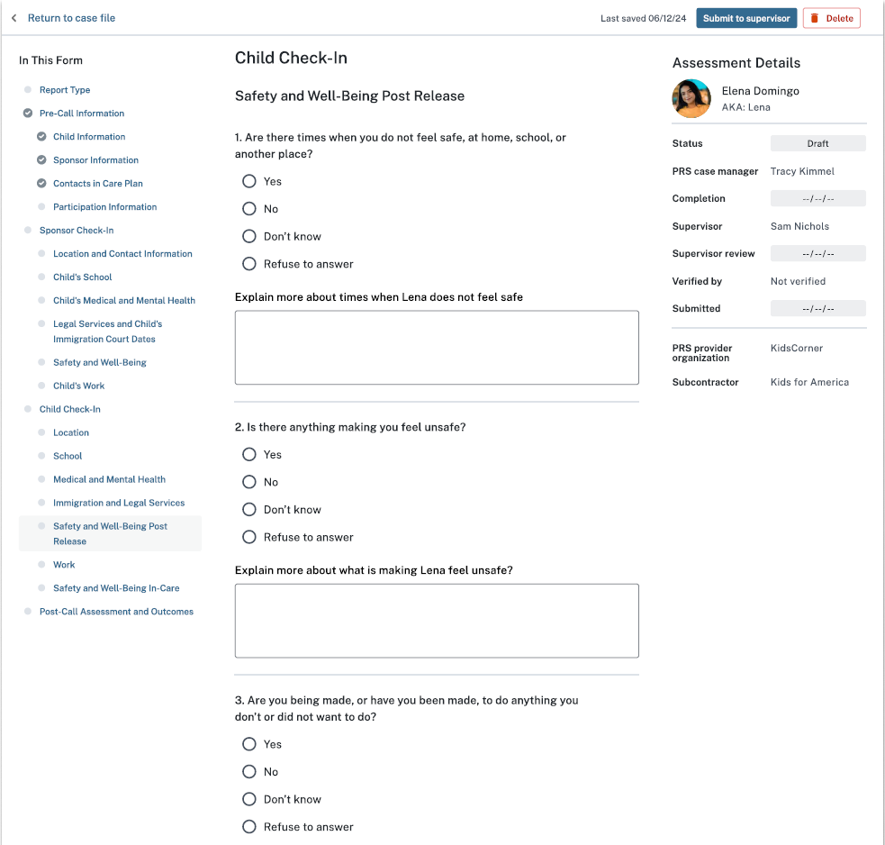



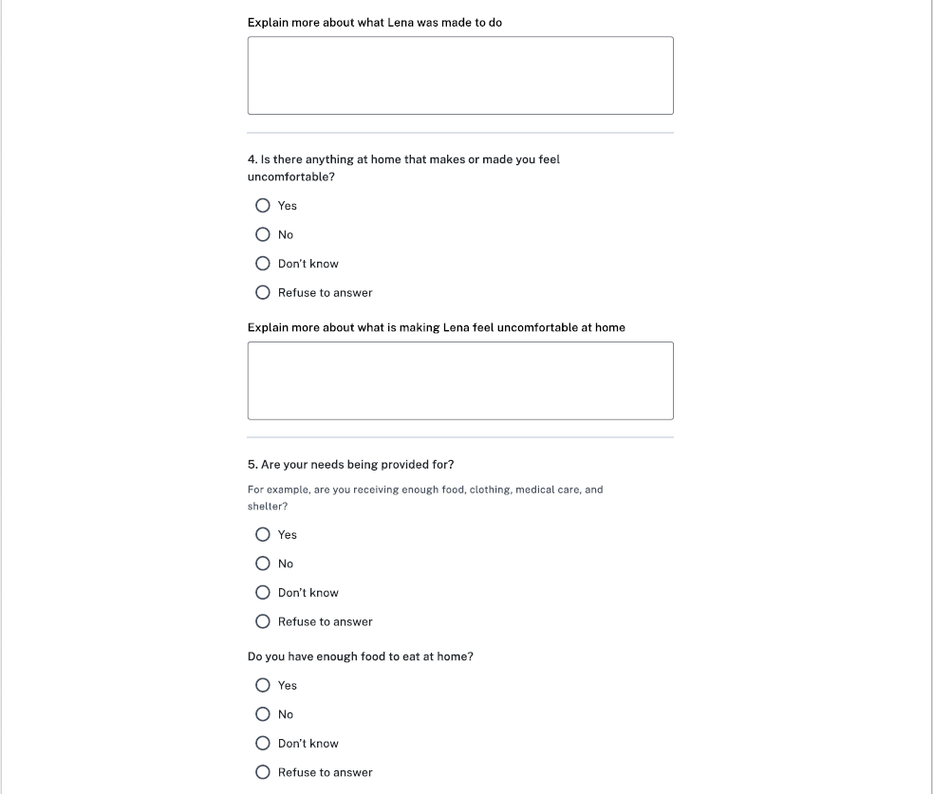



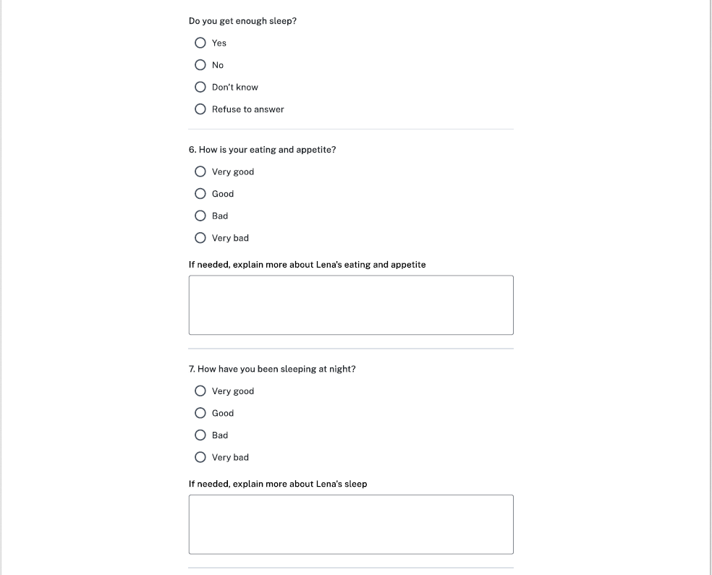

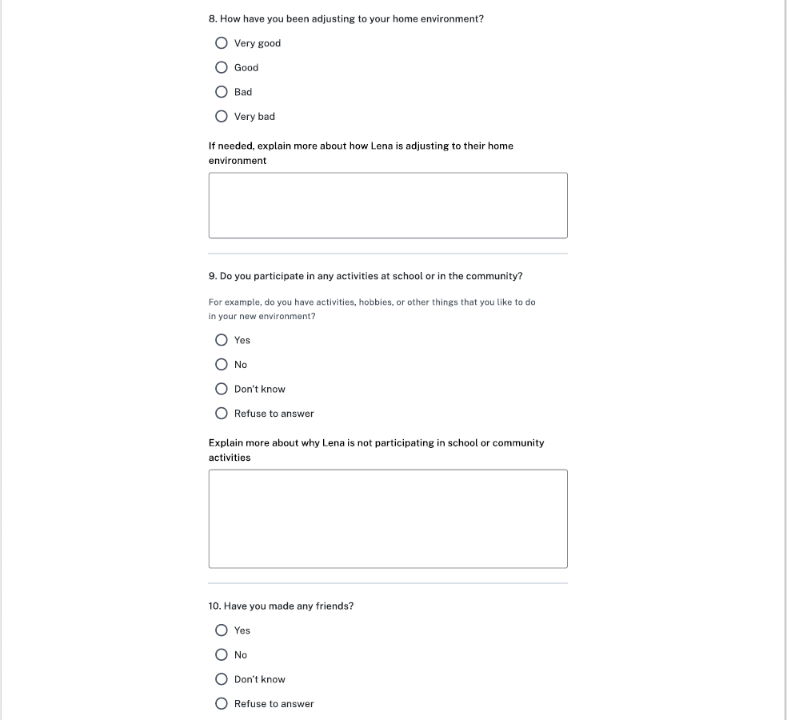



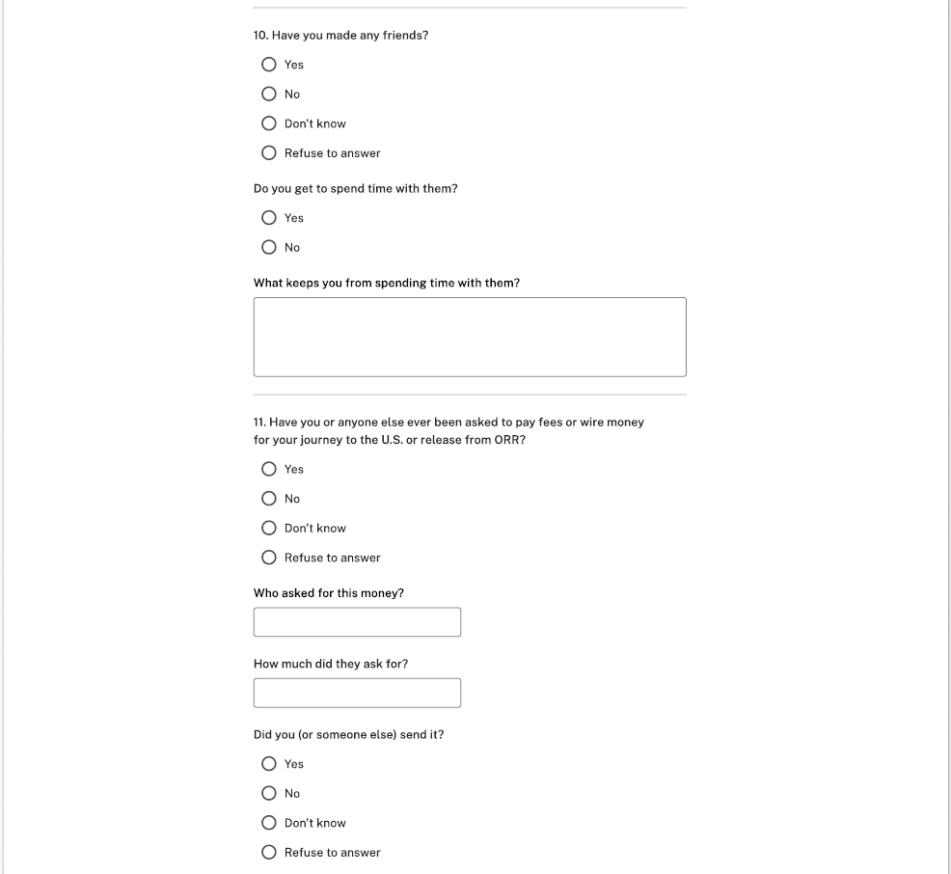

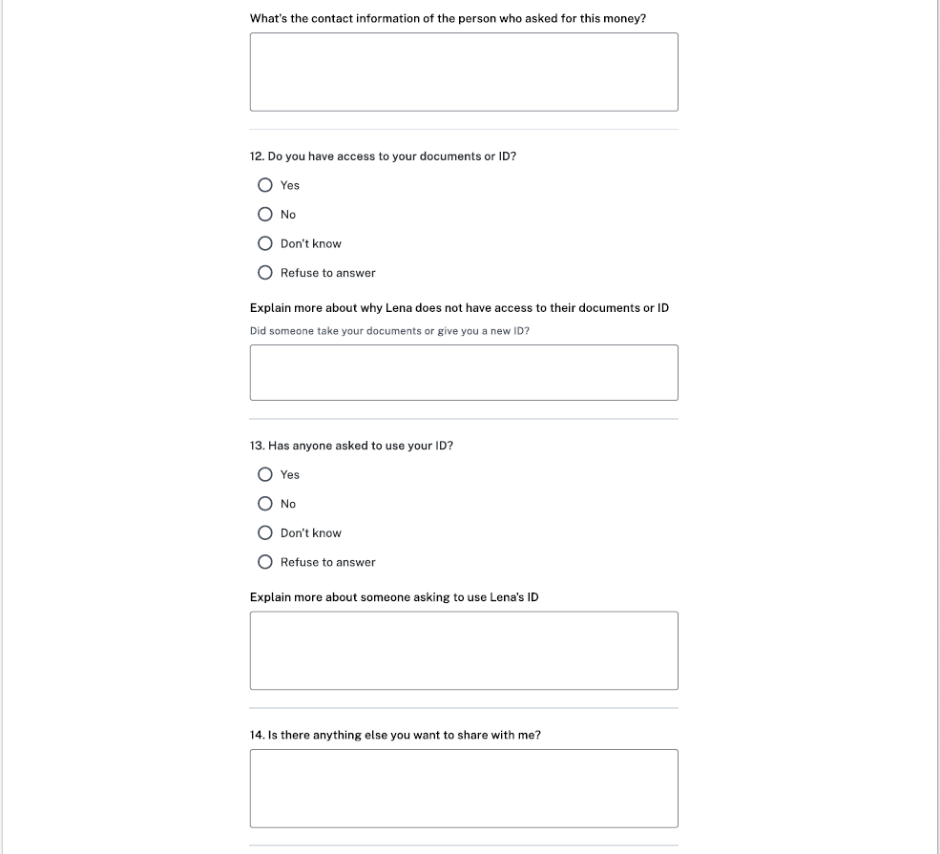

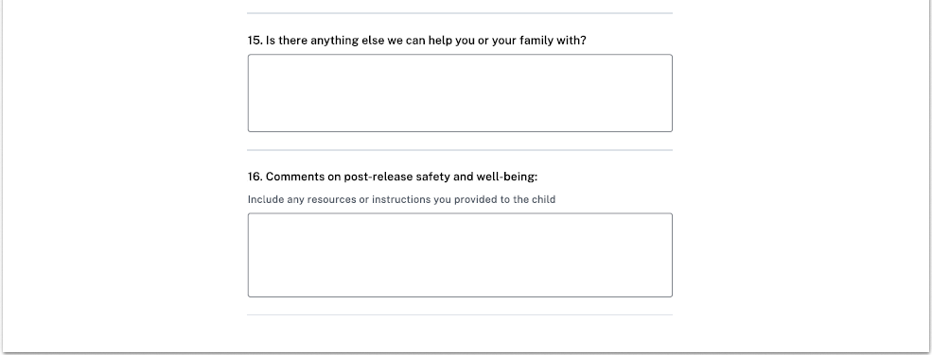

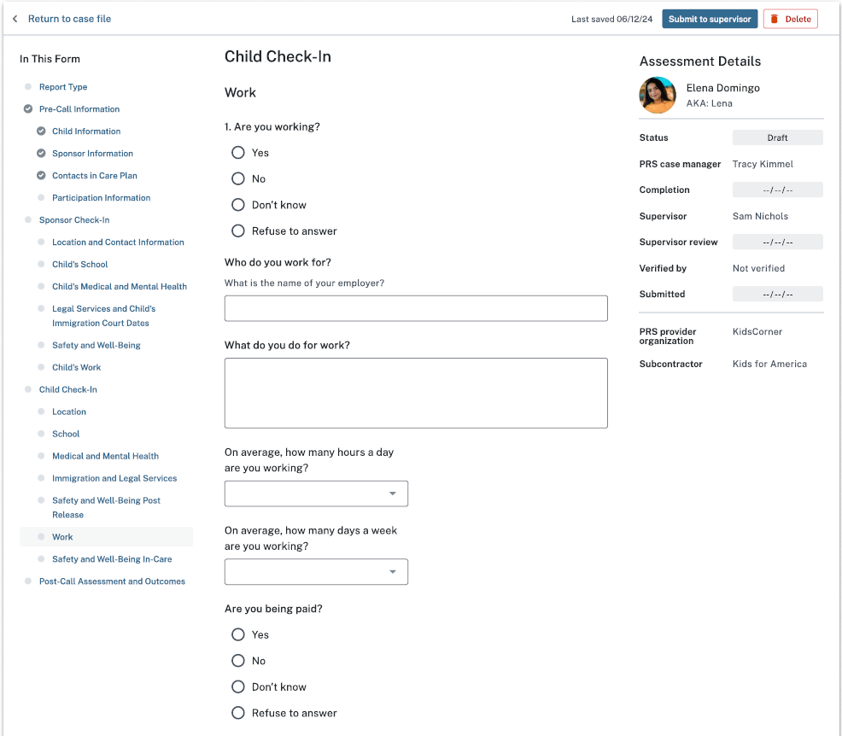

**Options:** [1-24]

**Options:** [1-7]

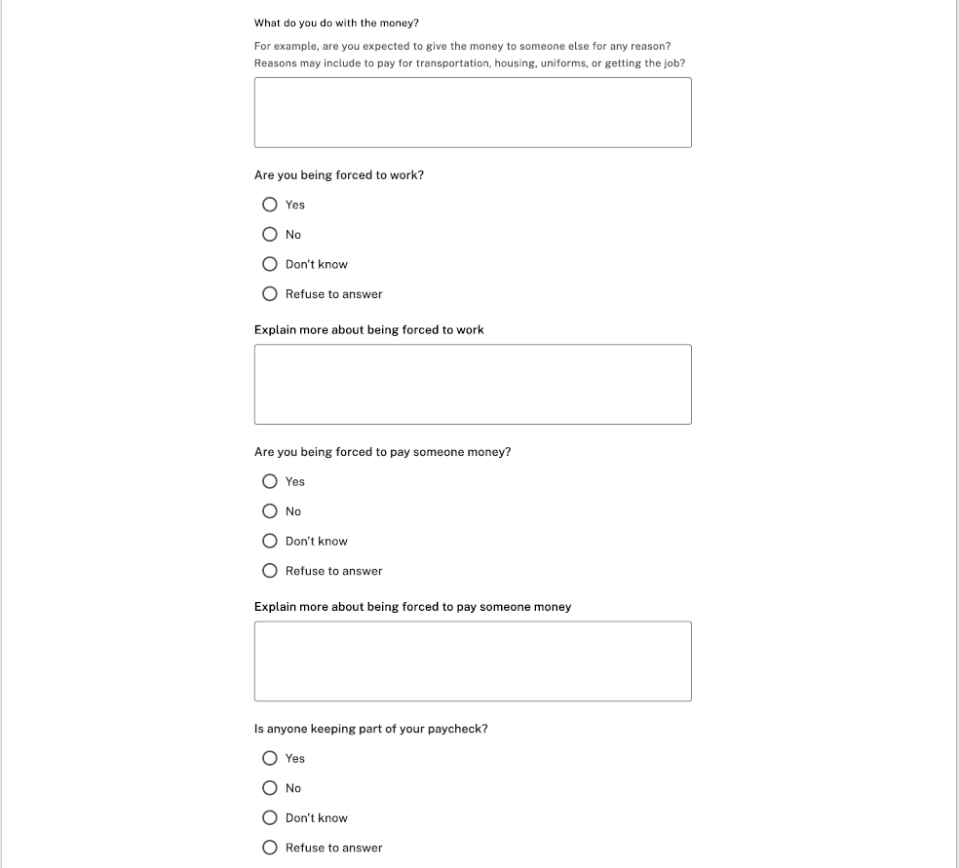



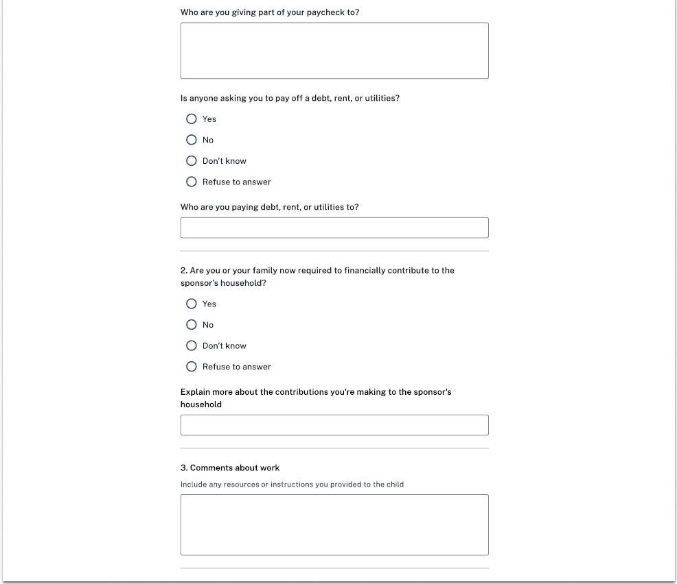

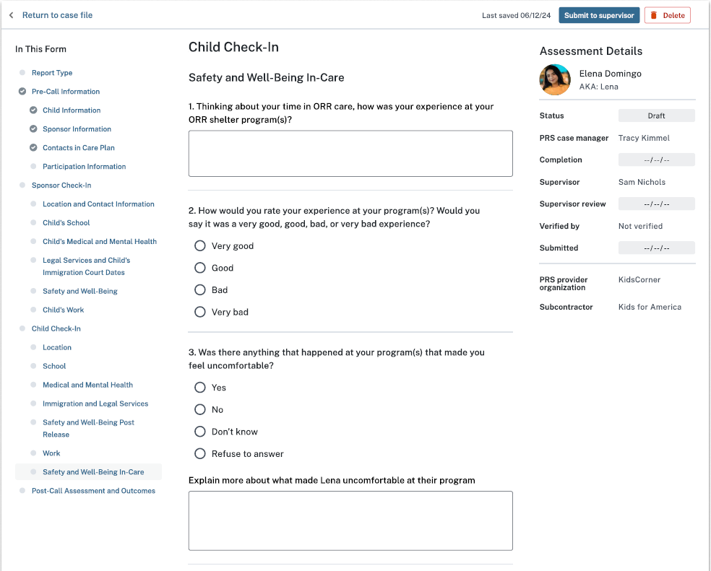

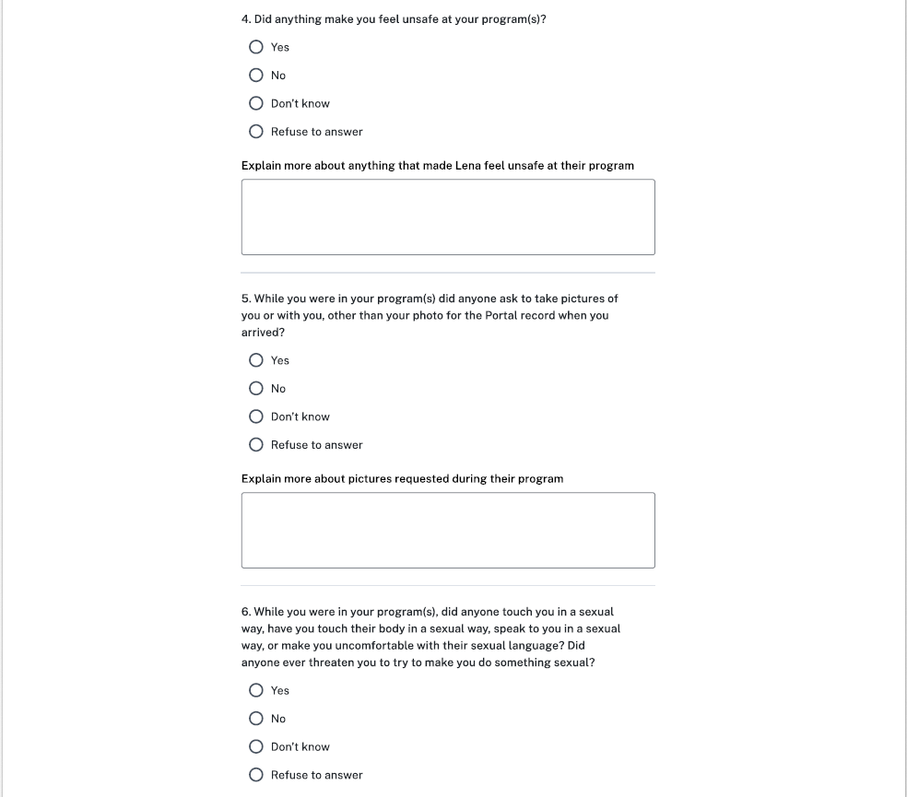



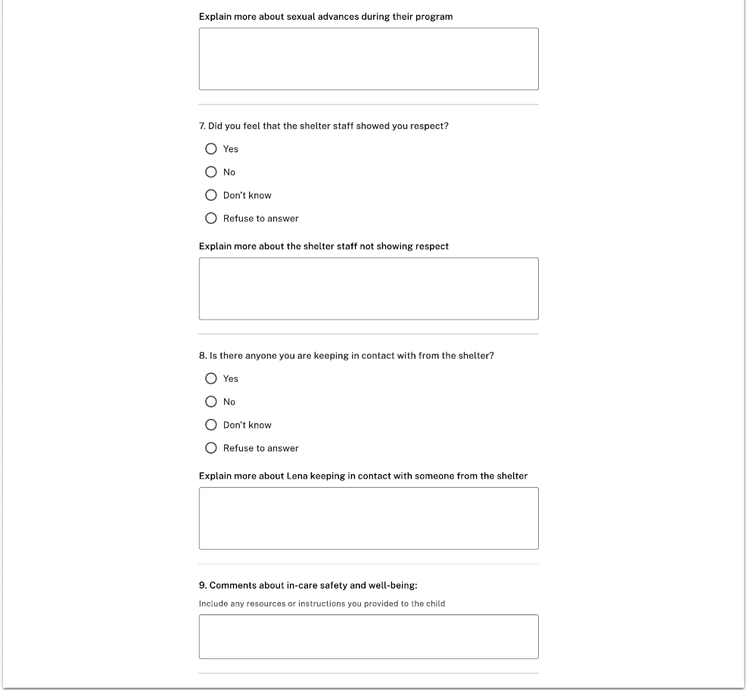

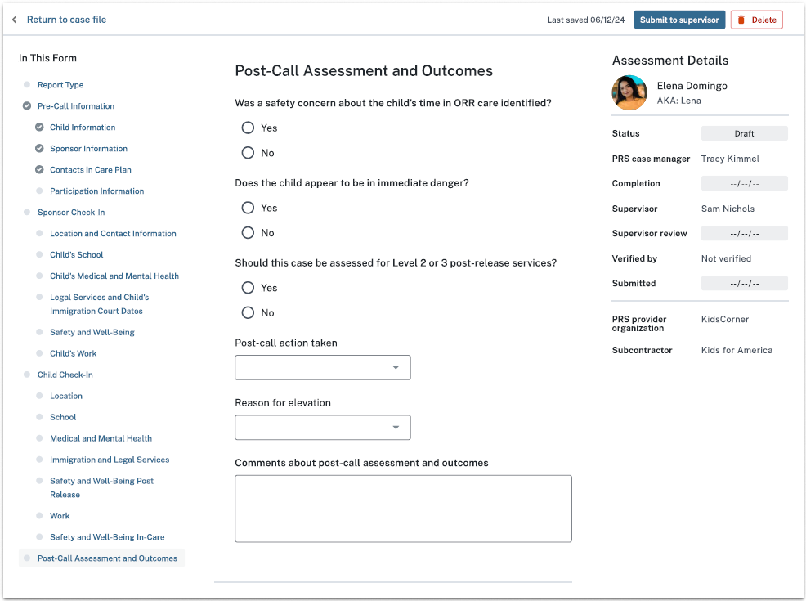

**Options:**

Child labor or labor trafficking

Sex trafficking

Neglect or abandonment

Physical abuse

Sexual abuse or harassment

Sponsor criminal activity

Child criminal activity

Child death

Child medical or mental health issue

Fraud against sponsor

Fraudulent sponsor

Other

**Options:**

Elevated to supervisor

Referred to ORR National Call Center

Referred to National Center for Missing and Exploited Children (NCMEC)

Reported to local law enforcement

Reported to Sexual Abuse Hotline

Reported to Child Abuse Hotline (State Licensing)

Referred to FFS

Contacted child’s attorney

Submitted Notification of Concern

Referred to OTIP

Flagged sponsor

Flagged address

Flagged household member

Flagged alternate caregiver

Contact child’s Child Advocate

Other

None