NOTE: The information displayed in this document is fake and does not belong to an actual person.
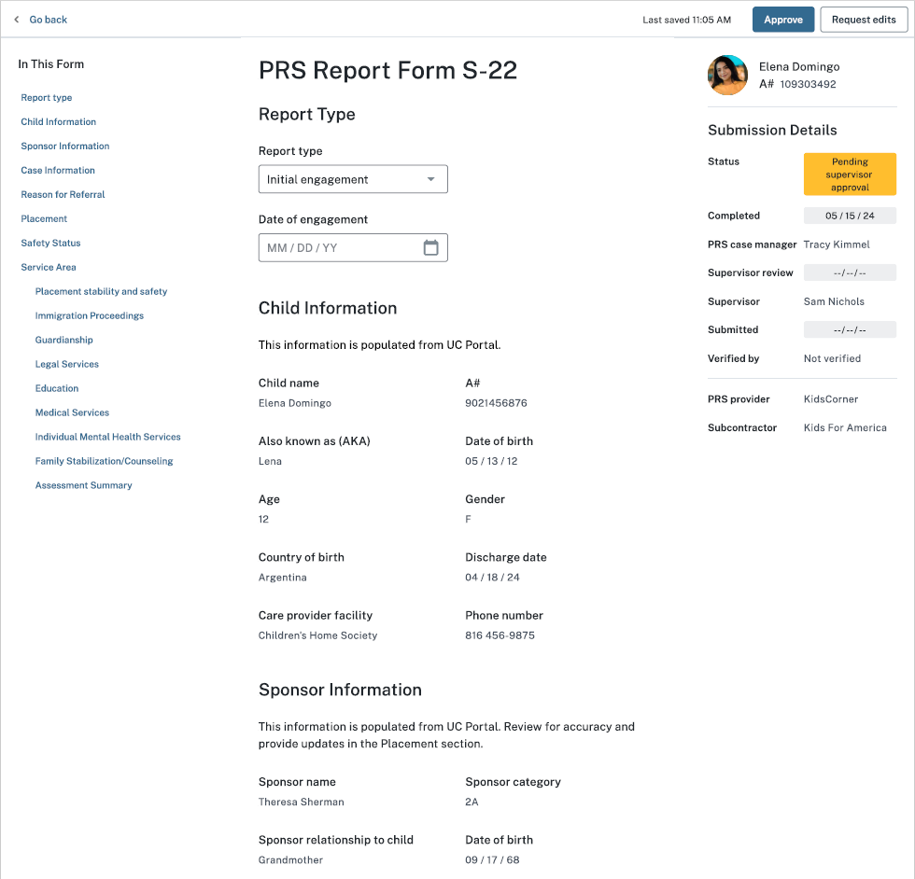
UAC
UAC
Sex
Options:
Initial engagement
Ongoing engagement
Closing engagement
THE PAPERWORK REDUCTION ACT OF 1995 (Pub. L. 104-13) STATEMENT OF PUBLIC BURDEN: The purpose of this information collection is to allow post-release service caseworkers to document referrals made and services provided at critical junctures of service provision, such as 14 day, 6 month, 12 month, and closure. Public reporting burden for this collection of information is estimated to average 1.08 hours per response, including the time for reviewing instructions, gathering, and maintaining the data needed, and reviewing the collection of information. This is a mandatory collection of information (Homeland Security Act, 6 U.S.C. 279, and Trafficking Victims Protection Reauthorization Act, 8 U.S.C. 1232). An agency may not conduct or sponsor, and a person is not required to respond to, a collection of information subject to the requirements of the Paperwork Reduction Act of 1995, unless it displays a currently valid OMB control number. If you have any comments on this collection of information, please contact UACPolicy@acf.hhs.gov.

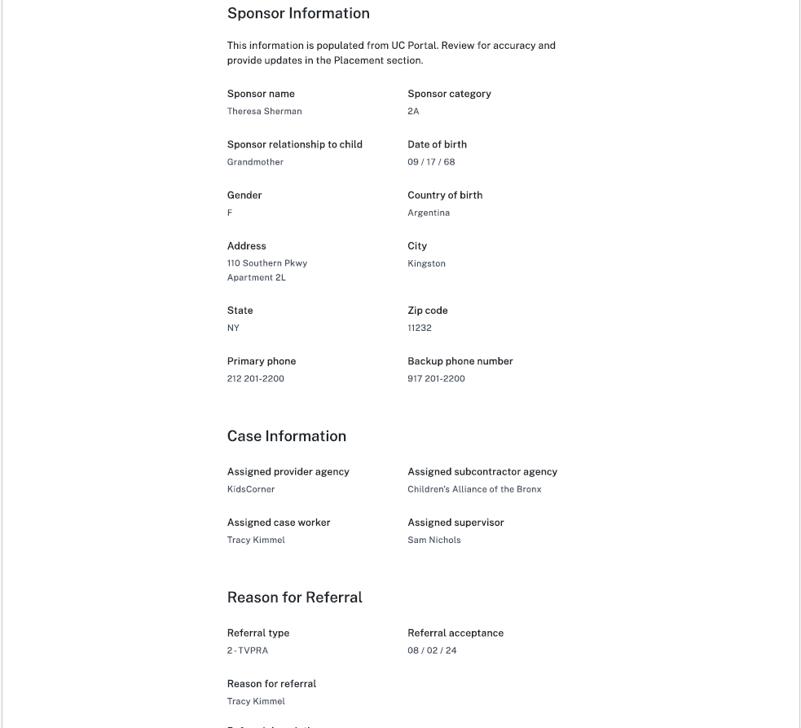
Sex
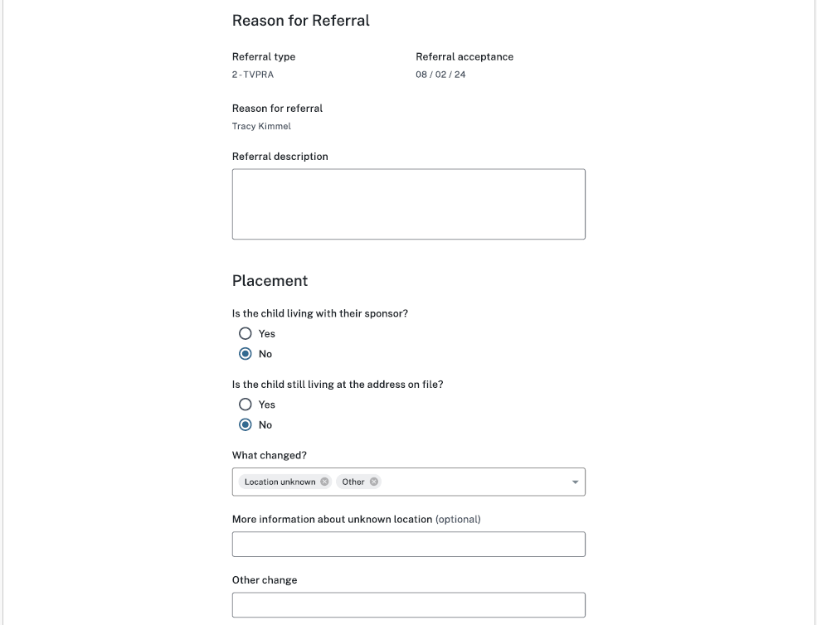
Options:
With alternate caregiver (ACG) or non-sponsor
Living independently
Known runaway
Returned to home country
Location unknown
Other
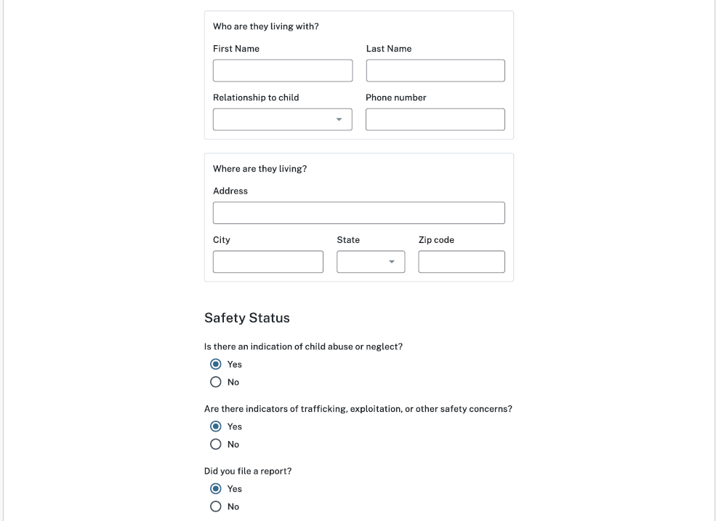
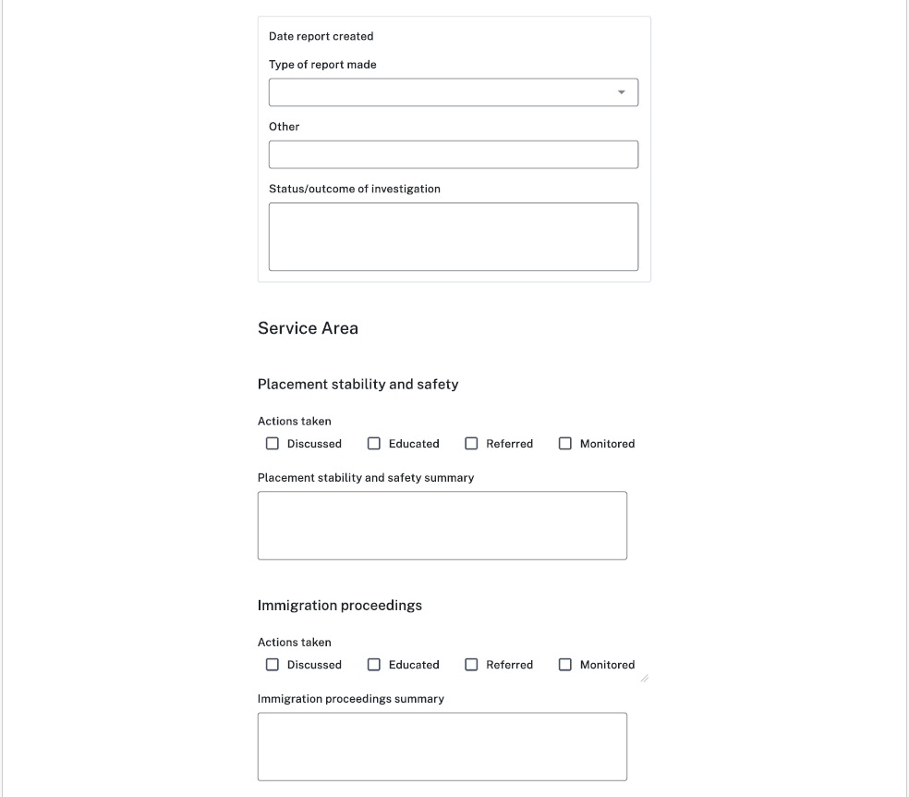
Options:
Law enforcement
Child Protective Services
Office of Trafficking in Persons
Other
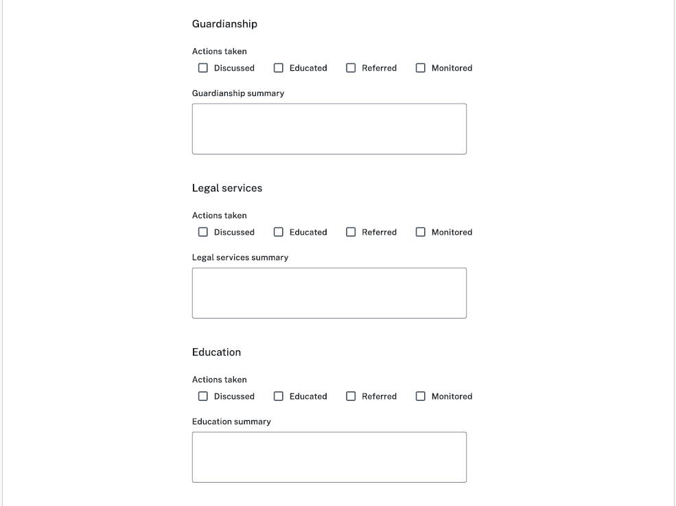
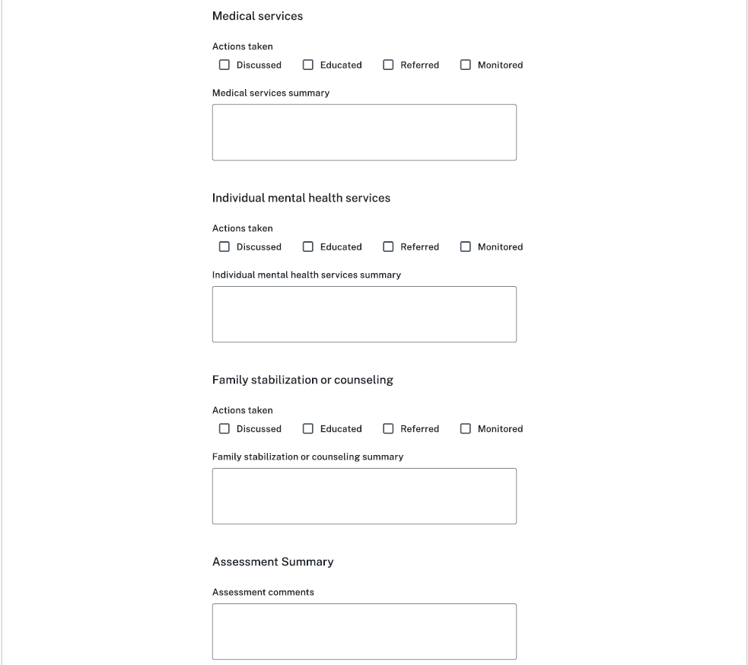
Trafficking Victims Assistance Program
Other services
Trafficking Victims Assistance Program summary
Substance abuse summary
Substance abuse
Other services summary

