NOTE: The information displayed in this document is fake and does not belong to actual people.

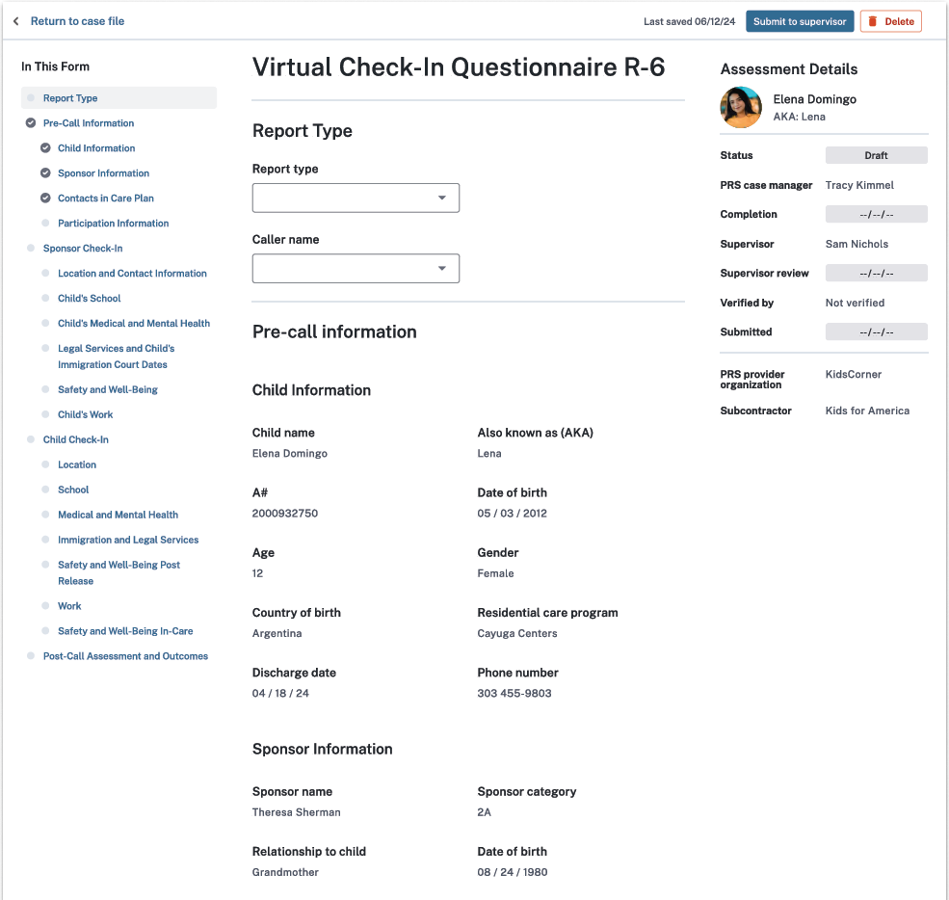
Sex
Options:
7-Day Virtual Check-In
14-Day Virtual Check-In
30-Day Virtual Check-In

THE PAPERWORK REDUCTION ACT OF 1995 (Pub. L. 104-13) STATEMENT OF PUBLIC BURDEN: The purpose of this information collection is to allow care provider facilities to document the outcome of calls made to unaccompanied alien children and their sponsors after release to ensure the child is safe and refer the sponsor to additional resources as needed. Public reporting burden for this collection of information is estimated to average 0.25 hours per sponsor and child response, and 0.58 hours per response for care providers, including the time for reviewing instructions, gathering, and maintaining the data needed, and reviewing the collection of information. This is a mandatory collection of information (Homeland Security Act, 6 U.S.C. 279, and Trafficking Victims Protection Reauthorization Act, 8 U.S.C. 1232). An agency may not conduct or sponsor, and a person is not required to respond to, a collection of information subject to the requirements of the Paperwork Reduction Act of 1995, unless it displays a currently valid OMB control number. If you have any comments on this collection of information, please contact UACPolicy@acf.hhs.gov.

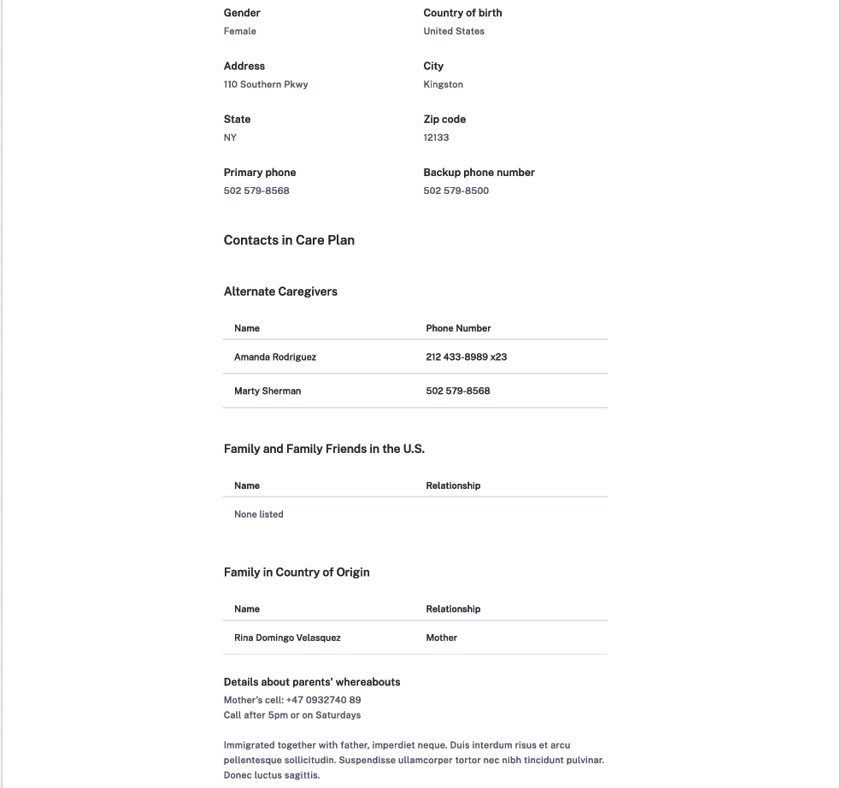
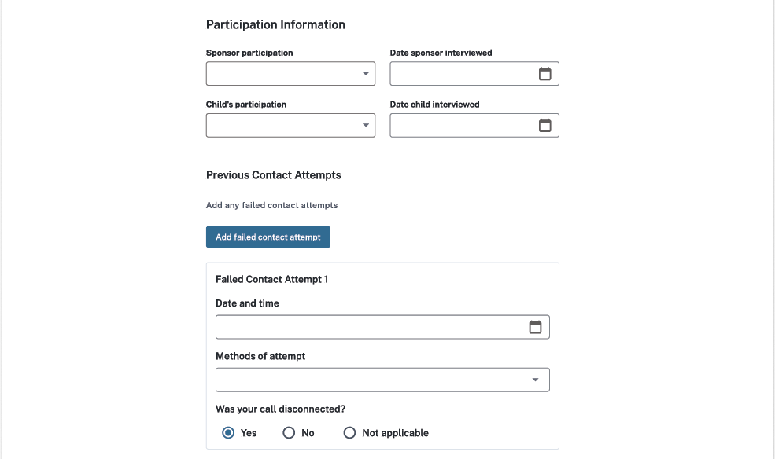
Options:
Called child and sponsor’s primary phone
Called child and sponsor's backup phone
Called number(s) in care plan
Called number(s) in home country
Sent WhatsApp or text message
Sent email
Sent letter
In-person visit
Other
Options:
Reached and participated alone
Reached and participated with someone else around
Reached and declined to participate
Not reached
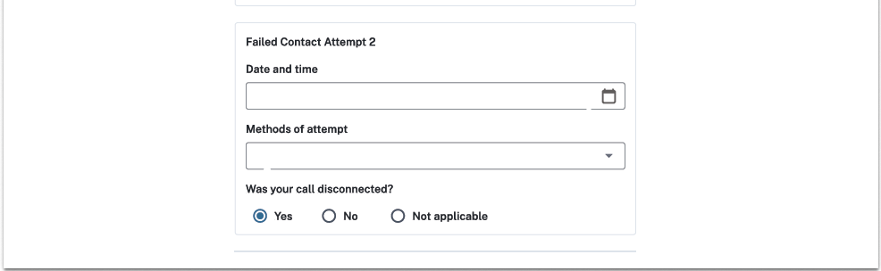
Options:
Called child and sponsor’s primary phone
Called child and sponsor's backup phone
Called number(s) in care plan
Called number(s) in home country
Sent WhatsApp or text message
Sent email
Sent letter
In-person visit
Other

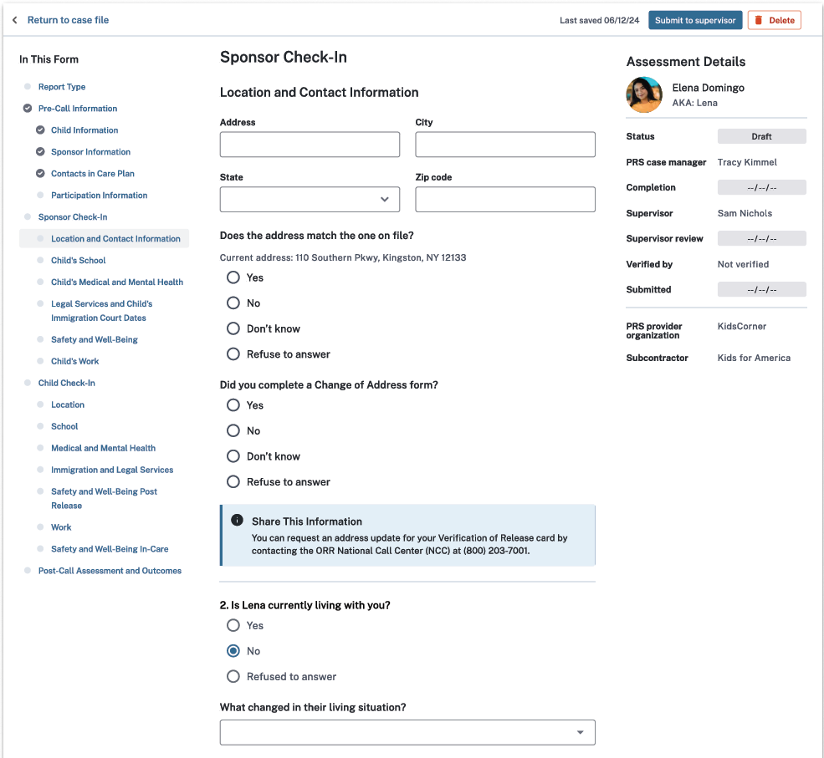
Options:
Living with alternate caregiver (ACG) or non-sponsor
Living independently
Known runaway
Arrested
Hospitalized
Death
Returned to home country
Location unknown
Other
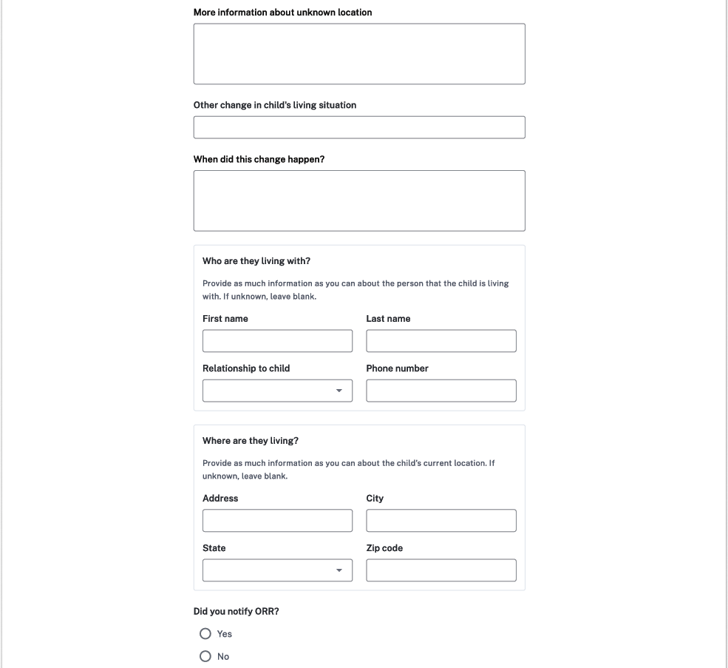
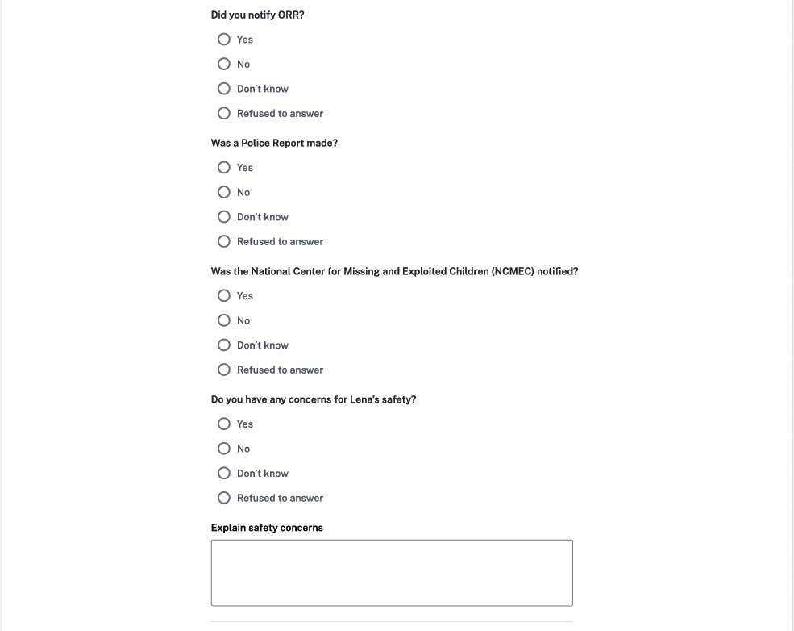
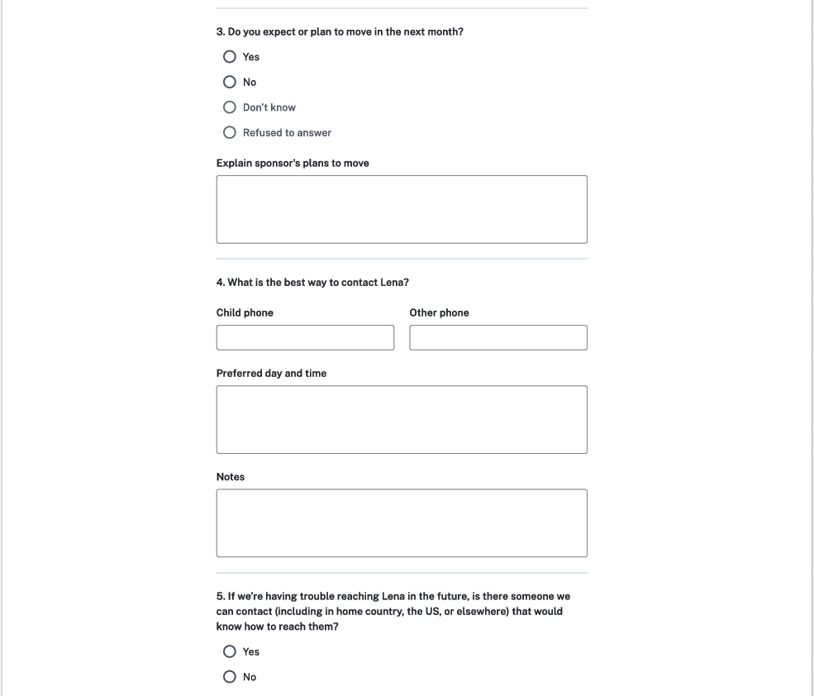
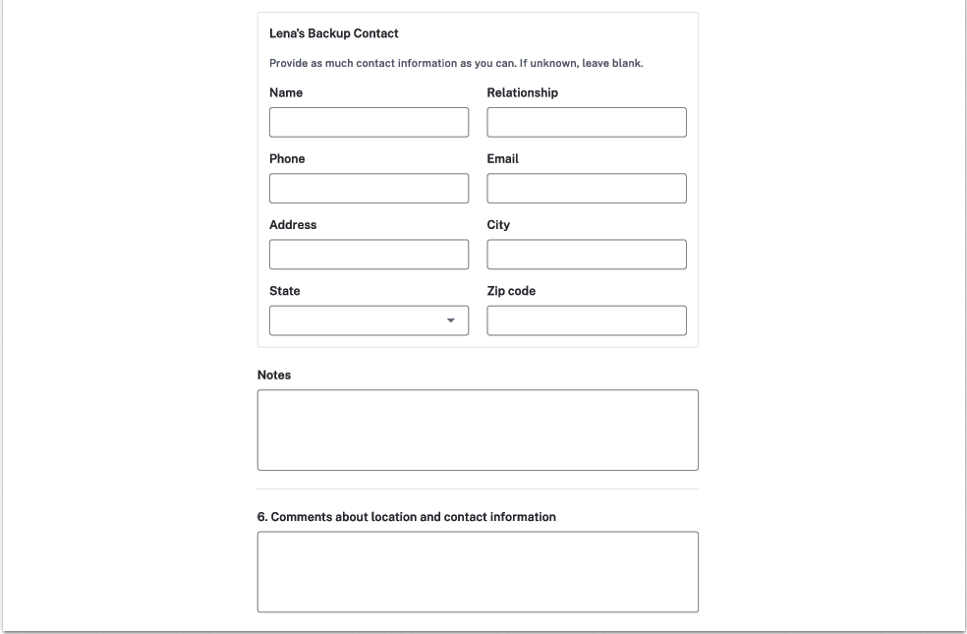

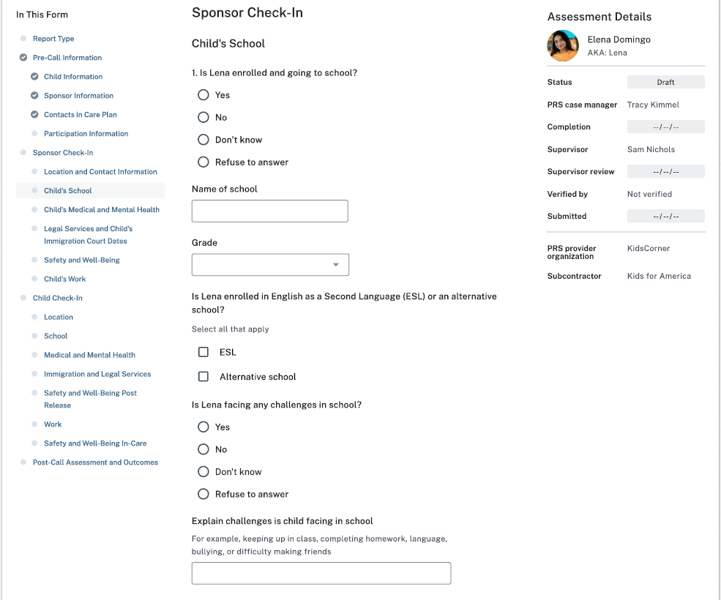
Options:
K, 1, 2, 3, 4, 5, 6, 7, 8, 9, 10, 11, 12, Not applicable
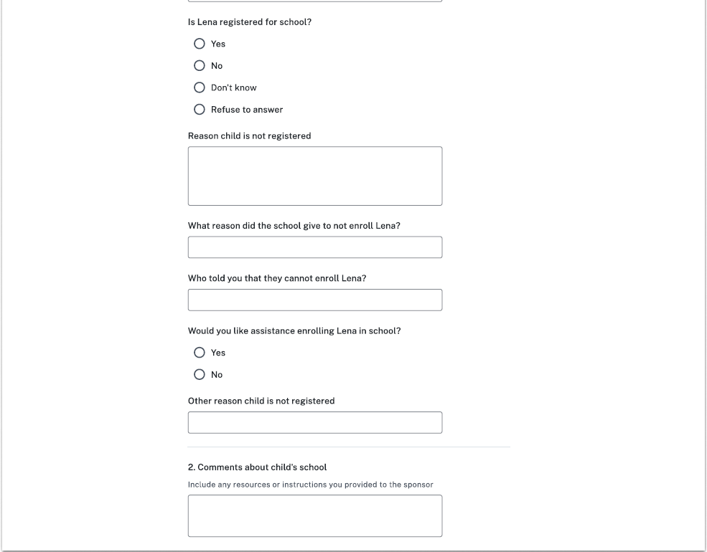
Options:
Immunizations
Documentation issues with identity or residency
Not planning on registering
Not of compulsory school age
Not interested or willing to attend
Transportation Issues
School not in session or summer break
School is resistant to enroll the child
Other
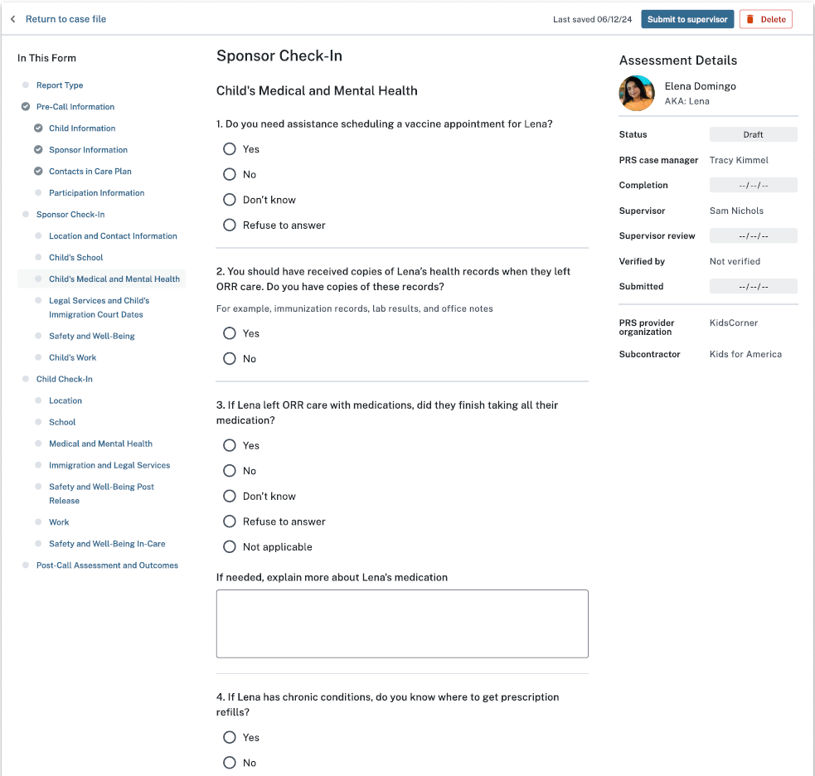
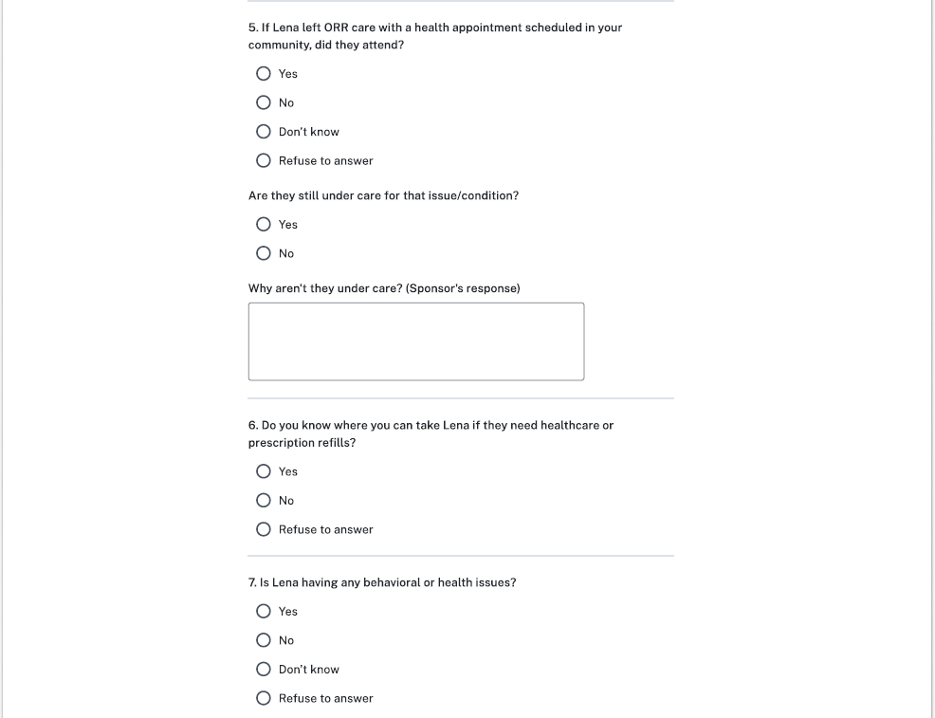
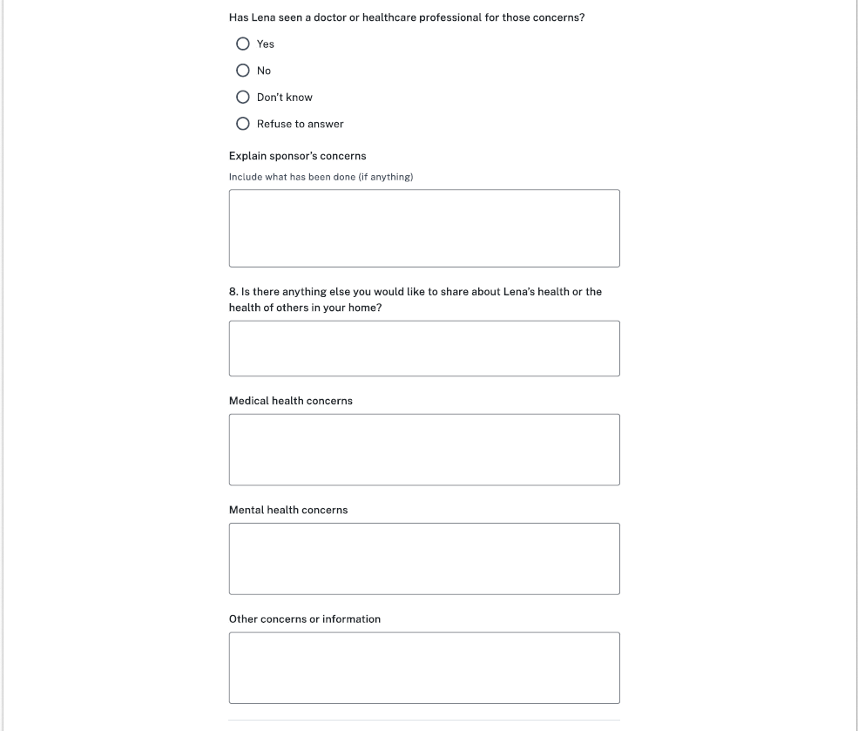


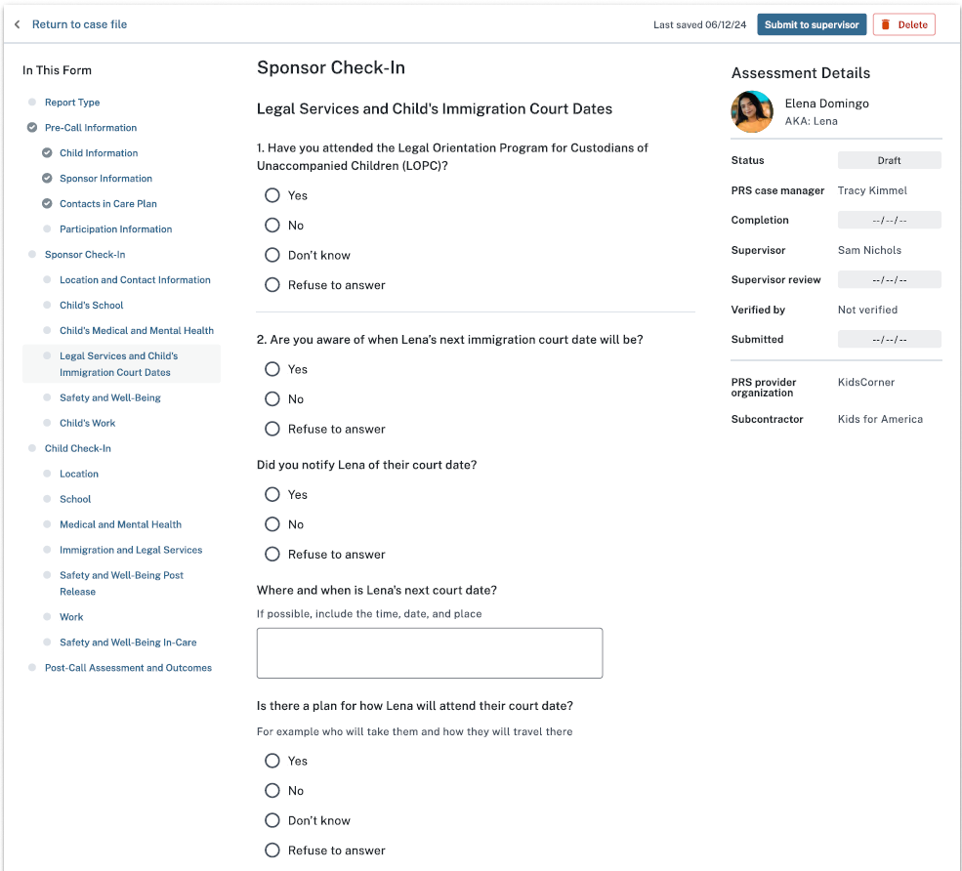
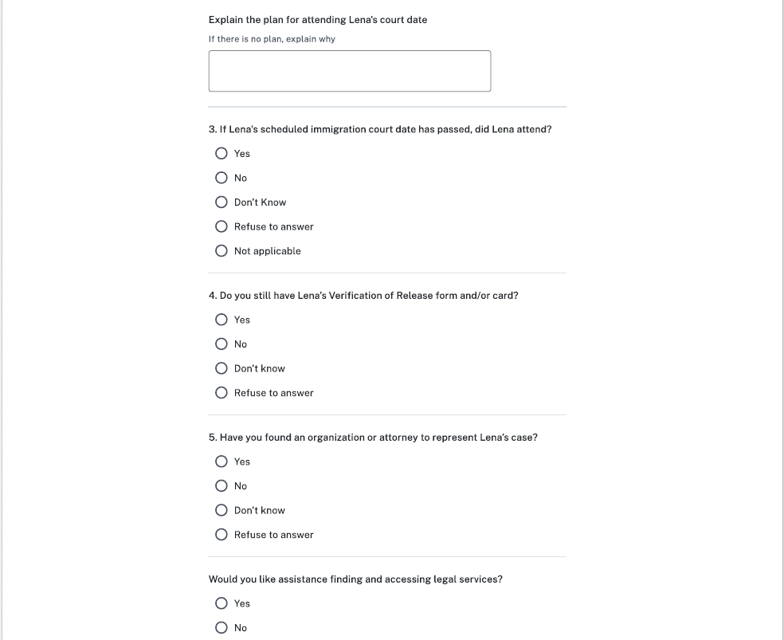
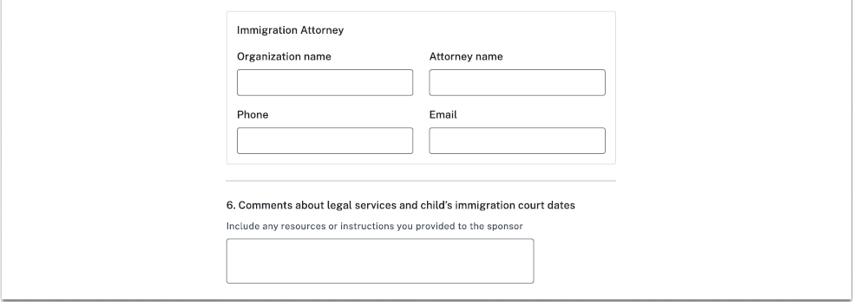
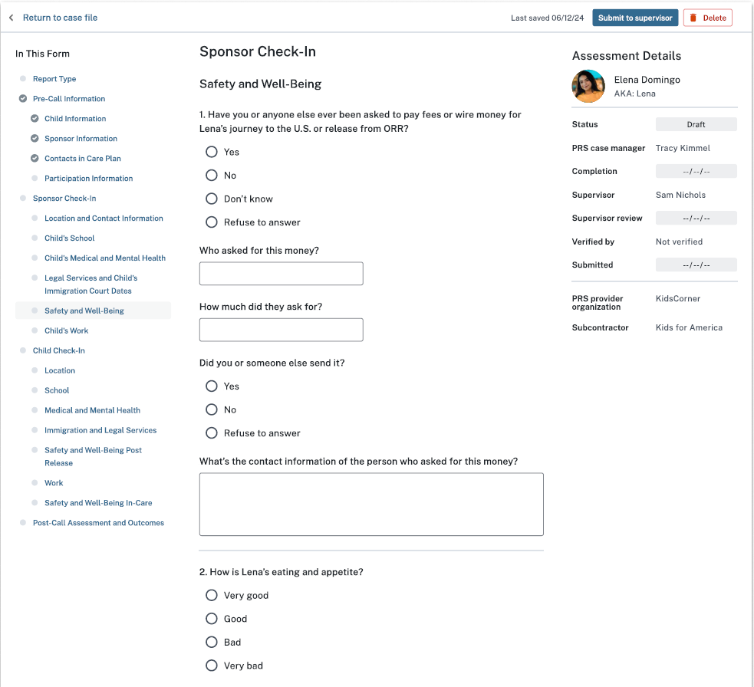
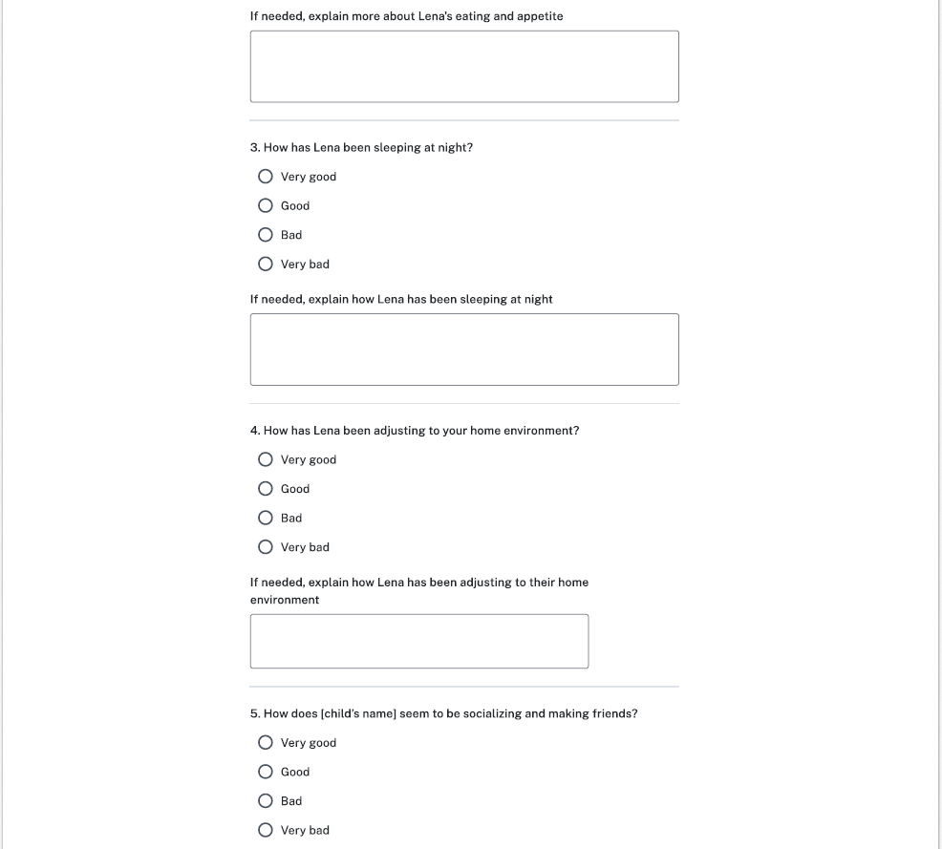
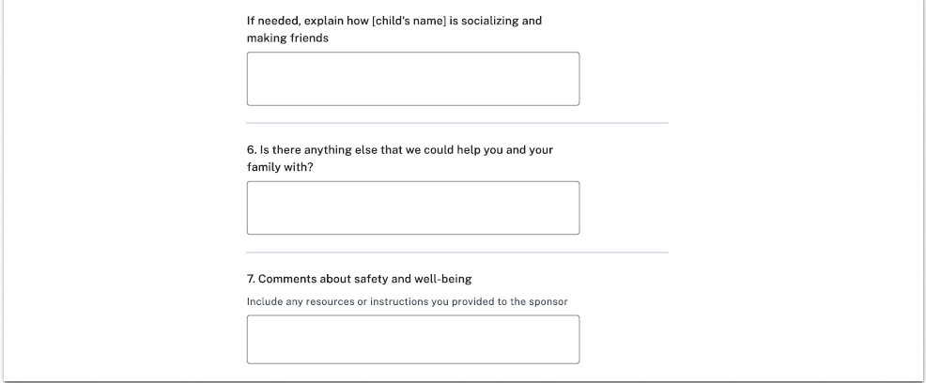

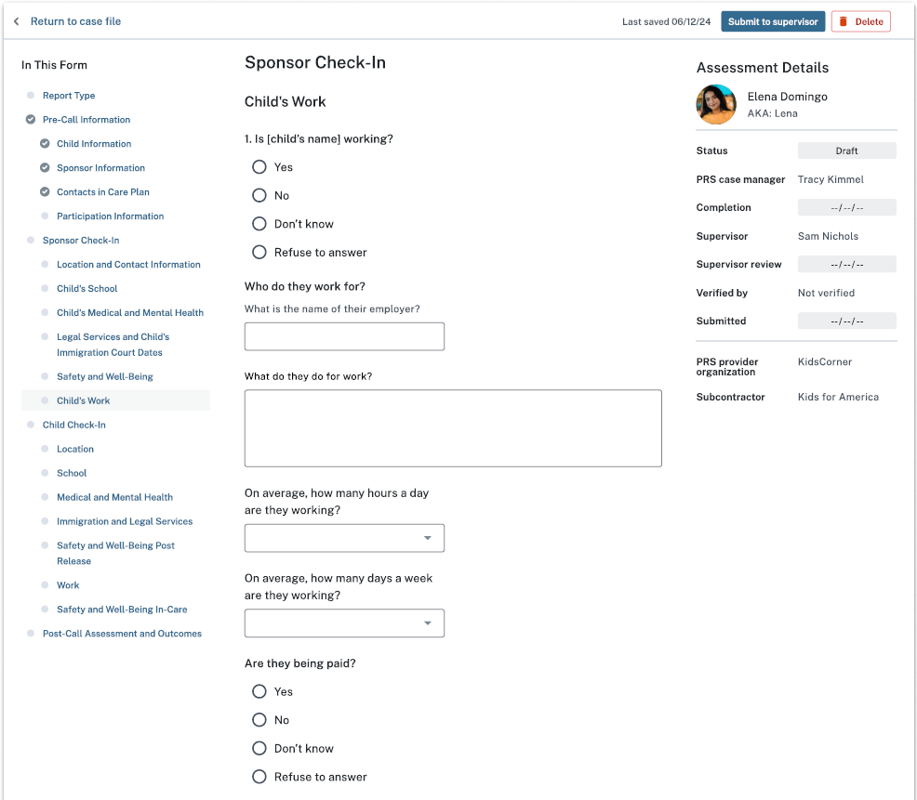
Options: [1-7]
Options: [1-24]
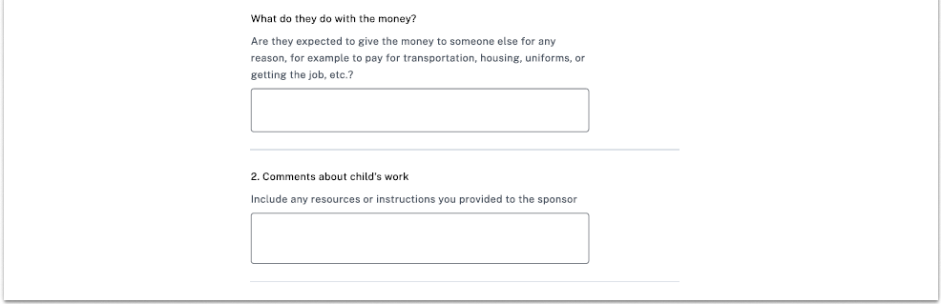

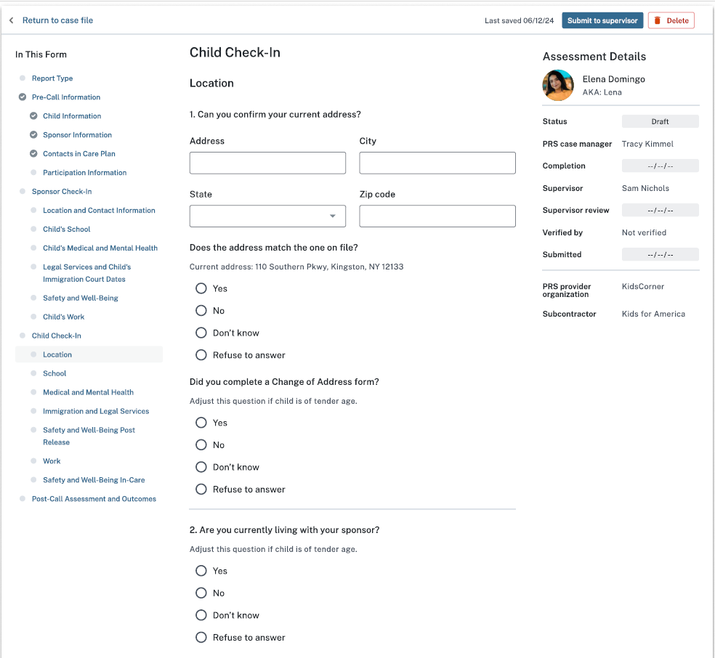
Options:
Living with alternate caregiver (ACG) or non-sponsor
Living independently
Location unknown
Other
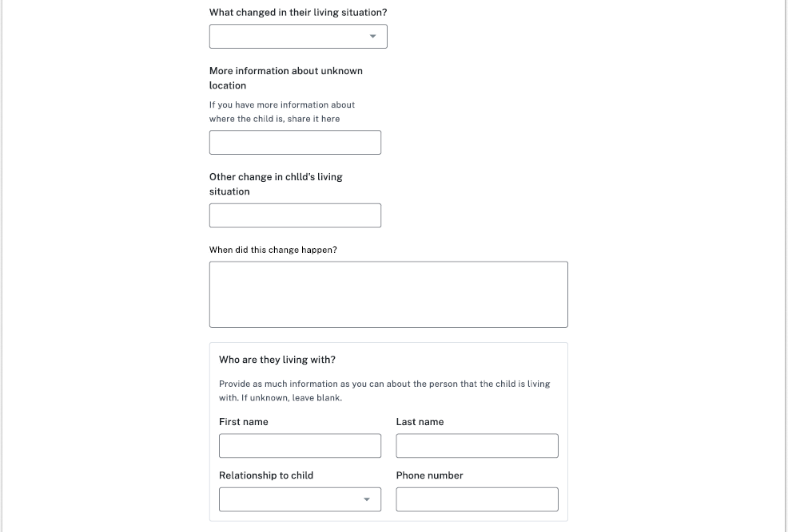
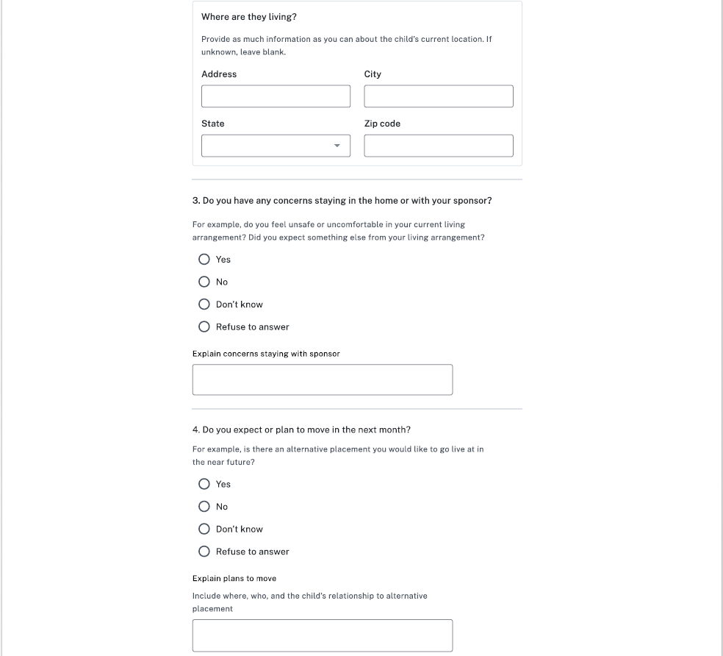
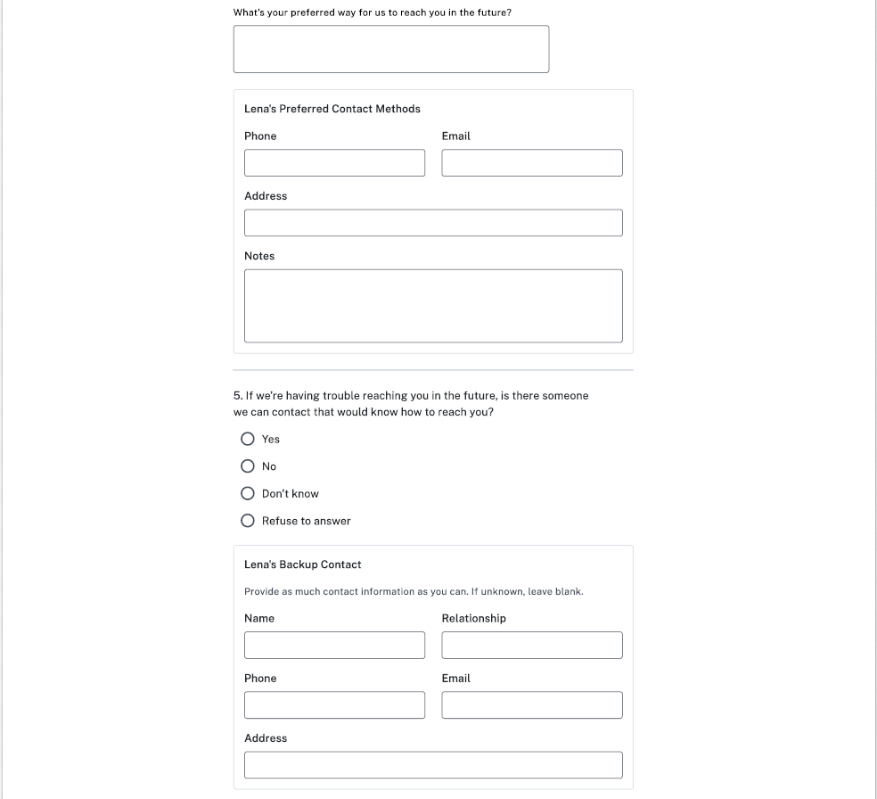
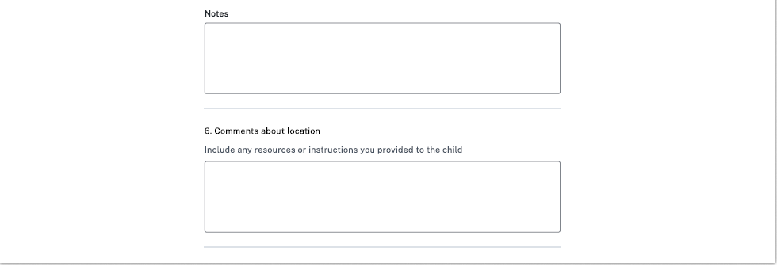

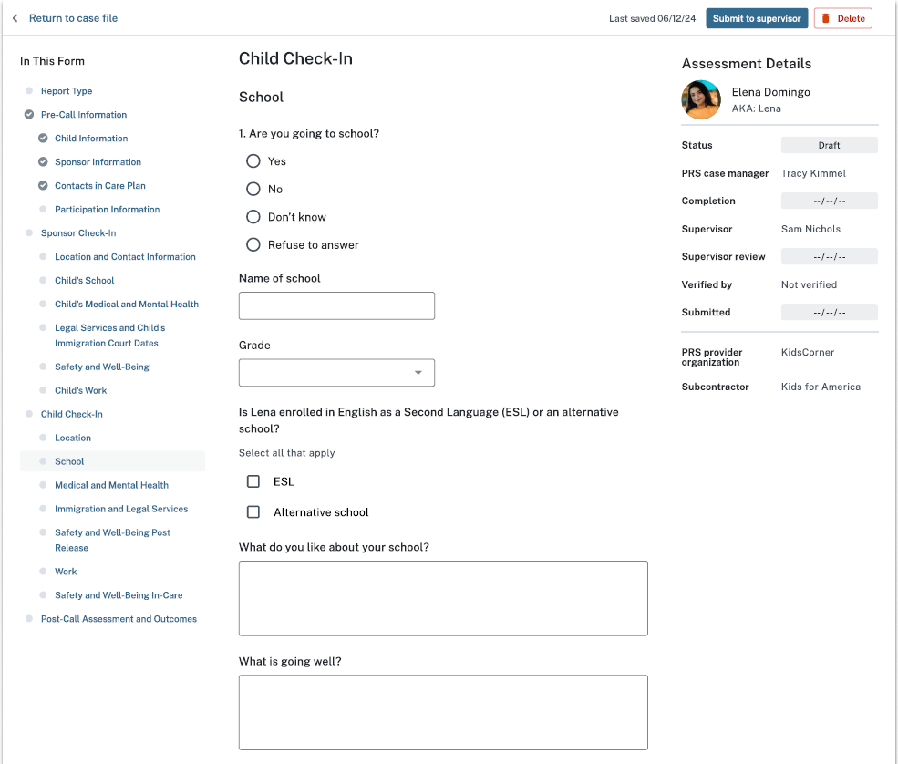
Options:
K, 1, 2, 3, 4, 5, 6, 7, 8, 9, 10, 11, 12, Not applicable
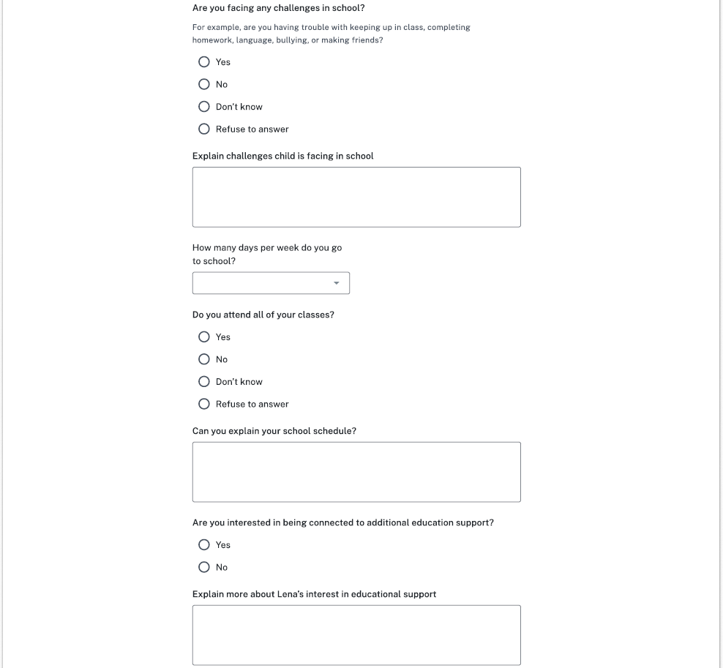
Options: [1-7]
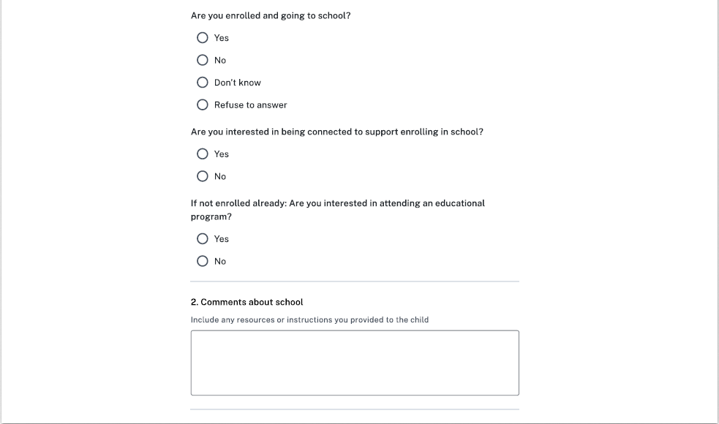

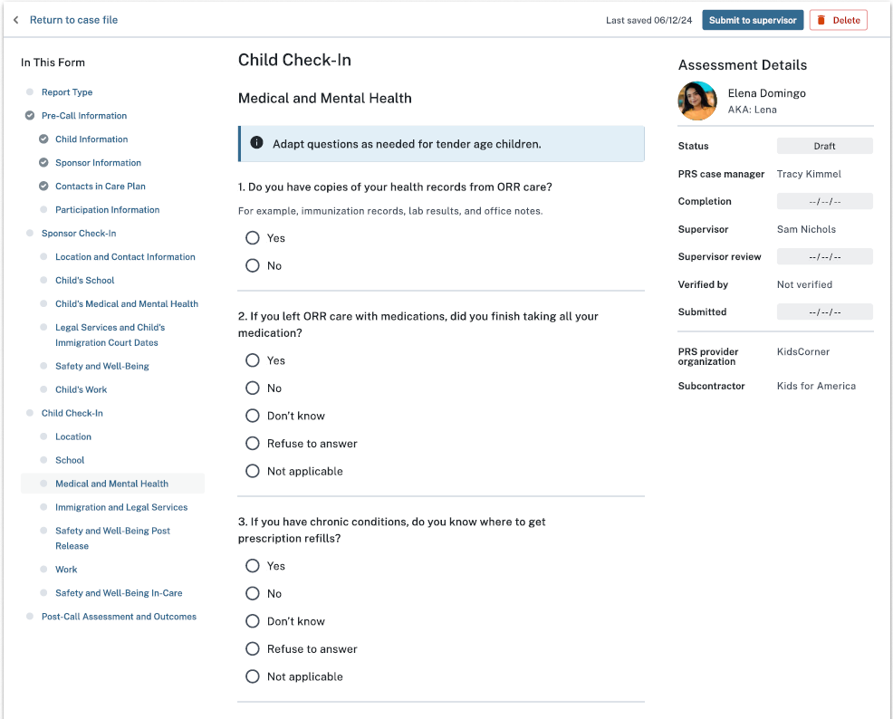
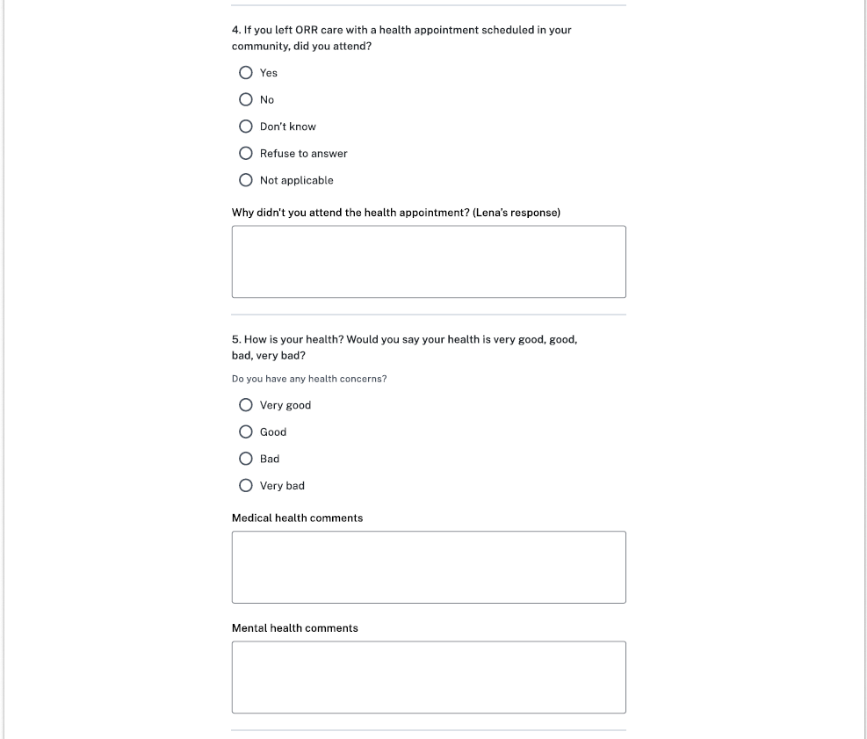
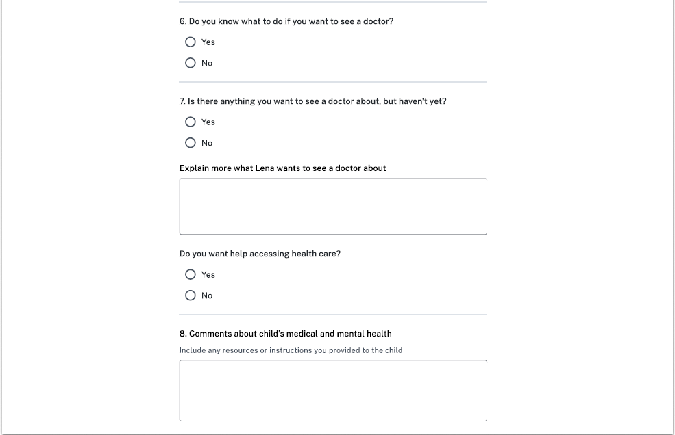

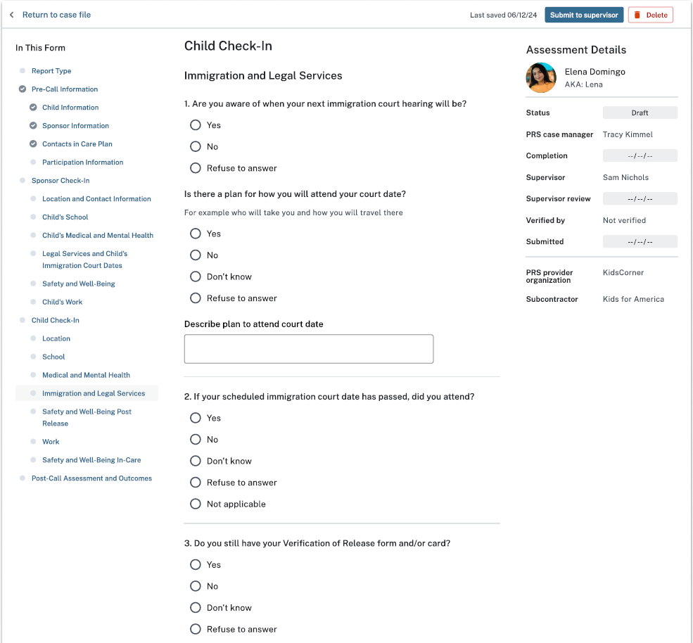
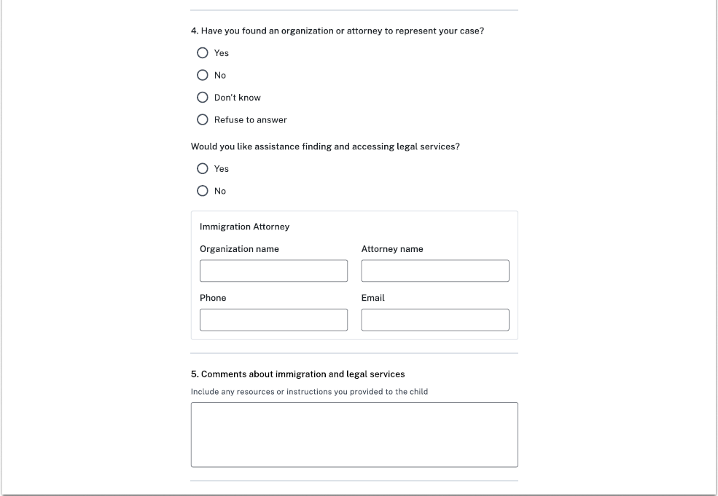

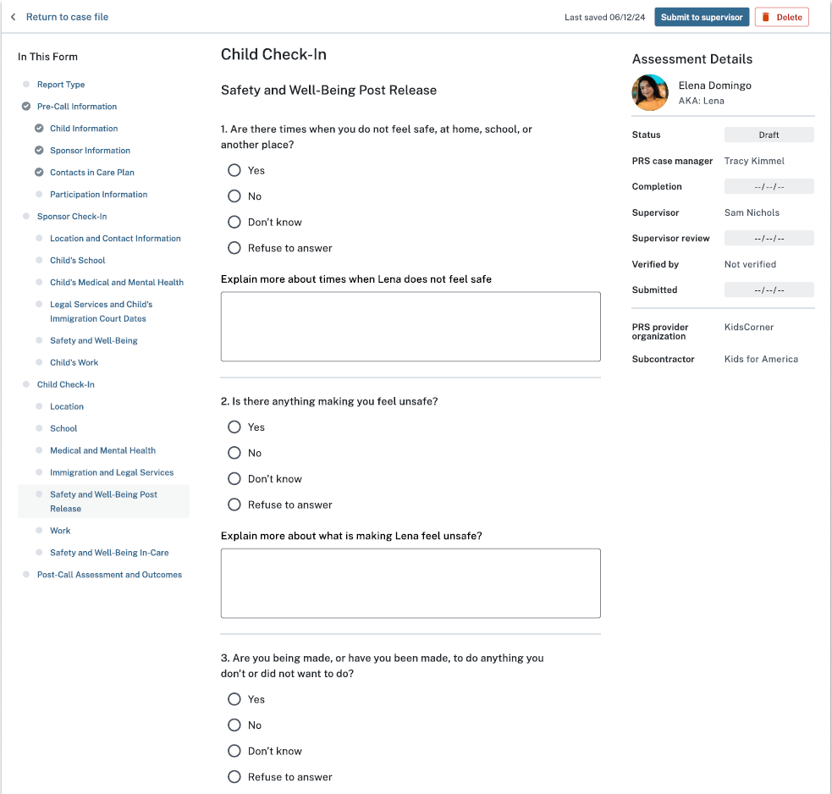
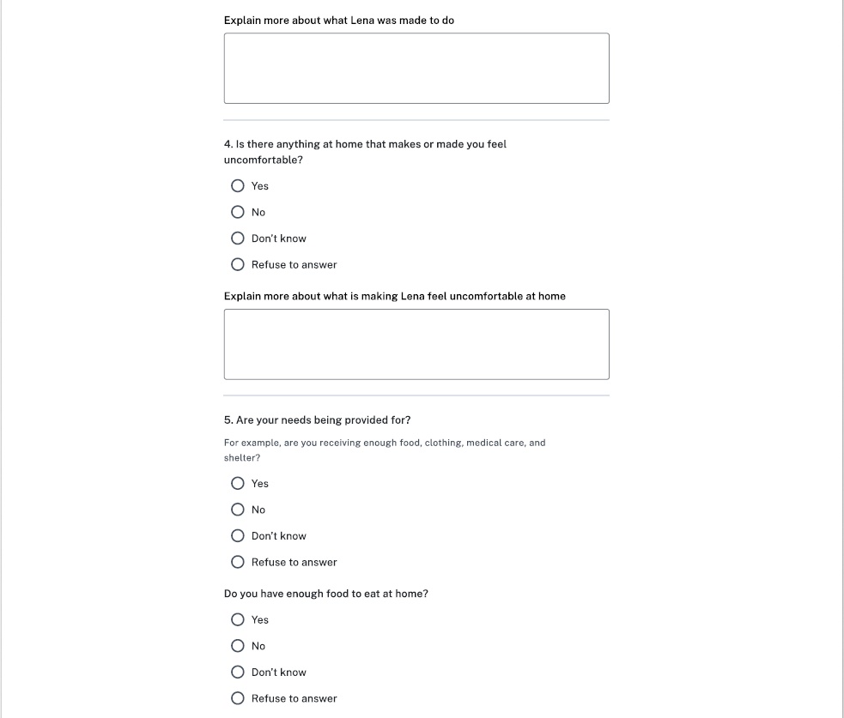
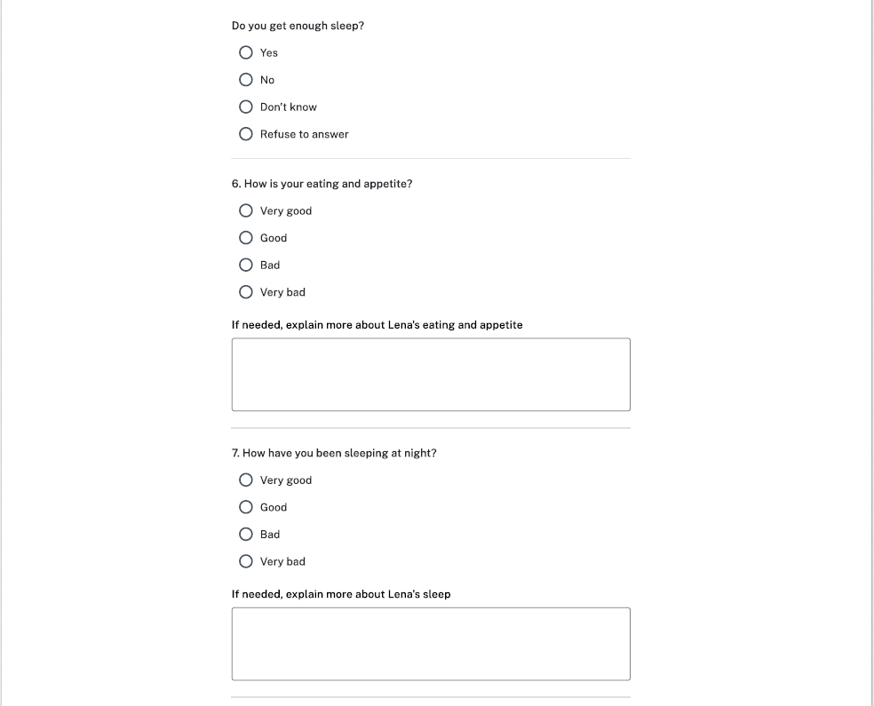
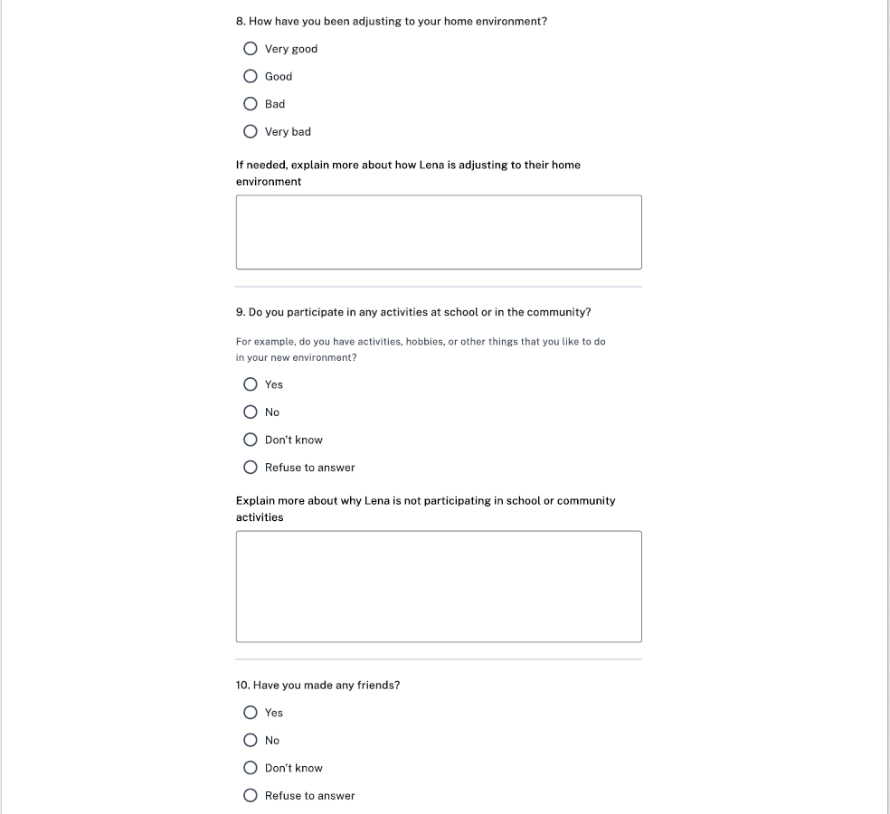
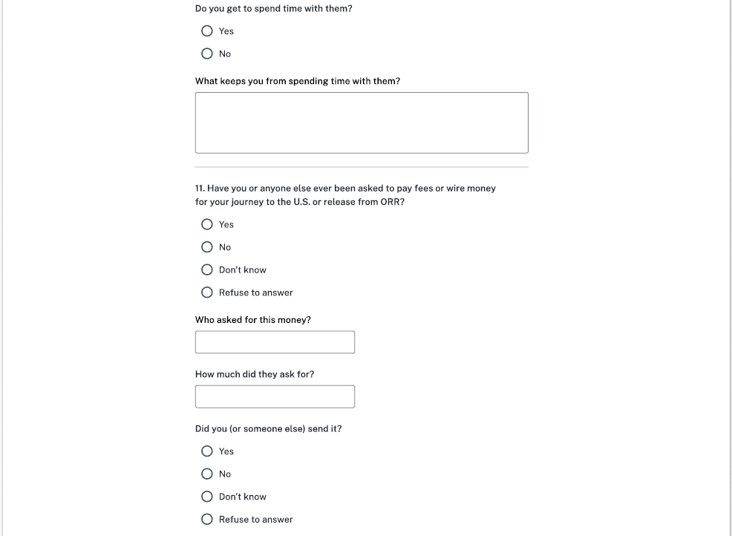

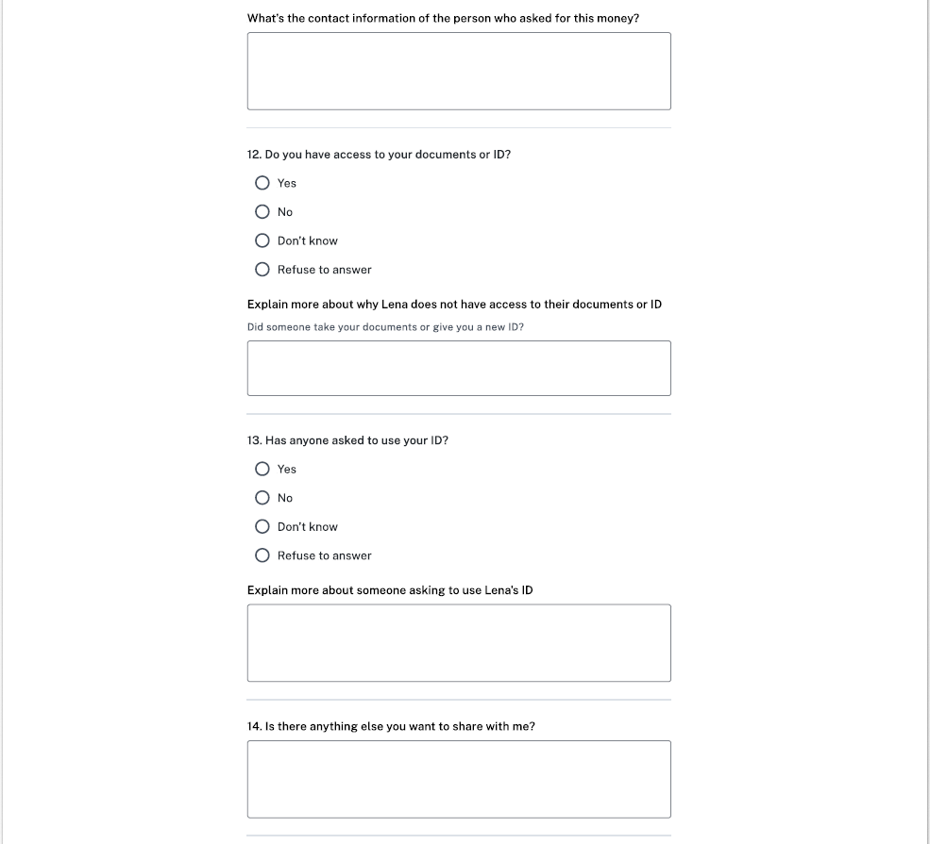
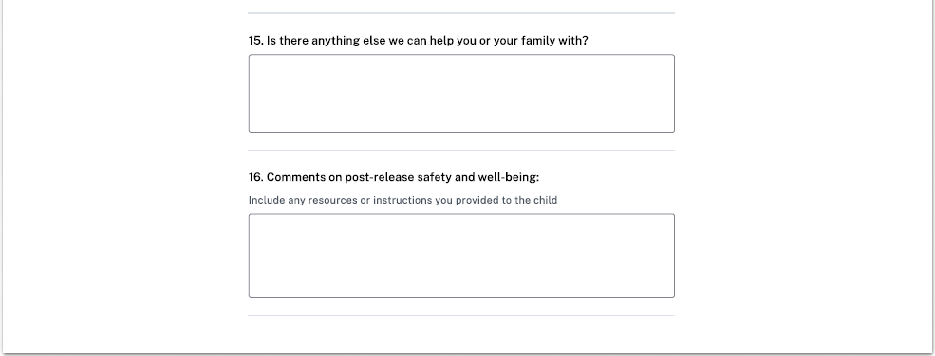
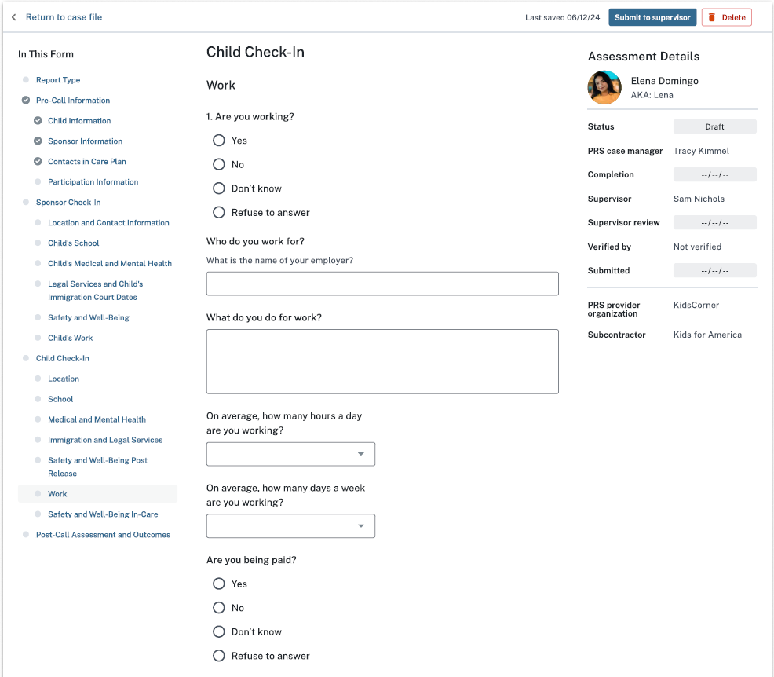
Options: [1-24]
Options: [1-7]
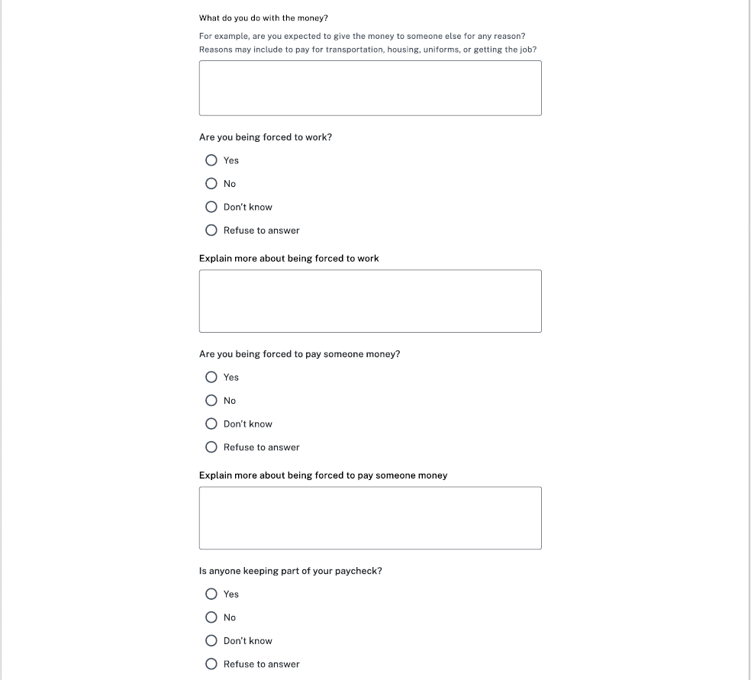
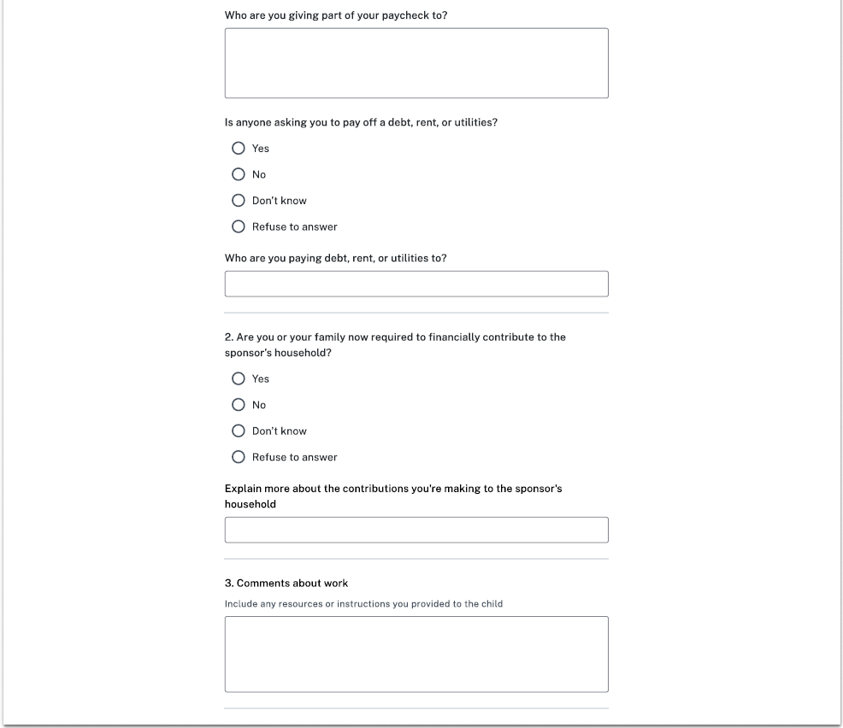
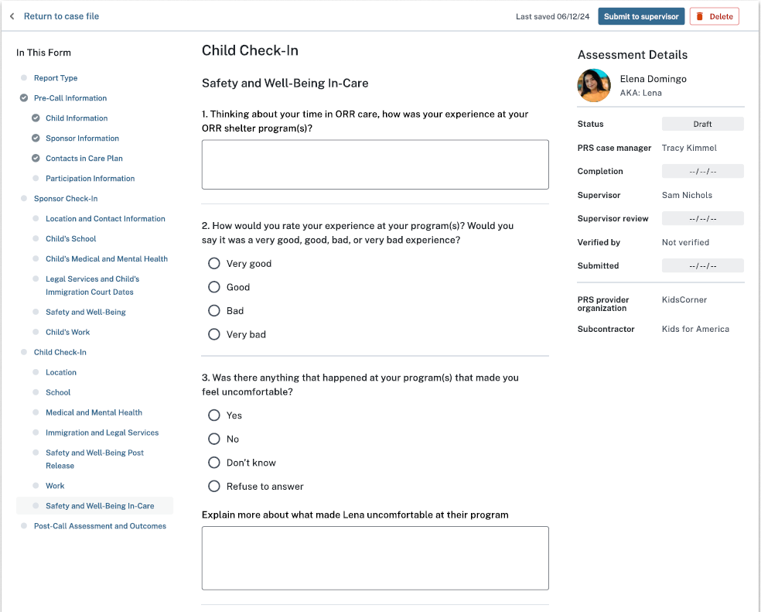
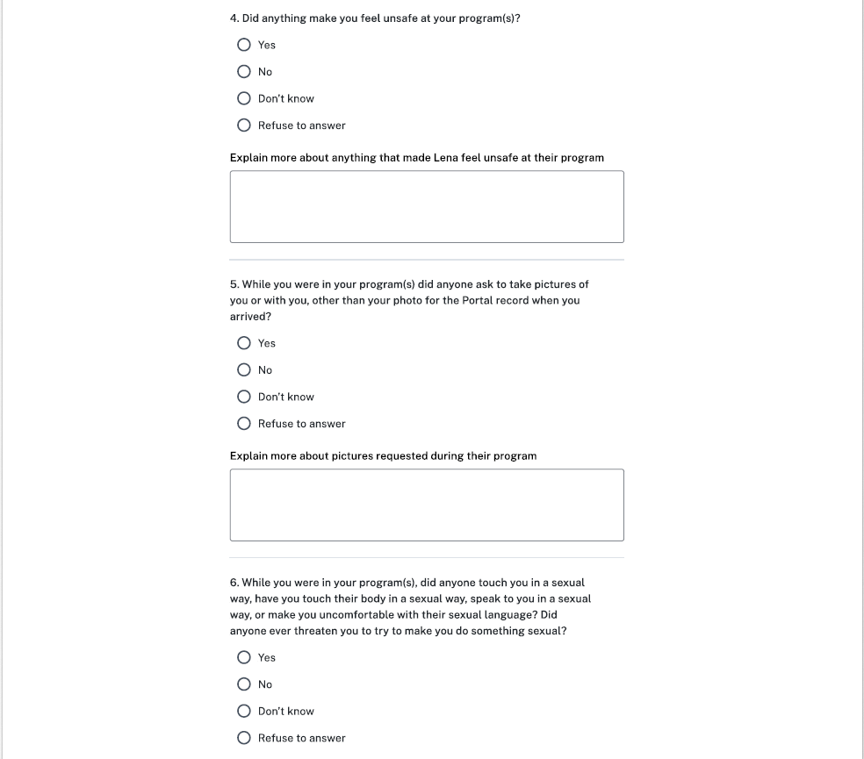
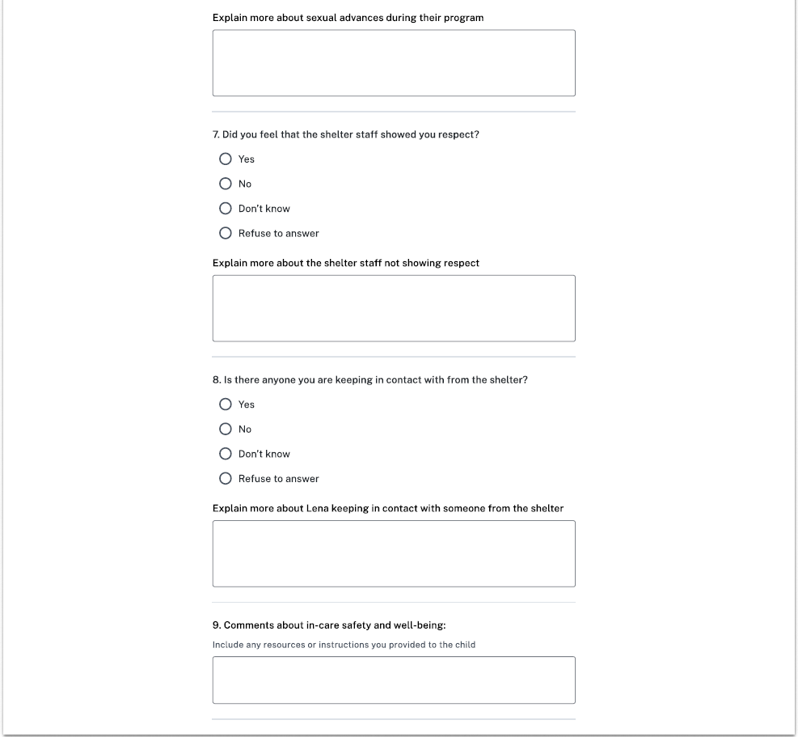
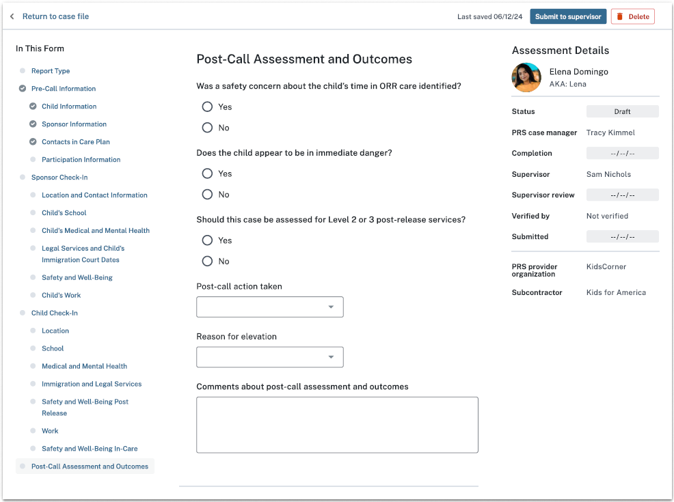
Options:
Child labor or labor trafficking
Sex trafficking
Neglect or abandonment
Physical abuse
Sexual abuse or harassment
Sponsor criminal activity
Child criminal activity
Child death
Child medical or mental health issue
Fraud against sponsor
Fraudulent sponsor
Other
Options:
Elevated to supervisor
Referred to ORR National Call Center
Referred to National Center for Missing and Exploited Children (NCMEC)
Reported to local law enforcement
Reported to Sexual Abuse Hotline
Reported to Child Abuse Hotline (State Licensing)
Referred to FFS
Contacted child’s attorney
Submitted Notification of Concern
Referred to OTIP
Flagged sponsor
Flagged address
Flagged household member
Flagged alternate caregiver
Contact child’s Child Advocate
Other
None

