Child Support Portal – Tax Offset, Administrative Offset, and Passport Denial Portal Processing Screens

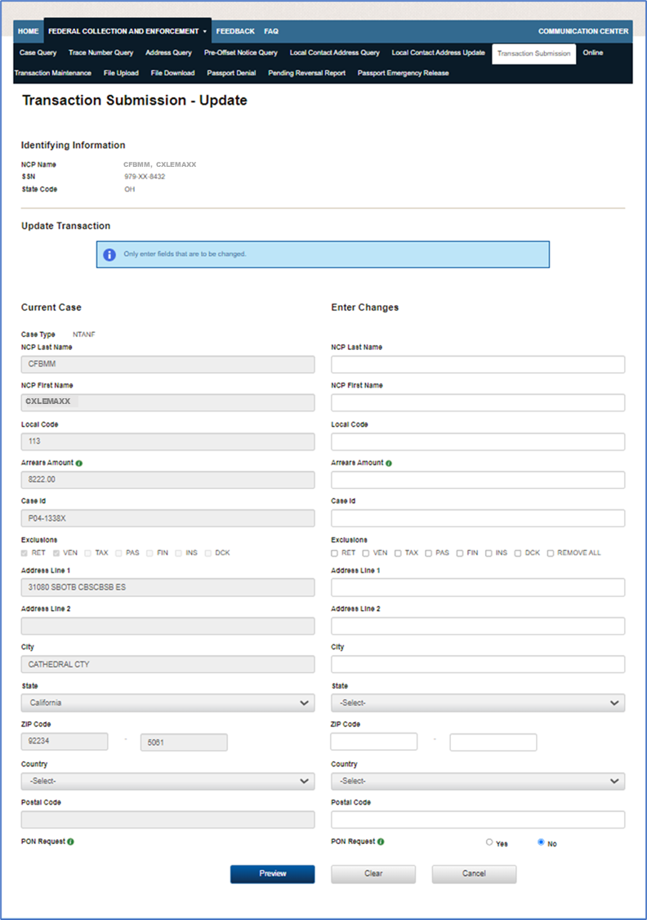

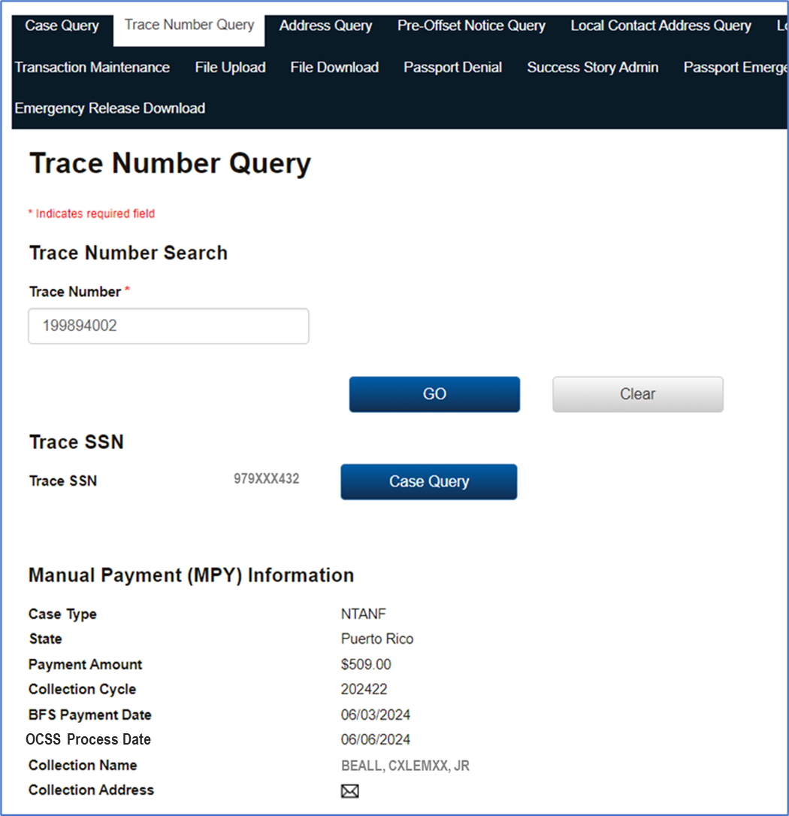

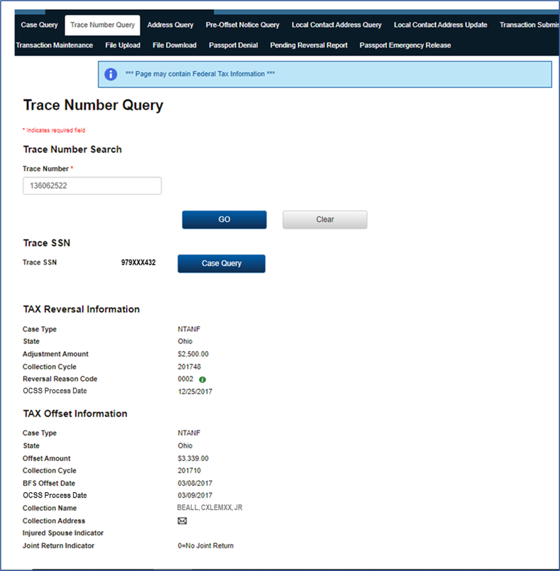

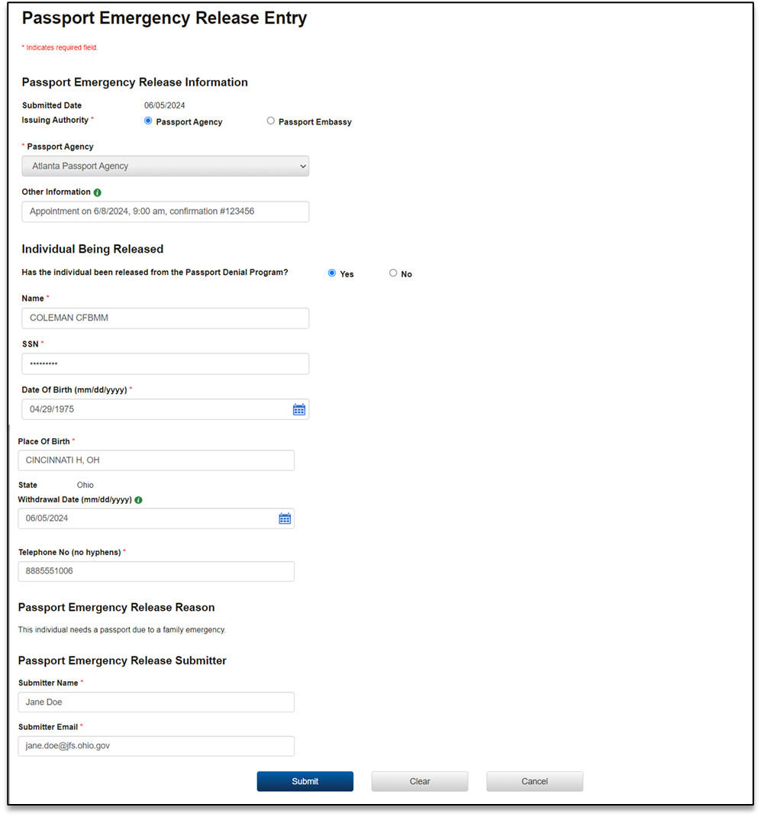

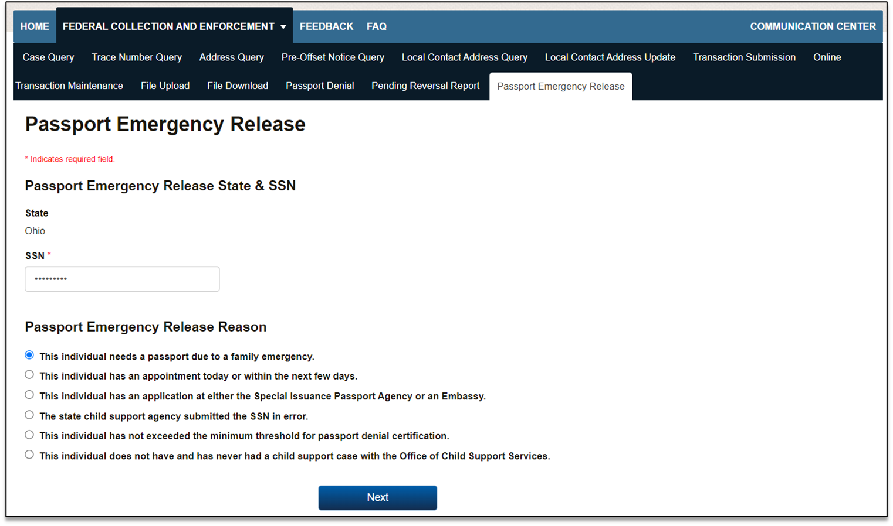

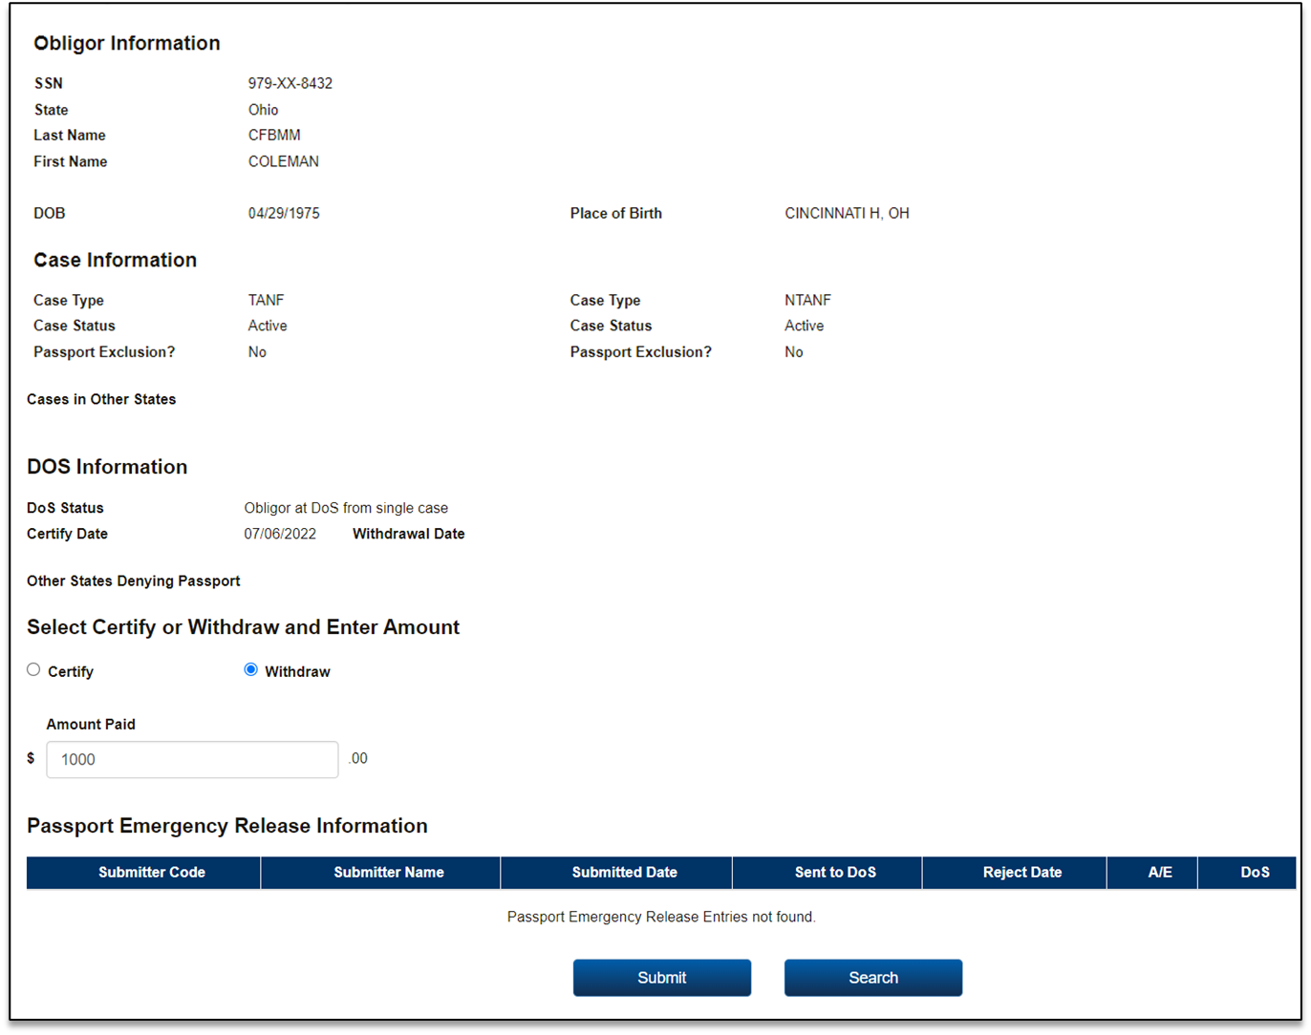

**PAPERWORK REDUCTION ACT OF 1995 (Pub. L. 104-13) STATEMENT OF PUBLIC BURDEN:** The purpose of this statutorily required (42 U.S.C. 652(b); 42 U.S.C. 664; 26 U.S.C. 6402(c); 31 CFR 285.3; 45 CFR 302.60; 45 CFR 303.72; 31 U.S.C. 3701 *et seq*.; 31 U.S.C. 3716(h); 31 CFR 285.1; 42 U.S.C. 652(k); 42 U.S.C. 654(31); 22 CFR 51.60; 42 U.S.C. 654(31); 42 U.S.C. 664; 31 CFR 285.1; and 31 CFR 285.3) information collection is to collect past due child support. Public reporting estimated burden for this collection of information is 0.01 hours per respondent, including the time for reviewing instructions, gathering and maintaining the data needed, and reviewing the collection of information. As provided by the 5 U.S.C. §§552a(b) and (e), any confidential information collected for this program is protected secured, and accessed only by authorized users. A federal agency may not conduct or sponsor an information collection without a valid OMB Control Number. No individual or entity is required to respond to, nor shall an individual or entity be subject to a penalty for failure to comply with a collection of information subject to the requirements of the Paperwork Reduction Act of 1995, without a current valid OMB Control Number. If you have any comments on this collection of information, please contact [OCSSFedSystems@acf.hhs.gov](mailto:OCSSFedSystems@acf.hhs.gov).