**Note: The information in the screenshots is intended for demonstration purposes only and does not contain personally identifiable or sensitive information.**

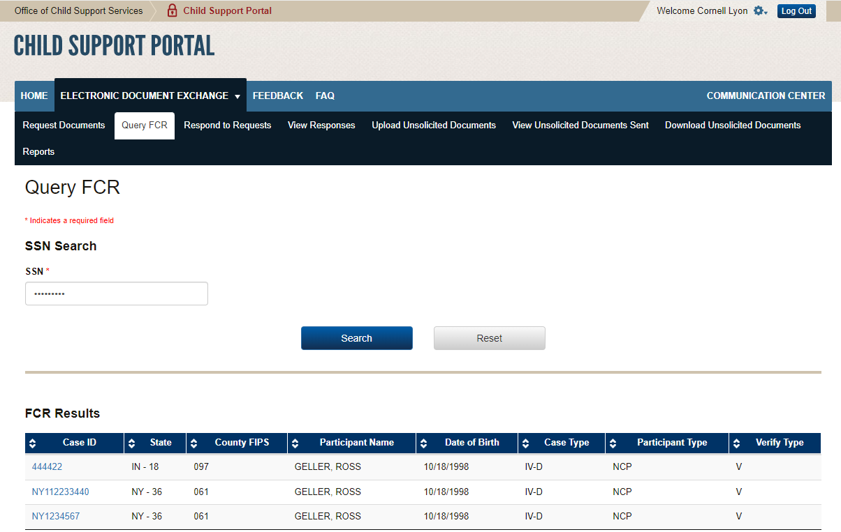

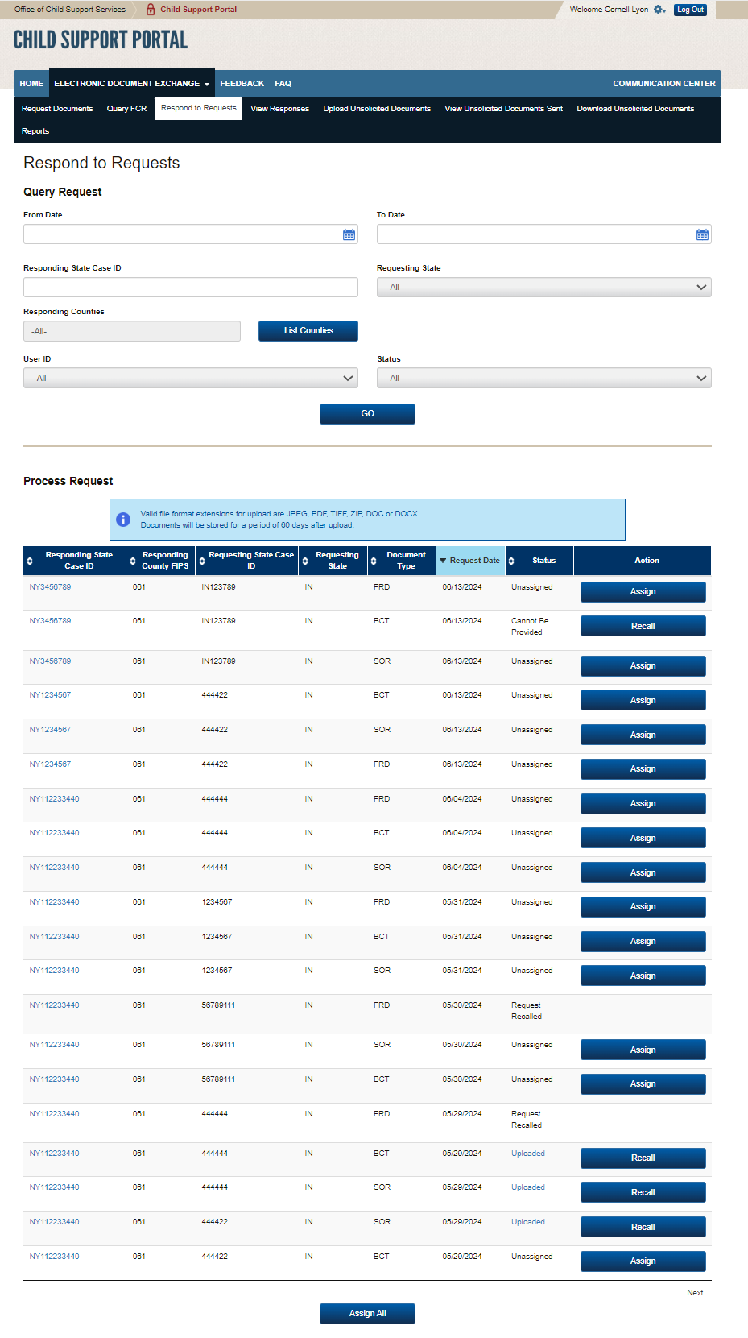

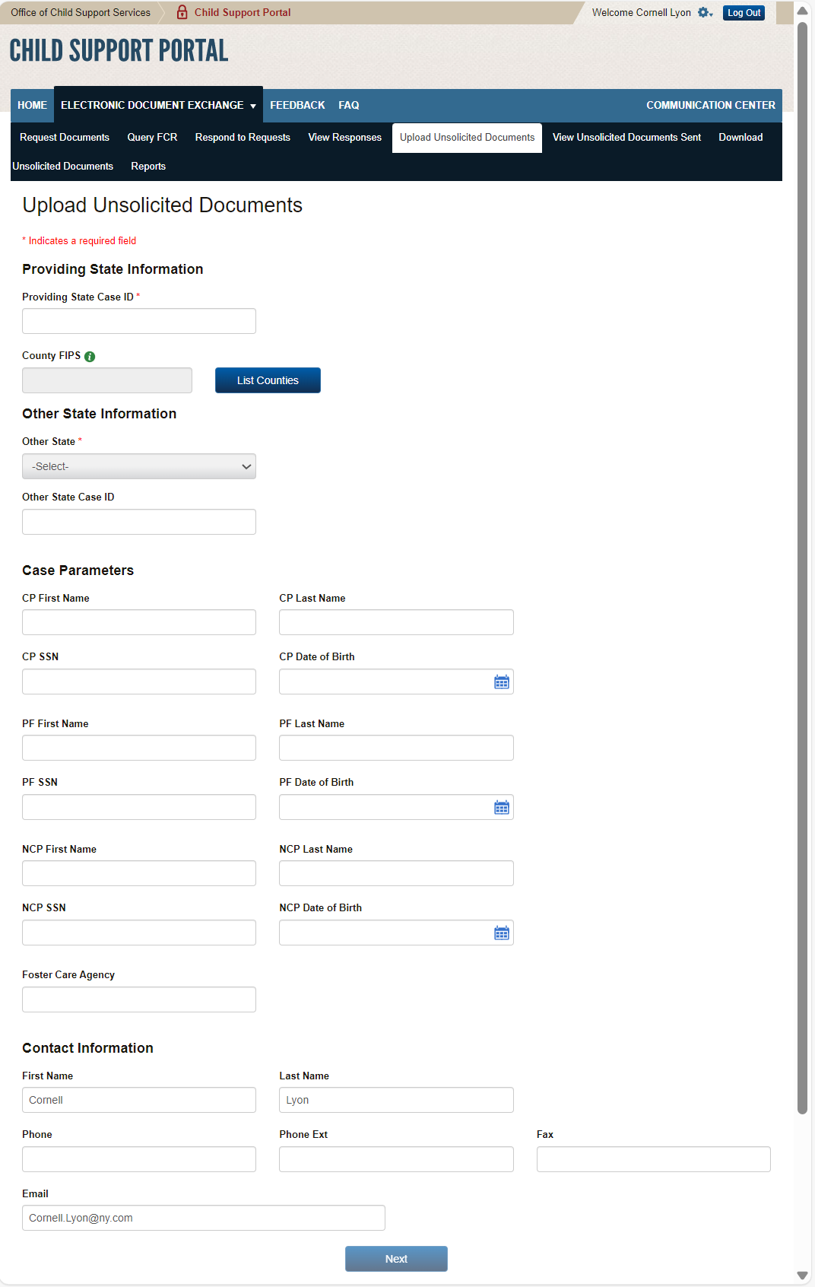

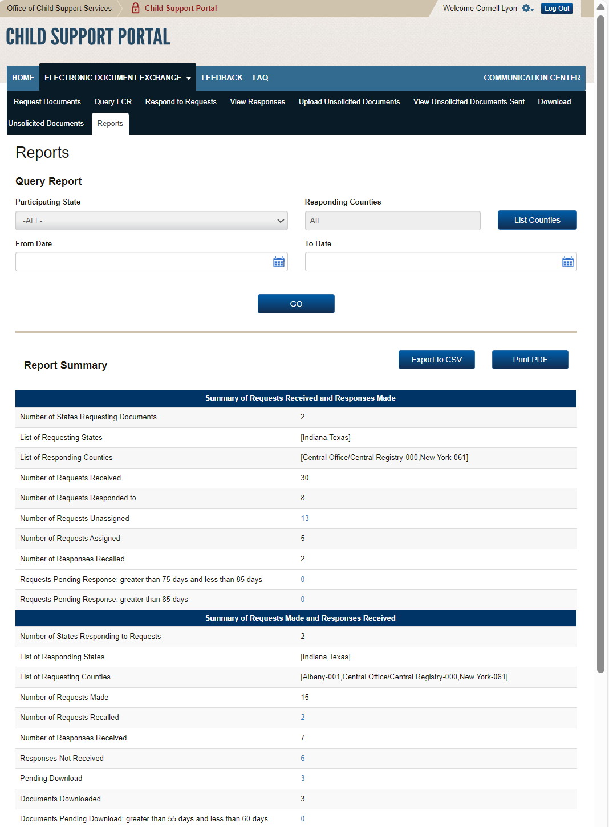

PAPERWORK REDUCTION ACT OF 1995 (Pub. L. 104-13) STATEMENT OF PUBLIC BURDEN: The purpose of this voluntary information collection is for authorized users in state child support agencies to exchange case documents electronically with other state child support agencies. Public reporting estimated burden for this collection of information is 0.17 hours per respondent, including the time for reviewing instructions, gathering and maintaining the data needed, and reviewing the collection of information. As provided by 42 U.S.C 653(m)(2), any confidential information collected for this program is secured and accessed only by authorized users. A federal agency may not conduct or sponsor an information collection without a valid OMB Control Number. No individual or entity is required to respond to, nor shall an individual or entity be subject to a penalty for failure to comply with a collection of information subject to the requirements of the Paperwork Reduction Act of 1995, without a current valid OMB Control Number. If you have any comments on this collection of information, please contact [OCSSFedSystems@acf.hhs.gov](mailto:OCSSFedSystems@acf.hhs.gov)