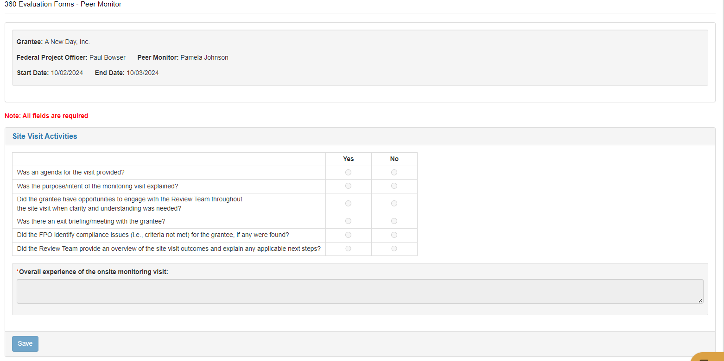

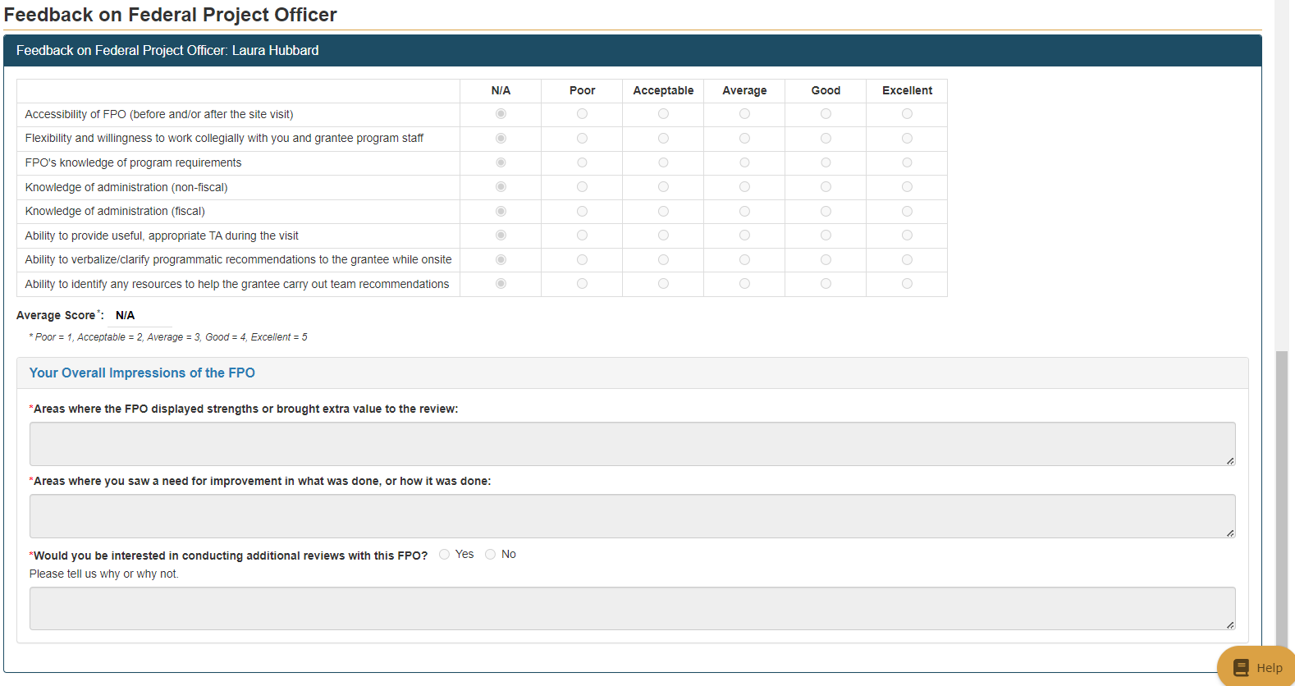
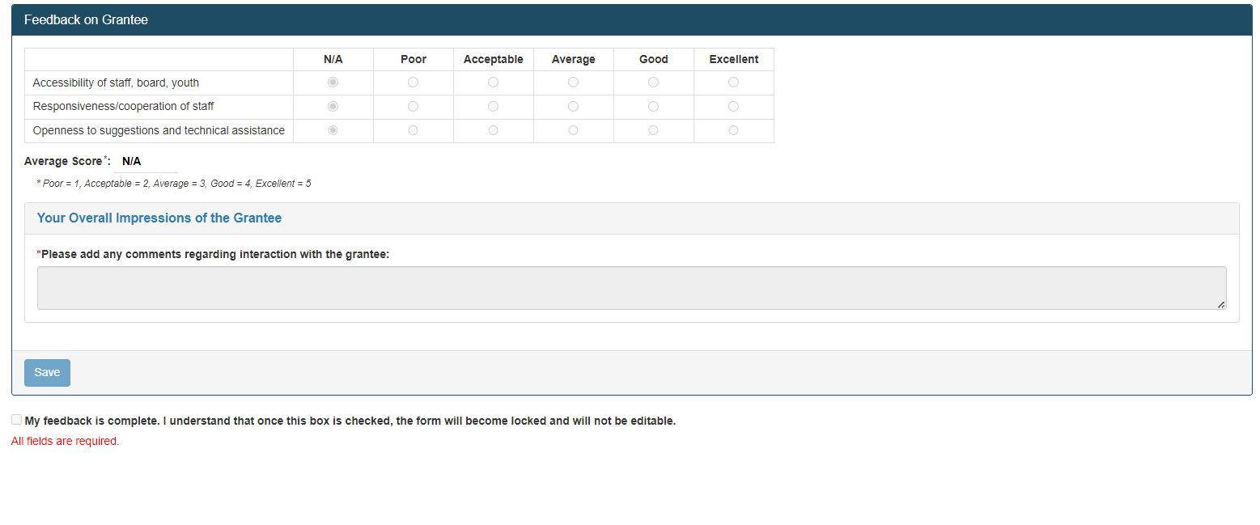
PAPERWORK REDUCTION ACT OF 1995 (Pub. L. 104-13) STATEMENT OF PUBLIC BURDEN: The purpose of this information collection is to collect feedback on RHY on-site monitoring processes. Public reporting burden for this collection of information is estimated to average 10 minutes per response, including the time for reviewing instructions, gathering and maintaining the data needed, and reviewing the collection of information. This is a voluntary collection of information. An agency may not conduct or sponsor, and a person is not required to respond to, a collection of information subject to the requirements of the Paperwork Reduction Act of 1995, unless it displays a currently valid OMB control number. The OMB # is 0970-0401 and the expiration date is 05/31/2027. If you have any comments on this collection of information, please contact help@gmatterstech.com.

NOTE: This entire document is one page online and the Paperwork Reduction Act statement is at the end of the document.

