Operations, Maintenance, and Enhancements for OCSS Systems
Electronic National Medical Support Notice
Software Interface Specification
Version 1.6
August 23, 2023
Administration for Children and Families
Office of Child Support Services
330 C Street SW, 5th Floor
Washington, DC 20201
Revision History
Date | Revision | Section* | Author
3/29/2021 | v1.0: Original release | Entire document | H. Rallapalli
6/29/2021 | v1.1: Minor updates | Sections 1, 2.11.1, and 2.11.2 | H. Rallapalli
8/18/2021 | v1.2: Minor updates | Changed .PDF to.pdf in all locations with sample file names | H. Rallapalli
1/31/2022 | v1.3: Minor updates | Entire document | H. Rallapalli
4/20/2022 | v1.4: Minor Updates | Sections 2.4, 2.10, 2.11 Chart 2-4 | M. Stanczyk
1/27/2023 | v1.5: Split document body and appendices into separate files | Entire document | J. Vierow
8/23/2023 | v1.6: Major updates | Entire document | M. Stanczyk
*See individual appendix files for specific changes to the appendices.
Table of Contents
1 Introduction 1-1
1.1 Purpose of Document 1-2
2 e-NMSN Files 2-1
2.1 Connectivity 2-1
2.2 Connectivity Requirements 2-1
2.3 Connectivity Testing 2-2
2.4 File Types 2-3
2.5 File Format 2-4
2.6 File Extensions 2-4
2.7 File Structure 2-4
2.8 Appending Files, Sending Multiple Files, and Zipping 2-5
2.9 File Names 2-5
2.10 File Processing 2-7
2.10.1 Daily Processing 2-7
2.10.2 Batching Files 2-7
2.10.3 Reject and Error Processing 2-8
2.10.4 Record Processing 2-9
2.10.5 e-NMSN 2-9
2.11 PDF Version of NMSN Form 2-9
2.11.1 Plan Summary 2-9
2.11.2 Multiple Insurance Options 2-10
2.11.3 Ineligible Children Details 2-11
2.12 PDF File Creation and Naming 2-11
2.13 e-NMSN Profile 2-14
2.14 Email Notification 2-14
3 e-NMSN Input Transaction Layouts 3-1
3.1 State Request File 3-1
3.2 Part-A Response File 3-1
3.3 Part-B Response File 3-2
List of Figures and Charts
Figure 1-1: Process Diagram 1-3
Figure 2-1: Connectivity 2-1
Figure 2-2: File Structure 2-4
Figure 2-3: Email Notification (States) 2-16
Figure 2-4: Email Notification (Employers, Third-party Providers, or Plan Administrators) 2-17

Chart 1-1: Supported File Types 1-1
Chart 2-1: e-NMSN Standard File Name for States 2-5
Chart 2-2: e-NMSN Part-A Response Standard File Name 2-6
Chart 2-3: e-NMSN Part-B Response Standard File Name 2-6
Chart 2-4: File Name and Naming Convention Examples 2-7
Chart 2-5: e-NMSN Standard File Name for PDF Request Files 2-11
Chart 2-6: e-NMSN Part-A Response Standard File Name for PDF 2-12
Chart 2-7: e-NMSN Part-B Response Standard File Name 2-13
Chart 2-8: File Name and Naming Convention Examples 2-13

Introduction
Automating the National Medical Support Notice (NMSN) facilitates the electronic exchange of healthcare coverage information between states and employers through a centralized process. The goal of centralizing the electronic NMSN (e-NMSN) process is to reduce costs and paperwork and increase efficiency by using the federal Office of Child Support Services (OCSS) Child Support Portal. On June 5, 2023, the Administration for Children and Families published a notice in the Federal Register Volume 88, Number 107, Page 36587, to announce that the Office of Child Support Enforcement is now the Office of Child Support Services (OCSS). Any reference to OCSE has now been changed to OCSS as they are one and the same.

Currently, states send NMSNs to employers, and employers and plan administrators send NMSN responses to states — nearly all on paper. The OCSS centralized process is the hub for transmitting files. OCSS picks up e-NMSNs from states and transmits them to employers, third-party providers, and plan administrators. OCSS picks up responses and delivers them to states. This is an efficient process because all stakeholders involved transmit information to OCSS only, minimizing communication setups with individual employers, third-party providers, plan administrators, and states.
Chart 1-1 lists the file type options in which states, employers, third-party providers, and plan administrators must send and receive files.
Chart 1-1: Supported File Types
Option | File Type | Availability
Programming Option (System-to-System) | Text | States, employers, third-party providers, and plan administrators
Programming Option (System-to-System) | XML | States, employers, third-party providers, and plan administrators
No Programming Option | PDF | Employers, third-party providers, and plan administrators
Depending on the file type used, take the action described below:
- If using the text file type, then use the record layouts in Appendices A through E.
Note: The e-NMSN SIS Appendices A through F have been broken out into separate files.
- If using the Extensible Markup Language (XML) file type, then contact the e-NMSN coordinator for the XML Schema Definition (XSD) files. Field-level validation, which are performed by OCSS when files are received, is the same as a text file. For field-level validation details, see Appendices A through E.
- If using the Portable Document Format (PDF) file type, then contact the e-NMSN coordinator for sample PDFs. Field-level validation, which are performed by OCSS when files are received, is the same as for a text file. For field-level validation details, see Chart C-2 in Appendix C, Chart D-2 in Appendix D, and Chart E-2 in Appendix E.
The file naming convention for PDF files is different from text and XML files; for more information, see sections 2.11 and 2.12.

Purpose of Document
This document describes the process required for states, employers, third-party providers, and plan administrators to exchange NMSN requests and responses via the e-NMSN system. The file naming convention, file types, connectivity, emails, and transaction record layouts of the e-NMSN system are included. The transaction record layouts include the following:
- e-NMSN Version Number Record
- e-NMSN Request Record
- e-NMSN Part-A Response Record
- e-NMSN Part-B Response Record
Figure 1-1 shows the e-NMSN process.
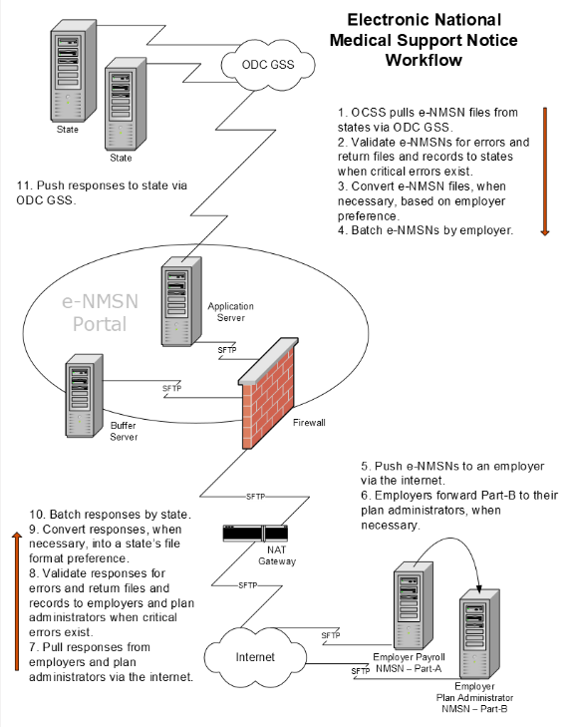
Figure 1-1: Process Diagram

e-NMSN Files
The Child Support Portal houses the e-NMSN system. The system is capable of transmitting standard, fixed-length files between states, employers, third-party providers, and plan administrators.
The following sections describe the email notification process and the connectivity, file types, file extensions, and formats submitted to the e-NMSN system.

Connectivity
Figure 2-1 shows the site architecture that supports the file transmission and connections needed for the exchange between states, employers, third-party providers, and plan administrators.
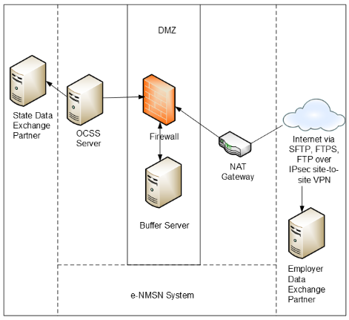
Figure 2-1: Connectivity

Connectivity Requirements
States connect to the OCSS network through Internet Protocol Security (IPsec) site-to-site Virtual Private Networks (VPNs). States exchange e-NMSN data through this connection to a Secure File Transfer Protocol (SFTP) or File Transfer Protocol Secure (FTPS) server at the state. An IPsec site-to-site VPN must be established between OCSS and the state.
OCSS connects to employers, third-party providers, and plan administrators through the internet with SFTP or FTPS. Employers, third-party providers, and plan administrators using the OCSS electronic Income Withholding for Support Order (e-IWO) process generally use their existing transfer connection as long as the connection is using SFTP or FTPS. If employers and plan administrators do not have an e-IWO connection using SFTP or FTPS, then other options for connecting to the e-NMSN system would need to be arranged.
All e-NMSN files require a designated location on the state SFTP or FTPS server for pickup and delivery. This requires a user ID and password to log on to the server. Secure Shell (SSH) key authentication can be used instead of a password if the state, employer, third-party provider, or plan administrator requests it. Read and write privileges on files must be granted to the user ID used by OCSS to log on to the state, employer, third-party provider, or plan administrator server. If using SFTP, the state can use the standard Transmission Control Protocol (TCP) port (22) or another TCP port on request.
The Gnu (https://www.gnupg.org/) Privacy Guard (GPG) encryption system is optionally provided by the e-NMSN system to encrypt data after it reaches the employer’s server. GPG is an open source variation of the Pretty Good Privacy (PGP) system encryption (https://www.broadcom.com/products/cyber-security/information-protection/encryption). Employers, third-party providers, and plan administrators must provide public keys for SFTP and GPG.
Use the following process to set up SFTP without a password and to use public-private keys:
- Create a public-private key pair for a user on the server by running the following command: ssh-keygen -t rsa.
- Create a public-private key pair for the user on the client by running the following command: ssh-keygen -t rsa.
The public-private key pair default locations are /home/xx/.ssh/id_rsa.pub and /home/xx/.ssh/id_rsa.
- OCSS emails its SSH public key to states, employers, third-party providers, and plan administrators.
- The employers, third-party providers, and plan administrators append the OCSS SSH public key to the /home/xx/.ssh/authorized_keys file on their SFTP servers.

Connectivity Testing
States, employers, third-party providers, and plan administrators can conduct connectivity testing with the e-NMSN system after they supply all necessary keys, Internet Protocol (IP) addresses, host names, user IDs, directories, and related information needed for connectivity. States, employers, third-party providers, and plan administrators can also coordinate a connectivity test by contacting the e-NMSN coordinator.
The suggested series of tests for the e-NMSN system includes:
- Ping the state, employer, third-party provider, and plan administrator SFTP or FTPS servers.
- Send a file to the states, employers, third-party providers, and plan administrators using SFTP or FTPS without testing GPG encryption.
- Send the same file to the states, employers, third-party providers, and plan administrators using SFTP or FTPS and testing GPG encryption.
If possible, testing the transfer of files between a state and employers, third-party providers, and plan administrators or vice versa is also suggested.

File Types
The various files transmitted via the e-NMSN system include the following:
- State Request File: An e-NMSN file generated by the state and sent to employers. At this time, the system does not include cover letters.
- Part-A Response File: A file generated by the employer or third-party provider and returned to the state. The file contains records for each request, indicates a response, and, if rejected, the reason for the rejection.
- Part-B Response File: A file generated by the employer, third-party provider, or plan administrator and returned to the state. The file contains one of the following possible responses:
  - Insurance information and the date the insurance becomes effective
  - A request for the state to choose a plan option if multiple are available
  - A waiting period for the employee and its expiration date or other expiration period
  - A reason the NMSN is not a “qualified medical child support order”
- State Error File: A file generated by the e-NMSN system in response to the receipt and validation of a state request. This contains the errors found in these files.
- Error File: A file generated by the e-NMSN system in response to the receipt and validation of an employer, third-party provider, or plan administrator response. This contains the errors found in these files.
- e-NMSN PDF Form Files: An Office of Management and Budget (OMB)-approved file. OMB renews its approval of these forms every three years.
For a form version of the order created by the e-NMSN system, go to https://www.acf.hhs.gov/css/form/national-medical-support-notice-forms-instructions.
Note: Error files are required. e-NMSN PDF Form files are optional, as determined by the completed e-NMSN Profile form; see section 2.13, e-NMSN Profile.

File Format
The e-NMSN process accepts State Request files and sends a State Error file in text or XML file formats.
Part-A Response files, Part-B Response files, and error files can be transferred as either XML or flat files.
The e-NMSN Form files are sent as PDF files.

File Extensions
States, employers, third-party providers, and plan administrators must include file extensions for all files. If the e-NMSN system receives a file from a state, employer, third-party provider, or plan administrator that does not include a file extension, the file is rejected and a processing summary email is generated with an error message.

File Structure
Whether using XML or a flat file, the primary files (State e-NMSN Request file and Error file) all adhere to the same file structure. Each file must contain a version number record, file header record, batch header record, detail records, batch trailer record, and a file trailer record. These record layouts are presented in section 3, e-NMSN Input Transaction Layouts.
Figure 2-2 shows the file structure to which the text files must adhere.
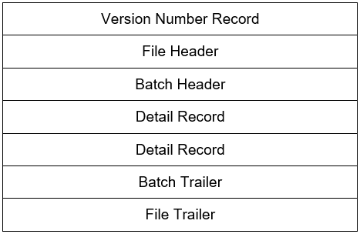
Figure 2-2: File Structure
The following requirements apply to text files:
- Each file must contain a version number record.
- Each file must contain at least one batch header and a batch trailer.
- Each file must include a file header and trailer.
- All records must start with a three-digit document code identifying the type of record.
- Document code values must display as specified in the record layouts in Appendices A through E.
- The system batches state requests by the employer.
- The system batches Part-A responses by the state.
- The system batches Part-B responses by the state.

Appending Files, Sending Multiple Files, and Zipping
Flat files can be appended. This means if a connectivity issue occurs between a state, employer, or plan administrator and the e-NMSN system, multiple files can be appended for those using flat files. Those using XML files must create separate files.
Each e-NMSN form is created in a separate file.

File Names
States, employers, third-party providers, and plan administrators supply file names for files through the e-NMSN Profile form. They can use a predefined naming standard unique to their organization, which must be a unique constant name and cannot be a variable, or the e-NMSN system’s standard file name. File names will be agreed upon between OCSS and the states, employers, third-party providers, and plan administrators during connectivity setup. File names are not case sensitive. File names for the e-NMSN PDF Order forms generated by the system are included in section 2.12, PDF File Creation and Naming.
Chart 2-1 specifies the values of each section of the e-NMSN standard file name.
Chart 2-1: e-NMSN Standard File Name for States
Field Name | Value
Identifier | Federal Information Processing Standards (FIPS) + 0000000  The nine digits are the two-digit locator code plus seven zeros.
Separator | Period (.)
File Type | ENR: e-NMSN Request file from the state  NER: Error file to the state  PAR: Valid Part-A Response file to the state  PBR: Valid Part-B Response file to the state
Separator | Period (.)
Date – Timestamp | CCYYMMDDHHMMSSS
Separator | Period (.)
Sequence Number | 0000
Separator | Period (.)
Extension Type | TXT: Text file extension  XML: Extensible Markup Language file extension
Chart 2-2 specifies the values of each section of the e-NMSN standard file name for a Part-A Response from employers and third-party providers.
Chart 2-2: e-NMSN Part-A Response Standard File Name
Field Name | Value
Identifier | Federal Employer Identification Number (FEIN):  If an employer is sending a response to Part-A, this is the nine-digit employer FEIN.  If a third-party provider is sending a response to Part-A, this is the nine-digit third-party provider FEIN.
Separator | Period (.)
File Type | ENM: e-NMSN Request file to the employer  ARE: Part-A Error file to the employer  ARF: Part-A Response file from the employer
Separator | Period (.)
Date – Timestamp | CCYYMMDDHHMMSSS
Separator | Period (.)
Sequence Number | 0000
Separator | Period (.)
Extension Type | TXT: Text file extension  XML: Extensible Markup Language file extension
Chart 2-3 specifies the values of each section of the e-NMSN standard file name for a Part-B Response from the employer, third-party provider, or plan administrator.
Chart 2-3: e-NMSN Part-B Response Standard File Name
Field Name | Value
Identifier | FEIN:  If an employer is sending a response to Part-B, this is the nine-digit employer FEIN.  If a third-party provider is sending a response to Part-B, this is the nine-digit third-party provider FEIN.  If a plan administrator is sending a response to Part-B, this is the nine-digit plan administrator FEIN.
Separator | Period (.)
File Type | BRE: Part-B error file to the employer or plan administrator  BRF: Part-B Response file from the employer or plan administrator
Separator | Period (.)
Date – Timestamp | CCYYMMDDHHMMSSS
Separator | Period (.)
Sequence Number | 0000
Separator | Period (.)
Extension Type | TXT: Text file extension  XML: Extensible Markup Language file extension
Chart 2-4 shows examples of different files and naming conventions for states, employers, third-party providers, and plan administrators.
Chart 2-4: File Name and Naming Convention Examples
Sample e-NMSN State File Names | Description
180000000.ENR.202002190225081.0001.txt or xml | e-NMSN Request file from the state
180000000.NER.202002190225081.txt or xml | Error file to the state
180000000.PAR.202002190225081.0001.txt or xml | Valid Part-A Response file to the state
180000000.PBR.202002190225081.0001.txt or xml | Valid Part-B Response file to the state
Sample e-NMSN File Names for Employer | Description
123456789.ENM.202002190225081.0001.txt or xml | e-NMSN Request file to the employer or third-party provider
123456789.ARE.202002190225081.txt or xml | Part-A Error file to the employer or third-party provider
123456789.ARF.202002190225081.0001.txt or xml | Part-A Response file from the employer or third-party provider
Sample e-NMSN Response File Names | Description
123456789.BRE.202002190225081.txt or xml | Part-B Error file to the employer, third-party provider, or plan administrator
123456789.BRF.202002190225081.0001.txt or xml | Part-B Response file from the employer, third-party provider, or plan administrator
123456789.987654321.BRF.202002190225081.0001.txt or xml | Part-B Response file from the employer, third-party provider, or plan administrator in which the second FEIN is the FEIN of the subsidiary or client linked to the responding employer or third-party provider
Note: For definitions of the files listed in this chart, see section 2.4, File Types.

File Processing

Daily Processing
Daily file processing starts at 5:30 a.m. ET. The e-NMSN system pushes all files to states, employers, third-party providers, and plan administrators by 6:45 a.m. ET. The e-NMSN system sends email notifications for the day’s processing starting at 7:00 a.m. ET.

Batching Files
States providing e-NMSN requests must group the orders in a batch by surrounding each group of orders with a batch header and batch trailer.
Employers, third-party providers, and plan administrators must group responses in a batch by surrounding each group of responses with a batch header and batch trailer.
The following assumptions will assist states and employers when batching their files:
- States batch e-NMSN requests by employer.
- There can be more than one batch in a state e-NMSN Request file for the same employer.
- Employers, third-party providers, and plan administrators batch responses by state.
- There can be more than one batch in an employer, third-party provider, or plan administrator file for the same state.
- Employer, third-party provider, and plan administrator Response files are batched according to the batches received from a state. For example, if State A sends Batch A on Monday and Batch B on Tuesday, the employer, third-party provider, or plan administrator Response file sent to the state on Wednesday may include two batches for State A.

Reject and Error Processing
The e-NMSN process performs validation on all inbound files to comply with the specifications. Strict validation occurs for structure and fields. The e-NMSN process rejects or returns files for three levels of errors: file, batch, and record.
Full file rejection can occur for the following reasons:
- Invalid file extension
- Invalid record length
- Invalid record sequencing
- Invalid or missing record identifier
- XML validation failed
- PDF validation error
- Empty files
- Invalid batch count in the file trailer
- Invalid or missing required data in the file header or trailer
- Failed validation for conditionally required fields on the file header or trailer
- Duplicate file
- The total number of records submitted in the batch and the record count do not match
- Invalid or missing required data in the batch header or trailer
- Invalid or missing subsidiary or client FEIN in the file header or trailer
If a file does not have a file extension or the file extension is not the file extension specified in the profile information, the file is returned in its entirety. If a problem occurs when processing the file because of this assumption, all files for the data exchange provider are returned to the provider.
Batch rejection occurs for the following reasons:
- The FEIN or state code entered may not participate in e-NMSN.
- Duplicate batch.
- Failed validation for conditionally required fields on the batch header or trailer.
Individual records can be returned for errors in the following instances:
- Conditionally required fields do not comply with the validation rules.
- Data is invalid due to noncompliance with data type rules or not following specified patterns.
- Invalid or missing required data in individual records.

Record Processing
Flat files must adhere to the e-NMSN record layouts. Data element rules are provided in Appendices A through E. XML files must adhere to the XML schema. XML schema files are available on request. The schemas include the record layout and the restrictions used to validate the information. The data element rules supplied through the flat file record layouts adhere to the data element rules defined in the XML schemas.

e-NMSN
The e-NMSN is a digital alternative to the paper form. OCSS developed a standard record layout designed to closely match the paper version of the OMB-approved NMSN form. The scope of the e-NMSN system is limited to processing NMSNs on IV-D child support agency cases. The e-NMSN system transfers the e-NMSN as a data file to employers. The e-NMSN system can create and forward a PDF version of the OMB-approved form with the data file to an employer if requested. The record layouts are based on the information in the NMSN form.

PDF Version of NMSN Form
State child support agencies are required to send the NMSN, comprised of Part-A and Part-B, to employers to enforce medical support orders.
The employer may be required to send a copy of the NMSN to the employee. The employer can opt to create the NMSN or request that the e-NMSN system create a PDF version of the NMSN. If an employer or third-party provider always or never wants a PDF version of the form, they can specify their preference on the e-NMSN Profile form.
Each e-NMSN form is saved as a PDF file. For example, a data file processed by the e-NMSN system that contains five NMSNs generates five PDF files. This action is based on the information provided by the employer on the Profile form.

Plan Summary
When employers, third-party providers, and plan administrators are responding with Part-B and provide an attachment with an insurance plan summary and insurance coverage information, they must use the following format to name the file and generate the insurance plan summary document:
Y,ThirdPartyorPlanAdministratorFEIN.EmployerFEIN.EmployeeLastname.CCYYMMDDHHMM.sequenceNumber.pdf or Word (all versions)
Example: Y, 123456789.999999999.JONE.202105191055.001.pdf
When an employer sends the file, the first node is not required (that is, ThirdPartyorPlanAdministratorFEIN).
Note: All insurance coverage information must be provided in the Addendum, Section 1. When OCSS generates the PDF, the text “Use Addendum – Section 1” is inserted in the enrollment data field and must use “Section 1” in the Addendum pages to provide the insurance coverage information.
If an additional document is attached to the response and option 2 is selected, insert text according to the example below. The values must be comma separated as shown below:.
Example: Y, 123456789.999999999.JONE.202105191055.001.pdf
The Y indicator makes the e-NMSN system look for an attachment file with the name provided after Y.
The attachment file will be stored in the same directory as the Part-B Response files.

Multiple Insurance Options
If option 3 is selected on the Part-B response and a Plan Options document is available to share with states, use the following naming convention
Y, ThirdPartyorPlanAdministratorFEIN.EmployerFEIN.EmployeeLastname.CCYYMMDDHHMM.sequenceNumber.pdf or Word (all versions)
Example: Y, 123456789.999999999.JONE. 202105191055.001.pdf
This naming convention is applicable when attaching the Plan Options document for an e-NMSN response and the plan options are unique for this employee or response.
When an employer has a single PDF or Word document for plan options for multiple e-NMSN responses, the employer can choose to use a name of their choice and a prefix with the employer FEIN and include this name in all Part-B PDF responses submitted for option 3. This action reduces the number of attachments sent with responses.
Values in this field must be structured as follows:
Example: Y, ThirdPartyorPlanAdministratorFEIN.EmployerFEIN.Employer_Chosen_Name.CCYYMMDDHHMM.pdf
When an employer sends a file, the first node (that is, ThirdPartyorPlanAdministratorFEIN) is not required.
The Y indicator makes the e-NMSN system look for an attachment with the name provided after Y. Values must be comma separated.
Note: All plan options must be included in one Word or PDF file.

Ineligible Children Details
If option 5 is selected on the Part-B response, use Section 2 in the Addendum to provide details about children who are not eligible for insurance coverage.
When OCSS generates the PDF, the text “Use Addendum – Section 2” is inserted in the “No longer eligible for coverage under the plan enrollment” data field.

PDF File Creation and Naming
This section explains how the e-NMSN system creates PDF files, which are sent with a flat file or XML file.
Chart 2-5 specifies the values of each section of the e-NMSN standard PDF file name for request files generated by OCSS to employers and third-party providers.
Chart 2-5: e-NMSN Standard File Name for PDF Request Files
Field Name | Value
Third-party Identifier | FEIN (Third-party provider): Nine-digit FEIN of the third-party provider.  This node is only present if the file is generated for a third-party provider.
Separator | Period (.)
Identifier | FEIN: Nine-digit FEIN of the employer
Separator | Period (.)
Identifier | FIPS: Two-digit locator code of state where the request originated
Separator | Period (.)
File Type | ENM: Request file to the employer or third-party provider
Separator | Period (.)
Employee Order Information | Employee Last Name: Last name of the employee in the PDF order  “_” – Separator  Document Tracking Identifier – Document Tracking Identifier of the order in the PDF
Separator | Period (.)
Batch Number | Batch number from the Request file from the state
Separator | Period (.)
Version Number | Version number of the PDF:  V1_0: Current Version  1: Major Version Number  “_”: Separator  0: Minor Version Number
Separator | Period (.)
Sequence Number | 0000
Separator | Period (.)
Order Type | OA: Part-A Request PDF  OB: Part-B Request PDF
Separator | Period (.)
Extension Type | PDF: Portable Document Format file extension
Chart 2-6 specifies the values of each section of the e-NMSN standard file name for a Part-A Response from employers and third-party providers.
Chart 2-6: e-NMSN Part-A Response Standard File Name for PDF
Field Name | Value
Third-party Identifier | FEIN (Third-party provider): Nine-digit FEIN of the third-party provider.  This node is only required if the file is received from a third-party provider.
Separator | Period (.)
Identifier | FEIN: Nine-digit FEIN of the employer
Separator | Period (.)
Identifier | FIPS: Two-digit locator code of the state where the request originated
Separator | Period (.)
File Type | ARF: Part-A Response file from the employer or third-party provider  ARE: Part-A Error File to the employer or third-party provider
Separator | Period (.)
Employee Order Information | Employee Last Name: Last name of the employee in the PDF response  “_” – Separator  Document Tracking Identifier – Document Tracking Identifier of the order in the PDF response
Separator | Period (.)
Batch Number | Batch number from the request file from the state
Separator | Period (.)
Version Number | Version number of the PDF:  V1_0: Current Version  1: Major Version Number  “_”: Separator  0: Minor Version Number
Separator | Period (.)
Sequence Number | 0000
Separator | Period (.)
Extension Type | PDF: Portable Document Format file extension
Chart 2-7 specifies the values of each section of the e-NMSN standard file name for a Part-B response from the employer, third-party provider, or plan administrator.
Chart 2-7: e-NMSN Part-B Response Standard File Name
Field Name | Value
Identifier | FEIN (Third-party provider): Nine-digit FEIN of the third-party provider.  This node is only required if the file is received from a third-party provider or plan administrator.
Separator | Period (.)
Identifier | FEIN: Nine-digit FEIN of the employer
Separator | Period (.)
Identifier | FIPS: Two-digit locator code of the state where the request originated
Separator | Period (.)
File Type | Employer, third-party provider, or plan administrator:  BRF: Part-B Response file  BRE: Part-B Error file
Separator | Period (.)
Employee Order Information | Employee Last Name: Last name of the employee in the PDF response  “_”: Separator  Document Tracking Identifier – Document Tracking Identifier of the order in the PDF response
Separator | Period (.)
Batch Number | Batch number from the request file from the state
Separator | Period (.)
Version Number | Version number of the PDF:  V1_0: Current Version  1: Major Version Number  “_”: Separator  0: Minor Version Number
Separator | Period (.)
Sequence Number | 0000
Separator | Period (.)
Extension Type | PDF: Portable Document Format file extension
Chart 2-8 shows examples of files and naming conventions for employers, third-party providers, and plan administrators.
Chart 2-8: File Name and Naming Convention Examples
Sample e-NMSN Standard File Name for PDF Request Files | Description
999999999.02.ENM.JONE_58288.12345.V1_0.0001.OA.pdf | e-NMSN Part-A Request file to the employer
999999999.02.ENM.JONE_58288.12345.V1_0.0001.OB.pdf | e-NMSN Part-B Request file to the employer
123456789.999999999.02.ENM.JONE_58288.12345.V1_0.0001.OA.pdf | e-NMSN Part-A Request file to the third-party provider
123456789.999999999.02.ENM.JONE_58288.12345.V1_0.0001.OB.pdf | e-NMSN Part-B Request file to the third-party provider
Sample e-NMSN Part-A Response File Names for PDF Files | Description
999999999.02.ARF.JONE_58288.12345.V1_0.0001. pdf | Part-A Response file from the employer
999999999.02.ARE.JONE_58288.12345.V1_0.0001. pdf | Part-A Error file to the employer
123456789.999999999.02.ARF.JONE_58288.12345.V1_0.0001.pdf | Part-A Response file from the third-party provider
123456789.999999999.02.ARE.JONE_58288.12345.V1_0.0001.pdf | Part-A Error file to the third-party provider
Sample e-NMSN Part-B Response File Names for PDF Files | Description
999999999.02.BRF.JONE_58288.12345.V1_0.0001.pdf | Part-B Response file from the employer
999999999.02.BRE.JONE_58288.12345.V1_0.0001.pdf | Part-B Error file to the employer
123456789.999999999.02.BRF.JONE_58288.12345.V1_0.0001.pdf | Part-B Response file from the third-party provider or plan administrator
123456789.999999999.02.BRE.JONE_58288.12345.V1_0.0001.pdf | Part-B Error file to the third-party provider or plan administrator
Note: For definitions of the files listed in this chart, see section 2.4, File Types.

e-NMSN Profile
To use the e-NMSN system, states, employers, third-party providers, and plan administrators must complete a Profile form. The form must be sent to the e-NMSN Coordinator before initiating any data exchange. Secure information, such as keys and passwords, can be sent directly to the e-NMSN Coordinator. Public keys for connecting to the OCSS servers are provided on request during the connection process.
If an employer indicates it will only send the Part-A Response and either a third-party provider or plan administrator will send the Part-B Response, specify this preference on the e-NMSN Profile form.

Email Notification
After file processing, the e-NMSN system emails a processing summary and any errors to the state, employer, or plan administrator.
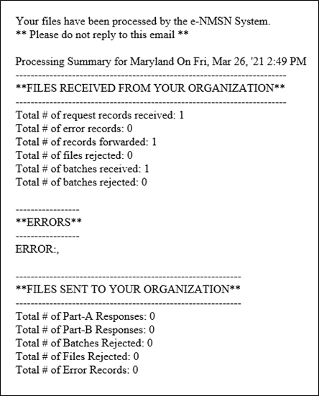
Figure 2-3 shows an example of an email sent to a state.
Figure 2-3: Email Notification (States)
Figure 2-4 shows an example of an email sent to an employer, third-party provider, or plan administrator.
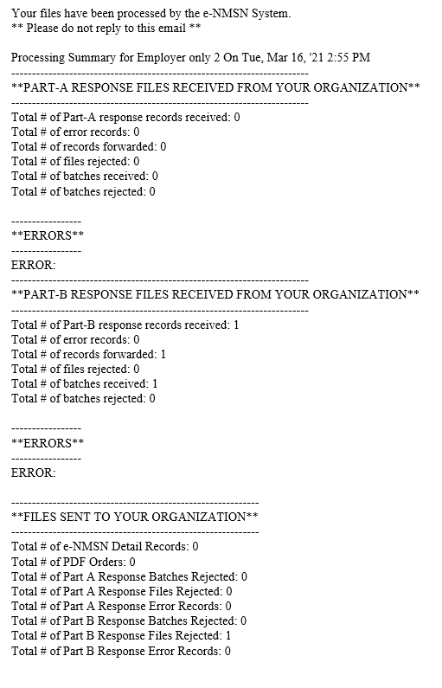
Figure 2-4: Email Notification (Employers, Third-party Providers, or Plan Administrators)
Note: If employers send the Part-A Response only, the Part-B Response section in Figure 2-4 is not included in the email.

e-NMSN Input Transaction Layouts
Appendices A through E contain the following transaction layouts accepted by the e-NMSN system:
- Version Number Record
- Universal Header/Trailer
- State Request File
- Part-A Response File
- Part-B Response File
Each record layout in the appendices includes:
- Field name
- Field length
- Location
- Field types (alphabetic, numeric, or alphanumeric)
- Field comments
The comment section in the record layouts indicates whether the field is required for the transaction or describes the conditions for conditionally required fields. The comments also provide an explanation about each field and its relationship to other fields or records. Optional fields must be filled with spaces if they are not used or the data is not available.

State Request File
The State Request file is batched by the FEIN. If a state makes a request to multiple employers, a batch for each FEIN is included in the file sent to the e-NMSN system. A header exists for each employer with its FEIN and the state’s FIPS code. The e-NMSN system batches the state request to each employer by FEIN and FIPS code. If multiple states send requests to one employer, the records are batched by the state.

Part-A Response File
The Part-A Response file is generated by the employer and batched by the state. If an employer is responding to several state Part-A requests, the file contains one batch header with the employer FEIN for each state. The file also contains the state’s locator code for each batch in the file.
If a third-party provider is responding to several state Part-A requests, the response contains one header with the third-party provider and the employer FEINs (the original state request was sent to this FEIN) for each state in the file. The file also contains the state’s locator code for each batch in the file.

Part-B Response File
The Part-B Response file is generated by the employer, third-party provider, or plan administrator. Depending on the preferences selected on the Profile form, records must be batched by the state.
If an employer is responding to several state Part-B requests, there will be one header with the employer FEIN for each state in the file. The file will also contain the state’s locator code for each batch in the file.
If a third-party provider or plan administrator is responding to several Part-B requests, the response will have one header with the third-party provider, plan administrator, and employer FEINs (the original state request was sent to this FEIN) for each state in the file. The file will also contain the state’s locator code for each batch in the file.
PAPERWORK REDUCTION ACT OF 1995 (Pub. L. 104-13) STATEMENT OF PUBLIC BURDEN: Through this information collection ACF, pursuant to 45 U.S.C. § 303.32, the Personal Responsibility and Work Opportunity Reconciliation Act of 1996 (PWRORA) Pub. L. 104-193 and the Child Support Performance and Incentives Act of 1998 (CSPIA) Pub. L. 105-200, Sec. 401(c), § 609, is gathering information from states to expedite employer processing of health care coverage in child support cases. Public reporting burden for this collection of information is estimated to average 10 minutes per response, including the time for reviewing instructions, gathering, maintaining the data needed, and reviewing the collection of information. The NMSN does collect confidential information in order to identify health care recipients. An agency may not conduct or sponsor, and a person is not required to respond to, a collection of information subject to the requirements of the Paperwork Reduction Act of 1995, unless it displays a currently valid OMB control number. The OMB Control Number: 0970-0222 and Expiration Date: 11/30/2025. If you have any comments on this collection of information, please contact OCSSFedSystems@acf.hhs.gov.

