Family Partners for Research Study

**Instrument 4:**

**Parent - In-Person Interviewer-Administered Assessment of Child Well-Being**

Contents

1. QP – INTRODUCTION TO THE STUDY 2

2. CHILD FUNCTIONING STATUS: VINELAND-3 MODULE 3

3. CHILD SOCIAL-EMOTIONAL STATUS: BASC-3 BESS MODULE 3

4. PARENTING STYLE: PACER MODULE 4

5. CHILD DEVELOPMENTAL STATUS: DAYC-2 MODULE 6

## QP – INTRODUCTION TO THE STUDY

*QP: Q=Question; P=Parent*

**---------------------------------------------------------------------------------**

**P_QP_BGN** ***[ PQP_BGN ] NoDeliv***

CASE ID : ^main_case.zrid

Subject: ^main_case.subject

Adult: ^main_case.ad_last ^main_case.ad_first

Child: ^main_case.childfirst

Child's age: ^AgeYY

Child's sex: ^Global.sex

IF INFORMATION ABOVE IS CORRECT, PRESS "1" AND ENTER TO CONTINUE.

IF INFORMATION ABOVE IS INCORRECT, CLOSE THE INTERVIEW TO RETURN TO CMS

1 Continue

**---------------------------------------------------------------------------------**

**P_QPConsent**

Thank you for your interest in participating in a study to inform possible future data collections for the National Survey of Child and Adolescent Well-Being (NSCAW). A few weeks ago, you completed the online part of this study. Today, we are going to go through the same survey questions, but I will be asking you the questions and entering your answers on my laptop, which will take about 30 minutes.

Once I finish going through the survey with you, I will observe you and your child during a play session, which will also take about 30 minutes. I will prompt you and your child to play with toys from my kit and do some activities. My observations will only be used for research purposes and will be kept confidential. Your child’s participation is voluntary. They will receive a $10 virtual gift card as a token of appreciation.

Finally, I will ask you about your feedback and experience with the surveys you participated in. That interview should take about 45 minutes. As a token of appreciation for your participation completing the in-person survey and this interview, you will receive a final $100 virtual gift card. The feedback you provide on your experience will help inform how we administer NSCAW to other parents in the future.

**Subject’s Statements**

**(1) Agreement to Participate in Today’s Interview**

Do you voluntarily agree to take part in today’s interview? You can choose not to participate at any time, and you are free to refuse to answer a question.

 Yes  No

**(2) Agreement for Permission for Child Participation in Play Session with Parent**

Do you provide permission for your child to take part in the Family Partners for Research Play Session?

1 = Yes, I give permission for my child to take part in the Family Partners for Research Play Session.

2 = No, I do not give permission for my child to take part in the Family Partners for Research Play

Session.

|  |
| --- |
| *PAPERWORK REDUCTION ACT OF 1995 (Pub. L. 104-13) STATEMENT OF PUBLIC BURDEN:  The purpose of this information collection is to gather feedback to inform future National Survey of Child and Adolescent Well-Being data collections.  Public reporting burden for this collection of information is estimated to average 1 hour per respondent, including the time for reviewing instructions, gathering and maintaining the data needed, and reviewing the collection of information. This is a voluntary collection of information. An agency may not conduct or sponsor, and a person is not required to respond to, a collection of information subject to the requirements of the Paperwork Reduction Act of 1995, unless it displays a currently valid OMB control number.  The OMB is* #*0970-0356 and the expiration date is 01/31/2027.  If you have any comments on this collection of information, please contact Melissa Dolan:* [*mdolan@rti.org*](mailto:mdolan@rti.org). |

Let's begin.

## CHILD FUNCTIONING STATUS: VINELAND-3 MODULE

Source: Vineland Adaptive Behavior Scales, Third Edition (Vineland-3): Sarah S. Sparrow, Domenic V. Cicchetti, Celine A. Saulnier; Pearson; copyright 2016. Standardized assessment tool measuring abilities and functioning through two scales: a Communication Scale containing Expressive, Receptive, and Written items, and a Daily Living Skills Scale containing Personal, Domestic, and Community items.

**For use in the online and in-person parent report.**

## CHILD SOCIAL-EMOTIONAL STATUS: BASC-3 BESS MODULE

Source: Behavior Assessment System for Children, Third Edition, Behavioral and Emotional Screening System (BASC-3 BESS): Randy W. Kamphaus, Cecil R. Reynolds; Pearson; copyright 2015. Standardized assessment tool measuring emotional and behavioral strengths and problems in children.

**For use in the online and in-person parent report.**

## PARENTING STYLE: PACER MODULE

**For use in the online and in-person parent report.** 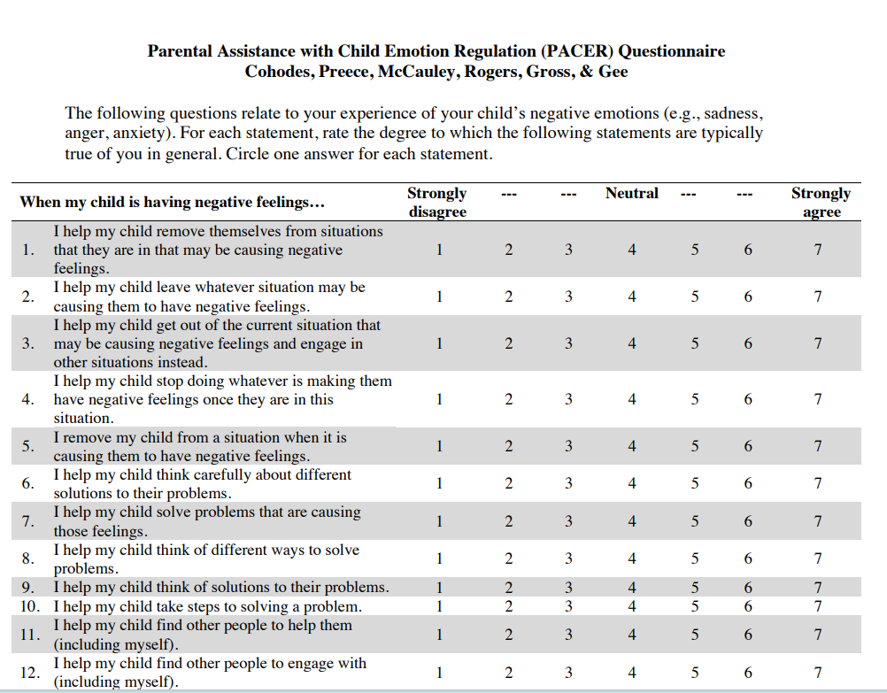

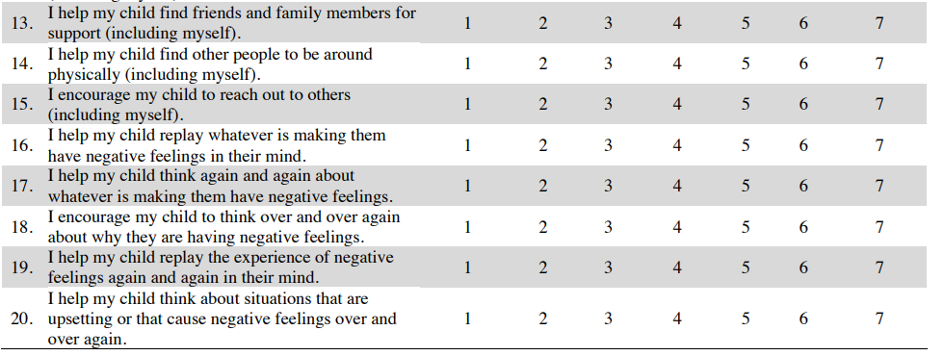

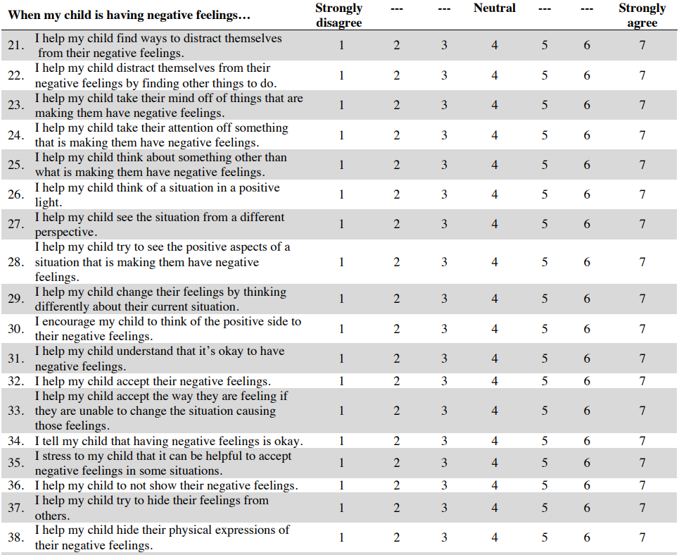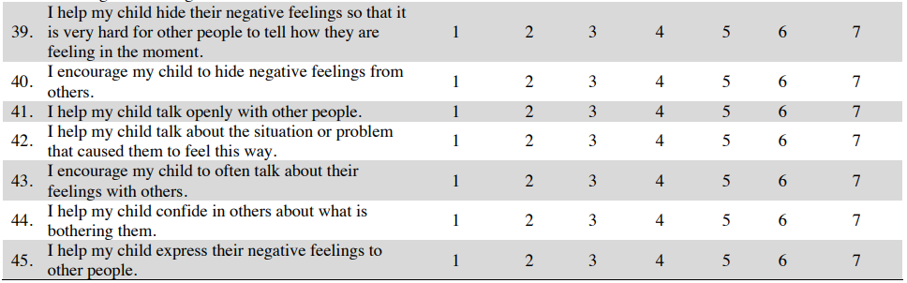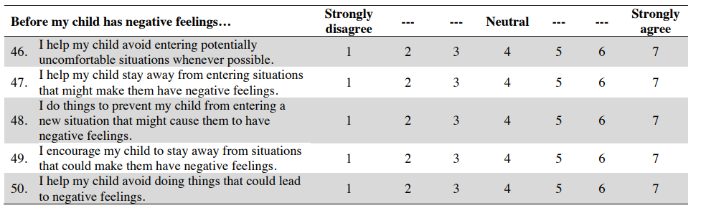

## CHILD DEVELOPMENTAL STATUS: DAYC-2 MODULE

Source: Developmental Assessment of Young Children, Second Edition (DAYC-2): by Judith K. Voress and Donal D. Hammill; Pearson; copyright 2013.

Standardized assessment tool measuring development through three scales: cognitive, communication, and social-emotional.

**For children aged 2 to 5 in-person.**