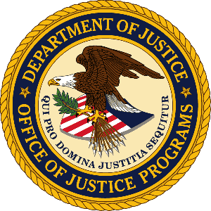

U.S. Department of Justice

Office of Justice Programs

Bureau of Justice Statistics

Washington, D.C. 20531

MEMORANDUM

TO: Office of the Chief Statistician of the United States
Office of Management and Budget

FROM: Bureau of Justice Statistics

SUBJECT: Non-substantive change request for the National Crime Victimization Survey (OMB Control No. 1121-0111)

DATE: May 5, 2025

This memo requests non-substantive changes to the National Crime Victimization Survey (NCVS) which is approved through 11/30/2026 under OMB Control No. 1121-0111. The Bureau of Justice Statistics (BJS) is proposing to update probe instructions related to the victim’s gender or gender identity as the basis for a hate crime. The Matthew Shepard and James Byrd, Jr., Hate Crimes Prevention Act of 2009 uses the term “gender” and “gender identity” as an actual or perceived characteristic that can be the basis for a hate crime. The Census Bureau collects NCVS data on hate crimes to fulfill BJS’s statutory requirement to report on Hate Crime Statistics under 34 U.S.C. 41305. Collecting these data is not in conflict with Executive Order 14168 titled “Defending Women from Gender Ideology Extremism and Restoring Biological Truth to the Federal Government.”

Description of changes to the NCVS instrument:
BJS seeks to revise the FR notes associated with HATE_GENID. See pages 154-155 in Attachment 1 for highlighted edits to the NCVS instrument on impacted questions.

Original FR notes for HATE_GENID –
If further clarification is needed, read: By intersex we mean people who have a difference of sex development (DSD) or were born with genitals, reproductive organs, or chromosomal patterns that do not correspond to a single sex.

If further clarification is needed, read: By gender non-conforming, we mean people whose gender expression, presentation, or behaviors do not confirm to society’s traditional gender norms.

Revised FR note –
If further clarification is needed, read: Please answer to the best of your ability.

Impact of these revisions:
These proposed modifications to the NCVS instrument are expected to have a negligible impact on burden, cost, and on victimization estimates.

Attachments:
Attachment 1. Revised 2025 NCVS Q1-2 Questionnaire with hate crime gender identity changes (OMB Control No. 1121-0111)

