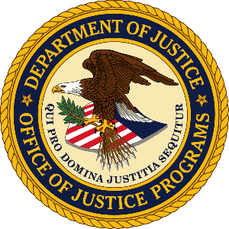

**U.S. Department of Justice**

Office of Justice Programs

*Bureau of Justice Statistics*

*Washington, D.C. 20531*

**MEMORANDUM**

**TO:** Office of the Chief Statistician

Office of Management and Budget

**FROM:** Bureau of Justice Statistics

**SUBJECT:** Non-substantive change request for the BJS OMB generic clearance agreement (OMB Number 1121-0339)

**DATE:** April 30, 2025

This memo requests non-substantive changes to the BJS OMB Generic Clearance for Cognitive, Pilot and Field Studies for Bureau of Justice Statistics Data Collection Activities which is approved through 1/31/2028 under OMB Control No. 1121-0339. The Bureau of Justice Statistics (BJS) is proposing to increase the number of previously approved responses from 30,000 to 60,000. This proposed increase reflects the total anticipated number of respondents for planned web panel screening and cognitive testing of proposed revisions to the National Crime Victimization Survey (NCVS) to test the new combined race and ethnicity question and to test the feasibility of adding new cybercrime measures to three NCVS supplements as detailed in the Supporting Statement A. The previously approved number of burden hours (25,000) reflect this testing, but the total number of approved responses did not reflect the anticipated number of respondents needed for this testing.