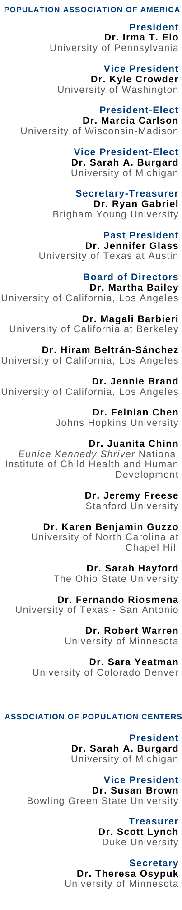
May 27, 2025

Ms. Erin Good
BLS Clearance Officer
Division of Management Systems
Bureau of Labor Statistics
Submitted by email to BLS_PRA_Public@bls.gov

Re: Response to FRN 2025-05325: Information Collection Activities

Dear Ms. Good,

On behalf of the Population Association of America (PAA) (www.populationassociation.org) and the Association of Population Centers (APC) (www.popcenters.org), we are pleased to submit comments in response to a Federal Register Notice published by the Department of Labor’s Bureau of Labor Statistics on March 28, 2025 (Citation 90 FR 14168; Document Number 2025-05325), requesting comments concerning the proposed extension without change of the American Time Use Survey (ATUS).

PAA is the premier professional, scientific society for over 3,000 behavioral and social scientists—including demographers, sociologists, economists, epidemiologists, and statisticians—who study the causes and consequences of population change. Our members conduct research and train scientists at U.S. universities and independent research organizations. APC is composed of approximately 40 federally funded, interdisciplinary population research centers nationwide. Our members are frequent users of the ATUS and are knowledgeable about methodological aspects of the ATUS as well as the Current Population Survey (CPS), from which the ATUS sample and considerable related information are drawn. Our members conduct independent research using ATUS data, work for or advise government agencies on methodological and substantive issues with data from ATUS, and disseminate findings using ATUS data to policymakers, stakeholders, and the public. Given these important connections, our members have a high stake in ensuring the continuity of ATUS.

As the main source for information on time use for residents of the United States, the ATUS provides critical data for supporting social, economic, and demographic research. We therefore have a strong, vested interest in ensuring that ATUS continues to collect benchmark data on time use in the United States.

ATUS data have been used by population scientists to study a variety of topics, including the following:

- Historical trends in the provision of paid and unpaid care to children and adults in the United States;

- Changes in the time that mothers spend parenting their children, and disparities in these trends by mothers’ education level;

- Levels of family caregiving provided by youth and young adults in the United States, and differences by sex, race/ethnicity, and school enrollment; and

- Changes in parenting time between mothers and fathers during Covid-19 pandemic.

Collection of ATUS is absolutely essential for the proper performance of the Bureau of Labor Statistics, and the Department of Labor more generally, because it provides the sole source of prospective, nationally representative information on time use. This information allows researchers, policymakers, and the public to understand how Americans spend their time and the trade-offs in time use between home activities and employment. As illustrated by the examples above, ATUS data also provide unique insights into caregiving by youth and adults and into care receipt among children and adults of all ages. There are, of course, numerous other topics that are illuminated by the information collected by ATUS that are important to population scientists and to government.

The agency’s estimate of the burden of the proposed collection of information seems accurate, based on our members’ involvement in collecting time use information for other surveys and our deep knowledge of survey research methods and practices.

We encourage the Bureau of Labor Statistics to continue working with external partners, such as IPUMS Time Use (https://timeuse.ipums.org/) to disseminate user-friendly ATUS data to the research community.

Finally, we encourage substantive and methodological developments that will minimize respondent burden yet continue to collect accurate and complete information on time use in the United States. In particular, a switch to data collection using the web—after careful development and testing to ensure historical comparability—may reduce the burden of completing the ATUS interview and help maintain response rates, which have been declining steadily over time.
Thank you for giving the population research community an opportunity to comment on the American Time Use Survey.

Sincerely,

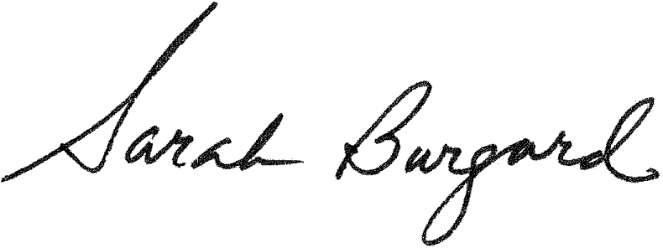
Dr. Irma T. Elo, President Dr. Sarah Burgard, President
Population Association of America Association of Population Centers

Gonalons-Pons, P., & Ansari-Thomas, Z. (2025). The Social Division of Care Work Time Over Half a Century. Demography, 62(2), 737-761.
Gao, M. G. (2025). Trends in the Developmental Gradient in Mothers’ Parenting Time by Maternal Education, 2003–2019. Demography, 11774972.
Miller, K. E., Hart, J. L., Useche Rosania, M., & Coe, N. B. (2024). Youth Caregivers of Adults in the United States: Prevalence and the Association Between Caregiving and Education. Demography, 61(3), 829-847.
Augustine, J. M., & Prickett, K. (2022). Gender disparities in increased parenting time during the COVID-19 pandemic: a research note. Demography, 59(4), 1233-1247.

