Board of Governors of the Federal Reserve System OMB Number 7100-0099 Approval expires December 31, 2025 Federal Deposit Insurance Corporation OMB Number 3064-0026 Approval expires February 28, 2026 Office of the Comptroller of the Currency OMB Number 1557-0124 Approval expires June 30, 2027
Page 1 of 3
Board of Governors of the Federal Reserve System
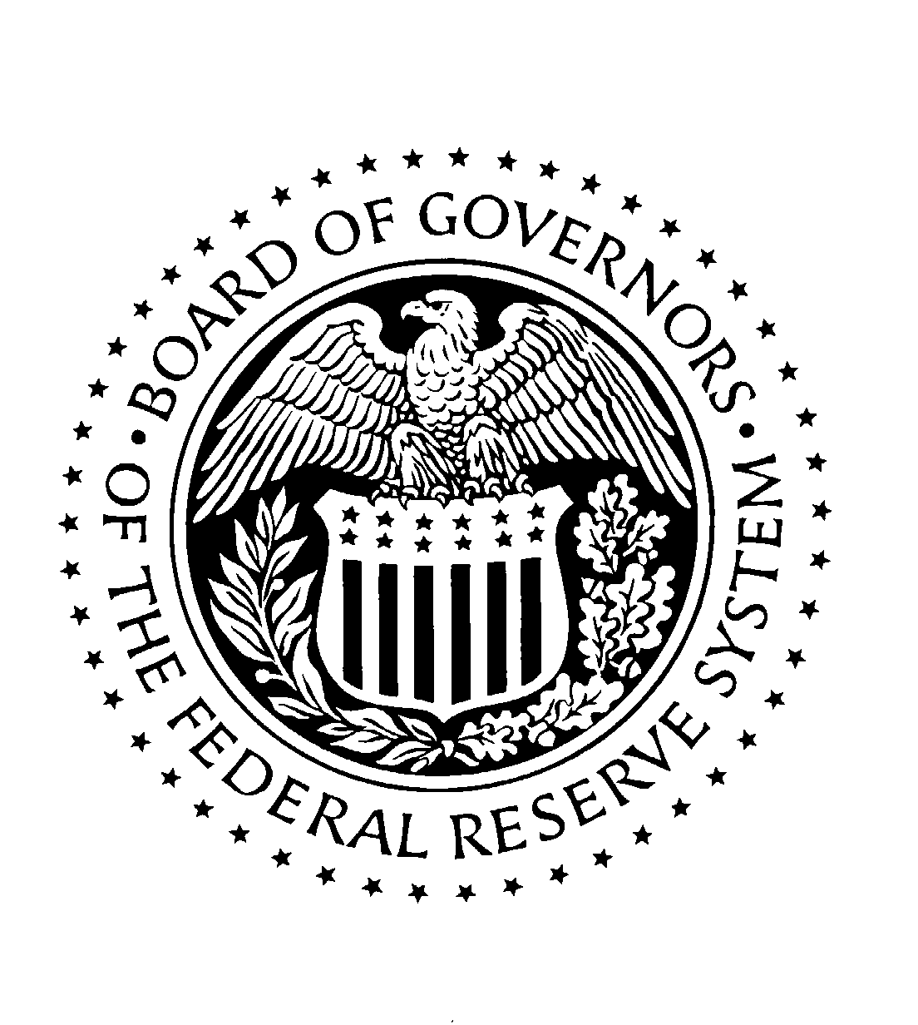

Transfer Agent Registration and Amendment Form—Form TA-1

Under sections 2, 17A(c), 17(a)(3), and 23(a) of the Securities Exchange Act of 1934 and the rules and regulations thereunder, the appropriate regulatory agencies (ARA's) are authorized to solicit from applicants for registration as a transfer agent and from registered transfer agents the information required to be supplied by the Form TA-1.
The information will be used for the principal purpose of determining whether the ARA should allow an application for
registration to become effective or should deny, accelerate, or postpone registration to an applicant.
Information supplied on this form will be available for inspection by any interested person.
An agency may not conduct or sponsor, and an organization (or a person) is not required to respond to, a collection of information unless it displays a currently valid OMB control number.

Public reporting for this collection of information is estimated to average 1.25 hours per registration, and 10 minutes per updating amendment, including the time for reviewing instructions, search- ing existing data sources, gathering and maintaining the data needed, and completing and reviewing the collection of information. Send comments regarding this burden estimate or any other aspect of this collection of information, including suggestions for reducing this burden, to: Secretary, Board of Governors of the Federal Reserve System, 20th and C Streets, NW, Washington, DC 20551; or Assistant Executive Secretary, Federal Deposit Insurance Corporation, Washington, DC 20429; or The Bank Advisory group, Office of the Comptroller of the Currency, Washington, DC 20219; and to the Office of Management and Budget, ATTN: Paperwork Reduction Project (7100-0099, 1557-0124, 3064-0026), Washington, DC 20503.

Form TA-1 Page 2 of 3
For Official Use Only
Reg/File Number

Transfer Agent Registration and Amendment Form
Please print or type all responses. Read all instructions before completing the form. Applicant must complete all information if registering as a transfer agent. For amendments, registrant must identify itself and the filing by answering questions 1 through 3. Thereafter, only answer questions that require amendment in addition to providing the name and signature of the person responsible, and the date (questions 14-16). Detailed guidance for each item on Form TA-1 appears in Part II (Special Instructions) of the instructions for Form TA-1.

- Appropriate Regulatory Agency (check one):
Board of Governors of the Federal Reserve System Federal Deposit Insurance Corporation
Office of the Comptroller of the Currency
- Filing Status of this form (check one): Registration
Amendment to Registration

- Full name of Registrant organization:

Full Name
- Financial Industry Number Standard (FINS) Number:

Previous Name (if being amended for name change)

- Main Office Location of Registrant: 6. Mailing Address:

Street Address Street Address

City
State
Zip Code
City State Zip Code

- Telephone Number:

Area Code / Phone Number
- Registrant Principal Location where Transfer Agent Processing Activities are:

Street Address

City State Zip Code

- List all other Registrant locations where Transfer Agent Processing Activities are conducted.
(Locations different from responses to questions 5 and 8 above):

Street Address Street Address

City
State
Zip Code
City
State
Zip Code

Street Address Street Address

City
State
Zip Code
City State Zip Code

Form TA-1 Page 3 of 3

Transfer Agent Registration and Amendment Form—Continued

- Does Registrant act (or will it act) as a transfer agent solely for its own securities and/or securities of an affiliate(s)? Yes No

- Has the Registrant contracted to have an outside organization perform transfer agent functions in the Registrant's name? ("Private Label" Servicing)
Yes No

If Yes, list the name(s) of Private Label Transfer Agents:
Appropriate Regulatory Agency (ARA) Assigned Registered Transfer Agent Number
-
8

-
8

-
8

- Does the Registrant perform any private label transfer agent services for another Registered Transfer Agent? Yes No

If Yes, list the name(s) of the Named Transfer Agents:

14. Full name of official responsible for form (print or type):
Appropriate Regulatory Agency (ARA) Assigned Registered Transfer Agent Number
-
8

-
8

-
8

-
8

-
8
13. Execution: The Registrant submitting this form, and the person executing it, hereby represent that all the information contained herein is true, correct, and complete.
Attention: Intentional misstatements or omissions of fact constitute federal criminal violations. See 18 U.S.C. 1001 and 15 U.S.C. 78ff(a).

15.

First Name Middle Name Last Name

14.a. Title of official responsible for form:

16.
Signature of Official Responsible for form

Title Date (MM/DD/YYYY)

