INFORMATION COLLECTION REQUEST (ICR):
Bathtub Slip Resistance Study
OMB Control Number: 3041-xxxx

- JUSTIFICATION

Circumstances Making the Collection of Information Necessary
The U.S. Consumer Product Safety Commission (CPSC) staff needs updated information to further develop bathing surface safety.
Falls are the leading cause of injury and death for older adults 65 and older. Information collected as part of the bathtub slip resistance study is needed to support CPSC staff in efforts to work with the ASTM F15.03 Committee on Safety Standards for Bathtub and Shower Structures to replace the obsolete ASTM F462 standard for bathing surface friction. This study will be used to inform CPSC staff of major requirements needed to achieve an efficient and effective slip-resistance standard.
The objective of this study is to conduct human slip research on three actual bathtubs on the market and to measure the friction demand of participants stepping into and out of the bathtubs when dry and wet. The study will involve a range of bathtub surfaces and a range of participants with emphasis on older adults. The results of the study will be shared with the ASTM F15.03 Committee on Safety Standards for Bathtub and Shower Structures.

Purpose and Use of the Information Collection
CPSC staff will share the results of the bathtub slip resistance study with the ASTM F15.03 committee working on replacing ASTM F462. In general, this study will be used to inform CPSC staff of major requirements needed to achieve an efficient and effective slip-resistance standard.
This human research study will include slip test to quantify the minimum frictional performance required for each bathtub’s bathing surface, as characterized by human slip test results. It will incorporate some of the unique ambulation characteristics associated with bathing in general – i.e., stepping over the bathtub lip, lower walking velocity than normal ambulation, abnormal gait characteristics common in older adults and vulnerable population, and shortened stepping movement.
Factors related to the biomechanics of human movement during entry and exit from the bathtub will be evaluated, including availability of handrails, utilization of mats or rugs in the area surrounding the tub or shower, and utilization of mats and/or stick-on materials on the bathing surface itself as exploratory research.

Description of study
CPSC contracted with Arizona State University (ASU) to conduct this study. The experiments will be conducted at ASU’s Locomotion Research Laboratory. Participants will be recruited from the Phoenix, Arizona metro area. All participants included in this study will be generally healthy adults between ages 18 and 95 years old.
The study will involve a total of three sessions to test three bathtub surfaces, where participants will walk into the tub and step out, while wearing fall arresting harness systems for safety. During these sessions, resistance forces under the foot and motion of the foot movements will be measured. The study will quantify the minimum frictional performance required for a bathing surface to reduce slips and falls.
For the data collection timeline, when participants agree to participate in the study, a research associate will go over the detailed procedure of the study and answer all the questions/concerns. After signing the consent form, all the participants’ height and weight will be measured, this will take approximately 5 minutes. Then participants will fill out the Medical History, questionnaire, survey etc, which will take about 10 to 15 minutes. After filling out all the participant documents, the subject will start the friction demand assessments on variety of Bathtubs (three different types) on the laboratory mockup of bathing floor surfaces.
Each test will take 20 minutes and, with three bathtubs, will last about two hours. The experiment will be done while on barefoot for stepping in and out of the bathing surfaces. We will ask: “You will be asked to wear comfortable clothing for the activity, and if not wearing the appropriate clothing, a change of clothes are available for the participants to wear for the duration of the experiment.” There will be a total of three sessions for this study protocol as a result of having to test three bathtub surfaces.
The study will utilize four major disciplines (epidemiology, tribology, biomechanics, and psychophysics) to cogently address and inform CPSC staff of major requirements needed to achieve an efficient and smooth transition towards an effective slip-resistance standard to improve bathing safety of our adult cohorts.
Each session procedure will be identical except for stepping on three different bathing surfaces. Participants will walk into the tub and step out of the tub, and we will measure resistant force under the foot (i.e., force plates) and motion of the foot movements. Two trials will be on the dry surface. Two more trials are on the same bathtub surface, but it will be sprayed on with a liquid solution (90% water, 10% SLS). Participants will be wearing a fall arresting harness system for safety. Once this session is completed (approximately 10-15 minutes), a 5-minute rest will be provided to the participant – thus, ending the first bathtub trials. The participants will go through two more bathtubs with the rest breaks. As such, with breaks in between, two hours will be compensated.
In this study, we will be testing the actual bathtub surfaces for slip resistance characteristics. We will test three types of bathtub surfaces:
Porcelain-enameled steel: Such bathing surface products typically use “gritty” surface roughness features (patterned or uniformly applied) to facilitate friction.
Embossed (vacuum-formed) sheet plastic: Such bathing surface products typically use 3D-profiled patterned friction features embossed into otherwise-smooth glossy sheet acrylic.
Simulated gelcoat/fiberglass: Such bathing surface products typically use 3D-profiled patterned friction features molded using a composite layup of a gelcoat (colored unreinforced resin) exposed surface backed by fiberglass and polyester resin.
Any of the following devices can be used to collect data within this protocol:
- D motion-capture system: (VICON®, nexus, 3 video cameras and 10 Bonita camera, by Oxford Metrics, Oxford, UK) that tracks the kinematics of whole body movement within the integration of kinetics.
- AMTI's AccuGait Optimized™ multi-axis force platform is a portable forceplate for quantifying human gait and balance.
- Inertial measurement units (IMU) system (acceleration, magnetometer, and gyroscope data in x, y, and z directions).
This study will quantify the minimum frictional performance required for bathing surface. Similar to the study performed by Siegmund et al., 2010, we will test all age groups (i.e., young, middle and older adults). Thus, approximately 500 participants will be tested while stepping over bathtub and shower pan rim mockups at about 2.5% slope grade (Figure 1).

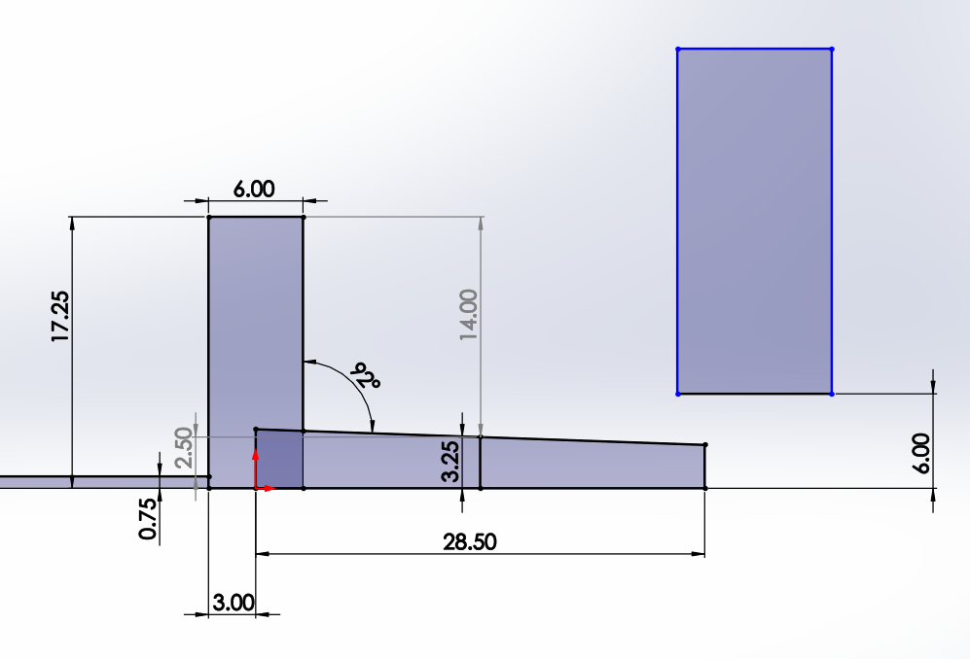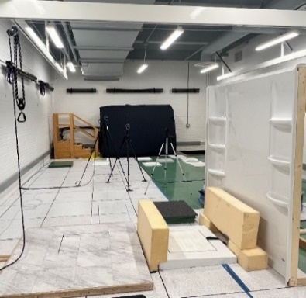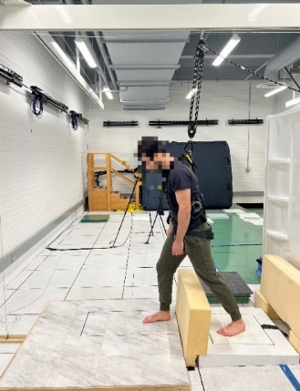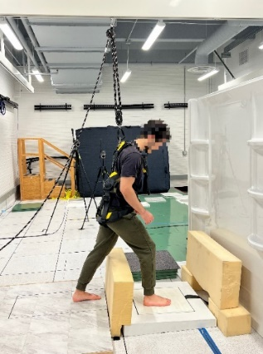

Figure 1. The experimental setup – stepping into the angled bathing surfaces.

Methods of dissemination
The data collected will be used in dissertations, theses, and masters applied projects. ASU will publish the results in a journal setting after permission is granted by CPSC. Results and data could be shared with other 3rd party organizations, but all subject information will be de-identified. Typically, CPSC will also post a report of the study to the CPSC website to disseminate the results to the public.

Use of Information Technology
The Questionnaires and initial recruitment forms can be sent via electronic forms – via email list etc.

Efforts to Identify Duplication and Use of Similar Information
The intent of this data collection is to obtain information that is not readily available elsewhere. The following references are examples of similar research on the subject:

- Lockhart TE, Woldstad JC, Smith JL. Assessment of slip severity among different age groups, metrology of pedestrian locomotion and slip resistance. American Society for Testing and Materials, ASTM STP. 2002; 1424:17-32.
- Lockhart TE, Woldstad JC, Smith JL, Ramsey JD. Effects of age related sensory degradation on perception of floor slipperiness and associated slip parameters. Saf Sci. 2002 Nov 1; 40(7-8):689-703. PMID: 20607132; PMCID: PMC2895329.

- Lockhart TE, Woldstad JC, Smith JL. Effects of age-related gait changes on the biomechanics of slips and falls. Ergonomics. 2003 Oct 10; 46(12):1136-60. PMID: 12933077; PMCID: PMC2891178.

- CPSC Staff Statement on Arizona State University (ASU) report “Factors influencing slip/fall risk while entering and exiting bathing surfaces.” https://www.cpsc.gov/s3fs-public/Task-3-Report-Bathing-Surfaces-Slip-Study_0.pdf?VersionId=DsZwYTg_Jf.1A2G9WwmKvqY23uTEE1Zf

Impact on Small Businesses or Other Small Entities
The information will not be collected from small businesses or other small entities.

Consequences to federal program or policy activities if collection is not conducted or is conducted less frequently
Injuries due to bathtub safety can increase significantly among older adults if not controlled. As indicated, CPSC staff needs updated information to support the efforts toward working with the ASTM F15.03 Committee on Safety Standards for Bathtub and Shower Structure to replace the obsolete ASTM F462 Safety standards for bathing surface safety.

Special Circumstances Relating to the Guidelines of 5 CFR §1320.5
There are no special circumstances. This information collection is consistent with the guidelines prescribed in 5 CFR §1320.5.

Consultation and Public Comments

Part A. Public Notice
On January 6, 2025 CPSC published a 60-day notice in the Federal Register (FR) seeking comments on the information collection request. 90 FR 613. The Commission received nine public comments. Responses to these public comments were published in the 30-day FR notice, 90 FR 15978, on April 16, 2025. Those responses are also provided here.
Most commenters expressed support for the proposed information collection with some commenters offering suggestions that were out of scope. Other comments included discussing the sample size, requesting clarity about the development of the standard, suggesting ways to measure data, and seeking information about the equipment that will be used to measure friction data.
An engineering consultant, a biomedical consultant, and an anonymous commenter opined that the proposed research includes a small sample size of bathtubs. The bathtubs in the study are representative of three types of bathtub surfaces. Staff assessed that this is adequate for gathering preliminary data on whether a minimum frictional performance for reducing slips and falls exists.
The engineering consultant further commented seeking clarity on how the results will be used to develop a standard. As stated in the Summary of the Collection of Information, during the three sessions where participants will step into and out of the bathtubs, the resistance forces under the foot and motion of the foot movements will be measured to quantify the minimum frictional performance required for a bathing surface to reduce slips and falls to support ASTM’s work in developing the standard.
The Tile Council of North America (TCNA) commented that transition from dry to wet surfaces should be considered, as unexpected changes in traction can cause slip incidents. Staff notes that the study will include transitions from dry to wet surfaces. TCNA also requested clarification on how friction data will be collected. Friction data will be collected using a force plate to quantify human gait and balance.
Another engineering consultant commented that CPSC’s proposed collection of information does not have practical utility because it will not provide useful information to replace ASTM F462, and they pointed to other research that should be considered. Practical utility is defined as ‘‘the ability of an agency to use information, particularly the capability to process such information in a timely and useful fashion.’’ 44 U.S.C. 3502(11). As stated in the Description of the Need for the Information and Proposed Use of the Information, the study will quantify the minimum frictional performance required for a bathing surface to reduce slips and falls. Staff intends to work with the ASTM F15.03 Subcommittee on Safety Standards for Bathtub and Shower Structures to replace the obsolete ASTM F462 standard for bathing surface friction that ASTM withdrew in 2016. This study will be used to inform CPSC of major requirements needed to achieve an efficient and effective slip-resistance standard. With this information, the Commission details its need and ability to process and use this information collection.
The National Floor Safety Institute (NFSI) also submitted comments to suggest that CPSC should not conduct their own research and instead rely on NFSI’s research and standard. As stated in the Description of the Need for the Information and Proposed Use of the Information, the Commission describes the need for this study to support CPSC’s efforts to work with the ASTM F15.03 Subcommittee on Safety Standard for Bathtub and Shower Structures to replace the withdrawn ASTM F462 standard.

Part B. Consultation

The CPSC has consulted with Thurmon Lockhart on this study. Over the past 30 years, Thurmon Lockhart, PhD, has researched and investigated the influence of frailty among older adults on gait and postural stability relevant to fall accidents. Given the similar research interests in motor control and rehabilitation engineering among various populations influenced by neurological deficits in this study, his expertise is valuable.

Explanation of any Payment or Gift
Participants will receive $100 for participation in the study. This incentive will encourage full participation in the study. Specifically, meeting with the research associate to address their questions and concerns, signing the consent form, being measured for height and weight, filling out their medical history questionnaire, and, after filling out all the patient documents, participating in the friction demand assessments on three different types of laboratory mockup bathing floor surfaces. Each complete session will take approximately 2 hours but could last up to 2.5 hours with breaks. As mentioned, two trials will be on the dry surface. Two more trials are on the same bathtub surface, but it will be sprayed on with a liquid solution (90% water, 10% SLS). Participants will be wearing a fall arresting harness system for safety.
The $100 payment is commensurate with the physical nature of the study and the time requested of the participants.

Assurance of Confidentiality Provided to Respondents
Data Security and Participant Confidentiality:

All the data will be depersonalized so no personal data will be compromised. Each participant will be assigned an identification number, e.g., two-letter alphabetical permutations and three number permutations (26 x 26 x 10 x 10 x 10 = 67,000), which will be written on the consent form that the participant signs. All other study files will use the participant's assigned ID number and the participant's name will appear nowhere else.
Data will be stored on an encrypted external hard drive and kept in a secure cabinet, drawer, or desk of the principal investigator (PI). Only the PI will have access to a document that contains the participant ID number of the participants. Data from this study will be stored for up to 10 years after the enrollment period. Undergraduate researchers, collaborative researchers, graduate research assistants, and postdoctoral fellows will have access to the data.
Participants will fill out a medical history form after signing all the necessary consent forms and before any data collection or surveys are filled out. From the medical history form, we can discern whether the participants meet all the inclusion criteria or if they meet any of the exclusion criteria. If subject is not qualified for the study, then they will be thanked for their time and dismissed from the study. Their medical history form will be shredded by the end of the day.
This study is a noninvasive and minimal risk study. If any problems or adverse event does occur, the issue will be immediately reported and discussed with the PI (Dr. Lockhart). The problem will be handled and reported according to the ASU IRB regulations and the clinical care required for the patient. Only the PI will have access to a document that contains the name, patient ID number, phone number, and address of the subjects.
Following a participant's voluntary interest in the study, participant will be provided with a consent form prior to the initiation of the study and details about the study’s purpose, procedure, risks involved, and all information relevant to the participant responsibilities, safety, privacy, and benefits. The consent form is provided beforehand to ensure the participant has ample time to review the documentation and arrive to the study with extensive knowledge of the study protocol, their requirements, and any questions/concerns they may have. If the potential subject is comfortable with their role in the study and general procedures involved, they will be enrolled into the study, whereby they will sign their informed consent in person. The subjects will then fill out a medical history form. Also, the subjects are free to withdraw from the study at any time and for any reason.
Participants may not request their personal results from the study.

Justification for Sensitive Questions
Questions asked in the study typically are not considered sensitive in nature.

Estimate of Hour Burden to Respondents
The estimated annual burden of the collection is summarized in table 1.
Table 1. Estimated Annual Reporting Burden
Respondent | Number of respondents | Frequency of response | Total number of responses | Duration of response (in hours) | Total estimated response burden  (in hours)
Bathtub Slip Resistance Study participant | 200 | 1 | 200 | 2.5 | 500

In the first year that the study is funded we expect there will be 36 participants in the bathtub slip resistance study focusing on older adults, however the burden estimate includes additional responses to account for burden to participants that are selected but ultimately not tested, as well as other study changes. In addition, the burden estimates account for the testing of younger age groups in future years, if funding becomes available. We estimated that each respondent will respond to the collection of information once. Therefore, the total estimated annual number of responses for the study is 200 (200 respondents × 1 response per participant).
Though response times will vary, on average, it will take 2.5 hours for respondents to fully participate in the study. Therefore, the annual estimated response burden is 500 hours (200 responses × 2.5 hours per response).

Estimate of Total Annual Cost Burden to Respondents
There are no costs to respondents and no respondent recordkeeping requirements associated with the study. There are no operating, maintenance, or capital costs associated with the collection.

Estimate of Annualized Costs to the Federal Government
The estimated annual cost of the information collection requirements to the Federal Government is approximately $197,477, which includes 12 staff months to examine and evaluate the information, as needed, as well as monitor the contract and other activities. This is based on a GS-13, step 5 level salaried employee. The average annual wage rate for a mid-level salaried GS-13 employee in the Washington, DC metropolitan area (effective as of January 2024) is $133,692 (GS-13, step 5). This represents 67.7 percent of total compensation (U.S. Bureau of Labor Statistics, “Employer Costs for Employee Compensation,” June 2024, Table 2., percentage of wages and salaries for all civilian management, professional, and related employees: https://www.bls.gov/news.release/archives/ecec_09102024.pdf). Adding an additional 32.3 percent for benefits brings average annual compensation for a mid-level salaried GS-13 employee to $197,477. Assuming that approximately 12 staff months will be required annually, this results in an annual cost to the federal government of $197,477.

Program Changes or Adjustments
This is a new collection of information. There are no program changes or adjustments.

Publication Plan
The data collected will be used in dissertations, theses, and masters applied projects. ASU will publish the results in a journal setting after permission is granted by CPSC. Results and data could be shared with other 3rd party organizations, but all subject information will be de-identified. Typically, CPSC will also post a report of the study to the CPSC website to disseminate the results to the public.

Rationale for Not Displaying the Expiration Date for OMB Approval
No such exception is sought. The OMB data collection number and expiration date will be displayed on informed consent form.

Exception to the Certification Statement
No such exception is sought. These activities comply with the requirements in 5 CFR § 1320.9.

Chowdhury et al., U.S. Consumer Prod. Safety Comm’n., Consumer Product-related Injuries and Deaths Among Adults 65 Years of Age and Older, 67–68 (2021), available at https://tinyurl.com/2t88v33m.
A force plate is a mechanical sensing system ‘‘designed to measure the ground reaction forces and moments involved in human movements.’’ More information available at: https://www.sciencedirect.com/topics/engineering/force-plate.

