SUPPORTING JUSTIFICATION – Part B
Bathtub Slip Resistance Study Funded by CPSC

BACKGROUND
There will be a total of three sessions for this study protocol as a result of having to test three bathtub surfaces. We will conduct human subject testing to assess slip resistance characteristics during stepping on bathtub surfaces on participants who are greater than 18 years old and less than or equal to 95 years of age. The human slip research study will determine the factors influencing slips and falls among different age groups and evaluate and compare to the biomechanical literature.

This study will quantify the minimum frictional performance required for bathing surface. Similar to the study performed by Siegmund et al., 2010, we will test all age groups (i.e., young, middle and older adults). Thus, approximately 500 participants will be tested while stepping over bathtub and shower pan rim mockups at about 2.5% slope grade (Figure 1).

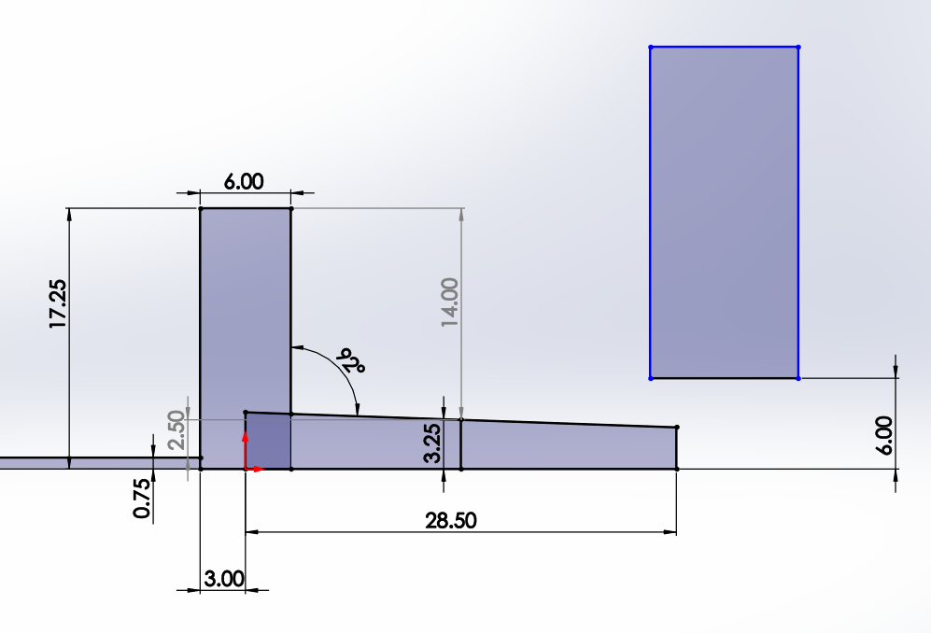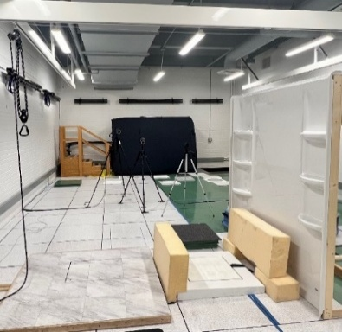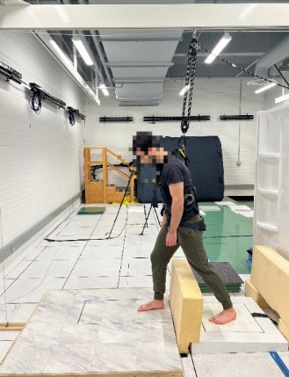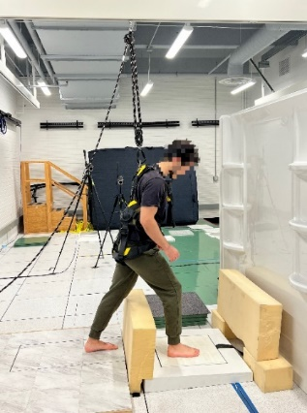

Figure 1. The experimental setup – stepping into the angled bathing surfaces.
Bathtubs will be made to accept interchangeable 18 inches square surfaces to be tested (need this cut as we need to measure friction demand from the forceplates). Three bathtubs Reference surfaces will include – porcelain-enamel steel, embossed sheet plastic and gelcoat/fiberglass (aka polymer/composite), bathing surfaces. Although extensive procedures will be developed and tested, in general, the participants will start at least 1.5 meters from the bathing surface and, step onto bathing surface (at normal walking pace while stepping over an 8 cm shower rim and stepping over a 38 cm bathtub rim onto the reference test surfaces) that is either dry or wet to assess friction demand characteristics (on the dry surfaces only) as well as slipperiness characteristics (on wet bathing surfaces) based on Lockhart et al., 2003 method and, dependent variables such as slip distances and slipping velocities, etc. Similar to Parijat and Lockhart (2012), we will use both dry and wet (90% water, 10%SLS solution) surfaces to assess realistic slipping characteristics during barefoot walking. Thus, the study will include independent variables such as bathtub surfaces (3 types), dry and wet contaminated floor surfaces (2), and three age groups (65-74, 75-84, and 85-90 years old) walking over bathtub. Thus, 3 x 2 x 3 three-way repeated measures ANOVA will be performed for the analyses. As this experimental design in itself creates 18 main and interaction effects, additional study of the use of handrails and mats outside the tub/shower as well as mats and stick-on materials inside the tub/shower would compound the interaction effects. As resources allow, the study could include these independent variables, and as indicated, we will perform exploratory research.

DESCRIPTION OF SAMPLING METHOD USED
Selection for study participation will occur mainly via email to the participants. The objective is to enroll a continuous case series, therefore all candidates that meet the inclusion and exclusion criteria will be approached for recruitment. Only those that decline to participate will not be enrolled if all inclusion and exclusion criteria are met. Participation is voluntary.
In the first year of the study we will be recruiting approximately 36 participants in three age groups (65-74, 75-84, and 85-90 years old) with 10, 15, and 5 individuals in each age group, of both sexes.
Participants will fill out a medical history form after signing all the necessary consent forms and before any data collection or surveys are filled out. From the medical history form, we can discern whether the participants meet all the inclusion criteria or if they meet any of the exclusion criteria. If subject is not qualified for the study, then they will be thanked for their time and dismissed from the study.

DESCRIPTION OF PROCEDURES FOR INFORMATION COLLECTION, INCLUDING STATISTICAL METHODOLOGY FOR STRATIFICATION AND SAMPLE SELECTION
Data from each sample test surface will be ranked by frictional performance. Psychophysical scale of slipperiness (Liker Rating 1 “not slippery” to 5 “very slippery) will be obtained prior to going into the tub (to assess visually can they obtain slipperiness), and out of the tub (to assess if tactile perception along with visual perception improves the rating – i.e., closer to the measured COF value). To avoid the problem of increased Type I error due to interim data analysis, a correction to the required p-values will be applied. For all statistical comparisons, transformations will be used for data that are not normally distributed, and non-parametric tests will be employed if extreme violations of normality are discovered. Transformations will be applied if the homogeneity of variances assumption is violated (Levene’s test). Corrections for multiple follow-up comparisons will be done using Bonferroni correction.
Some psychophysical slipperiness scales will be evaluated using non-parametric ANCOVA using Mantel- Haenszel statistics. Initial analyses will be conducted using a mixed-factor multivariate analysis of variance (MANOVA). Using the Wilks’ Lambda test, the MANOVA will allow for determination of which factors and relevant interactions have significant effects on the dependent variables as a whole.
Additionally, repeated measures ANOVA will also be performed. The measurements associated with endpoint assessments will be used in the final model. the current quote from the contractor in this task will include independent variables such as bathtub surfaces (3 types), dry and wet contaminated floor surfaces (2), and three age groups ((65-74, 75-84, and 85-90 years old) walking over bathtub. Thus, 3x 2 x 3 three-way repeated measures ANOVA will be performed for the analyses. As this experimental design in itself creates 18 main and interaction effects, additional study of the use of handrails and mats outside the tub/shower as well as mats and stick-on materials inside the tub/shower would compound the interaction effects beyond a level that could be studied in the one-year contract performance term. Separate quotes would be required for including these independent variables. However, as indicated, we will perform exploratory research.
Data from each sample test surface will be ranked by frictional performance. Psychophysical scale of slipperiness (Liker Rating 1 “not slippery” to 5 “very slippery) will be obtained prior to going into the tub (to assess just visually can they obtain slipperiness), and out of the tub (to assess if tactile perception along with visual perception improves the rating – i.e., closer to the measured COF value). To avoid the problem of increased Type I error due to interim data analysis, a correction to the required p-values will be applied. For all statistical comparisons, transformations will be used for data that are not normally distributed, and non-parametric tests will be employed if extreme violations of normality are discovered.
Transformations will be applied if the homogeneity of variances assumption is violated (Levene’s test). Corrections for multiple follow-up comparisons will be done using Bonferroni correction.

PROCEDURES
Some psychophysical slipperiness scales will be evaluated using non-parametric ANCOVA using Mantel- Haenszel statistics. Initial analyses will be conducted using a mixed-factor multivariate analysis of variance (MANOVA). Using the Wilks’ Lambda test, the MANOVA will allow for determination of which factors and relevant interactions have significant effects on the dependent variables as a whole.
Additionally, repeated measures ANOVA will also be performed. The measurements associated with endpoint assessments will be used in the final model.

DESCRIPTION OF METHODS TO MAXIMIZE RESPONSE RATE AND TO DEAL WITH NON-RESPONSE ISSUES
Following a participant's voluntary interest in the study, participant will be provided with a consent form prior to the initiation of the study and details about the study’s purpose, procedure, risks involved, and all information relevant to the participant responsibilities, safety, privacy, and benefits.
The consent form is provided beforehand to ensure for participant to have ample time to review the documentation and arrive to the study with extensive knowledge of the study protocol, their requirements, and any questions/concerns they may have. If the potential subject is comfortable with their role in the study and general procedures involved, they will be enrolled into the study, whereby they will sign their informed consent in person. The subjects will then fill out a medical history form. Also, the subjects are free to withdraw from the study at any time and for any reason.

DESCRIBE ANY TESTS FOR PROCEDURES OR METHODS TO BE UNDERTAKEN

Data Analysis. Data from each sample test surface will be ranked by frictional performance. To avoid the problem of increased Type I error due to interim data analysis, a correction to the required p-values will be applied. For all statistical comparisons, transformations will be used for data that are not normally distributed, and non-parametric tests will be employed if extreme violations of normality are discovered.

Transformations will be applied if the homogeneity of variances assumption is violated (Levene’s test). Corrections for multiple follow-up comparisons will be done using Bonferroni correction. Some psychophysical slipperiness scales will be evaluated using non-parametric ANCOVA using Mantel- Haenszel statistics. Initial analyses will be conducted using a mixed-factor multivariate analysis of variance (MANOVA). Using the Wilks’ Lambda test, the MANOVA will allow for determination of which factors and relevant interactions have significant effects on the dependent variables as a whole. Additionally, repeated measures ANOVA will also be performed. The measurements associated with endpoint assessments will be used in the final model.

PROVIDE NAME AND PHONE NUMBER OF INDIVIDUALS CONSULTED ON STATISTICAL ASPECTS OF STUDY DESIGN AND OTHER PERSONS WHO WILL COLLECT/ANALYZE INFORMATION FOR AGENCY

Thurmon Lockhart, telockha@asu.edu, 540-257-3058

Appendix A.
The OMB Control Number and Expiration date will be displayed in the following format on participant documents:
OMB Control Number: 3041-XXXX
Expiration Date: XX/XX/XXXX

