Instructions and Notes:
- Depending on the nature of what you are doing, some sections may not be applicable to your research. If so mark as “NA”.
- When you write a protocol, keep an electronic copy. You will need to modify this copy when making changes.

- Protocol Title
Adult Bathing Surface Slip Resistance (II)
- Background and Objectives
Provide the scientific or scholarly background for, rationale for, and significance of the research based on the existing literature and how it will add to existing knowledge.
- Describe the purpose, specific aims, or objectives.
- State the hypotheses to be tested.
- Describe the relevant prior experience and gaps in current knowledge.
- Describe any relevant preliminary data.
Falls are the leading cause of injury death for older adults 65 and older attributing to a total of 38,742 unintentional fall-related deaths and nearly 3 million emergency room visits in 2021 (Kakara et al., 2023). Furthermore, traumatic brain injury (TBI) disproportionately affects older adults with people aged 75 years and older comprising majority of TBI-related hospitalization and TBI-related deaths in the U.S. (Kakara et. al., 2023). Until recently, the voluntary standard that specified minimum slip-resistance of bathtubs was the ASTM F462 “Standard Consumer Safety Specification for Slip-Resistant Bathing Facilities” which was withdrawn in 2016. Since then, U.S. Consumer Product Safety Commission (CPSC) staff have been participating in the ASTM F15.03 “Committee on Safety Standards for Bathtub and Shower Structures” meetings to develop a replacement standard. To support the work needed to correlate slip-resistance to bath surfaces, CPSC contracted with Arizona State University (ASU) to conduct human subject slip-resistant research on sample bath test surfaces in 2022-2023. The study results demonstrated that slip behavior was related to friction demand, and it was measurable and varied according to the friction mechanism of the bath surfaces during stepping over the bathtubs.

The objective of this study is to conduct human slip research on bathtubs and measure the friction demand of participants stepping into and out of the bathtubs, under both dry and wet conditions. The study will involve a range of bathtub surfaces currently available on the market (three exemplar bathtubs) and a range of participants, with emphasis on older adults. The results of the study will be shared with the ASTM F15.03 Task Group.

In general, we will utilize four major disciplines (epidemiology, tribology, biomechanics, and psychophysics) to address and inform CPSC staff of major requirements needed to achieve an efficient and smooth transition towards an effective slip-resistance standard that will improve bathing safety. Accordingly, we will briefly introduce four perspectives which further elucidate the factors involved in slip resistance performance during ambulation over bathtubs.

This human research study will include a slip test to quantify the minimum frictional performance required for each bathing surface, as characterized by human slip test results. This study will incorporate some of the unique ambulation characteristics associated with bathing in general—i.e., stepping over the bathtub lip, walking velocity which is lower than normal ambulation, abnormal gait characteristics common in older adults and vulnerable populations, and shortened stepping movements.

Factors related to the biomechanics of human movement during entry and exit from the bathtub will be evaluated, including: availability of handrails, utilization of mats or rugs in the area surrounding the tub or shower, and utilization of mats and/or stick-on materials on the
bathing surface itself (as exploratory research).

Kakara R, Bergen G, Burns E, Stevens M. Nonfatal and Fatal Falls Among Adults Aged ≥65 Years — United States, 2020–2021. MMWR Morb Mortal Wkly Rep 2023;72:938–943. DOI: http://dx.doi.org/10.15585/mmwr.mm7235a1

- Data Use  Describe how the data will be used. Examples include:  - Dissertation, Thesis, Undergraduate honors project  - Publication/journal article, conferences/presentations  - Results released to agency or organization | - Results released to participants/parents  - Results released to employer or school  - Other (describe)
The data collected from this proposal will be used in:
- Dissertations, theses, masters applied projects.
- Subsequent publication/journal articles, conference/presentations.
- Results and data could be shared with other 3rd party organizations, but all subject information will be de-identified.
Participants may not request their personal results from the study.

- Inclusion and Exclusion Criteria
Describe the inclusion and the exclusion criteria for the study.
Describe how individuals will be screened for eligibility.
Indicate specifically whether you will target or exclude each of the following special populations:
- Minors (individuals who are under the age of 18)
- Adults who are unable to consent
- Pregnant women
- Prisoners
- Native Americans
- Undocumented individuals
Participants will be recruited from the surrounding areas of the Phoenix Metro area. The experiments will be conducted at the ASU Locomotion Research Laboratory in Tempe, Arizona. All participants included in this study will generally be healthy.
The objective is to enroll a continuous case series; therefore all candidates that meet the inclusion and exclusion criteria will be approached for recruitment. Only those that decline to participate will not be enrolled if all inclusion and exclusion criteria are met.

Inclusion criteria:
- Subject has voluntarily signed and dated an informed consent form (ICF), approved by the ASU Institutional Review Board (IRB), authorization prior to any participation in the study.
- Subject should be in good physical condition in terms of general movements.
- Subject is male or female and is ≥ 18 and years of age and, less than or equal to 95 years of age.
- Subject is ambulatory and able to walk ≥ 3 meters
- Subject is able to follow the protocol.

Exclusion criteria:
- Subject is unable to walk 3 meters without assistance
- Subject indicates “yes” to shortness of breath, dizziness, frequent headache, easily fatigue and pain in arm, shoulder or chest and requires an assistive device in the Medical History Form under the general information
- Subject has a mental, cardiac, respiratory, neurodegenerative disorder
- Subject reports having undergone major surgery, less than 6 weeks prior to enrollment in the study
(A Medical History Form will be used for the eligibility to participate in the study)
- Number of Participants
Indicate the total number of participants to be recruited and enrolled
- Provide a rationale for the proposed enrollment number
- What percentage of screened individuals will likely qualify for the study?

- Participation is voluntary. We will be recruiting approximately 36 participants three age groups (65-74, 75-84, and 85-90 years old) with 10, 15, and 5 individuals in each age group - equal in sex.

- Recruitment Methods
- Describe when, where, and how potential participants will be identified and recruited.
- Describe materials that will be used to recruit participants. (Attach copies of these documents with the application.)
- Does any member have a dual role with the study population?
- Study subject enrollment will come from general surrounding areas of the Phoenix Metro area.
- Subject participation is voluntary and subject will be recruited without respect to sex, race, or ethnicity. If needed fliers will be directly disseminated to the participants via a newspaper advertisement.
- Information included in the ad will be the name and purpose of the study with a brief description of the protocol. Contact information with the team will be provided in the form of an email address of the PI and PhD students. Additional recruitment (if required) will consist of a newspaper advertisement or post on the ASU School of Biological Health and Systems Engineering website for test participation. If we do require additional recruitment, we will submit the modifications to the IRB for approval.

- Study Timelines
Describe:
- The duration of an individual participant’s participation in the study.
- The duration anticipated to enroll all study participants.
- The estimated date for the investigators to complete this study (up to and including primary analyses).
- Individual Participant Timeline
Regarding the data collection timeline, when participants agree to join the study, a research associate will go over a detailed procedure of the study and answer all the questions/concerns. After signing the consent form, the participant’s height and weight will be measured. This will take approximately 5 minutes. The participant will then fill out intake paperwork (the Medical History Form, questionnaire, survey, etc.), which should take approximately 10–15 minutes. After filling out all the intake paperwork, participants will start the friction demand assessments on three different bathtubs on a laboratory mockup of bathing floor surfaces. Each test will take about 20 minutes and will last up to two hours, in total. The procedure for each session will be identical, with the exception of the bathing surface. Participants will walk into the bathtub and step out of the tub. We will measure underfoot resistant force (e.g. using force plates) and foot movements. Two trials will be conducted under dry conditions. Two more trials will be conducted on the same bathtub surface, but after being sprayed with a liquid solution (90% water, 10% SLS). Participants will be wearing a fall arresting harness system for safety. Once this session is completed (approximately 10-15 minutes), a 5-minute rest will be provided to the participant, thus ending the first set of bathtub trials. The participants will go through two more bathtub trials, with the rest breaks. Given these breaks, participants will be compensated for two hours.

- Study Timeline
This study will take place over one year. Enrollment into this study will be done continuously over the first six months of the study. Recruitment will begin after protocol is approved by the IRB. After the first six months of data collection, the primary analyses for all the enrolled patients will be initiated. It is expected to take several months to complete all analyses. Final analyses of all enrolled patients will occur 9 months after the final data collection and is expected to take 2–3 months.

- Procedures Involved
Describe and explain the study design. Provide a description of all research procedures being performed and when they are performed. Describe procedures including:
- The documents/ measures / devices/ records /sampling that will be used to collect data about participants. (Attach all surveys, scripts, and data collection forms.)
- What data will be collected including long-term follow-up?
- All drugs and medical devices used in the research and the purpose of their use, and their regulatory approval status.
- Describe the available compensation (monetary or credit that will be provided to research participants).
- Describe any costs that participants may be responsible for because of participation in the research.
NOTE: Bathing Surfaces:

Previously, we’ve used reference surfaces that may be used in a future ASTM bathing surface friction standard. In this study, we will be testing the actual bathtub surfaces for slip resistance characteristics.

In general, we will test three types of bathtub surfaces:

Porcelain-enameled steel: Such bathing surface products typically use “gritty” surface roughness features (patterned or uniformly applied) to facilitate friction.

Embossed (vacuum-formed) sheet plastic: Such bathing surface products typically use 3D-profiled patterned friction features embossed into otherwise-smooth glossy sheet acrylic.

Simulated gelcoat/fiberglass: Such bathing surface products typically use 3D-profiled patterned friction features molded using a composite layer of a gelcoat (colored unreinforced resin) exposed surface backed by fiberglass and polyester resin.

ASU will conduct a human subject testing for three bathtub surfaces slip resistance effect on participants who are greater than 18 years old and, less than 95 years old (thus, we will collect young-during mostly pilot trials, as well as older adults).

The experiment will be done barefoot and will require participants to step into and out of the bathtubs. Participants will be asked to wear comfortable clothing for the activity. If participants are not wearing the appropriate clothing, a change of clothes will be available for the participants to wear for the duration of the experiment.

Equipment:
The following devices will be used to collect data.
- D motion-capture system: (VICON®, nexus, 3 video cameras and 10 Bonita camera, Oxford Metrics, Oxford, UK) that tracks the kinematics of whole-body movement within the integration of kinetics;
- AMTI's AccuGait Optimized™ multi-axis force platform is a portable forceplate for quantifying human gait and balance; and
- Inertial measurement units (IMU) system (acceleration, magnetometer, and gyroscope data in x, y, and z directions).

Tests:
There will be total of three sessions for this study protocol as a result of having to test three bathtub surfaces. We will conduct human subject testing to assess slip resistance characteristics during stepping on bathtub surfaces, for participants who 18 to 95 years of age. The human slip research study will determine if there are factors influencing slips and falls among different age groups and evaluate/compare these factors to a biomechanical literature review. This study will quantify the minimum frictional performance required for bathing surface. Approximately 500 participants will be tested while stepping over bathtub and shower pan rim mockups, at about a 2.5% slope grade (Figure 1).

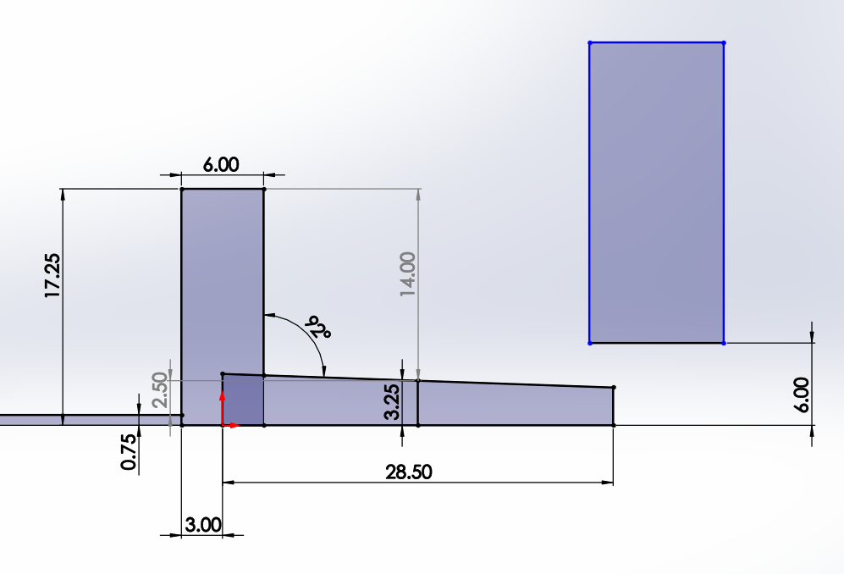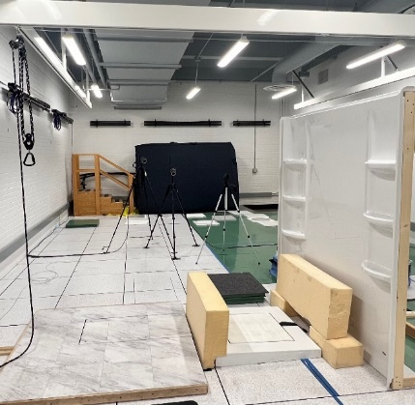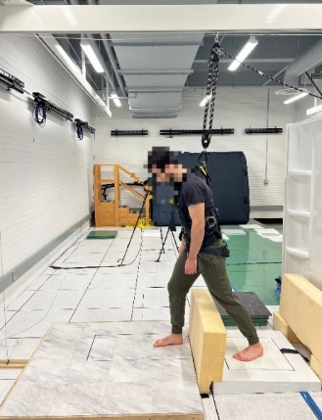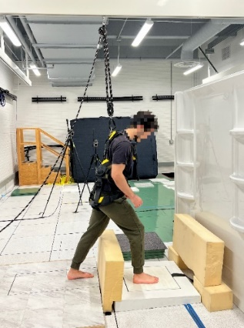

Figure 1. The experimental setup – stepping into the angled bathing surfaces.
Bathtubs will be made to accept interchangeable 18 inches square surfaces to be tested. The three bathtub reference test surfaces will include: porcelain-enamel steel, embossed sheet plastic, and gelcoat/fiberglass. Although extensive procedures will be developed and tested, in general, the participants will start at least 1.5 meters from the bathing surface and, step onto bathing surface while stepping over an 8 cm shower rim and stepping over a 38 cm bathtub rim onto the reference test surfaces. The surfaces will either be dry or wet: to assess friction demand characteristics and slipperiness characteristics, respectively. The study will examine dependent variables such slip distances and slipping velocities. We will use both dry and wet (90% water, 10% SLS solution) surfaces to assess realistic slipping characteristics during barefoot walking. Thus, the current quote from the contractor in this task will include independent variables such as three bathtub surfaces, two dry and wet contaminated floor surfaces, and three age groups (65–74, 75–84, and 85–90 years old). Thus, 3x2x3 three-way repeated measures ANOVA will be performed for the analyses.
Data from each reference test surface will be ranked by frictional performance. Psychophysical scale of slipperiness (e.g., a Liker Rating of 1 (“not slippery”) to 5 (“very slippery)) will be obtained prior to participants entering the tub as well as when exiting the tub. To avoid the problem of increased Type I error due to interim data analysis, a correction to the required p-values will be applied. For all statistical comparisons, transformations will be used for data that are not normally distributed. Non-parametric tests will be employed if extreme violations of normality are discovered. Transformations will be applied if the homogeneity of variances assumption is violated (e.g., Levene’s test). Corrections for multiple follow-up comparisons will be done using Bonferroni correction.
Some psychophysical slipperiness scales will be evaluated using non-parametric ANCOVA as well as Mantel- Haenszel statistics. Initial analyses will be conducted using a mixed-factor multivariate analysis of variance (MANOVA). Additionally, in combination with the Wilks’ Lambda Test, the MANOVA will allow for determination of which factors and relevant interactions have significant effects on the dependent variables, as a whole. Repeated measures ANOVA will also be performed. The measurements associated with endpoint assessments will be used in the final model.

Questionnaires:
- A Medical History Form, designed specifically for this study, will be used to determine eligibility.

- Withdrawal of Participants
Describe anticipated circumstances under which participants will be withdrawn from the research without their consent.
Describe procedures that will be followed when participants withdraw from the research, including partial withdrawal from procedures with continued data collection.
Participants are free to withdraw from the study at any time and for any reason. Should the clinical care team determine that it is in the patient’s best interest to be removed from the study, the participant will be removed from the study, the participants will be thanked and excused. A member of the study team will discuss the reason for the removal.

- Risks to Participants
List the reasonably foreseeable risks, discomforts, hazards, or inconveniences to the participants related the participants’ participation in the research. Include as many useful detail for the IRB’s consideration, including: the probability, magnitude, duration, and reversibility of the risks. Consider physical, psychological, social, legal, and economic risks. Reference this information when appropriate.
- If applicable, indicate which procedures may have risks to an embryo or fetus should the participant be or become pregnant.
- If applicable, describe risks to others who are not subjects.
There are no anticipated risks in completing any of these protocols in the study. We are using non-invasive devices and asking participants who have passed inclusion and exclusionary criteria to perform common daily living activities, such as walking and standing. For safety, a postural stability assessment will be conducted with two researchers—one in front, and one in back of, the participant: in case of dizziness or instability.

A safety harness will be used throughout all experimental trials.

The COVID safety guidelines are to be followed during the data collection as a risk mitigation measure. (https://researchintegrity.asu.edu/in-person-guidance.) Based on all the safety measures mentioned above and the nature of the activities being done, the researchers believe that this study poses only a minimal risk to the participant. The ASU IRB will review this proposed study and will determine that it is in compliance with federal laws and ASU policies governing the protection of human subjects in research.

- Potential Benefits to Participants
Realistically describe the potential benefits that individual subjects may experience from taking part in the research. Include the probability, magnitude, and duration of the potential benefits. Indicate if there is no direct benefit. Do not include compensation or benefits to society or others.
There is no expected benefit to participating in this study.
- Setting
Describe the sites or locations where your research team will conduct the research.
- Identify where research procedures will be performed.
- For research conducted outside of the ASU describe:
  - Site-specific regulations or customs affecting the research.
  - Local scientific and ethical review structures in place.
Participants will be recruited from the surrounding areas of the Phoenix Metro area. The experiments will be conducted at the ASU Locomotion Research Laboratory in Tempe, Arizona.

If all inclusion and exclusion criteria are met, only those that decline to participate will not be enrolled.

- Multi-Site Research
If this is a multi-site study where you are the lead investigator, describe the processes you will use to ensure communication among sites, such as:
- Each site has the most current version of the protocol, consent document, and HIPAA authorization.
- Required approvals have been obtained at each site (including approval by the site’s IRB of record).
- Describe processes you will use to communicate with participating sites.
- Participating sites will safeguard data as required by local information security policies.
- Local site investigators conduct the study appropriately.
Research will be conducted at a single site.

- Resources Available
Describe the qualifications (e.g., training, experience, oversight) of you and your staff as required to perform your roles. Where applicable, describe knowledge of the local study sites, culture, and society. Provide enough information to convince the IRB that you have qualified staff for the proposed research.
Describe other resources available to conduct the research: For example, as appropriate:
- Describe your facilities.
- Describe the availability of medical or psychological resources that participants might need as a result of any anticipated consequences of the human research.
- Describe your process to ensure that all persons assisting with the research are adequately informed about the protocol, the research procedures, and their duties and functions.
Over the past 30 years, Thurmon Lockhart, PhD, has researched fall accidents among older adults as well as gait and postural stability. All of the equipment that has been included in this proposal is readily available in the Locomotion Research Laboratory.

All researchers will have acquired the CITI human subjects training, or equivalent training for clinical research, before working with any participants. Researchers will be provided with the test protocols to ensure their compliance. Because of the absence of complication in the protocols, we anticipate no obstacles in compliance procedures.
- Prior Approvals. Describe any approvals that will be obtained prior to commencing the research. (E.g., school, external site, funding agency, laboratory, radiation safety, or biosafety approval.)
No prior approvals other than Arizona State’s IRB is required.
- Data Management and Confidentiality
Describe the data analysis plan, including procedures for statistical analysis.
Describe the steps that will be taken to secure the data during storage, use, and transmission.
- Training, authorization of access, password protection, encryption, physical controls, certificates of confidentiality, and separation of identifiers and data
Describe how data and any specimens will be handled:
- What personal identifiers will be included in that data or associated with the specimens?
- Where and how data or specimens will be stored?
- How long the data or specimens will be stored?
- Who will have access to the data or specimens?
- Who is responsible for receipt or transmission of the data or specimens?
- How will data and specimens be transported?
- If data or specimens will be banked for future use, describe where the specimens will be stored, how long they will be stored, how the specimens will be accessed, and who will have access to the specimens.
- Describe the procedures to release data or specimens, including: the process to request a release, approvals required for release, who can obtain data or specimens, and the data to be provided with specimens.
All researchers involved in the data collection process will have obtained the required certification/training/authorizations for using test equipment prior to the study.

Data Analysis
Data from each sample test surface will be ranked by frictional performance. To avoid the problem of increased Type I error due to interim data analysis, a correction to the required p-values will be applied. For all statistical comparisons, transformations will be used for data that are not normally distributed, and non-parametric tests will be employed if extreme violations of normality are discovered. Transformations will be applied if the homogeneity of variances assumption is violated (Levene’s test). Corrections for multiple follow-up comparisons will be done using Bonferroni correction.
Some psychophysical slipperiness scales will be evaluated using non-parametric ANCOVA using Mantel- Haenszel statistics. Initial analyses will be conducted using a mixed-factor multivariate analysis of variance (MANOVA). Using the Wilks’ Lambda test, the MANOVA will allow for determination of which factors and relevant interactions have significant effects on the dependent variables as a whole. Additionally, a repeated measures ANOVA will also be performed. The measurements associated with endpoint assessments will be used in the final model.

Data Security and Participant Confidentiality:
Describe how data and any specimens will be handled:
- What personal identifiers will be included in that data or associated with the specimens?
  - All the data will be depersonalized so that no personal data will be compromised.
  - Each participant will be assigned an identification number, e.g., a two-letter alphabetical permutation and a three number permutation (26x26x10x10x10 = 67,000), which will be written on the consent form that the participant signs.
  - All other study files will use the participant's assigned ID number and the participant's name will not appear anywhere else.
- Where and how data or specimens will be stored? How long will the data or specimens will be stored? If data or specimens will be banked for future use, describe where the specimens will be stored, how long they will be stored, how the specimens will be accessed, and who will have access to the specimens.
  - Data will be stored on an encrypted external hard drive and kept in a secure cabinet, drawer, or the desk of the PI.
  - Only the PI will have access to a document that contains the patient ID number of the participants.
  - Data from this study will be stored for up to 10 years after the enrollment period.
- Who will have access to the data or specimens?
  - Undergraduate researchers
  - Collaborative researchers
  - Graduate research assistants
  - Post-doctoral fellows
- Who is responsible for receipt or transmission of the data or specimens? How will data and specimens be transported?
  - Ultimately, the PI is responsible for receipt and transmission of the data. Research assistants will be provided the required access to testing equipment that is laboratory-owned, for data collection.
Describe the screening process that will be used.
Participants will fill out a Medical History Form after signing all the necessary consent forms and before any data collection or surveys are filled out. From the Medical History Form, we can discern whether the participants meet all the inclusion criteria or if they meet any of the exclusion criteria. If a subject is not qualified for the study, then they will be thanked for their time and dismissed from the study. Their Medical History Form will be shredded by the end of the day.
Describe the procedures to release data or specimens, including: the process to request a release, approvals required for release, who can obtain data or specimens, and the data to be provided with specimens.
Participants may not request their personal results from the study.

- Safety Monitoring
This is required when research involves more than Minimal Risk to participants. The plan might include establishing a data monitoring committee and a plan for reporting data monitoring committee findings to the IRB and the sponsor. Describe:
- The plan to periodically evaluate the data collected regarding both harms and benefits to determine whether participants remain safe.
- What data are reviewed, including safety data, untoward events, and efficacy data?
- How the safety information will be collected (e.g., with case report forms, at study visits, by telephone calls with participants).
- Who will review the data?
This study is a noninvasive and minimal risk study. If any problems or an adverse event does occur, the issue will be immediately reported and discussed with the PI (Dr. Lockhart). The problem will be handled and reported according to the ASU IRB regulations and the clinical care required for the patient. Only the PI will have access to a document that contains the name, patient ID number, phone number, and address of the subjects.

- Consent Process
Describe the process and procedures process you will use to obtain consent. Include a description of:
- Who will be responsible for consenting participants?
- Where will the consent process take place?
- How will consent be obtained?
- If participants who do not speak English will be enrolled, describe the process to ensure that the oral and/or written information provided to those participants will be in that language. Indicate the language that will be used by those obtaining consent. Translated consent forms should be submitted after the English is approved.
Following a participant's voluntary interest in the study, participants will be provided with a consent form prior to the initiation of the study and details about: the study’s purpose; procedure; risks involved; and all information relevant to the participant responsibilities, safety, privacy, and benefits.
The consent form is provided beforehand to ensure that each participant has ample time to review the documentation and arrive to the study with extensive knowledge of the study protocol, their requirements, and any questions/concerns they may have. If the potential subject is comfortable with their role in the study and general procedures involved, they will be enrolled into the study, whereby they will sign their informed consent in-person. The subjects will then fill out a Medical History Form. Also, the subjects are free to withdraw from the study at any time and for any reason.

- Investigational New Drug or Devices
If the drug is investigational (has an IND) or the device has an IDE or a claim of abbreviated IDE (non-significant risk device), include the following information:
- Identify the hold of the IND/IDE/Abbreviated IDE.
- Explain procedures followed to comply with FDA sponsor requirements for the following:

 | Applicable to:
FDA Regulation | IND Studies | IDE studies | Abbreviated IDE studies
21 CFR 11 | X | X
21 CFR 54 | X | X
21 CFR 210 | X
21 CFR 211 | X
21 CFR 312 | X
21 CFR 812 |  | X | X
21 CFR 820 |  | X

N/A

- CITI
Provide the date that the members of the research team have taken the CITI training for human participants. This training must be taken within the last 4 years. Additional information can be found at: http://researchintegrity.asu.edu/training/humans

The PI has completed the CITI training for human participants on February 6, 2025. Additionally, all other researchers working on the study will be required to complete this training.

