Screen #1

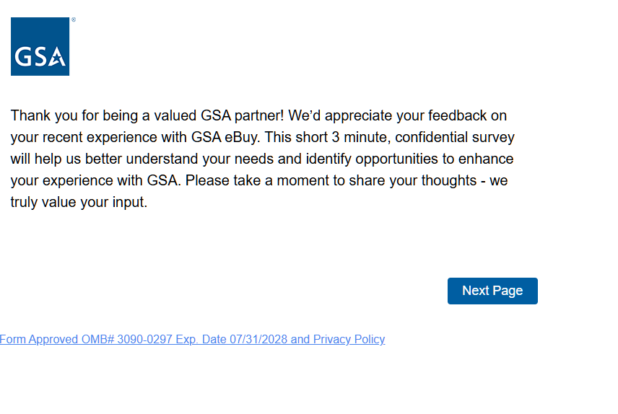
Screen #2

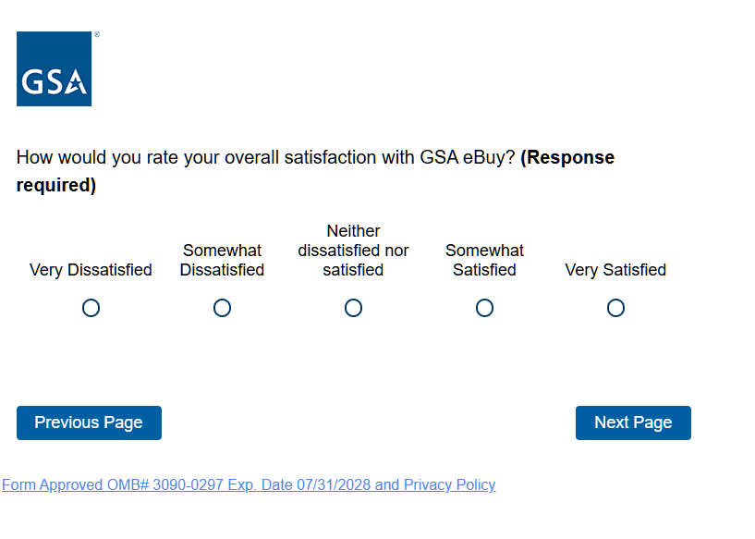
Screen #2 Displayed to respondents who respond Very Dissatisfied, Somewhat Dissatisfied, or Neither dissatisfied nor satisfied

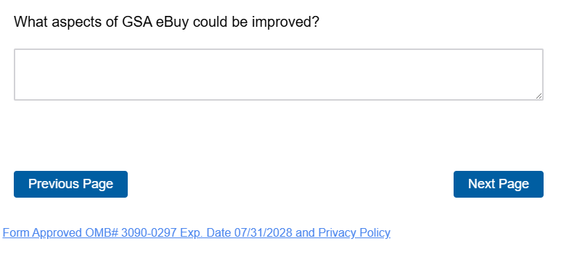
Screen #2 Displayed to respondents who respond Somewhat Satisfied or Very Satisfied

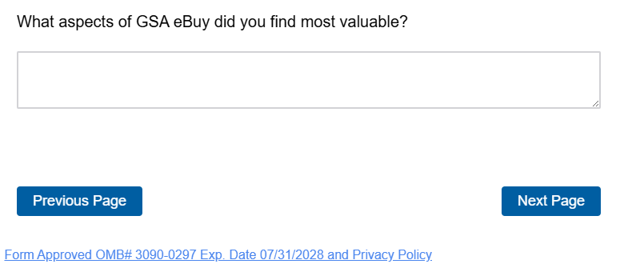
Screen #3
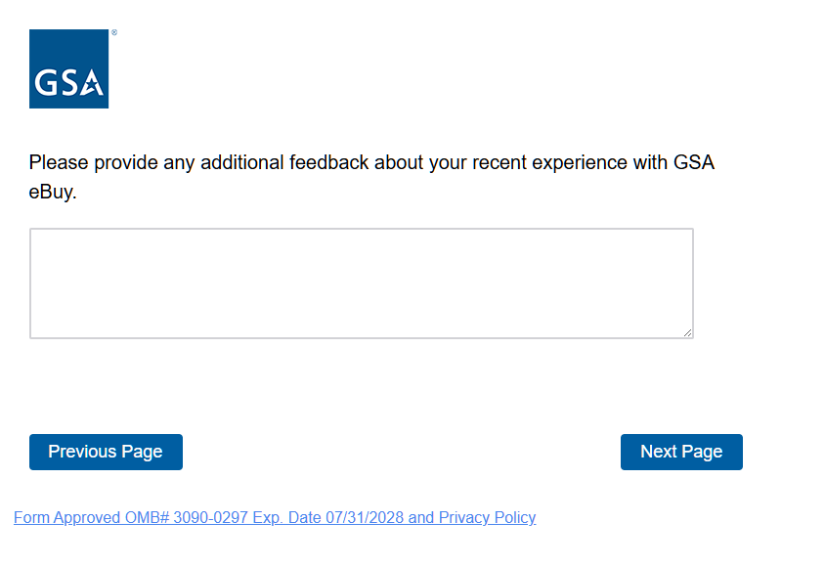
Screen #4
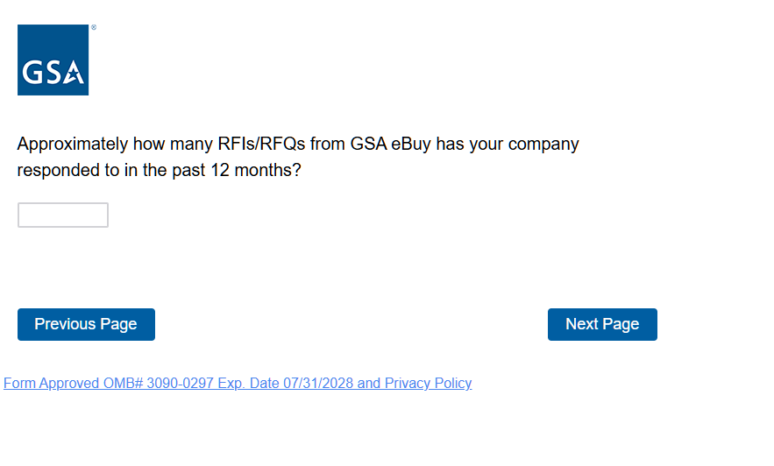
Screen #5
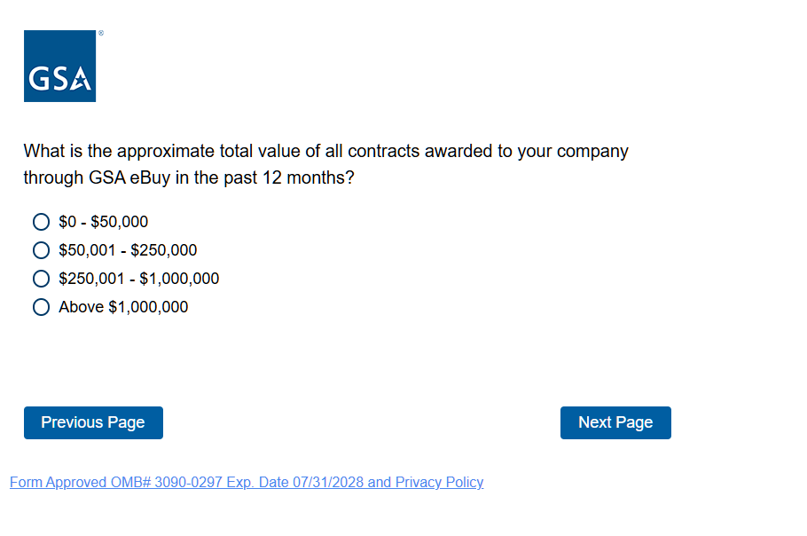
Screen #6
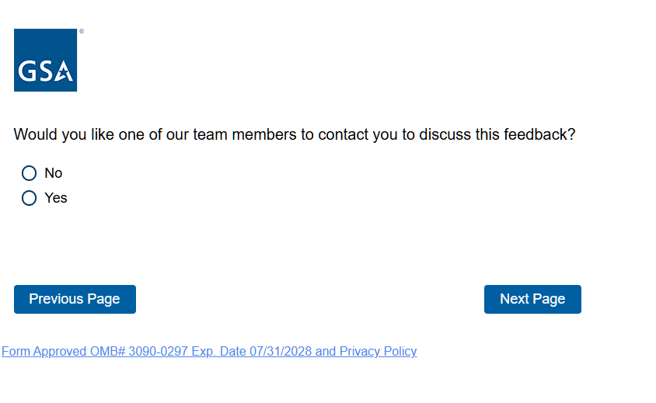
Screen #6 Displayed to respondents who reply yes
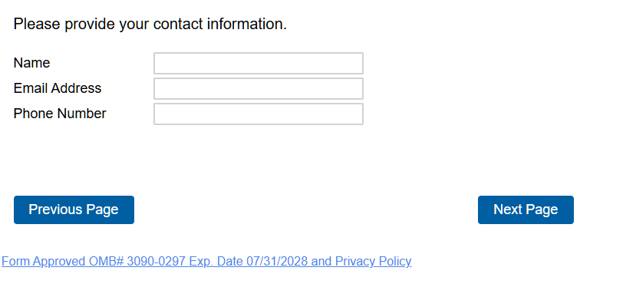
Screen #7
