Invite email sent to NSCS call center customers

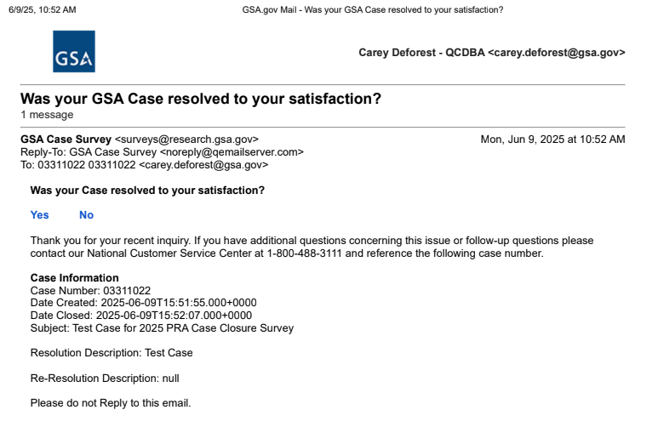

Screen #1 - Provided to respondents who were not satisfied with call center’s resolution

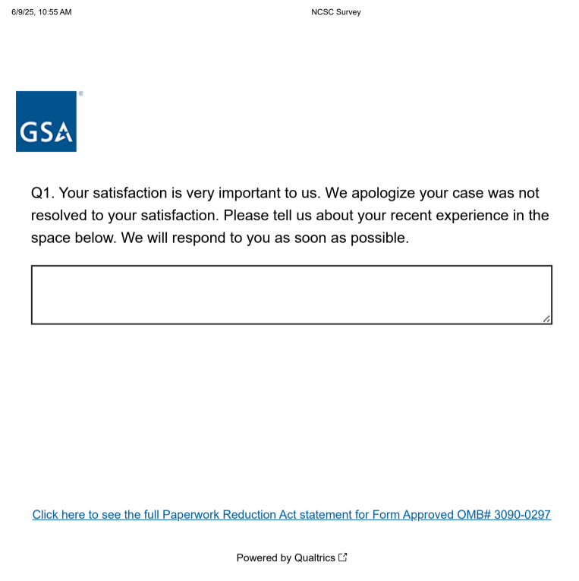

Screen #2 - Provided to respondents who were satisfied with call center’s resolution

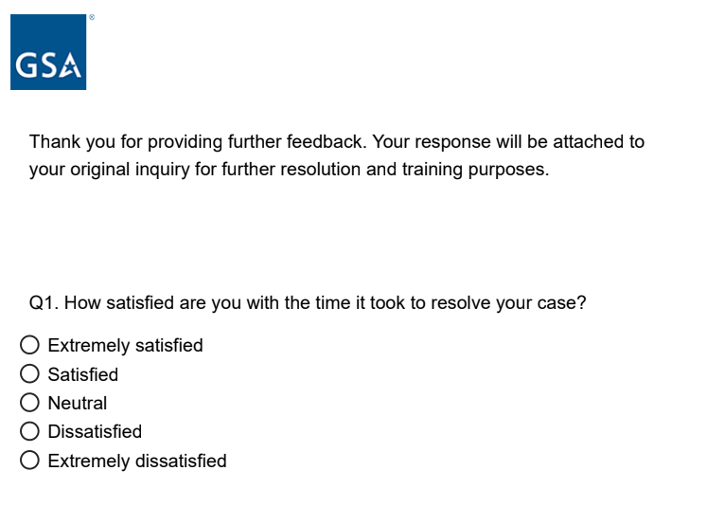
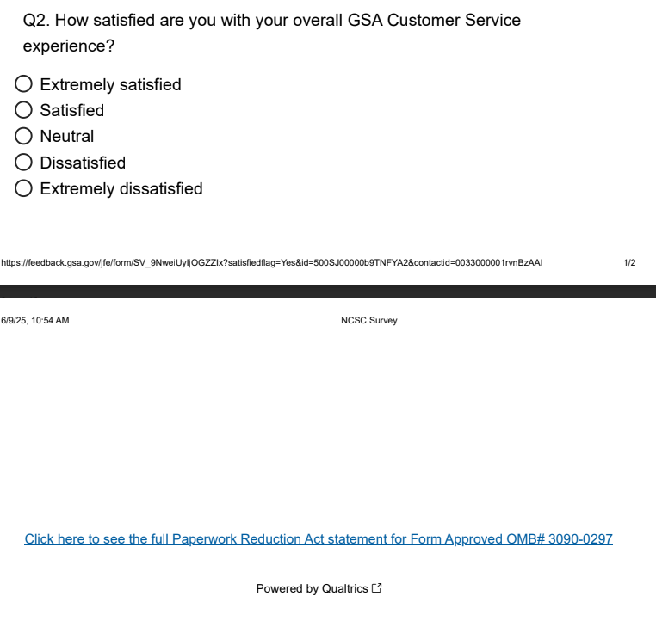
Screen #3 - Provided to respondents who were satisfied with call center’s resolution

