CENSUS OF AGRICULTURE
National Agricultural Statistics Service National Operations Center
9700 Page Avenue Suite 400 St. Louis, MO. 63132-1547
OFFICIAL BUSINESS
Penalty for Private Use $300

FORWARDING SERVICE REQUESTED

Please Respond by February 18, 2026

Dear Producer, OMB No. 0535-0259 Exp. Date X/XX/20XX

There is still time to complete the 2025 Local Food Marketing Practices Survey. If you have already responded, thank you. If you are no longer involved in any agricultural production, or need assistance completing this questionnaire, please call us toll free at 888-424-7828 so we can update our records.
Using this URL and survey code, please complete the Local Food Marketing Practices Survey by February 18: agcounts.usda.gov
Survey Code: <<survey code>>
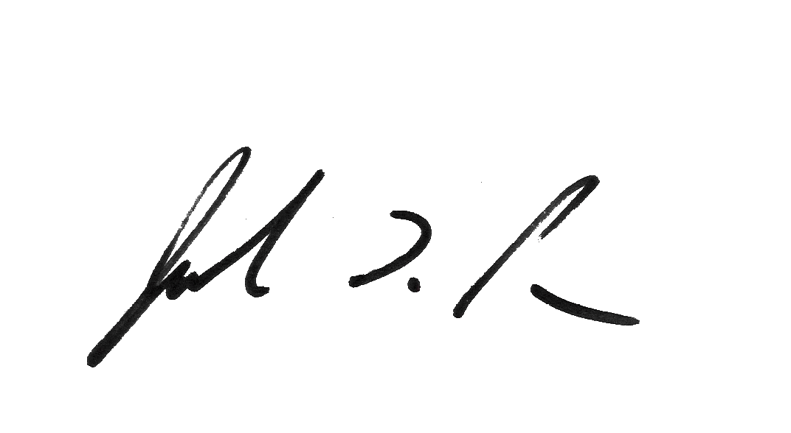
Everyone who receives this questionnaire is required by law (Title 7 USC 2204(g) Public Law 105-113) to respond. All information you provide is confidential, protected by federal law (Title III of Pub. L. No. 115-435, codified in 44 U.S.C. Ch. 35), and will be used for statistical purposes only. We will publish the data Decemeber 16, 2026, on Quick Stats at quickstats.nass.usda.gov. To access past data or more information about this survey, visit nass.usda.gov/agcensus.
Sincerely,

Joseph L. Parsons
Administrator, National Agricultural Statistics Service
United States Department of Agriculture

To respond, follow these steps:
- Go to agcounts.usda.gov
- Enter your survey code: <<survey code>>
- Select Submit & Get Survey(s).

- Find 2025 Local Food and Marketing Practices and select Start Survey.

- Follow the survey prompts.

- Complete the survey through the conclusion section and select Submit Survey.
According to the Paperwork Reduction Act of 1995, an agency may not conduct or sponsor, and a person is not required to respond to a collection of information unless it displays a valid OMB control number. The valid OMB number is 0535-0259. The time required to complete this information collection is estimated to average 60 minutes, including the time for reviewing instructions, searching existing data sources, gathering and maintaining the data needed, and completing and reviewing the collection of information.

