CENSUS OF AGRICULTURE
National Agricultural Statistics Service National Operations Center
9700 Page Avenue Suite 400 St. Louis, MO. 63132-1547
OFFICIAL BUSINESS
Penalty for Private Use $300

FORWARDING SERVICE REQUESTED

Please Respond by February 5, 2026

Dear Producer, OMB No. XXXX-XXXX Exp. Date X/XX/20XX

The U.S. Department of Agriculture (USDA) is conducting the 2025 Organic Survey to gather detailed statistics on local and regional food systems. Collected once every five years, these data inform decisions that affect you, your community, and industry. Everyone who receives a census is required by law to respond (Title 7 USC 2204(g) Public Law 105-113). Whether you are engaged in agricultural activity or not, please reply promptly so we can update our records.
Using this URL and survey code, please complete the Organic Survey by February 5: agcounts.usda.gov
Survey Code: <<survey code>>
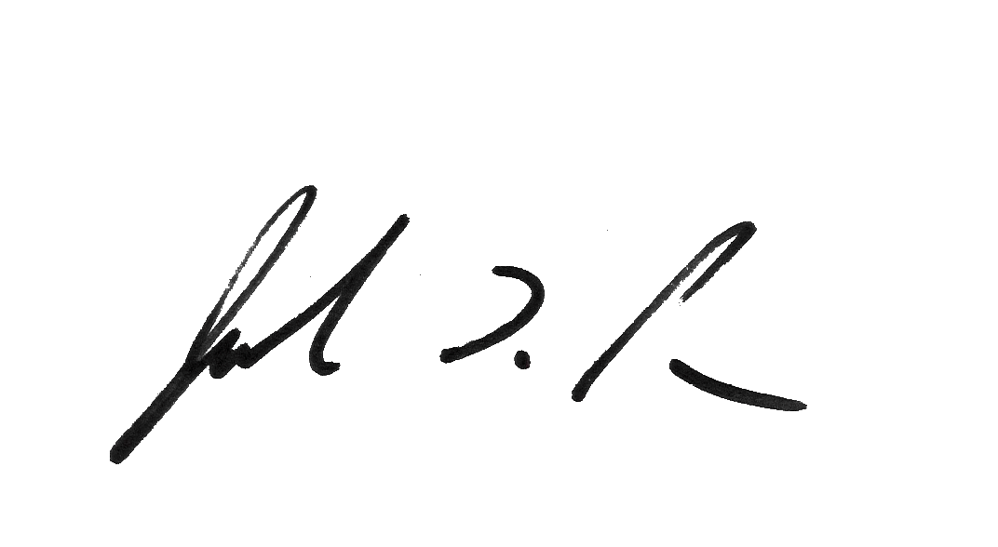
You will also receive a paper questionnaire in a few weeks. You do not have to fill out the paper version if you respond online. All information you provide is confidential and protected by federal law. If you need assistance completing the survey, call toll-free 888-424-7828. For more information, visit: https://www.nass.usda.gov/Surveys/Guide_to_NASS_Surveys/Organic_Production/index.php.
Sincerely,

Joseph L. Parsons
Administrator, National Agricultural Statistics Service
United States Department of Agriculture

To respond, follow these steps:
- Go to agcounts.usda.gov
- Enter your survey code: <<survey code>>
- Select Submit & Get Survey(s).

- Find 2025 Organic Survey and select Start Survey.

- Follow the survey prompts.

- Complete the survey through the conclusion section and select Submit Survey.
According to the Paperwork Reduction Act of 1995, an agency may not conduct or sponsor, and a person is not required to respond to a collection of information unless it displays a valid OMB control number. The valid OMB number is XXXX-XXXX. The time required to complete this information collection is estimated to average XX minutes, including the time for reviewing instructions, searching existing data sources, gathering and maintaining the data needed, and completing and reviewing the collection of information.

