**United States Department of Agriculture**

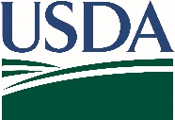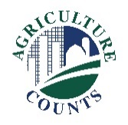

National Agricultural Statistics Service

January 5, 2026

Dear Producer,

According to our records, the U.S. Department of Agriculture’s National Agricultural Statistics Service (NASS) has not received your completed 2025 Organic Survey report form. Please complete and return your form today - **the deadline is February 5**. If you have already responded, thank you for your participation. If you are no longer involved in any organic agricultural operations, or need assistance completing this questionnaire, please call us toll free at 888-424-7828 so we can update our records.

The data gathered in this survey are important to help organizations, businesses, and policymakers make informed decisions that affect the well-being and growth of the organic agriculture industry.

If you have not yet responded, please do so one of the following ways:

* Online at agcensus.usda.gov. Responding online is fast and secure. All you need is your unique survey code from the mailing label to begin.
* By mail. Complete the enclosed form and return it in the envelope provided.

If a response is not received, a NASS representative may personally follow up with you to gather this information by phone or in person.

**The information you provide will be used for statistical purposes only. This survey is part of the Census of Agriculture Program, and as such is required and protected by law (Title 7 USC 2204(g) Public Law 105-113). These federal laws also require that NASS keeps your identity and your answers confidential.**

We will publish the data October 30, 2026, in the Quick Stats database at quickstats.[nass.usda.gov](http://www.nass.usda.gov).

Thank you for your participation and support of U.S. agriculture. For more information about the Organic Survey, visit nass.usda.gov/AgCensus.

Sincerely,

Joseph L. Parsons, Administrator

National Agricultural Statistics Service

U.S. Department of Agriculture

Enclosure