Supporting Statement – Part A

ORGANIC SURVEY

OMB No. 0535 – 0249

The National Agricultural Statistics Service (NASS) of the United States Department of Agriculture (USDA) requests approval from the Office of Management and Budget (OMB) to renew the Organic Survey information collection for a period of three years.

In 2026, NASS will be conducting the 2025 Organic Survey. The 2025 Organic Survey will be conducted as a follow-on to the 2022 Census of Agriculture. This survey will have a mandatory reporting requirement as authorized under Title 7 Sec. 2204(g) Public Law 105-113. This mandatory follow-on survey is conducted once approximately every five years.

The USDA Risk Management Agency (RMA) Organics survey will not be included in this information collection request (ICR). It will be submitted separately through IC 0535-0264.

The target population for this census consists of all certified organic farms and transitioning farms. Certified organic farms must meet the qualifications set out by the Agricultural Marketing Service (AMS) of the USDA and be certified compliant by an approved agent of AMS. Transitioning farms have filed a plan and have begun the process of becoming certified organic.

The Organic Survey will be conducted in all 50 States. The initial mailing to respondents in early December will consist of a pressure sealer mailer that will contain information on how the respondents can go online and complete the questionnaire through our Computer-Aided Self-Administered Interview (CASI) system. This will be followed in early January by a mailing of approximately 27,000 mailing packets containing a questionnaire, cover letter, instruction sheet, and return envelope. A third mailing in late January to nonrespondents will be a reminder pressure sealer mailer. The fourth mailing in late February will contain another questionnaire, cover letter, instruction sheet, and return envelope. All questionnaires will be keyed from image at the National Operations Center (NOC) in Olivette, Missouri. E-mail reminders may be used for respondents who opted-in to receiving E-Mail reminders. There will be phone follow-up for those who do not respond to the mail requests. There will also be a limited number of face-to-face interviews conducted.

NASS will release data at the State level and for each major organic commodity when possible. Some State level data may need to be released on a regional or national level due to confidentiality rules.

SECTION A. JUSTIFICATION

1. Explain the circumstances that make the collection of information necessary. Identify any legal or administrative requirements that necessitate the collection. Attach a copy of the appropriate section of each statute and regulation mandating or authorizing the collection of information.

The primary functions of NASS are to prepare and issue State and national estimates of crop and livestock production, disposition, and prices and to collect information on related environmental and economic factors, whole farm characteristics, and operator demographics. Timely, reliable, and detailed statistics help maintain a stable economic atmosphere and reduce risk for production, marketing, and distribution operations.

General authority for these data collection activities is granted under U.S. Code Title 7, Section 2204 which specifies that "The Secretary of Agriculture shall procure and preserve all information concerning statistics ... and shall distribute them among agriculturists."

The Organic Survey data will be collected under the authority of 7 U.S.C. 2204(a). Individually identifiable data collected under this authority are governed by Section 1770 of the Food Security Act of 1985 as amended, 7 U.S.C. 2276, which requires USDA to afford strict confidentiality to non-aggregated data provided by respondents. This Notice is submitted in accordance with the Paperwork Reduction Act of 1995, Pub. Law 104-13, 44 U.S.C. 3501, et seq. and Office of Management and Budget regulations at 5 CFR part 1320.

The Organic Survey will also help to fulfill mandates set forth by the “Food, Agriculture, Conservation, and Trade Act of 1990” (Pub. Law 101-624) and the “Farm Security and Rural Investment Act of 2002” (Pub. Law 107-171) as amended by the “Agricultural Act of 2014” (Pub. Law 113-79).

According to the 2022 Census of Agriculture, there were 17,446 farms that produced and sold a total of $11.2 billion.

Food safety and nutrition concerns continue to aid legislators in establishing policies for our Nation’s food supply. Accurate measures of non-organic products used to make food have a firm foundation while there is a serious lack of information regarding the Organic sector’s contribution to our food supply.

Our nation’s consumers are becoming increasingly aware of the impact that quality food has as a cornerstone for overall health and quality of life. As more research and studies are conducted there will be a continuing need for an accurate account of what organic production can contribute as a supplement to our overall intake of food products.

- Indicate how, by whom, and for what purpose the information is to be used. Except for a new collection, indicate the actual use the agency has made of the information received from the current collection.

The primary purpose of the Organic Survey is to provide acreage, production, and sales data for a variety of organic crop and livestock commodities as well as to gather information on organic marketing practices. These data will be provided by certified organic farms and transitional farms in all 50 States. National and State estimates (when released) will be set for all items that are collected on the survey.

Producers, universities, legislators, farm businesses, etc. are in need of organic production and economic data in order to make various important marketing and business decisions. The production of organic commodities can be a very profitable alternative for America’s farmers and ranchers and the information gathered will help in the continued orderly development of this expanding agricultural industry.

NASS plans to collect the following organic crop information for acreage in production, quantity produced, quantity sold, and value of sales for field crops, vegetables, fruits, tree nuts and berries. NASS plans to collect information on inventory, quantity sold and value of sales, for organic: livestock, poultry and livestock products. In addition, NASS will collect information on the different marketing practices.

As part of the Organic Farming Initiatives, the data will be used to provide solid production and market data about the supply of key organic commodities. Presently, conventional farmers have access to various types of USDA data for non-organic commodities, while there is no long term, comparable data available for organic producers.

These data will be used to enhance programs like the Environmental Quality Incentives Program (EQIP) by providing accurate, detailed data for agricultural products produced using organic practices. Data will provide valuable information regarding the potential expansion of the Market Access Program to allow for more organic agricultural exports. The Federal Crop Insurance Corporation (FCIC) will use these data to provide better insurance coverage for organic crops.

3. Describe whether, and to what extent, the collection of information involves the use of automated, electronic, mechanical, or other technological collection techniques or other forms of information technology, e.g. permitting electronic submission of responses, and the basis for the decision for adopting this means of collection. Also describe any consideration of using information technology to reduce burden.

NASS will use a Computer-Aided Self-Administered Interview (CASI) instrument for soliciting responses to the Organic Survey. The 2019 Organic Survey, which was conducted as a follow-on survey to the 2017 Census of Agriculture and had a mandatory reporting requirement, had a 25% online response rate.

NASS will also be publicizing this survey with:
- Communication Officers of State Departments of Agriculture (COSDA),
- Community Based Organizations,
- USDA Radio,
- RFD-TV (Rural Media Group),
- Attendance at trade shows,
- Social Media (Twitter and Facebook), and
- County Extension Newsletter.

Follow–up telephone interviews and a limited number of face-to-face interviews will be used for data collection of non-respondent cases. NASS will utilize survey management and methodology information technology to target operations that have a higher probability of producing organic products.

4. Describe efforts to identify duplication. Show specifically why any similar information already available cannot be used or modified for use for the purposes described in Item 2 above.

The Organic Survey is expected to produce reliable data, that is both current and on a national scale. The first national scale survey that was conducted by NASS was in 2009 for the reference period 2008. The 2019 Organic Survey collected data for certified producers and had a mandatory response. The 2025 Organic Survey will also return to the mandatory reporting and will include certified organic producers, and transitioning producers.

Internal committees within USDA that include NASS, Economic Research Service (ERS), Agricultural Marketing Service (AMS), Agricultural Research Service (ARS), Cooperative State Research Education and Extension Service (CSREES), and Natural Resource and Conservation Service (NRCS) have been formed to help coordinate the different aspects of NASS data collection efforts and to eliminate the possibility of duplication of efforts.

5. If the collection of information impacts small businesses or other small entities (Item 5 of OMB Form 83-I), describe any methods used to minimize burden.
The information requested can be provided with a minimum of difficulty from normal operating records. Approximately 93 percent of the operations in the sample are small businesses as defined in the Small Business Administration’s Table of Small Business Size Standards:

SBA Table of Size Standards

6. Describe the consequence to Federal program or policy activities if the collection is not conducted or is conducted less frequently, as well as any technical or legal obstacles to reducing burden.

Under the Agricultural Adjustment Act of 1938 (Pub. Law 75-430) and the Federal Crop Insurance Reform Act (Pub. Law 103-354) as amended through Public Law 113-79; the Department of Agriculture Organic Act of 1944 as amended; and the Organic Foods Production Act of 1990 as amended, greater emphasis has been placed on the production and marketing of organic crops in the United States. The Risk Management Agency (RMA), the Federal Crop Insurance Corporation (FCIC), the Agricultural Marketing Service (AMS) and numerous other Federal and State agencies rely on the availability of accurate, timely organic data in order to perform their duties. Within this growing sector of farm production, less frequent data collection would greatly impair the accuracy of these other agencies work.

The 2025 Organic Survey will be conducted as a follow-on to the 2022 Census of Agriculture. This survey will have a mandatory reporting requirement as authorized under Title 7 Sec. 2204(g) Public Law 105-113.

7. Explain any special circumstances that would cause an information collection to be conducted in a manner requiring respondents to report information to the agency more often than quarterly;

There are no special circumstances associated with this information collection.

- Provide a copy and identify the date and page number of publication in the Federal Register of the agency's notice, required by 5 CFR 1320.8 (d), soliciting comments on the information collection prior to submission to OMB. Summarize public comments received in response to that notice and describe actions taken by the agency in response to these comments

The first Notice soliciting comments was published in the Federal Register on January 30, 2025 on pages 8514-8515. There was one public comment received but was deemed non-substantial. The comment is attached to this submission.

Describe efforts to consult with persons outside the agency to obtain their views on the availability of data, frequency of collection, the clarity of instructions and record-keeping, disclosure, or reporting format (if any), and on the data elements to be recorded, disclosed, or reported.

NASS has solicited input from other agencies and organic institutions regarding operation practices and marketing.

9. Explain any decision to provide any payment or gift to respondents.

There are no payments or gifts to respondents.

10. Describe any assurance of confidentiality provided to respondents and the basis for the assurance in statute, regulation, or agency policy.
Questionnaires include a statement that individual reports are confidential. U.S. Code Title 18, Section 1905; U.S. Code Title 7, Section 2276; and the Confidential Information Protection and Statistical Efficiency Act of 2018, Title III of Pub. L. No. 115-435, codified in 44 U.S.C. Ch. 35 and other applicable Federal laws. All employees of NASS and all enumerators hired and supervised under a cooperative agreement with the National Association of State Departments of Agriculture (NASDA) must read the regulations and sign a statement of compliance.

The following CIPSEA Pledge statement will appear on all future NASS questionnaires.

The information you provide will be used for statistical purposes only. Your responses will be kept confidential and any person who willfully discloses ANY identifiable information about you or your operation is subject to a jail term, a fine, or both. This survey is conducted in accordance with the Confidential Information Protection and Statistical Efficiency Act of 2018, Title III of Pub. L. No. 115-435, codified in 44 U.S.C. Ch. 35 and other applicable Federal laws. For more information on how we protect your information please visit: https://www.nass.usda.gov/confidentiality.

All individuals who may access these confidential data for research are also covered under Titles 18 and CIPSEA and must complete a Certification and Restrictions on Use of Unpublished Data (ADM-043) agreement.

11. Provide additional justification for any questions of a sensitive nature.

No questions of a sensitive nature are anticipated in work conducted under this clearance.

12. Provide estimates of the hour burden of the collection of information. The statement should indicate the number of respondents, frequency of response, annual hour burden, and an explanation of how the burden was estimated. If this request for approval covers more than one form, provide separate hour burden estimates for each form and aggregate the hour burdens in Item 13 of OMB Form 83-I. Provide estimates of annualized cost to respondents for the hour burdens for collections of information, identifying and using appropriate wage rate categories.

The time required to complete the Organic Survey questionnaire is expected to average 40 minutes per respondent. Time will vary since operations differ in size, scope of production, and practices utilized. Response burden hours are shown in the table below.

The estimated annual cost to the public of completing a questionnaire is assumed to be comparable to the hourly rate of those requesting the data. Using the estimated annual reporting time of 18,727 hours is multiplied by $45.32 per hour for a total cost to the public of $848,707.64.

NASS uses the Bureau of Labor Statistics’ Occupational Employment Statistics (most recently published on April 2, 2025 for the previous May) to estimate an hourly wage for the burden cost. The May 2024 mean wage for bookkeepers was $25.01. The mean wage for farm managers was $46.75. The mean wage for farm supervisors was $30.46. The mean wage of the three is $34.07. To calculate the fully loaded wage rate (includes allowances for Social Security, insurance, etc.) NASS will add 33% for a total of $45.32 per hour
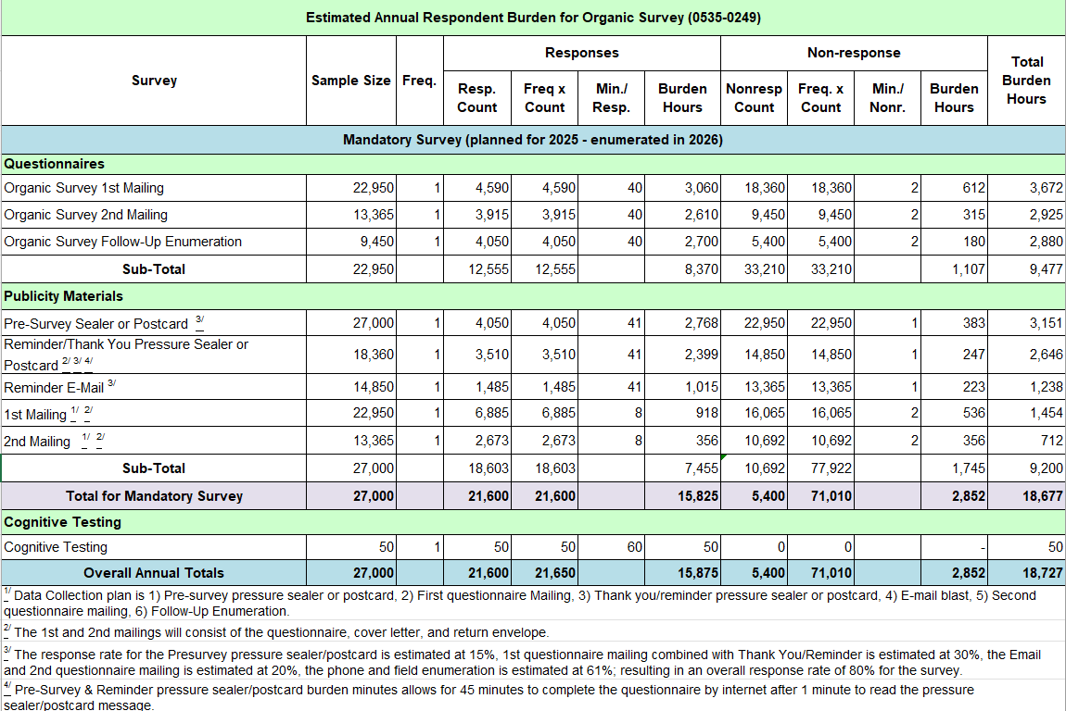
13. Provide an estimate of the total annual cost burden to respondents or recordkeepers resulting from the collection of information.

There are no capital/startup or ongoing operation/maintenance costs associated with this information collection period.

14. Provide estimates of annualized cost to the Federal government; provide a description of the method used to estimate cost which should include quantification of hours, operational expenses (equipment, overhead, printing, and staff), and any other expense that would not have been incurred without this collection of information.

The total cost to the Federal Government for the Organic Survey is estimated at $2,700,000. Almost all the total goes to federal personnel wages and benefits; the remainder is for data collection, supplies, postage, computer processing, and similar items.

15. Explain the reasons for any program changes or adjustments reported in Items 13 or 14 of the OMB Form 83-I (reasons for changes in burden).

The USDA RMA Organics survey will be submitted separately via IC 0535-0264 and not included in this ICR. Removing the Quality Control Worksheet decreased responses, but burden hours increased slightly due to questionnaire changes.

 | Current Inventory | New Inventory | Difference
Respondents | 27,550 | 27,000 | -550
Responses | 98,236 | 92,660 | -5,576
Burden Hours | 18,684 | 18,727 | 43

16. For collections of information whose results will be published, outline plans for tabulation and publication. Address any complex analytical techniques that will be used. Provide the time schedule for the entire project, including beginning and ending dates of the collection of information, completion of report, publication dates, and other actions.

Approximate annual time schedule for the Organic Survey:

Pressure Sealer for Internet Response Mailing December
Initial Mail-out Early January
Reminder Sealer (Internet Response Mailing) Late January
Reminder Email February
Follow-up Mailing February
Telephone / Field Follow-up Late March – April
Review, Analysis, and Summary January – September
Estimation September – October
Quick Stats/Disclosure Review September – October
Quick Stats Release (Proposed) October

To aid telephone and field follow-up by enumerators, each enumerator will receive an Interviewer’s Manual. To aid statisticians in the edit and analysis of reported data, Regional Field Offices will receive Census Administration Manuals.

All the data will be available in NASS Quick Stats found at: https://quickstats.nass.usda.gov/.

17. If seeking approval to not display the expiration date for OMB approval of the information collection, explain the reasons that display would be inappropriate.

No approval is requested for non-display of the expiration date.

18. Explain each exception to the certification statement identified in Item 19, “Certification for Paperwork Reduction Act Submissions” of OMB Form 83-I.

No exceptions to the Certification Statement should be required. If so, OMB approval will be requested in advance of conducting the survey.

June, 2025

