OMB Control Number: 0648-0829

Expiration Date

York River Outdoor Recreation Survey:

Understanding Visitor Experiences, Motivations, and Barriers

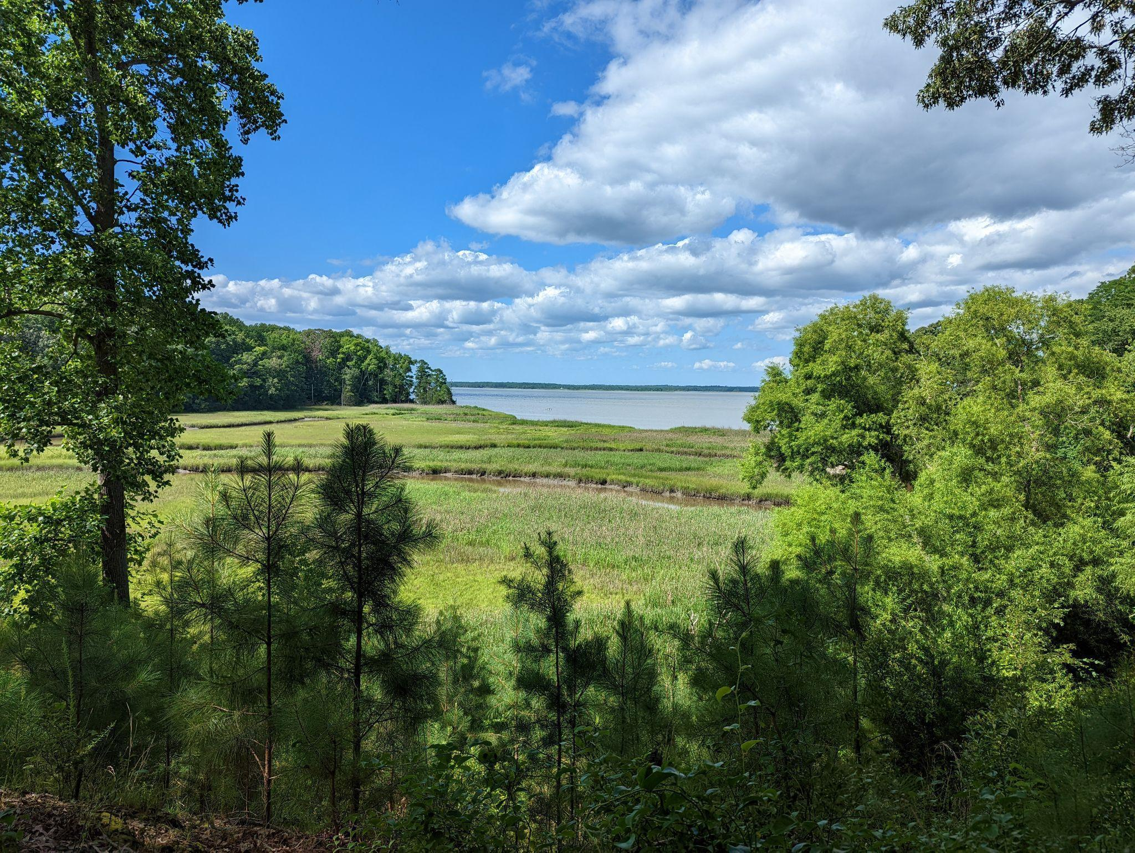



We are interested in learning about your outdoor experiences in and around the York River (see map on next page). This survey will ask about what motivates you to engage in outdoor recreation, any challenges you might have encountered, and details about your most recent trip to the York River and surrounding areas. Your responses will help local policy makers, including park managers and municipalities, improve outdoor recreation experiences in and around the York River.

By completing the survey, you are consenting to participate in this research. Although we hope that you will answer every question, you are free to skip any questions. Your participation is voluntary, and you may withdraw your consent and discontinue participation at any time. The survey will take approximately 10 minutes to complete.

You will not be individually identified, and your responses will be used for statistical purposes only. Data collection will be managed by an external vendor who will not collect or store names. Mailing addresses will be used exclusively by the vendor for distributing survey materials and will not be linked to individual responses. Additionally, NOAA will not have access to or retain any mailing address information.

**Public Burden Statement**

The public reporting burden for this information collection is estimated at 10 minutes per response. This burden estimate includes time for reading the instructions, reviewing the questions, and completing the survey instrument. Send comments regarding the accuracy of this burden estimate and any suggestions for reducing the burden to: noaa.nccos.sstex@noaa.gov. You are not required to respond to this collection of information unless a valid OMB control number is displayed.

To be completed by the adult (age 18 and over) in your

household who has the next upcoming birthday.

**This is a map of the York River and surrounding parks and natural areas.**

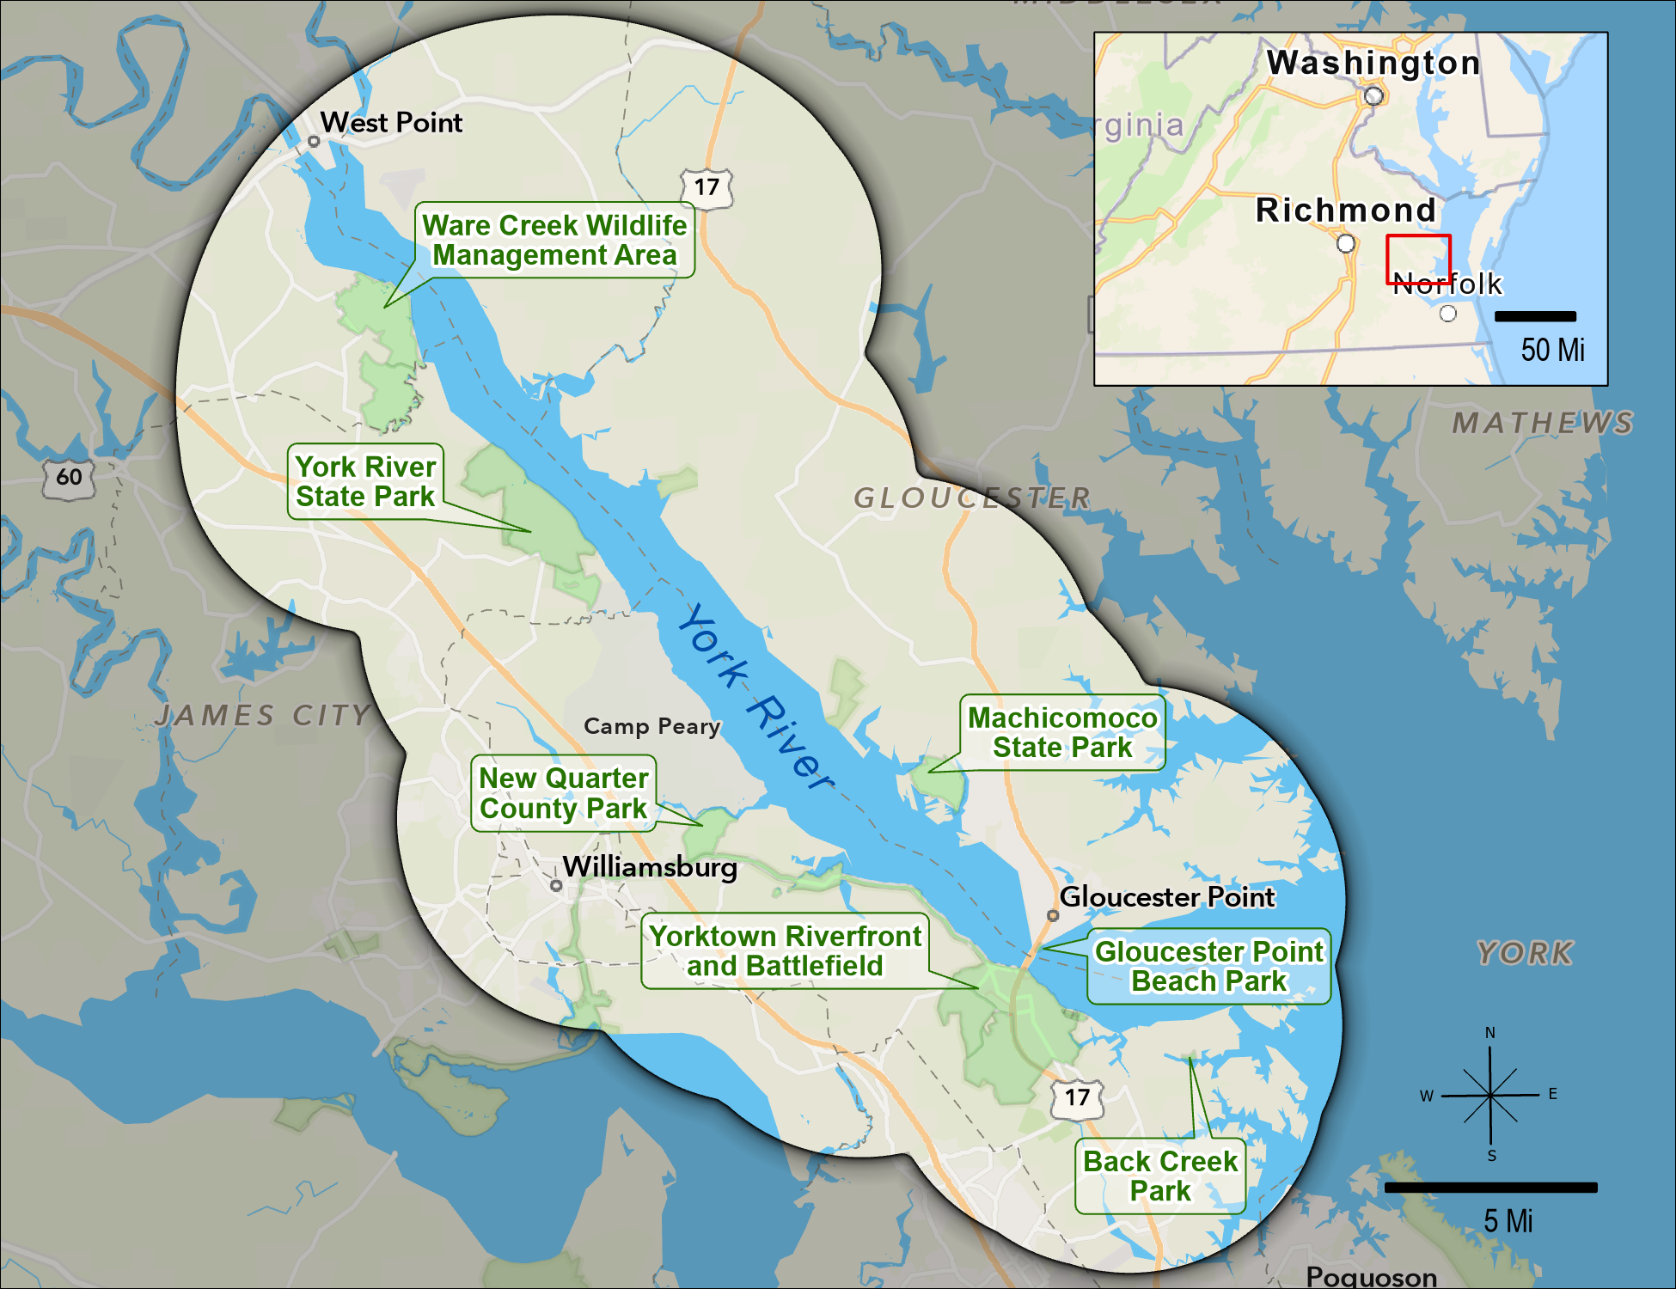

1. **Looking at the map above, did you take any trips to the York River or any surrounding park or natural area for outdoor recreation within the last 12 months?**

*A trip is defined as an intentional visit where at least 10 minutes are spent on-site. Same-day reentries are considered to be a single trip. Trips may include overnight stays.*

* Yes
* No → SKIP to PAGE 7 (Q21)
* Unsure → SKIP to PAGE 7 (Q21)

1. **Approximately, how many trips did you take to the York River or any surrounding park or natural area for outdoor recreation within the last 12 months?** ____ number of trips
2. **When was the last time you took a trip to the York River or any surrounding park or natural area for outdoor recreation?** __/___ (MM/YYYY)

Please only consider your **most recent trip** to the York River or any surrounding park or natural area for outdoor recreation when answering questions on this page.

1. **What type of group were you traveling with on this trip?** *Please select all that apply.*
   * Alone
   * Family
   * Friends
   * Organized group
2. **Including yourself, how many people were in your personal group on this trip?** ____ number of people

*Your personal group is defined as you and anyone with whom you visited the York River or any surrounding park or natural area on this trip, such as a spouse, family, and friends. This does not include the larger or organized group that you might have traveled with, such as a school, church, scout, or tour group.*

1. **Including yourself, how many people in your personal group were of each of the following age categories?**

|  |  |
| --- | --- |
| 4 years old or younger | _______number of people |
| 5-17 years old | _______number of people |
| 18-64 years old | _______number of people |
| 65 years old or older | _______number of people |

1. **Approximately, how much time did you spend specifically within the York River or any surrounding park or natural area during this trip?**

Day trip:

* Less than an hour
* 1-2 hours
* 2-3 hours
* 3-4 hours
* 4-8 hours
* 8-12 hours

_____ Number of days if longer than 1 day

1. **Referring to the map on page 2, did you visit any of the following locations on this trip?**

|  |  |  |  |
| --- | --- | --- | --- |
|  | Yes | No | Unsure |
| Ware Creek Wildlife Management Area |  |  |  |
| York River State Park |  |  |  |
| New Quarter Park |  |  |  |
| Yorktown Riverfront/Battlefield |  |  |  |
| Back Creek Park |  |  |  |
| Gloucester Point Beach Park |  |  |  |
| Machicomoco State Park |  |  |  |

Please only consider your **most recent trip** to the York River or any surrounding park or natural area for outdoor recreation when answering questions on this page.

1. **Did you participate in any of the following activities within the York River or any surrounding park or natural area during this trip?**

|  |  |  |
| --- | --- | --- |
|  | Yes | No |
| Walking, hiking, or running |  |  |
| Nature photography |  |  |
| Viewing wildlife, including birdwatching |  |  |
| Hunting |  |  |
| Swimming or wading |  |  |
| Sunbathing/relaxing on a beach |  |  |
| Fishing |  |  |
| Boating (motorized and non-motorized) |  |  |
| Paddle sports (for example, canoeing and kayaking) |  |  |
| Educational/interpretive program |  |  |

1. **When participating in water-based activities, such as swimming, kayaking, or boating, did you bring a mobile device, such as a smartphone, tablet, or smartwatch, with you?**
   * Yes, and I kept it on
   * Yes, but I turned it off
   * No
   * I did not participate in water-based activities on this trip
2. **When participating in land-based activities, did you bring a mobile device, such as a smartphone, tablet, or smartwatch, with you?**
   * Yes, and I kept it on
   * Yes, but I turned it off
   * No
   * I did not participate in land-based activities on this trip
3. **If you brought a mobile device and kept it on, did you use it for any of the following reasons?**

|  |  |  |
| --- | --- | --- |
|  | Yes | No |
| Safety/In case of emergency |  |  |
| Navigation |  |  |
| Social media |  |  |
| Photography |  |  |
| Learn about the park |  |  |
| Other, please specify |  |  |

* + I didn’t bring a mobile device and/or keep it on

Please only consider your **most recent trip** to the York River or any surrounding park or natural area for outdoor recreation when answering questions on this page.

1. **Did you use any of the following forms of transportation to reach your primary destination on this trip?**

|  |  |  |
| --- | --- | --- |
|  | Yes | No |
| Walking |  |  |
| Personal vehicle, including watercraft |  |  |
| Bicycle, including electric |  |  |
| Public transportation (for example, bus, rail, or ferry) |  |  |
| Rental car |  |  |
| Taxi or rideshare (for example, Uber or Lyft) |  |  |

1. **Did you purchase a Virginia State Park annual pass in the last 12 months?**
   * Yes
   * No → SKIP to Q16
2. **How much did you spend on your Virginia State Park annual pass in the last 12 months?** $____
3. **Did you purchase a Virginia hunting or fishing license in the last 12 months?**
   * Yes
   * No → SKIP to Q18
4. **How much did you spend on your Virginia hunting or fishing license(s) in the last 12 months?** $____
5. **Please estimate the amount you spent on each of the following items during this trip, and indicate how many people, including yourself, shared those expenses.***If you didn’t spend any money on an item, please mark it as $0 for the estimated amount. If you paid for yourself only, please mark it as 1 for the number of people.*

|  |  |  |
| --- | --- | --- |
|  | Estimated Amount | Number of People |
| Gas | $_________ |  |
| Tolls | $_________ |  |
| Public transportation, taxi, or rideshare fare | $_________ |  |
| Entrance fees (excluding annual passes) | $_________ |  |
| Parking fees (excluding annual passes) | $_________ |  |
| Bait and tackle | $_________ |  |
| Equipment rental fees | $_________ |  |
| Tour or guide fees | $_________ |  |
| Lodging (for example, hotel or campground) fees | $_________ |  |

Please only consider your **most recent trip** to the York River or any surrounding park or natural area for outdoor recreation when answering questions on this page.

1. **How important to you were the following features when deciding to take this trip?**

|  |  |  |  |  |
| --- | --- | --- | --- | --- |
|  | Not at all  important | Somewhat  important | Very  important | Extremely  important |
| Designated walking/hiking trails |  |  |  |  |
| Designated blueways/kayak trails |  |  |  |  |
| Access to water (e.g. rivers and lakes) |  |  |  |  |
| Restrooms |  |  |  |  |
| Picnic areas |  |  |  |  |
| Fishing areas |  |  |  |  |
| Parking areas |  |  |  |  |
| Internet or cell service |  |  |  |  |
| Educational/interpretive program |  |  |  |  |
| Educational/interpretive signage |  |  |  |  |
| Directional signage |  |  |  |  |
| Personal/personal group safety |  |  |  |  |
| Access for people with disabilities |  |  |  |  |
| Equipment/gear rentals |  |  |  |  |
| Other, please specify |  |  |  |  |

1. **Looking at this same list of features, how satisfied were you with the quality of each of the following features on this trip?**

|  |  |  |  |  |  |
| --- | --- | --- | --- | --- | --- |
|  | Not at all  satisfied | Somewhat  satisfied | Very  satisfied | Extremely  satisfied | Not applicable |
| Designated walking/hiking trails |  |  |  |  |  |
| Designated blueways/kayak trails |  |  |  |  |  |
| Access to water (e.g. rivers and lakes) |  |  |  |  |  |
| Restrooms |  |  |  |  |  |
| Picnic areas |  |  |  |  |  |
| Fishing areas |  |  |  |  |  |
| Parking areas |  |  |  |  |  |
| Internet or cell service |  |  |  |  |  |
| Educational/interpretive program |  |  |  |  |  |
| Educational/interpretive signage |  |  |  |  |  |
| Directional signage |  |  |  |  |  |
| Personal/personal group safety |  |  |  |  |  |
| Access for people with disabilities |  |  |  |  |  |
| Equipment/gear rentals |  |  |  |  |  |
| Other, please specify |  |  |  |  |  |

1. **Do you intend to visit the York River or any surrounding parks or natural areas for outdoor recreation in the future?**

* Yes, within the next 12 months
* Yes, but not within the next 12 months
* No
* Unsure

1. **Regardless of how you answered the question above, which of the following are reasons why you may not visit the York River or surrounding areas for outdoor recreation in the next 12 months?**

|  |  |  |  |
| --- | --- | --- | --- |
|  | Not a reason | Minor reason | Major reason |
| Trails poorly maintained |  |  |  |
| Limited/no blueways/kayak trails |  |  |  |
| Limited/no water access (e.g. rivers and lakes) |  |  |  |
| Limited/no restrooms |  |  |  |
| Limited/no picnic areas |  |  |  |
| Limited/no fishing areas |  |  |  |
| Limited/no parking areas |  |  |  |
| Limited/no internet or cell service |  |  |  |
| Limited/no educational/interpretive programs |  |  |  |
| Limited/no information on available facilities, amenities, or activities |  |  |  |
| Signs are not in my preferred language |  |  |  |
| Park staff does not speak in my preferred language |  |  |  |
| Concerns about safety or security |  |  |  |
| Discrimination/do not feel welcome |  |  |  |
| Limited/no access for people with disabilities |  |  |  |
| Limited/no equipment/gear |  |  |  |
| Not enough time |  |  |  |
| Too expensive |  |  |  |
| Too far to travel |  |  |  |
| Limited/no public transportation |  |  |  |
| No one to go with |  |  |  |
| Not interested in outdoor recreation |  |  |  |
| Other, please specify |  |  |  |

*This is the final section of the survey. The following questions ensure that all groups are fairly represented.*

***All answers are confidential.***

1. **Are you…?**
   * Male
   * Female
2. **What is your race and/or ethnicity?** *Please select all that apply* and enter additional details in the spaces below*.*

* American Indian or Alaska Native- *Enter, for example, Navajo Nation, Blackfeet Tribe of the Blackfeet Indian Reservation of Montana, Native Village of Barrow Inupiat Traditional Government, Nome Eskimo Community, Aztec, Maya, etc*. ­______________________________________________
* Asian-*Provide details below*.
  + - Chinese
    - Asian Indian
    - Filipino
    - Vietnamese
    - Korean
    - Japanese
    - *Enter, for example, Pakistani, Hmong, Afghan, etc.* ________________________
* Black or African American-*Provide details below*.
  + - African American
    - Jamaican
    - Haitian
    - Nigerian
    - Ethiopian
    - Somali
    - *Enter, for example, Trinidadian and Tobagonian, Ghanaian, Congolese, etc*. ________
* Hispanic or Latino-*Provide details below*.
  + - Mexican
    - Puerto Rican
    - Salvadoran
    - Cuban
    - Dominican
    - Guatemalan
    - *Enter, for example, Colombian, Honduran, Spaniard, etc*. ___________
* Middle Eastern or North African-*Provide details below*.
  + - Lebanese
    - Iranian
    - Egyptian
    - Syrian
    - Iraqi
    - Israeli
    - *Enter, for example, Moroccan, Yemeni, Kurdish, etc.* _______________
* Native Hawaiian or Pacific Islander-*Provide details below*.
  + - Native Hawaiian
    - Samoan
    - Chamorro
    - Tongan
    - Fijian
    - Marshallese
    - *Enter, for example, Chuukese, Palauan, Tahitian, etc*. _____________
* White-*Provide details below*.
  + - English
    - German
    - Irish
    - Italian
    - Polish
    - Scottish
    - *Enter, for example, French, Swedish, Norwegian, etc.* _____________

1. **In what year were you born?** _____ YYYY
2. **When visiting an area for outdoor recreation, what language do you prefer information to be in?** *Please select all that apply.*

* English
* Arabic
* Chinese
* Korean
* Spanish
* Vietnamese
* Other (please specify) _____

1. **What is the highest degree or level of school you have completed?** *Please check only one.*
   * Less than high school
   * Some high school, no diploma
   * High school graduate/GED
   * Vocational/trade school certificate
   * Some college, no diploma
   * Two-year college degree
   * Four-year college degree
   * Graduate or professional degree
   * Prefer not to answer
2. **Do you own or rent this residence (where this survey was mailed to)?**

* Own
* Rent
* Other

1. **Is this your primary residence?**
   * Yes
   * No
2. **How long have you been a resident of your current town?** _____ number of years
3. **How long have you been a Virginia resident?** _____ number of years
4. **How many people, including yourself, live in your household?** ____ number of people
5. **How many of these people are at least 18 years old?** ____ number of people at least 18
6. **Which best describes your current employment status?** *Please check only one.*

* Unemployed
* Employed full-time
* Employed part-time
* Retired
* Student
* Homemaker
* Prefer not to answer

1. **What was your annual household income in 202X, before taxes?** *Please check only one.*

* Less than $25,000
* $25,000 to $49,999
* $50,000 to $74,999
* $75,000 to $99,999
* $100,000 to $149,999
* $150,000 to $199,999
* $200,000 or more
* Prefer not to answer

**Thank you very much for taking the time to complete our survey. If you have any additional comments, please feel free to include them in the space provided below.**

*Thank you! That’s our last question. Please place this completed questionnaire in the* ***postage-paid*** *envelope provided and drop it off in the mail.*