OMB Control Number: 0648-NERR

Expiration Date:

Public Perceptions of Prescribed Fires

in Coastal Alabama and Mississippi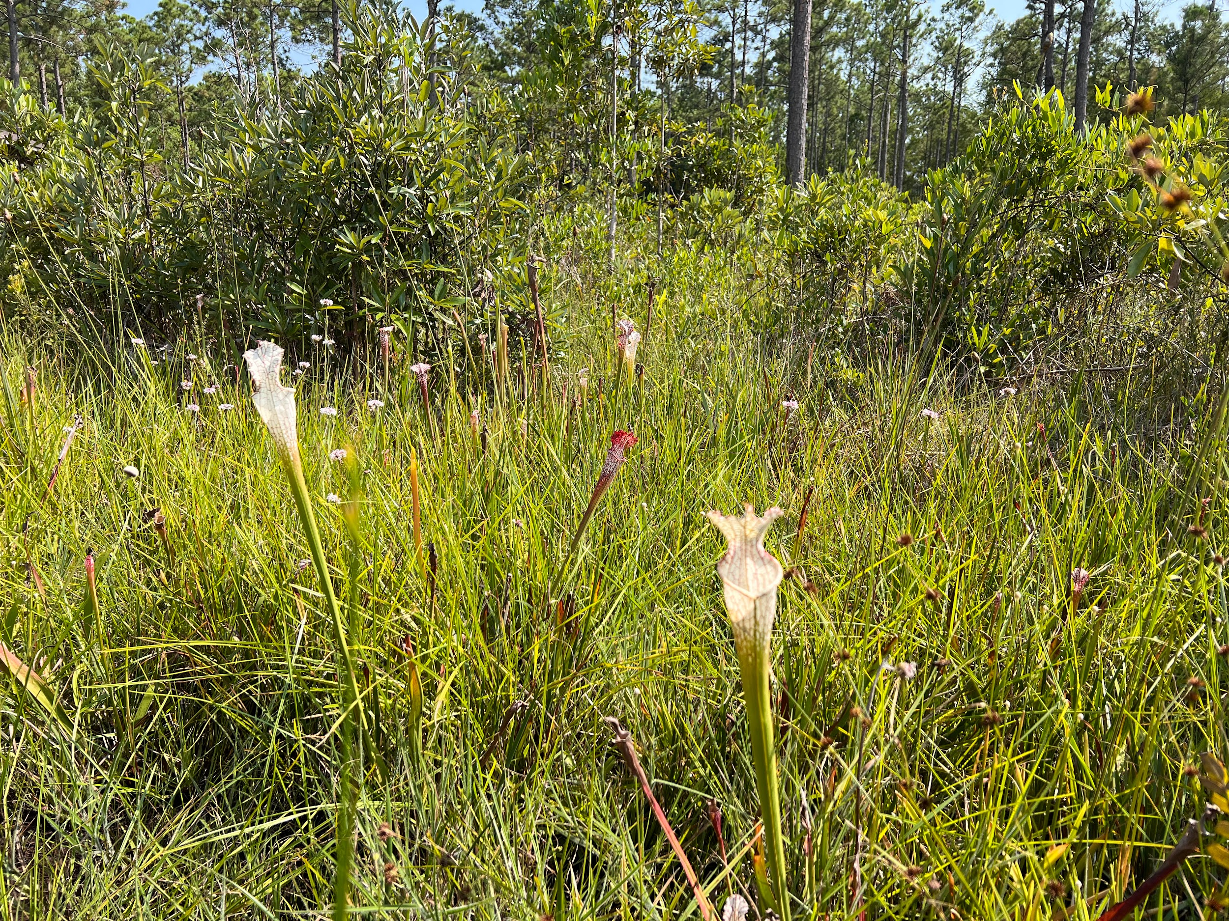

Prescribed fires - a land conservation and management technique - are used in many locations. We are interested in learning about your perceptions and opinions related to prescribed fires in the public lands within the Gulf Coast region of Alabama and Mississippi. Even if you are not familiar with prescribed fires, your responses will help local policy makers improve community awareness and understanding of prescribed fires.

By completing the survey, you are consenting to participate in this research. Although we hope that you will answer every question, you are free to skip any questions. Your participation is voluntary, and you may withdraw your consent and discontinue participation at any time. The survey will take approximately 10 minutes to complete.

You will not be individually identified, and your responses will be used for statistical purposes only. Data collection will be managed by an external vendor who will not collect or store names. Mailing addresses will be used exclusively by the vendor for distributing survey materials and will not be linked to individual responses. Additionally, NOAA will not have access to or retain any mailing address information.

**Public Burden Statement**

The public reporting burden for this information collection is estimated at 10 minutes per response. This burden estimate includes time for reading the instructions, reviewing the questions, and completing the survey instrument. Send comments regarding the accuracy of this burden estimate and any suggestions for reducing the burden to: noaa.nccos.sstex@noaa.gov. You are not required to respond to this collection of information unless a valid OMB control number is displayed.

To be completed by the adult (age 18 and over) in your

household who has the next upcoming birthday.

1. **Before today, had you heard about prescribed fires within the Gulf Coast region of Alabama and Mississippi?**

* Yes
* No, but I had heard of prescribed fires, in general → SKIP to Q5
* No, I hadn’t heard about prescribed fires before today → SKIP to Q6

1. **Have you had any of the following experiences with prescribed fires within the Gulf Coast region of Alabama and Mississippi within the last five years?**

|  |  |  |
| --- | --- | --- |
|  | Yes | No |
| Worked with prescribed fire programs at my job |  |  |
| Private property of myself or someone I know was affected by a prescribed fire |  |  |
| Saw the flames of a prescribed fire |  |  |
| Saw the smoke of a prescribed fire |  |  |
| Experienced discomfort from the smoke of prescribed fire |  |  |
| Saw parts of a forest or grassland that had recently been burned |  |  |
| Saw the regrowth of plants and trees after a prescribed fire |  |  |
| Changed my recreation plans because of a prescribed fire |  |  |
| Had family/friends tell me about prescribed fires |  |  |
| Other, please specify |  |  |

1. **Do you believe enough information is provided to residents about prescribed fires within the Gulf Coast region of Alabama and Mississippi?**

* Too little information
* The right amount of information
* Too much information
* Don't know

1. **How timely do you believe information is provided to residents about prescribed fires within the Gulf Coast region of Alabama and Mississippi?**
   * Not at all timely
   * Slightly timely
   * Moderately timely
   * Extremely timely
   * Don’t know
2. **In general, how knowledgeable do you feel about prescribed fires?**
   * Not at all knowledgeable
   * Slightly knowledgeable
   * Moderately knowledgeable
   * Extremely knowledgeable
3. **Given what you currently know about prescribed fires, what best describes your opinion about prescribed fires within the Gulf Coast region of Alabama and Mississippi?**
   * I support prescribed fires within the Gulf Coast region of Alabama and Mississippi → SKIP to Q8
   * I oppose prescribed fires within the Gulf Coast region of Alabama and Mississippi → SKIP to Q8
   * I have not made up my mind
4. **Even if you have not made up your mind, which way are you leaning?**
   * To support prescribed fires within the Gulf Coast region of Alabama and Mississippi
   * To oppose prescribed fires within the Gulf Coast region of Alabama and Mississippi
   * I don’t know
5. **Prescribed fires are one strategy to achieve management outcomes on public lands. How important are the following management outcomes to you?**

|  |  |  |  |  |
| --- | --- | --- | --- | --- |
|  | Not at all important | Slightly important | Moderately important | Extremely important |
| Lower wildfire risk |  |  |  |  |
| Control invasive species |  |  |  |  |
| Minimize spread of pest insects and disease |  |  |  |  |
| Improve wildlife habitat |  |  |  |  |
| Improve plant diversity |  |  |  |  |
| Improve forage for grazing |  |  |  |  |
| Improve forest appearance |  |  |  |  |

1. **Thinking about the same list and given what you currently know about prescribed fires, how effective do you think prescribed fires are at achieving these management outcomes?**

|  |  |  |  |  |  |
| --- | --- | --- | --- | --- | --- |
|  | Not at all effective | Slightly effective | Moderately effective | Extremely effective | Don’t know |
| Lower wildfire risk |  |  |  |  |  |
| Control invasive species |  |  |  |  |  |
| Minimize spread of pest insects and disease |  |  |  |  |  |
| Improve wildlife habitat |  |  |  |  |  |
| Improve plant diversity |  |  |  |  |  |
| Improve forage for grazing |  |  |  |  |  |
| Improve forest appearance |  |  |  |  |  |

1. **Thinking about the same list again, how much do you trust that managers within the Gulf Coast region of Alabama and Mississippi are doing their best to achieve these management outcomes?**
   * Don’t trust at all
   * Slightly trust
   * Moderately trust
   * Completely trust
   * Don’t know
2. **Given what you currently know about prescribed fires, how would you rate your concern about the following potential effects?**

|  |  |  |  |  |
| --- | --- | --- | --- | --- |
|  | Not at all concerned | Slightly concerned | Moderately concerned | Extremely concerned |
| Smoke and associated health issues |  |  |  |  |
| Wildlife mortality during burns |  |  |  |  |
| Possible escape to private property |  |  |  |  |
| Decreased forest aesthetics shortly after burns |  |  |  |  |
| Limited recreational access during/shortly after burns |  |  |  |  |
| Cost of conducting burns |  |  |  |  |

1. **Thinking about the same list, how much do you trust that managers within the Gulf Coast region of Alabama and Mississippi are doing their best to minimize the potential effects of prescribed fires?**
   * Don’t trust at all
   * Slightly trust
   * Moderately trust
   * Completely trust
   * Don’t know

*This is the final section of the survey. The following questions ensure that all groups are fairly represented.*

***All answers are confidential.***

1. **Are you…?**
   * Male
   * Female
   * Transgender, non-binary, or another gender
   * Prefer not to answer
2. **What is your race and/or ethnicity?** *Please select all that apply.*

* American Indian or Alaska Native
* Asian
* Black or African American
* Hispanic or Latino
* Middle Eastern or North African
* Native Hawaiian or Pacific Islander
* White
* Other (please specify) _____
* Prefer not to answer

1. **In what year were you born?** _____ YYYY
2. **What language do you prefer to use at home?** *Please select all that apply.*

* English
* Arabic
* Chinese
* Korean
* Spanish
* Vietnamese
* Other (please specify) _____

1. **What is the highest degree or level of school you have completed?** *Please check only one.*
   * Some high school, no diploma
   * High school graduate/GED
   * Vocational/trade school certificate
   * Some college, no diploma
   * Two-year college degree
   * Four-year college degree
   * Graduate or professional degree
   * Prefer not to answer
2. **Do you own or rent this residence (where this survey was mailed to)?**

* Own
* Rent
* Other

1. **Is this your primary residence?**
   * Yes
   * No
2. **How long have you been a resident of your current town?** _____ number of years
3. **How long have you been a resident of your current state?** _____ number of years
4. **How many people, including yourself, live in your household?** ____ number of people
5. **How many of these people are at least 18 years old?** ____ number of people at least 18
6. **Which best describes your current employment status?** *Please check only one.*

* Unemployed
* Employed full-time
* Employed part-time
* Retired
* Student
* Homemaker
* Prefer not to answer

1. **What was your annual household income in 202X, before taxes?** *Please check only one.*

* Less than $25,000
* $25,000 to $49,999
* $50,000 to $74,999
* $75,000 to $99,999
* $100,000 to $149,999
* $150,000 to $199,999
* $200,000 or more
* Prefer not to answer

**Thank you very much for taking the time to complete our survey. If you have any additional comments, please feel free to include them in the space provided below.**

*Thank you! That’s our last question. Please place this completed questionnaire in the* ***postage-paid*** *envelope provided and drop it off in the mail.*