**Offshore Wind Energy Development and the Gulf of America Region**

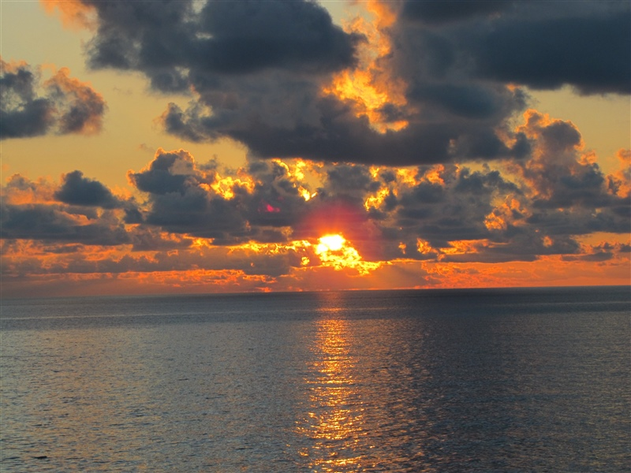

Credit: Officers and Crew of NOAA Ship PISCES; Collection of Commander Jeremy Adams, NOAA Corps Location: Gulf of America

Offshore wind energy development is proposed in the Gulf of America (see map below) by the Bureau of Ocean Energy Management (BOEM). This survey is one of several studies to collect information to inform decision-making processes. We are interested in learning about your opinions. Your responses will help NOAA and BOEM understand the potential human and social impacts from offshore wind energy development in the Gulf of America.

By completing the survey, you are consenting to participate in this research. Although we hope that you will answer every question, you are free to skip any questions. Your participation is voluntary, and you may withdraw your consent and discontinue participation at any time. The survey will take approximately 15 minutes to complete.

You will not be individually identified, and your responses will be used for statistical purposes only. Data collection will be managed by an external vendor who will not collect or store names. Mailing addresses will be used exclusively by the vendor for distributing survey materials and will not be linked to individual responses. Additionally, NOAA will not have access to or retain any mailing address information.

**Public Burden Statement**

The public reporting burden for this information collection is estimated to be 15 minutes per response. This burden estimate includes time for reading the instructions, reviewing the questions, and completing the survey instrument. Send comments regarding the accuracy of this burden estimate and any suggestions for reducing the burden to: noaa.nccos.sstex@noaa.gov. You are not required to respond to this collection of information unless a valid OMB control number is displayed.

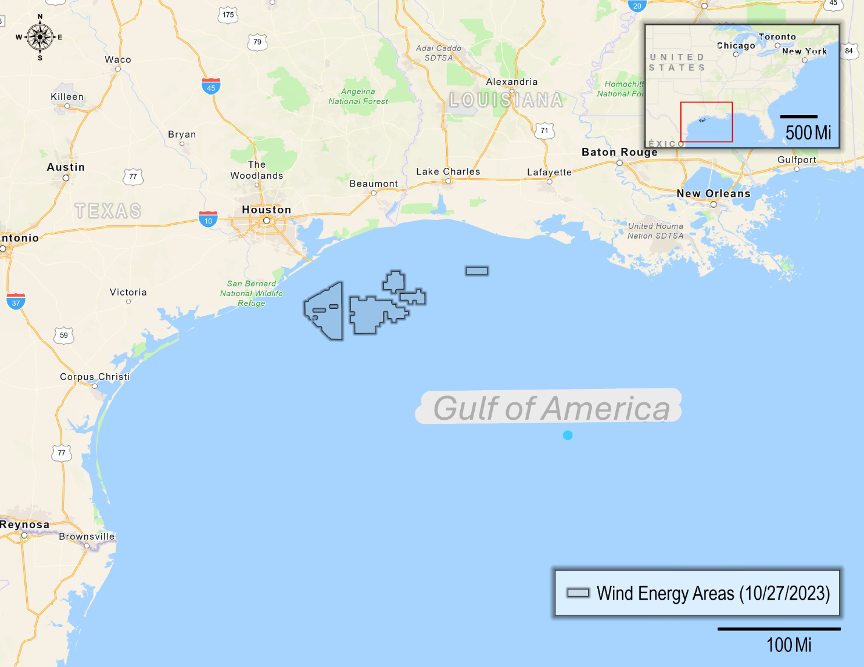

1. Before today, had you heard about the potential for offshore wind energy development in the Gulf of America?

* Yes
* No, but I had heard about offshore wind energy, in general
* No, and I hadn’t heard about offshore wind energy before today

1. How knowledgeable do you feel about offshore wind energy?

* Not at all knowledgeable
* Somewhat knowledgeable
* Very knowledgeable
* Extremely knowledgeable

1. Given what you currently know about offshore wind energy, have you formed an opinion about its potential development in the Gulf of America?

* I support offshore wind energy in the Gulf of America (SKIP to Q5)
* I oppose offshore wind energy in the Gulf of America (SKIP to Q5)
* I have not yet made up my mind (CONTINUE to Q4)

1. [IF Q3=3] Even though you have not yet made up your mind about offshore wind energy development in the Gulf of America, which way are you leaning?

* To support development
* To oppose development
* I don’t know

The Gulf of America produces oil and gas. We are interested in understanding your perceptions of the impacts from offshore oil and gas in the Gulf of America.

1. What potential impact do you think oil and gas production in the Gulf of America has on these items? (select one response for each item)

|  |  |  |  |  |  |  |
| --- | --- | --- | --- | --- | --- | --- |
|  | Very negative impact | Negative  impact | No  impact | Positive  impact | Very positive impact | Not  Sure |
| Affordability of residential electricity |  |  |  |  |  |  |
| Reliability of residential electricity |  |  |  |  |  |  |
| Commercial fishing |  |  |  |  |  |  |
| Commercial aquaculture |  |  |  |  |  |  |
| Coastal community livelihoods |  |  |  |  |  |  |
| Recreational fishing |  |  |  |  |  |  |
| Views of the ocean |  |  |  |  |  |  |
| Coastal habitats |  |  |  |  |  |  |
| Whales, dolphins, and sea turtles |  |  |  |  |  |  |
| Migratory birds and seabirds |  |  |  |  |  |  |
| Tribal orTraditional way of life |  |  |  |  |  |  |
| Marine navigation |  |  |  |  |  |  |
| Water quality |  |  |  |  |  |  |

In addition to oil and gas, the Gulf of America may also produce energy from offshore wind in the future. We are interested in understanding your perceptions of potential impacts from offshore wind energy in the Gulf of America.

1. Given what you currently know about offshore wind energy, what potential impact do you think offshore wind energy production in the Gulf of America will have on these same items? (select one response for each item)

|  |  |  |  |  |  |  |
| --- | --- | --- | --- | --- | --- | --- |
|  | Very negative impact | Negative  impact | No  impact | Positive  impact | Very positive impact | Not  Sure |
| Affordability of residential electricity |  |  |  |  |  |  |
| Reliability of residential electricity |  |  |  |  |  |  |
| Commercial fishing |  |  |  |  |  |  |
| Commercial aquaculture |  |  |  |  |  |  |
| Coastal community livelihoods |  |  |  |  |  |  |
| Recreational fishing |  |  |  |  |  |  |
| Views of the ocean |  |  |  |  |  |  |
| Coastal habitats |  |  |  |  |  |  |
| Whales, dolphins, and sea turtles |  |  |  |  |  |  |
| Migratory birds and seabirds |  |  |  |  |  |  |
| Tribal orTraditional way of life |  |  |  |  |  |  |
| Marine navigation |  |  |  |  |  |  |

1. Next, please tell us how important these same items are to you in terms of your quality of life in the Gulf of America region. (select one response for each item)

|  |  |  |  |  |
| --- | --- | --- | --- | --- |
|  | Not at all  important | Somewhat  important | Very  important | Extremely  important |
| Affordability of residential electricity |  |  |  |  |
| Reliability of residential electricity |  |  |  |  |
| Commercial fishing - excluding shrimping |  |  |  |  |
| Commercial shrimping |  |  |  |  |
| Commercial aquaculture |  |  |  |  |
| Coastal community livelihoods |  |  |  |  |
| Recreational saltwater fishing |  |  |  |  |
| Views of the ocean |  |  |  |  |
| Coastal habitats |  |  |  |  |
| Whales, dolphins, and sea turtles |  |  |  |  |
| Migratory birds and seabirds |  |  |  |  |
| Tribal/Traditional way of life |  |  |  |  |
| Marine navigation |  |  |  |  |

1. How important do you think it is to pursue offshore wind energy development in the Gulf of America?

* Not at all important
* Somewhat important
* Very important
* Extremely important

1. How important is it for electricity produced by offshore wind energy development in the Gulf of America to… (select one response for each item)

|  |  |  |  |  |
| --- | --- | --- | --- | --- |
|  | Not at all important | Somewhat important | Very important | Extremely important |
| Be used in your state? |  |  |  |  |
| Provide electricity for residential use? |  |  |  |  |
| Provide electricity for industrial use? |  |  |  |  |
| Provide electricity for commercial use? |  |  |  |  |
| Replace electricity produced by non-renewable sources? |  |  |  |  |

1. Which of the following sources would you prefer to produce energy for your state? (select one response for each item)

|  |  |  |
| --- | --- | --- |
|  | Yes | No |
| Hydropower (dams) |  |  |
| Coal |  |  |
| Oil (petroleum-based fuels) |  |  |
| Natural gas |  |  |
| Offshore wind |  |  |
| Land-based wind |  |  |
| Nuclear |  |  |
| Solar |  |  |
| Biomass (wood, plant or animal materials) |  |  |
| Marine hydropower (wave, tidal, current) |  |  |
| Geothermal |  |  |

1. Do you believe that climate change is happening?

* Yes (CONTINUE to Q12)
* No (SKIP to Q14)
* I don’t know (SKIP to Q13)

1. Do you believe climate change is mainly caused by human activities or natural forces?

* Human activities
* Natural forces
* I don't know

1. Do you believe offshore wind energy could be an effective way to reduce climate change?

* Yes
* No
* I don’t know

The next several questions will ask about your past experiences, intentions, and preferences related to public participation in local issues in the Gulf of America region.

1. In the last 12 months, have you done any of the following in response to either any environmental issue or offshore wind energy development in the Gulf of America? (select one response for each item)

|  |  |  |  |
| --- | --- | --- | --- |
|  | Any environmental issue in the Gulf of America region | Offshore wind energy in the Gulf of America | Neither |
|
| Signed a petition |  |  |  |
| Written a letter to the editor |  |  |  |
| Contacted a public official |  |  |  |
| Joined or renewed membership to an advocacy group |  |  |  |
| Attended a public meeting sponsored by a government agency |  |  |  |
| Attended a public meeting sponsored by an advocacy group |  |  |  |
| Attended a demonstration |  |  |  |
| Contributed money to an organization |  |  |  |
| Voted in a federal, state, or local election |  |  |  |
| Displayed your position, such as with a bumper sticker, clothing, or yard sign |  |  |  |
| Tried to change a friend’s or relative’s mind |  |  |  |
| Tried to influence others using social media |  |  |  |

1. In the next 12 months, how likely are you to do any of the following in response to offshore wind energy development in the Gulf of America? (select one response for each item)

|  |  |  |  |  |
| --- | --- | --- | --- | --- |
|  | Not at all likely | Somewhat likely | Very likely | Extremely likely |
| Sign a petition |  |  |  |  |
| Write a letter to the editor |  |  |  |  |
| Contact a public official |  |  |  |  |
| Join or renew membership to an advocacy group |  |  |  |  |
| Attend a public meeting sponsored by a government agency |  |  |  |  |
| Attend a public meeting sponsored by an advocacy group |  |  |  |  |
| Attend a demonstration |  |  |  |  |
| Contribute money to an organization |  |  |  |  |
| Vote in a federal, state, or local election |  |  |  |  |
| Display your position, such as with a bumper sticker, clothing, or yard sign |  |  |  |  |
| Try to change a friend’s or relative’s mind |  |  |  |  |
| Try to influence others using social media |  |  |  |  |

1. How important is it for members of the public to provide input on offshore wind energy development in the Gulf of America?

* Not at all important
* Somewhat important
* Very important
* Extremely important

1. How influential do you think public input is on offshore wind energy development in the Gulf of America?

* Not at all influential
* Somewhat influential
* Very influential
* Extremely influential
* I don’t know

1. How important to you are the following goals of public participation? (select one response for each item)

|  |  |  |  |  |
| --- | --- | --- | --- | --- |
|  | Not at all important | Somewhat important | Very important | Extremely important |
| Identify what is most important to the public |  |  |  |  |
| Incorporate public preferences into decisions |  |  |  |  |
| Create opportunities for fair discussion |  |  |  |  |
| Allow all interested individuals to have a say |  |  |  |  |
| Inform decision makers to public needs |  |  |  |  |
| Identify public preferences for potential solutions |  |  |  |  |
| Incorporate traditional and local knowledge into decisions |  |  |  |  |
| Incorporate Tribal knowledge into decisions |  |  |  |  |
| Provide information to the public |  |  |  |  |

1. How influential do you think the results of this survey will be on offshore wind energy development in the Gulf of America?

* Not at all influential
* Somewhat influential
* Very influential
* Extremely influential

1. Are you aware that the Bureau of Ocean Energy Management (BOEM) has hosted public meetings or asked for public comments related to offshore wind energy development in the Gulf of America?

* Yes
* No

This is the final section of the survey. The following questions ensure that all groups are fairly represented. ***All answers are confidential.***

1. **Are you….?**

* Female
* Male

1. **What is your race and/or ethnicity?** *Please select all that apply.*

□ **American Indian or Alaska Native –** *Enter, for example, Navajo Nation, Blackfeet Tribe of the Blackfeet Indian Reservation of Montana, Native Village of Barrow Inupiat Traditional Government, Nome Eskimo Community, Aztec, Maya, etc.* ____________________________

□ **Asian –** *Provide details below.*

□ Chinese □ Asian Indian □ Filipino

□ Vietnamese □ Korean □ Japanese

*Enter, for example, Pakistani, Hmong, Afghan, etc. _______________________*

□ **Black or African American –** *Provide details below.*

□ African American □ Jamaican □ Haitian

□ Nigerian □ Ethiopian □ Somali

*Enter, for example, Trinidadian and Tobagonian, Ghanaian, Congolese, etc. ____________________*

□ **Hispanic or Latino –** *Provide details below.*

□ Mexican □ Puerto Rican □ Salvadoran

□ Cuban □ Dominican □ Guatemalan

*Enter, for example, Colombian, Honduran, Spaniard, etc. _________________________________*

□ **Middle Eastern or North African –** *Provide details below.*

□ Lebanese □ Iranian □ Egyptian

□ Syrian □ Iraqi □ Israeli

*Enter, for example, Moroccan, Yemeni, Kurdish, etc. ____________________________________*

□ **Native Hawaiian or Pacific Islander –** *Provide details below.*

□ Native Hawaiian □ Samoan □ Chamorro

□ Tongan □ Fijian □ Marshallese

*Enter, for example, Chuukese, Palauan, Tahitian, etc. __________________________________*

□ **White –** *Provide details below.*

□ English □ German □ Irish

□ Italian □ Polish □ Scottish

*Enter, for example, French, Swedish, Norwegian, etc.___________________________________*

1. In what year were you born? __________
2. Is English your primary language?

* Yes
* No

1. What is the highest level of education you have completed? *Please check only one.*

* Less than 9th grade
* 9th to 12th grade, no diploma
* High school graduate (includes equivalency)
* Some college, no degree
* Occupational, technical, or vocational program
* Associate's degree
* Bachelor's degree
* Graduate or professional degree

1. Are you a seasonal or year-round resident of the Gulf of America region?

* Seasonal resident (I live in the Gulf of America region only part of the year)
* Year-round resident (I live in the Gulf of America region all year)

1. How many years have you been a resident of the Gulf of America region? __________
2. Do you own or rent this residence (where this survey was mailed to)?

* Own
* Rent
* Other

1. How many people, including yourself, live in your household? __________
2. How many of these people are at least 18 years old? __________
3. Do you or does anyone in your household currently hold a saltwater fishing license?

* Yes
* No

1. Which best describes your current employment status? *Please select all that apply.*

* Unemployed
* Employed full-time
* Employed part-time
* Retired
* Student
* Homemaker

1. Are you or anyone in your household currently employed in one of the following industries? (please select Yes or No for each item)

|  |  |  |
| --- | --- | --- |
|  | Yes | No |
| Fishing or fishing related (such as aquaculture, seafood preparation, or wholesalers) |  |  |
| Generation or distribution of renewable energy |  |  |
| Extraction or distribution of oil or natural gas |  |  |
| Marine construction |  |  |
| Port management or operations |  |  |
| Utility systems construction |  |  |
| Real estate, rental, or leasing |  |  |

1. What was your annual household income in 202X, before taxes? *Please check only one.*

* Less than $25,000
* $25,000 to $44,999
* $45,000 to $74,999
* $75,000 to $124,999
* $125,000 or more

Thank you very much for taking the time to complete our survey. If you have any additional comments, please feel free to include them in the space provided below.

*Thank you! That’s our last question. Please place this completed questionnaire in the* ***postage-paid*** *envelope provided and drop it off in the mail.*