EventPLUS: Yellow Ribbon Reintegration Program

Data Collection: During Deployment mailer, Sms evaluations

YRRP CfE

2022

Contents

During Deployment Mailer Evaluation (USAR only) 2

Items 2

OMB Control Number & Agency Disclosure 6

Breakout SMS Evaluations 7

Items 7

OMB Control Number & Agency Disclosure 8

# During Deployment Mailer Evaluation (USAR only)

## Items

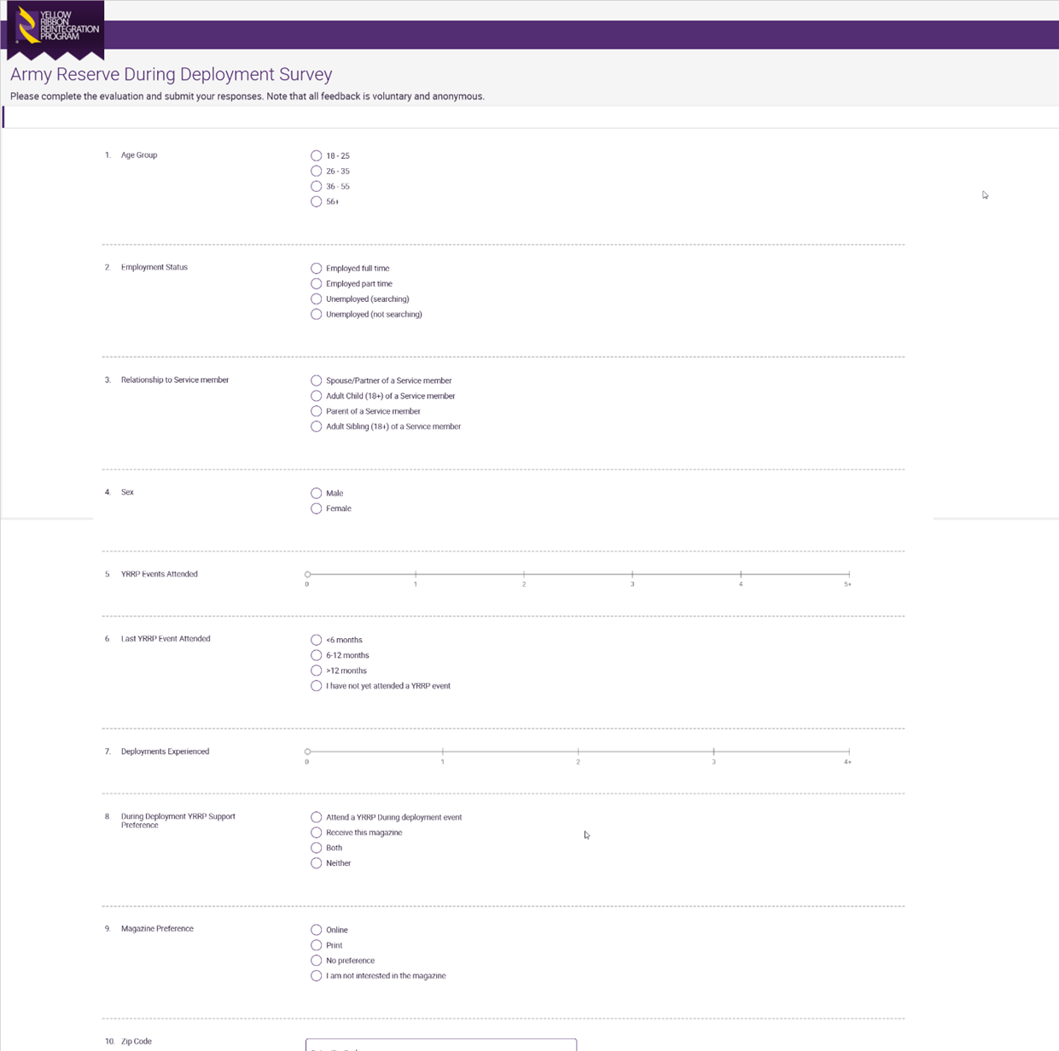

Expanded on following pages

## OMB Control Number & Agency Disclosure

# Breakout SMS Evaluations

## Items



