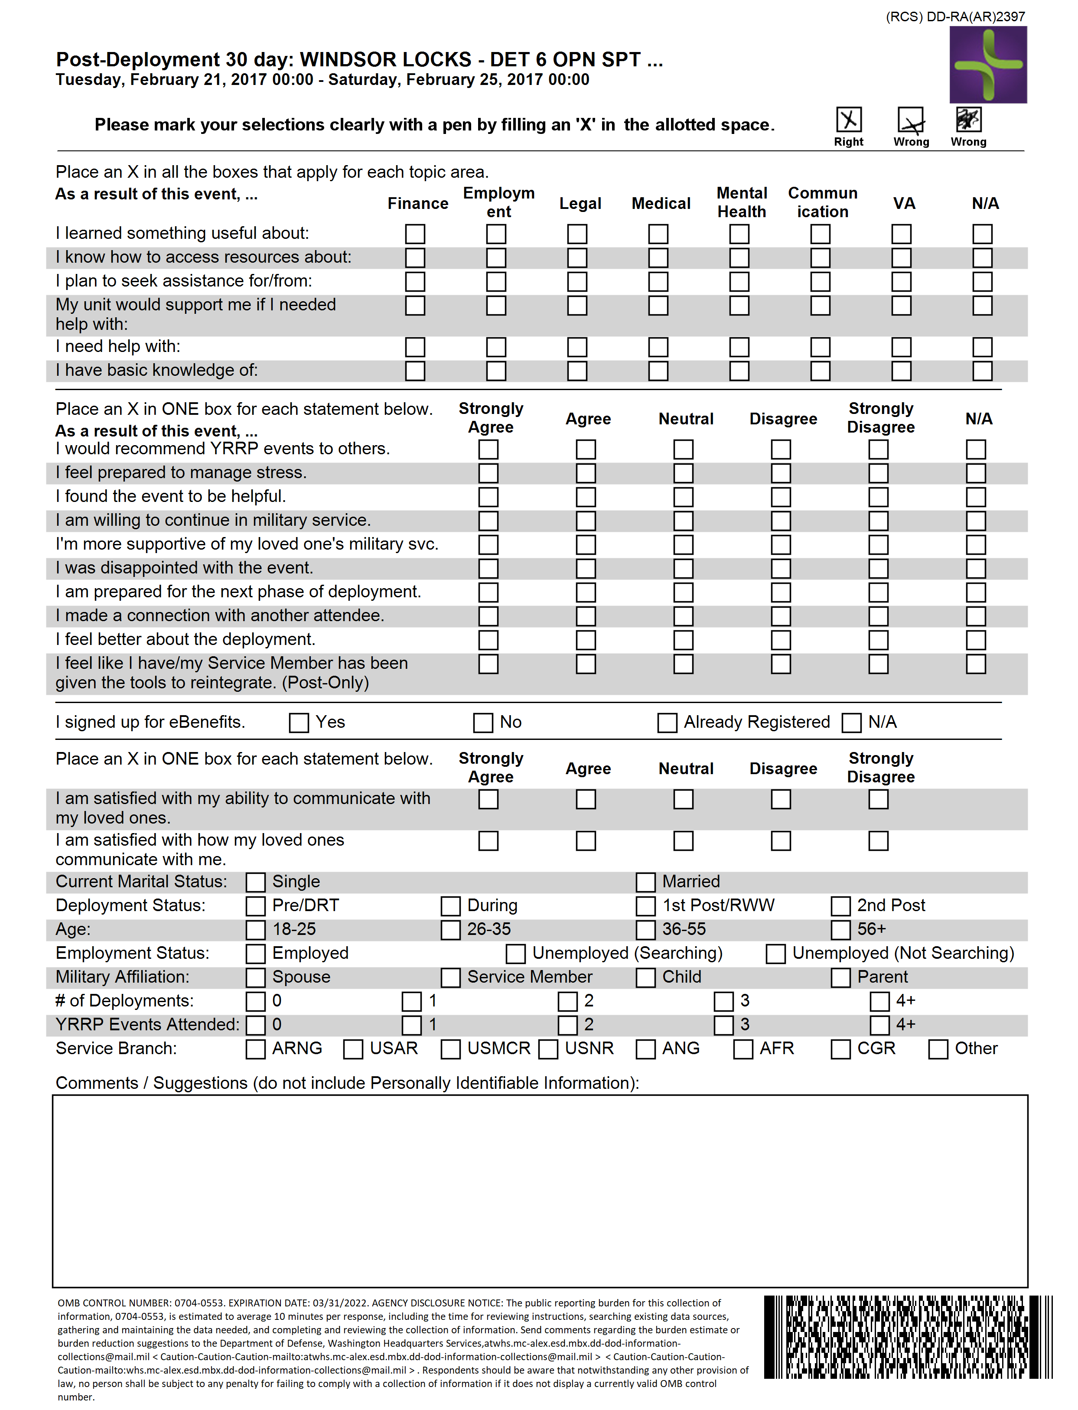

OMB CONTROL NUMBER: 0704-0553. EXPIRATION DATE: 05/31/2025. AGENCY DISCLOSURE NOTICE: The public reporting burden for this collection of information, 0704-0553, is estimated to average 10 minutes per response, including the time for reviewing instructions, searching existing data sources, gathering and maintaining the data needed, and completing and reviewing the collection of information. Send comments regarding the burden estimate or burden reduction suggestions to the Department of Defense, Washington Headquarters Services,atwhs.mc-alex.esd.mbx.dd-dod-information-collections@mail.mi. Respondents should be aware that notwithstanding any other provision of law, no person shall be subject to any penalty for failing to comply with a collection of information if it does not display a currently valid OMB control number.

[Grab your reader’s attention with a great quote from the document or use this space to emphasize a key point. To place this text box anywhere on the page, just drag it.]