OMB CONTROL NUMBER: 0704-0553

OMB EXPIRATION DATE: 05/31/2025

**AGENCY DISCLOSURE NOTICE**

The public reporting burden for this collection of information, 0704-0553, is estimated to average 5 minutes per response, including the time for reviewing instructions, searching existing data sources, gathering and maintaining the data needed, and completing and reviewing the collection of information. Send comments regarding the burden estimate or burden reduction suggestions to the Department of Defense, Washington Headquarters Services, at whs.mc-alex.esd.mbx.dd-dod-information-collections@mail.mil. Respondents should be aware that notwithstanding any other provision of law, no person shall be subject to any penalty for failing to comply with a collection of information if it does not display a currently valid OMB control number.

**Military Community Support Programs (MCSP) ______________(Installation for the Site Visit)**

**Pre-Site Visit Questionnaire**

Please complete this short questionnaire regarding Military Community Support Programs in support of the Site Visit that will be held on_________ at________. Your responses will help enhance our understanding of the user experience and shape the briefings we provide during the site visit. This questionnaire is anonymous, and feedback will not be attributed to individuals. This questionnaire is voluntary and typically takes less than five minutes to complete. Thank you for providing your feedback. (Click the arrow below to continue).

**Level of Familiarity with Military Community Support Programs (MCSP) after attending the Site Visit**

1. How familiar are you with the following MCSP programs or services?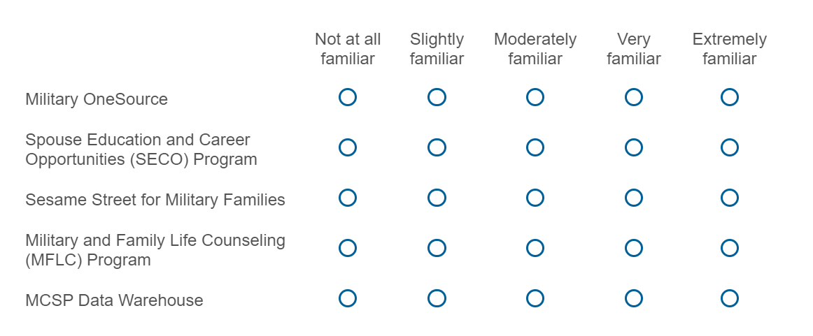
2. How can MCSP collaborate with installations to increase familiarity of programs such as Military OneSource, SECO, MFLC and Sesame Street for Military Families? (Write in below. Please do not include any personally identifiable information.)
3. What best practices have you utilized when coordinating with programs such as Military OneSource, SECO, MFLC and Sesame Street for Military Families on your installation? (Write in below. Please do not include any personally identifiable information.)